*Dear customer!*

You have got «COLD-01» local hypothermia device (hereinafter - device), intended for biological tissues` surface layer local contact cooling with the purpose to get therapeutic effect for different pathologic process and to carry out cosmetic cryomassage

Please, read the operating manual through carefully since it is the document identifying basic technical parameters, performance characteristics, therapeutic indications and contraindications of the device guaranteed by manufacturing works.

Besides the document let you know the device design, principles and mode of its operation the strict observance of which provide both the optimal application of «COLD-01» device for treatment and prophylaxis the wide range of diseases in the condition of physiotherapeutic departments and patient care - preventive clinic, as well as at home by the patient himself under physio-therapeutist`sadvice.

**!**

***Attention!*** *To**carry out treatment**procedures in home conditions does not require special training and any special skills.*  The safe work with the device requires prior careful study of its operating manual and furthermore strictly comply with all its recommendations.

**!**

***Attention!*** Please, keep the operating manual during the whole period of the device service life. «COLD-01» device is to be handed to the third person only with the operating manual.

***Device`s signs***

**!**

*Warnings relating to safety and effective operation of the device*

**

*The working surface is protected with* *reinforced insulation.*



*Conformity to national normative documents.*



**+28ºС**

**+10ºС**

*Operating ambient air temperature: from +10 to +28 ºС.*

***TABLE OF CONTENTS***

|  |  |
| --- | --- |
| Safety recommendations ….......................................................... | 3 |
| Intended use and mode of functioning .......................................... | 5 |
| Storage and transportation .......................................................... | 7 |
| Delivery complete set..................................................................... | 8 |
| Indication for application.............................................................. | 8 |
| Contraindications to local hypothermia.................................... | 9 |
| The order of intended use …......................................................... | 10 |
| Maintenance support...................................................................... | 12 |
| Specifications................................................................................... | 13 |
| The list of used standards ............................................................. | 14 |
| Possible malfunctions and ways of their elimination............. | 14 |
| Acceptance certificate................................................................ | 15 |
| Manufacturer`s warranty................................................................... | 16 |

**SAFETY RECOMMENDATIONS**

**Hypothermia *— reliable and safe technology***

Hypothermia is rather safe practice for medical personnel, patients and environment under its proper use and observance of appropriate safety requirements. Safety of hypothermia technique depends not only on the device itself but greatly defined by the correctness of your actions and the fulfillment of all indications on safety norms and rules.

Treatment procedures with the help of the device are to be carried out only after prior acquaintance with the operating manual paying special attention to safety indications marked with exclamation point **(!)**

***WARNING ! –*** *person hazard relating warning sign*.

**!**

***ATTENTION! –*** *hazards relating to possible device failure or its damage.*

**!**

Work with electricity is associated with the certain risk for the medical personnel and patients, therefore demands strict fulfillment of all safety norms and requirements.

Carry out procedures at the places convenient to connect mains-operated plug into power supply socket excluding both mains cord and cables tension between power supply source- unit and thermoelectric unit, otherwise use ready-made extension cord. «COLD-01» device should be connected only into serviceable socket with working mains voltage ~120-220/230V.

***IT IS FORBIDDEN TO CONNECT THE DEVICE INTO THE MAINS WITHOUT PROTECTIVE GROUNDING MAT (LOOP).***

***ATTENTION!***

**!**

To lift, carry and unplug the device by pulling the mains cord is forbidden.

To lift, carry and unplug the device by pulling the mains cord is forbidden.

In order to avoid the damage of the device keep it away from the children.

Make device visual examination prior to start treatment procedure. The use of device with damaged body of both power supply unit, thermo-electric unit or cables is **PROHIBITED!**



The device should be kept and used in dry premise.



Avoid moisture penetration inside both control block-unit and thermo-electric unit while treating their surfaces with disinfectant solution. Protect the device from moisture, shakes and impacts.



Keep the device out of direct sun beams and high temperatures influence.

After device storage or transportation at the low temperatures before its use it should be kept at room temperature not less than four hours.



Don`t twist and bend cables, after its usage keep the device in consumer`s container.



**Instruction on environment protection:** Utilize the device upon termination of its service life as electronics waste products at the specialized recycling centers.



**Responsibility exclusion:** manufacturing-works does not bear responsibility for damages as a result of the above stated instructions non-observance

**INTENDED USE and THE MODE OF FUNCTIONING**

The device is designed for biological tissues` surface layer hypothermia local contact cooling with the purpose to get therapeutic effect and to carry out cosmetic cryo-massage

The device can be used in patient care institutions and home conditions under physician advice.

To carry out procedures with the help of the devices by the patient himself in home condition does not require any special training and skill.

Hypothermia exposure has therapeutic effects as follows:

– analgetic; – spasmolytic;

– anti-edema(tous); – antiinflammatory;

– reparative –regenerative; – desensitizing;

– immunopotentiating; – hemostatic.

Constructively the device (fig.1) consists of thermo-electric unit ( 1 ) and power supply source unit (2) with mains cord.

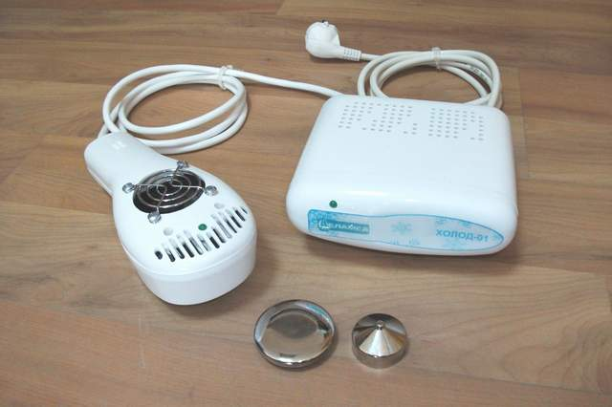

1

2

Fig. 1

1 – thermo-electric unit ;

2 – power supply source unit.

On the thermo-electric unit`s body (fig.2) there is adapter (1) the cooling working surface of which is Ø30 mm. Thermo-electric unit complete set includes the changeable attachment (capping) (2) with working surface Ø 50mm. and changeable attachment (3) with working surface Ø 6 mm. The changeable attachments are fixed to thermo-electric unit`s adapter with a help of threaded joint. Adapter`s or changeable attachments` working surfaces come into contact with biological tissue.

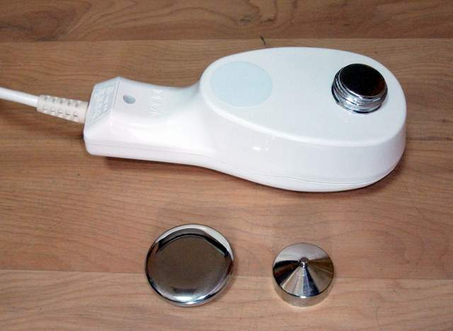

1

2

3

Fig. 2

1 – adapter;

2 – the changeable attachment with working surface Ø 50mm.

3 – the changeable attachment with working surface Ø 6 mm.

On the top part of the thermo-electric unit `s body (fig.3) there is indicator (1) intended to display operating condition of the thermo-electric unit ( green glowing) and alarm signaling ( red glowing). Besides there are vent holes:

а) inlet vent hole ( 2 ) with metal protective lattice (caging);

b) outlet vent hole - shutters (3) to provide the work of fan arranged under protective lattice.

***ATTENTION!*** In the picture (3) there is shown the position of the thermo-electric unit before its preparation for operation – vent hole has the free outlet in environmental air***.***

**!**

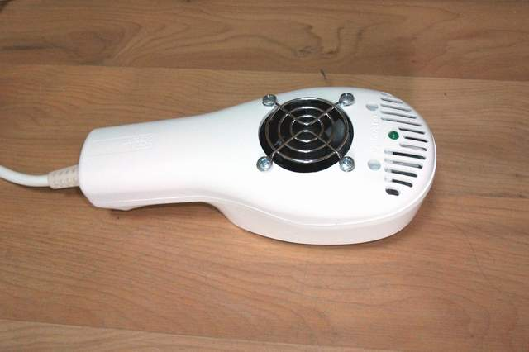

1

2

3

Fig 3

1 – both operating mode and alarm signaling indicator;

2 – inlet vent hole with metal protective lattice;

3 – outlet vent hole - shutters.

The operating principle of the device is the use of thermoelectric effect on the basis of Peltje phenomenon when the direct current is transmitted through a circuit of two diverse materials, thus one of them starts to heat up, and another - to cool. Peltje thermoelectric element is used as a source of cold, cooling surface of which is in thermal contact with the adapter of the thermoelectric unit, and the heated up surface is cooled forcedly by the fan arranged inside the body of the thermoelectric unit.

**STORAGE and TRANSPORTATION**

While in service the device after its intended use should be stored in consumer`s package.

Under the operating manual delivery of the device for an exchange or repair should be carried out in consumer`s package in its full completeness.

The device withstands the storage in the non-heating premises with the air temperature from -50 °С to +40 °С, relative humidity - up to 98%.

The device is transported by all covered transportation facilities in accordance with cargo transportation rules for the condition 5 according to GOST 15150-69 at the ambient temperature between - 50 °С - +50 °С and relative humidity max. 98%.

**DELIVERY COMPLETE SET**

Device possible delivery variants are given in table 1.

Table 1

|  |  |
| --- | --- |
| Name | Quantity |
| «COLD-01» device for local hypothermia.  An attachment with working surface of Ø 50mm.  An attachment with working surface of Ø 6mm  Operating manual  Application instruction  Case | 1  1  1  1  1  1 |

**INDICATION TO APPLICATION**

***Diseases and traumas of locomotor apparatus:***

*●* soft tissues, ligaments, tendons, joints traumas;

*●* long pipe bones` fractures;

*●*post fixation, posttraumatic, postoperative contractures;

*●* the state after arthrostatic operations on knee joint;

*●* the state after knee and hip joints replacement;

*●* deforming polyosteoarthrosis;

*●* epicondylitis;

*●* scapulohumeral periarthritis;

*●* tendovaginitis.

***Surgical pathology :***

*●* wounds and trophic ulcer;

*●* *decubituses*;

*●* burns;

*●* keloid cicatrixes.

***Rheumatologic(al) pathology:***

*●* arthritises (rheumatoid, psoriatic, podagric and other etiology) 1-2 stage activity inflammatory process without system manifestations;

*●* seronegative spondylarthritis, Bechterew's disease of 1-2 stage of activity activity inflammatory process without system manifestations

***Neurologic pathology:***

*●* osteochondrosis with pain and musculo - tonic syndromes;

*●* trigeminal neuralgia;

*●* facial nerve neuropathy;

*●* disseminated both sclerosis and encephalomyelitis;

*●* cervical osteochondrosis with inadequate blood circulation in vertebrobasilar basin;

*●* myofascial syndrome;

*●* spastic paresis and hemiparesis;

*●* dorsopathy;

*●* phantom-limb pains

*●* migraine.

***Skin diseases:***

*●* inflammatory skin diseases (acne, dermatitis);

*●* neurodermatitis;

*●* atopic dermatitis.

***Cosmetology:***

*●* dermal age-related changes;

*●* post surgical operation states in face and body cosmetology.

**!**

***CONTRAINDICATIONS TO LOCAL HYPOTHERMIA***

– diseases of peripheral vessels: Rheino illness, varicose veins, an obliterating both atherosclerosis and endarteritis

– sickle-cell anemia;

– cold bronchial asthma;

– coronary heart disease with stenocardia attacks provoked by cold factor;

– hypersensitivity to the cold factor;

– feverish states (the body temperature is higher than 38 ºС);

– cachexia;

– heavy diseases of cardiovascular system with blood circulations decompensation;

– hypertonic illness of 3 stages, crisis point in the disease coarse;

– lung active tuberculosis with the high-grade intoxication;

– blood systemic diseases at the stage of disease acute condition;

– epilepsy with the often attacks;

– hysteria with spastic attacks;

– psychoses with the phenomena of psychomotor agitation;

– diabetes heavy form with decompensation;

– syringomyelia;

– chronic renal insufficiency with decompensation;

– chronic hepatic insufficiency with decompensation;

– systemic collagensis.

**THE ORDER OF INTENDED USE**

**Device preparation for operation**

Before application after its storage in cold premise, the device should be warmed up to the room temperature within 4 hours.

Disinfection of the device outer surfaces ( if required) is to be carried out by twice wiping with the calico napkin, moistened in solution, allowed in the medical practice, with 10-15 minute interval between wiping (the napkin should be wrung out in order to prevent penetration of disinfection solution inside the device).

**Device operation order**

Connect the power supply source-unit mains cable`s plug into the socket.

**Be user, that:**

а) green glowing indicator on power supply source unit **is lighting;**

b) fan under protective lattice (caging) on thermoelectric unit`s body is rotating – **you can hear specific noise;**

c) green luminescence indicator on thermoelectric unit`s body **is flickering.**

***ATTENTION! In case if one of above specified attributes of the device`s proper work is absent - the device is to be disconnected and it is necessary to apply to the service center.***

**!**

***ATTENTION! The power supply source -unit within its work will be heated up, therefore it is forbidden to cover it with any materials blocking its natural cooling.***

**!**

***ATTENTION! 1. It is forbidden to block ventilating apertures on the thermoelectric unit (fig. 3) as it can disturb the work of the device.***

**!**

***2. It is forbidden to put the thermoelectric unit with ventilating apertures downward on a surface because inflow of cooling air is considerably reduced that can cause overheating of the thermoelectric unit.***

On 10 minutes expiration (at the air temperature no more than +28 ºС) the temperature on the thermoelectric unit`s adapter working surface will reach specified value and it`s time to start procedure, the indicator on the thermoelectric unit should *continuously shine with GREEN light*.

Hold the thermoelectric unit by the body`s handle.

Adapter`s working surface is to be in direct contact with the problem area and the hypothermic exposure is to be carried out in strict compliance with the Instruction on Application.

***WARNING! To avoid a trauma see that the long hair not to get in an aperture with a protective metal lattice on the top cover of the thermoelectric unit***

**!**

***WARNING! It is necessary to pay special attention that procedure incorrect performance (mainly long contact of a working surface with biological tissue at one and the same place) can result in negative reactions:***

**!**

***– skin redness - 1-st degrees frostbite;***

***– formation of bubbles– 2-nd degrees frostbite;***

***– skin necrosis – 3-rd degrees frostbite.***

***Thus, should the adapter (attachment) be held motionlessly on biological tissue at one and the same place for long time (more than 30 seconds) it is POSSIBLE TO GET COLD BURN with the subsequent skin necrosis!***

***The frostbite basic feature is the white ischemic sport even without evident painful sensation!***

*Cold exposure duration up to negative reactions occurrence is various and depends on several factors: first of all - the concrete person`s cutaneous covering (skin) individual features and structure, second – obtusion (decrease of sensitivity) to cold exposure, for example, with ages or against the background of some diseases. Therefore periodic monitoring (in 10-15 sec.) of skin surface state in the area of exposure is necessary while carrying out procedure under the stable technique.* With the purpose to enlarge the area of a treatable surface fix (screw joint) replaceable attachment of the larger diameter to adapter. The inside surface of the attachment is desirable to be watered.

Attachment with diameter of working surface Ø 6mm is used to carry out point exposure.

***Notes.***

*1. On a cooling working surface of the adapter or attachment there is inevitable formation of ice or snow "cap" - condensate, as a natural process of freezing air moisture out.*

*2 The sign of zero temperature is the melting of the formed "cap" on the thermoelectric unit`s adapter or replaceable attachment.*

***ATTENTION!***

**!**

***Attachment replacing is to be to done when thermoelectric unit`s adapter is warm.***

***For this it is necessary:***

***- to disconnect the thermoelectric unit from power supply mains;***

***- to wait when the adapter or a replaceable attachment will melt;***

***- to fix or unfix a replaceable attachment;***

***- to connect the device to power supply mains in order to continue work with the device again.***

If on 15 minutes expiration the adapter of the thermoelectric unit or a replaceable attachment hasn`t cooled and the indicator lights continuously with red luminescence it means that the device is out of order and it is necessary to apply to service center.

If the indicator on the thermoelectric device is blinking with red glowing it means that the temperature on a working surface is lower than - 12 ºС. In this case the device is to be disconnected from the power supply mains 120-230V, it should be kept to full melting of condensate on the thermoelectric unit`s adapter or replaceable attachment and then be connected to the power supply mains 120-230V again.

**MAINTENANCE SERVICE**

Maintenance service of the device includes routine inspection, dusting, clearing and the periodic monitoring of its serviceability.

Preventive inspection of the device is carried out not less than once in three months. Special attention is to be drawn to integrity of cables, plug, mains cord, power supply source-units` cases and thermoelectric unit`s body.

**SPECIFICATIONS**

1. Device electro-safety protection class is **I,** the working part electrical sock protection type is **ВF** GOST Р 50267.0-92 (IEC 601-1-88).

2. The device operating state is provided with power supply mains alternating current: frequency – 50-60 Hz, voltage – 120-230V.

3. The device is used in the following conditions:

– environmental air temperature is from +10 to +28 ºС;

– air relative humidity is up to 85% with temperature +25 ºС.

4. Device power consumption: not more than 70 VA

5. The means of the working surface cooling – thermoelectric (Peltje element 35 W).

6. The temperature on adapter`s working surface without thermal loading: **-** 8±1 ºС.

7. The temperature on the 50mm attachment `s working surface without thermal loading: -7±1 ºС.

8. The temperature on the 6mm attachment `s working surface without thermal loading: -6±1 ºС.

The temperature on the working surface is not regulated.

9. Nose level: not more than 35 dB.

10. Continuous work duration: not less than 8 hours;

11. The time of working temperatures setting after device connection to power supply mains: not more than 10 min.

12. Device`s components parts outer surfaces are stable to the disinfection by any chemical solution allowed to application in medical practice for products made of plastic and metal.

13. Device average lifetime is not less than 5 years.

14. Overall dimensions and weight of the device`s main component parts are given in table 2.Table 2

|  |  |  |  |  |
| --- | --- | --- | --- | --- |
| Name of component parts | Overall dimensions, mm, no more | | | Weight, kg, no mote |
| length | width | height |
| Thermoelectric unit  Power supply source -unit | 200  155 | 85  140 | 80  75 | 0,65  0,5 |

**THE LIST OF USED STANDARDS**

EN ISO 10993-1:2009+Cor.1:2010

EN 60601-1:2006+AC:2010

**CE 0044**  DIN EN ISO 15223-1:2013

EN 60601-1-8:2007 +AC:2010

EN 60601-1-11:2010

**POSSIBLE FAULTS AND THE WAYS OF THEIR ELIMINATION**

|  |  |  |
| --- | --- | --- |
| Fault discretion | Possible reason | The user`s action or the means of fault elimination |
| On connection the power supply source-unit`s plug to power supply mains – green color indicator on power supply source-unit and thermoelectric unit is not lighting | 1. The absence of mains voltage 120-230V.  2. Bad contact in electrical operated socket  3. The breaking of mains cable integrity on power supply source-unit.  4. Power supply source-unit`s  failure. | Be sure in the mains availability.  Be sure in the mains availability.  Apply to a service center  Apply to a service center |
| On connection the power supply source-unit`s plug to power supply mains – green color indicator on power supply source-unit is lighting **but the indicator of green luminescence on thermoelectric unit is not lighting and fan does not work** | Breaking of connecting cable`s integrity between power supply source-unit and thermoelectric unit | Apply to a service center |
| On 15 min. expiration after connection the power supply source-unit`s plug to power supply mains - green color indicator on power supply source-unit is lighting; fan works on thermoelectric unit **and red color indicator is continuously lighting.** | Thermoelectric unit is out of order | Apply to a service center  . |
| On connection the power supply source-unit`s plug to power supply mains – green color indicators are lighting both on power supply source-unit and thermoelectric unit, **but the fan does not work on thermoelectric unit.** | Fan is out of order | Apply to a service center  . |

**ACCEPTANCE CERTIFICATE**

«COLD-01» local hypothermia device works number ___________, is in compliance with technical specifications GIKS.941519.107. SP and is recognized as ready for operation.

Output date _____________________ stamp

____________________________________________________

(signature of person responsible for acceptance)

«COLD-01» local hypothermia device works number ___________, is packed according to the requirements stipulated by the design documentation.

Date of packing _____________________

The packing is done by_________________

**MANUFACTURER`S WARRANTY**

The manufacturer guarantees the device quality conformity to the requirements of operating manual`s section « Technical specifications» should the customer strictly observes conditions and rules of storage, transportation and maintenance.

*Device operation life warranty period - 12 month from the day of sale.*

Within the warranty period manufacturing works free of charge does the repair or replace the device or its components parts against the warranty coupon presentation

*Guaranty terms and conditions.*

The guarantee is valid only with the availability of the right filled guarantee coupon with indication trade organization product serial No, date of sale and clear seal in it.

The guarantee does not cover the following cases:

- device has signs of non-authorized action or there was attempts to repair it in the unauthorized service center;

- if non-authorized changes of device design or its circuit have been revealed;

- device has mechanical damages;

- device has the damages as a result of ingress of foreign objects, substances and liquids in it.;

- device has the damages caused by power supply mains parameters unconformity to the requirements of State standards

Electric circuits, the description and other design specifications are being sent by the manufacture on request of the authorized service centers.