Dear Customer!

Thank you for purchasing the “OPHTHALMAG” device (below referred to as the Device) designed for treatment of ophthalmologic and ENT diseases, as well as a variety of dentofacial neurological and trauma conditions, with low-frequency, low-intensity pulsed magnetic field.
Please carefully study this Operating Manual, which is a document identifying the basic technical parameters and characteristics of the Device, indications for and contraindications against its usage, as well as the directions for its application and safety features, certified by the Manufacturer.
Knowing the above, you shall ensure optimal usage of the Device’s unique features for treatment and prevention of a wide range of diseases, both at physiotherapy departments of healthcare facilities and in home conditions upon doctor’s advice.
Please keep the Operating Manual throughout the whole service life. When handing the “OPHTHALMAG” device over to another user, please make sure to hand in the Manual as well.

Attention! For any questions about application of the “OPHTHALMAG” device, please call the Manufacturer’s information hotline at +7 800 200 01 13.
!

Symbols on the Device
!

Warnings related to safety and effective operation.

The housing is protected with reinforced insulation. No safety grounding is required.
Read carefully the Operating Manual for the Device.

Emitter is protected with reinforced insulation.

Compliant with domestic regulatory documents.

+35 ºС
+10 ºС

Operating ambient temperature: from +10 ºC to +35 ºС.

Compliant with the CU TR 020/2011 Technical Regulations of
the Customs Union between Russia, Belarus and Kazakhstan.

TABLE OF CONTENTS
Safety Instructions…………….………..………..….. | 4
Intended Use and Operating Principle…………….… | 5
Transportation and Storage…………….……….…… | 8
Delivery Set…………….………..………..….……..... | 8
Indications for Use……..….……..….……..….……... | 8
Contraindications……..….……..….……..….……..... | 9
Directions for Use……..….……..….……..….…….... | 9
Maintenance Service…………….……….………….. | 16
Specifications…………….……….………………….. | 16
List of Standards Used…………….……….……….. | 18
Acceptance Certificate…………….……….……….. | 18
Environmental Responsibility…………….………... | 19
Manufacturer`s Warranty…………….……….……… | 20
Appendix A…………….……….……….……………. | 21

SAFETY INSTRUCTIONS
Please read this Operating Manual carefully before starting the therapeutic or routine procedures with the Device.

Carry out the procedures in places suitable for plugging the device into the power supply socket without straining the mains cord or the emitters` cables; otherwise use power extenders of industrial production. The OPHTHALMAG Device is to be connected only to a properly functioning socket with an operating voltage of ~220V or ~230V.
No lifting, carrying, or unplugging of the Device by pulling the mains cord is allowed.

To avoid possible damage to the Device, keep it away from reach of children.
Make sure to do visual examination of the Device prior to procedure start. Using the Device if its housing, emitters, or cables are damaged is PROHIBITED!

Please store and use the power and control unit, as well as the emitters, only in dry places.

Avoid penetration of moisture inside the power and control unit and emitters while treating their surfaces with disinfectant solutions. Protect the Device from dampness, shock and impact.

Keep the Device away from direct sunlight and high temperatures.

After storage or transportation of the Device at low temperatures, keep it at room temperature for at least 4 hours prior to usage start.

Do not twist or bend the cables; store the Device in the consumer container after its usage.

Do not place an operational Device nearby (less than 0.5 m apart from) magnetic data carriers (floppy disks, credit cards, video records, mobile memory units).

Instructions on environmental protection: dispose of the Device upon termination of its service life as electronic waste at specialized recycling points.

Exclusion of liability: the Manufacturer shall not be held liable for damages resulting from non-observance of the above instructions.

INTENDED USE AND OPERATING PRINCIPLE
The Device consists of a power and control unit (Fig. 1 pos.1) and two emitters (Fig. 1 pos.2). The stand platform (Fig. 1 pos.3) is provided to ensure optimal positioning of the emitters against the exposed organs by adjusting to patients’ anatomic features. Figure 1 suggests a most practical positioning of the power and control unit while arranging the workplace for treatment procedures.
Individual inductors of an emitter

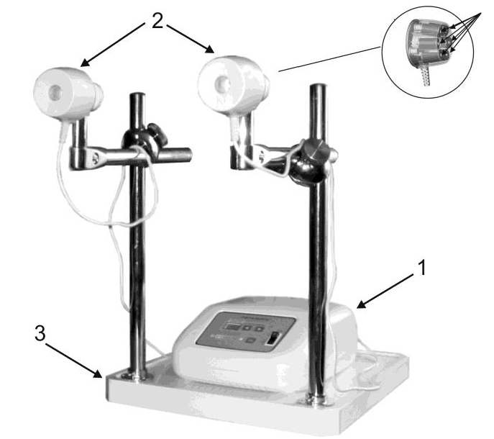

Fig. 1

The Device generates two types of pulsed magnetic fields: “travelling” and “static”.
The “travelling” type field is one which produces sequential excitation of all the individual inductors in an emitter. The motion of the generated “travelling” magnetic field can be directed in two ways:

- clockwise (Fig. 2 a) / counterclockwise (Fig. 2 b).

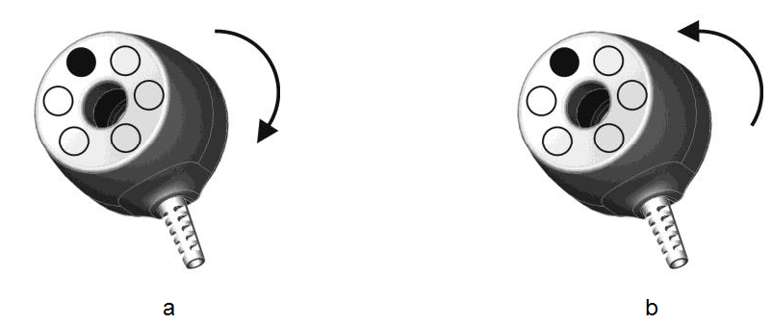
Fig. 2

The “static” type field (Fig. 3) presumes simultaneous excitation of all the individual inductors in the emitters.

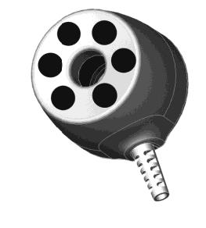
Fig. 3

Function of the control and display elements

The front panel of the power and control unit has the following controls and displays (Fig. 4):

1 - Power switch;
2 - ‘’ button: program number setup (number downwards);
3 - ‘’ button: program number setup (number upwards);
4 - “START/STOP” button: switching the magneto-action on/off;
5 - LED indicator displaying (depending on the operating mode) either the program number, or the exposure time under the selected program, or the time left until the procedure end, or the error code;
6 - magneto-action indicator.

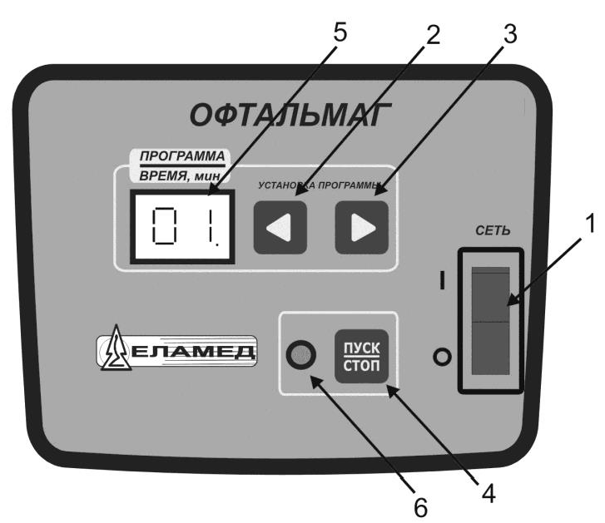

Fig. 4

TRANSPORTATION AND STORAGE
The device endures storage in a non-heated storage room with air temperature from -50 °С to +40 °С and relative air humidity of up to 98%.
The device can be transported by all covered vehicles under the GOST R 50444-92 standard in compliance with the rules of carriage applicable to a specific carrying vehicle under condition 5 of GOST 15150-69 at an ambient temperature from -50 С to +50 С and relative air humidity of up to 98%.

DELIVERY SET
The complete delivery set for the Device and its accessories is listed in Table 1.
Table 1
Name | Quantity in  delivery set
Power and control unit | 1
Emitter | 2
Accessories:  Stand platform, including:  - Rack  - Stand rod  - Cross-bar  - Four-point holder  Handle  Holder  Magneto-action indicator  3 mm (commercial) bent hex wrench (Inbus) | 1  2  2  2  2  2  1  1
Operating Manual | 1
Instruction for Product Use | 1
Brief instruction for exposure initiation | 1

Indications for Use
- Diseases of the eye and adnexa.
- Diseases of the ear and mastoid process.
- Diseases of the respiratory system.
- Diseases of the nervous system.
- Diseases of the digestive system.
- Injury and certain other consequences of external causes.
- Certain infectious diseases.
- Endocrine, nutritional and metabolic diseases.

CONTRAINDICATIONS
- Hemorrhage and coagulopathy.
- Systemic blood diseases.
- Malignant neoplasms.
- Severe cardiac arrhythmia (atrial fibrillation, paroxysmal tachyarrhythmia).
- Cardiac, aortic, and major vessels aneurism.
- Myocardial infarction in the acute period.
- Ischemic and hemorrhagic stroke in the acute period.
- Purulent processes, acute tuberculous process, infectious diseases in the acute stage, febrile diseases.
- Thyrotoxicosis.
- Pregnancy.
- Implanted pacemaker.
- Acute glaucoma.
- Corneal foreign body and eyeball injuries before surgical exploration.
- Acute periods of thrombosis of retinal central vein and artery, retinal detachment.
- Tuberculous eye lesion.
!

Attention!
- Malignant neoplasms are a relative contraindication. Magneto-therapy may be applied for treatment and rehabilitation purposes (as intended) on the background of malignant diseases ONLY at specialized care departments and as prescribed by attending doctor.
- Presence of stents or condition after coronary artery bypass surgery is not a contraindication against treatment.
- Presence of titanium elements is not a contraindication.
- Presence of dental prostheses is not a contraindication.

DIRECTIONS FOR USE
After storage in cold premises, the Device should be warmed up to room temperature for 4 hours before use.
Disinfection of the Device components is required prior to its first usage and later on when necessary.
Disinfection means
Disinfection of the Device’s outer surfaces is to be carried out by wiping them twice with a heavy muslin or gauze cloth moistened with a disinfectant solution which is approved for usage with plastic or metal products (for instance, 1% solution of chloramine, 3% hydrogen peroxide solution mixed with 0.5% solution of a household detergent, 0.5% solution of Lysoformin 3000, 2% solution of Virkon). The interval between the wipings should be at least 15 minutes. Make sure to squeeze the cloth out in order to avoid leakage of the solution inside the Device components. Then wipe the surfaces with a napkin, moistened with water and squeezed out, until the disinfectant odor wears off, and dry them at an ambient temperature of up to +50 °C.
To prepare the workplace using the stand platform, the following steps are required in a successive order:

- Position the two stand rods (Fig. 5 pos. 1) onto the rack (Fig. 5 pos. 2) and then fixate them with the help of the hex wrench (Fig. 5 pos. 3).

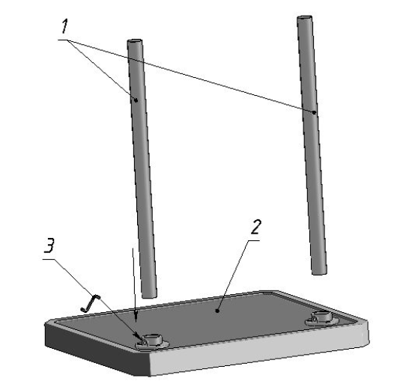

Fig. 5

- Loosen the holder nut (Fig. 6 pos. 1); align the ridges on each of the pieces against one another (Fig. 6 pos. 2).

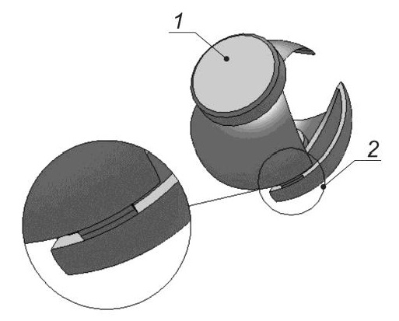

Fig. 6

- Align the cross-bar (Fig. 7 pos. 1) with the holder (Fig. 7 pos. 2) as shown in Fig. 8.

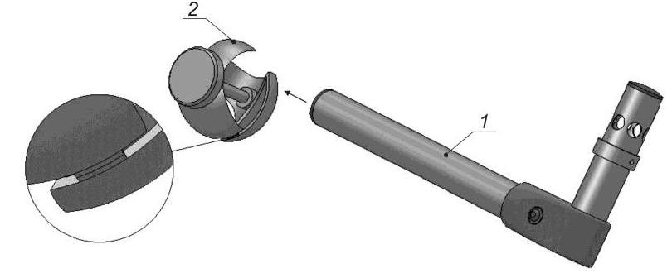

Fig. 7

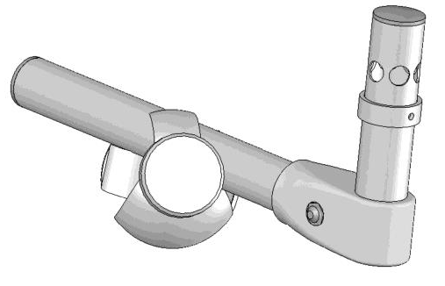

Fig. 8

- Place the assembly obtained onto the left stand rod of the platform (Fig. 9 pos. 1); tighten the nut (Fig. 9 pos. 2).

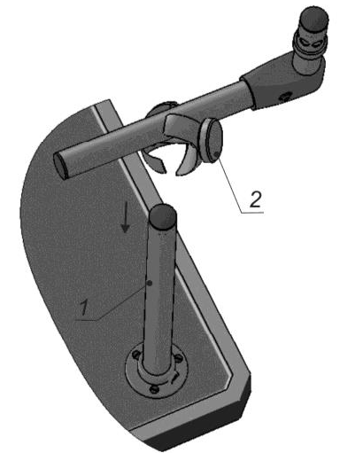

Fig. 9
Fig. 6
- In the same way, assemble together the second holder and cross-bar and place them onto the right stand rod of the platform.

The complete stand platform assembly is shown in Fig. 10.

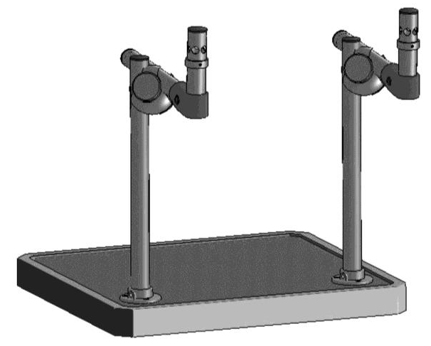

Fig. 10

- Position the two emitters (Fig. 11 pos. 1) onto the cross-bars (Fig. 11 pos. 3). To do so, attach a holder (Fig. 11 pos. 2) onto each of the emitters and then use the holders to fasten the emitters on the bars.
The emitters are fastened onto the cross-bars with the help of screws (Fig. 11 pos. 4).
Vertical and horizontal adjustment of the emitters is performed using nuts (Fig. 11 pos. 5) and holder screws (Fig. 11 pos. 4).

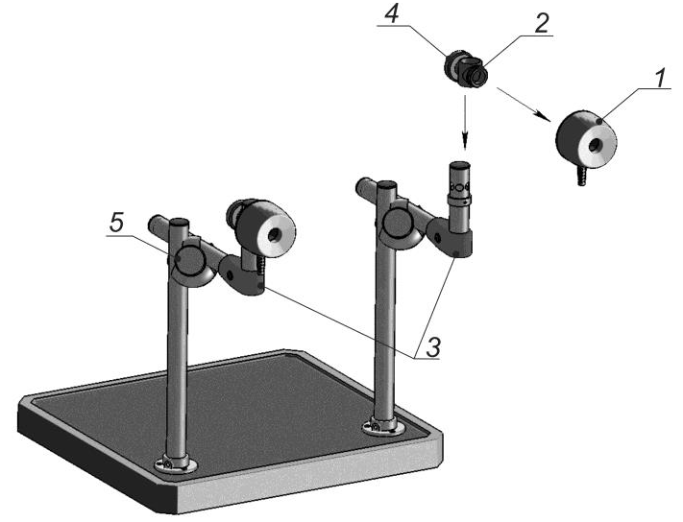

Fig. 11

Note: For a more convenient treatment procedure, the emitters can also be attached to a special handle (in addition to their placement on the stand platform) as shown in Fig. 12.
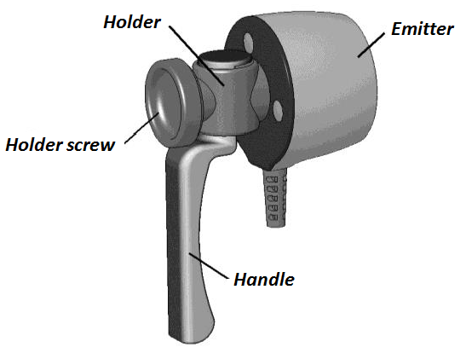

Fig. 12

- Position the power and control unit in a way to ensure procedure convenience.
- Connect the emitters to the power and control unit.
!

Attention!

To avoid improper connection of the emitters, pay attention to the markings “1” and “2” on the emitters` connectors. They should be turned upwards and correspond to the markings of the sockets on the power and control unit. After plugging the connectors in, make sure to fixate them with screws (Fig. 13, 14).

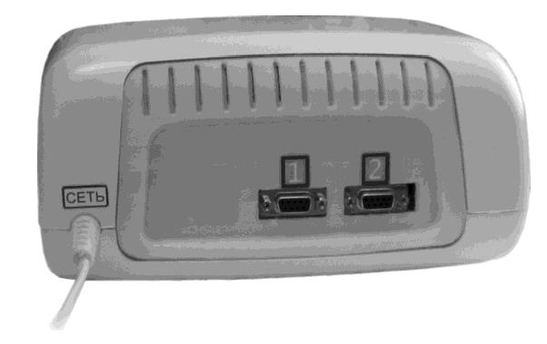

Fig. 13

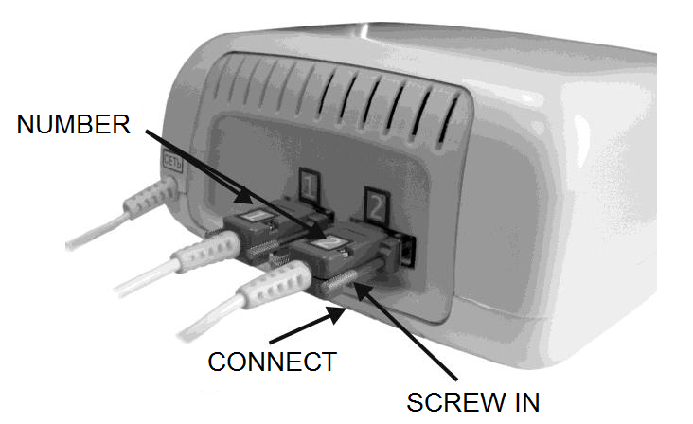

Fig. 14

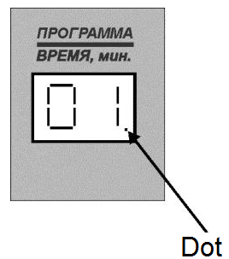
Press the “POWER” switch to activate the Device, while the power-on indicator will light up, and the power and control unit’s display box will be showing the number of the last program used. A dot will light in the right bottom corner of the display (Fig. 15).

Set the number of the required program according to the Instruction for Product Use with the help of “” and “” buttons.
Fig. 15

Place the emitters in accordance with the selected treatment method.
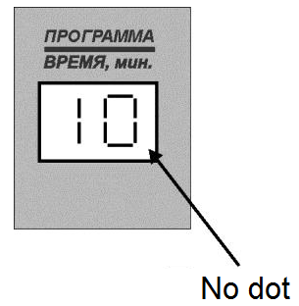
After pressing the “START/STOP” button, the magneto-action indicator will light up, while the LED display will be showing the time remaining until the procedure end, and the dot in the lower right corner will disappear (Fig. 16). The Device will start generating the preset magneto-action.

Fig. 16

Note:
- In case of disconnection or malfunction of the emitter required for the procedure, the Device produces a sound indication, and an error code is displayed in the display box (see Table 2).

- Operability of each of the emitters can be checked with the help of a magnetic field indicator. However, keep in mind that the indicator does not respond to fields with density amplitude of less than 10 mT. The methods for the emitters’ operability control are described in the “MAINTENANCE SERVICE” section.
Due to the limited sensitivity of the field indicator to magnetic fields, absence of its response while performing operability control during an exposure program involving a field density amplitude of less than 10 mT IS NOT A SYMPTOM OF THE DEVICE FAILURE.

After the exposure procedure is over, the respective sound indication will be generated, the magneto-action indicator on the control panel will fade, and the LED display will return to the last used program number (with the dot in the right bottom corner).
If a next magneto-therapy session is not planned, switch the power and control unit off by pressing the “POWER” switch on the front panel.

The Device has self-diagnostics functions: in case of a malfunction, the exposure stops, and an error code is indicated on the display, accompanied by a sound signal. The list of malfunctions and troubleshooting methods are given in Table 2.
Table 2.
Visual symptoms of a malfunction | Possible cause of a malfunction | Troubleshooting method
1. An alarm sound signal is generated, and an ‘E1’ code is displayed | There is a bad contact in the connection plug of emitter 1. | Switch the Device off. Check the connector fixation.  Switch the Device on.
 | Break in the connecting cable. | Contact the service office.
2. An alarm sound signal is generated, and an ‘E2’ code is displayed | There is a bad contact in the connection plug of emitter 2. | Switch the Device off. Check the connector fixation.  Switch the Device on.
 | Break in the connecting cable. | Contact the service office.
3. An alarm sound signal is generated and an ‘E3’ code is displayed | Malfunction of emitter 1 or 2. | Contact the service office.

MAINTENANCE SERVICE
Maintenance of the Device is quite simple and includes routine inspection, cleaning from dust and dirt, disinfection, and periodic control of its operability.
Periodic operability control is to be carried out at least once a year. For this purpose, do the following:
- connect the emitters to the power and control unit and arrange them in a way to provide easy access to the individual inductors of both emitters;
- plug the Device to the mains and press the “POWER” switch to activate it;
- select an exposure program which uses maximal magnetic field density and pulse repetition frequency (Program No. 29);
- activate the magneto-action;
- check the presence of magnetic field in each of the emitters by moving the magnetic field indicator over their working surfaces and making sure that the indicator LED is continuously glowing in a pulsating manner;
- stop the action;
- press the “POWER” switch to deactivate the Device and unplug it from the mains.

Routine inspection is to be performed at least once every three months. During the inspection, it is necessary to check the integrity of the cables, plug, mains cord, and the housings of the emitters and the power and control unit.

Disinfection is to be carried out as may be necessary.

SPECIFICATIONS
- The Device is functional with power supply from alternating current mains of 220V (-10%; +10%) or 230V (-10%; +6%), frequency 50Hz.
- Device electric power consumption: 16 VA max.
- The parameters and characteristics of the pulsed magnetic fields generated by the Device are specified in Appendix 1 below.
Absolute deviation of the field density peak value on the emitters’ surface from the preset one (A) is within ± [0.2A+0.6] mT.
Relative deviation of magnetic field pulses repetition frequency is within ±5%;
Relative deviation of the total exposure time is within ±5%;
Relative deviation of the magneto-action time and the break time is within ±5%;
- Temperature of the emitters’ surfaces, max.: 41 ºС.
- Device operating mode setting time, max.: 30 sec.
- The surfaces of the Device emitters are marked with the magnetic field polarity: ‘N’ – north.
- The Device displays the following indications:
- program number;
- exposure time;
- malfunction code;
- presence of magneto-action;
- The duration of the Device’s continuous operation is at least 8 hours in an intermittent mode: magneto-action followed by a 5-minute break.
- Mean service life is no less than 5 years.
- The exterior surfaces of the Device components are resistant to chemical disinfection with any solution approved in medical practice for application on plastic and metal products.
- The length of the mains cord is 1.5 ± 0.1 m.
- The length of the connective cables from the emitters to the power and control unit is 1.2 ± 0.1 m.
- The overall dimensions and weight of the Device components and accessories, as well as of the accessories set parts are given in Table 3.

Table 3.
Component name | Dimensions, mm |  |  |  | Weight, kg,  max.
 | length | width | height | diameter
Power and control unit | 240±5 | 300±5 | 115±5 |  | 3.0
Emitter |  | 47±2 |  | 70±3 | 0.5
Stand platform | 400±5 | 690±5 | 547±5 | - | 3.5
Handle | 130±10 | 40±5 |  | 25_{-0.5} | 0.02
Magnetic field indicator |  |  | 14±1 | 50±3 | 0.03
Holder | 55±5 |  |  |  | 0.02

LIST OF STANDARDS USED
GOST R 50267.0-92 (IEC 601-1-88) “Medical electrical equipment. Part 1. General safety requirements”.
GOST R 51609-2000 “Medical products. Classification in accordance with potential risk of using”. Section 5 (Appendix 9 of Directive 93/42/ЕЕС).
GOST R ISO 10993.1-99 “Medical devices. Biological evaluation of medical devices. Part 1. Evaluation and testing” (ISO 10993-1:2009).
GOST R 50267.0.2 – 2005 (IEC 601-1-2-93) “Medical electrical equipment. Part 1. General safety requirements. Part 2. Electromagnetic compatibility. Requirements and test methods”.
GOST R 50444-92 “Medical instruments, apparatus and equipment. General specifications”.
GOST 15150-69 “Machinery, instruments, and other technical products. Models for various climatic regions. Categories and operating, storage, and shipping conditions with particular reference to climate factors”.
GOST R 50267.0.4-99 “Medical electrical equipment. Part 1. General safety requirements. 4. Safety requirements for programmable medical electrical systems”.
GOST R 51318.11-99 “Electromagnetic compatibility of technical equipment. Radio disturbance from industrial, scientific, medical and domestic (ISMD) radio-frequency equipment. Limits and test methods”.

ACCEPTANCE CERTIFICATE
“OPHTHALMAG” magneto-therapy device, factory serial number______________, is manufactured and accepted in compliance with the technical specification GIKS.941519.108 SP and is hereby validated as ready-for-service.

Software release No. ____________________________________

Date of production _______________________ Stamp

______________________________________
(signature of a person responsible for acceptance)

“OPHTHALMAG” magneto-therapy device is packed according to the requirements specified in the design documentation.

Date of packing _____________________

Packed by __________________________ Stamp

ENVIRONMENTAL RESPONSIBILITY
Environmental responsibility is among the top priorities of the Yelatma Instrument Making Enterprise’s operations. We also believe that our customers share our concern for the environment.
We have designed, manufactured, and packed the Device with a particular focus on selecting the materials which are safe for humans and the environment.
Below you can find several tips on how to make your own contribution to a safer environment.
One of the key aspects of environmental activity is choosing an optimal method for the Device disposal with due regard for environmental compliance.
Despite the fact that the Device does not contain any substances which are hazardous to human health, it should not be disposed of as unsorted waste. Nearly all of the Device components are recoverable and recyclable. This is why we recommend that our customers dispose of their worked-out devices in an environmentally safe way. To do so, please contact an organization which is certified/authorized for waste service provision. If you have any questions, consult your local authorities (in Russia, for instance, these are the local offices of the Federal Service for Surveillance on Consumer Rights Protection and Human Wellbeing) or the store where you have purchased the Device.

By following these recommendations, you contribute to preserving the planet’s resources.

Manufacturer’s Warranty
The Manufacturer hereby guarantees that the quality of the Device conforms to the requirements of the Operating Manual (“Specifications” section), provided that the conditions of proper storage, transportation, and usage are met by the Customer.
Guaranteed service life (warranty period) is 12 months from the date of sale.
Within the warranty period, the Manufacturer shall repair or replace the defective Device or its parts at their own expense upon presentation of the warranty service coupon.
Warranty provisions.
The warranty is only valid if the Customer has a correctly filled-in warranty coupon, with the factory serial number and date of sale indicated and a vivid stamp of the trading company.
The warranty does not cover the following cases:
- if the Device bears traces of outside interference or repair attempts by non-authorized servicing companies;
- if unauthorized changes into the design or construction of the Device have been detected;
- if the Device has any mechanical damages;
- if the Device has been damaged as a result of penetration of foreign objects, substances or liquids;
- if the Device has been damaged as a result of connecting it to a power line that does not comply with the national standards.
The Manufacturer shall forward the electric circuit diagram, description, and other technical files upon request of the authorized servicing centers.
Please send a faulty Device for repairs, together with the Operating Manual and an enclosed explanatory note, to the following address:

Yelatma Instrument Making Enterprise, JSC
25 Yanin St., Yelatma, Kasimov District, Ryazan Region
391351 Russia
Call us for any additional maintenance information at:
Yelatma: +7 (49131) 2-04-57

For any questions on the Device quality and service maintenance, please call our 24-hour free hotline at: +7 800 200 01 13
Appendix A
Parameters and Features of the
Preset Exposure Programs
Program No. | Emitters used |  | Type of field | Type of magnetic wave scan | Field density amplitude,  mT | Pulse repetition frequency, pulses / sec | Exposure mode | Total exposure time,  min | Action time and break time, sec
 | Emitter No. 1 | Emitter No. 2
1 | 2 | 3 | 4 | 5 | 6 | 7 | 8 | 9 | 10
1 | + | + | Travelling | CW | 4 | 10 | i/m | 20 | 1
2 | + | + | Travelling | CCW | 8 | 12 | cont. | 20
3 | + | + | Travelling | CW | 6 | 12 | cont. | 20
4 | + | + | Travelling | CW | 4 | 100 | cont. | 10
5 | + | + | Travelling | CW | 10 | 100 | cont. | 20
6 | + | + | Static | - | 6 | 10 | i/m | 30 | 2
7 | + | + | Travelling | CCW | 6 | 100 | cont. | 15
8 | + | + | Travelling | CCW | 10 | 10 | cont. | 20
9 | + | + | Static | - | 6 | 10 | cont. | 30
10 | + | + | Travelling | CCW | 4 | 100 | cont. | 10
11 | + | + | Travelling | CW | 6 | 100 | cont. | 20
12 | + | + | Travelling | CW | 6 | 10 | cont. | 20
13 | + | + | Static | - | 6 | 12 | cont. | 15
14 | + | + | Static | - | 6 | 16 | cont. | 10
15 | + | + | Static | - | 6 | 6 | i/m | 15 | 5
16 | + | + | Travelling | CW | 6 | 8 | cont. | 20
17 | + | + | Travelling | CW | 10 | 5 | cont. | 20
18 | + | + | Travelling | CW | 6 | 2 | cont. | 20
19 | + | + | Travelling | CW | 4 | 100 | cont. | 20
20 | + | + | Travelling | CW | 6 | 50 | cont. | 20
21 | + | + | Travelling | CW | 4 | 100 | cont. | 15
22 | + | + | Travelling | CW | 6 | 8 | i/m | 20 | 2
23 | + | + | Travelling | CW | 8 | 5 | i/m | 20 | 1
24 | + | + | Travelling | CW | 6 | 12 | i/m | 20 | 1
25 | + | + | Travelling | CW | 4 | 12 | cont. | 15
26 | + | + | Travelling | CW | 6 | 12 | i/m | 20 | 2
27 | + | + | Travelling | CW | 10 | 15 | cont. | 20
28 | + | + | Travelling | CW | 8 | 15 | cont. | 18
29 | + | + | Travelling | CW | 15 | 100 | cont. | 15
30 | + | + | Travelling | CW | 15 | 8 | cont. | 15
31 | + | + | Travelling | CW | 10 | 8 | cont. | 20
32 | + | + | Static | - | 6 | 6 | cont. | 20
33 | + | + | Travelling | CW | 4 | 16 | cont. | 20
34 | + | + | Travelling | CW | 4 | 16 | cont. | 15
35 | + | + | Travelling | CW | 8 | 16 | cont. | 20
36 | + | + | Travelling | CW | 4 | 10 | cont. | 20
37 | + | + | Travelling | CW | 10 | 6 | cont. | 20
38 | + | + | Travelling | CW | 10 | 10 | i/m | 20 | 3
39 | + | + | Static | - | 6 | 16 | cont. | 20
40 | + | + | Travelling | CW | 4 | 16 | cont. | 15
41 | + | + | Travelling | CCW | 10 | 10 | i/m | 20 | 2
42 | + | + | Travelling | CW | 4 | 100 | cont. | 20

Abbreviations key:

- “CW” – clockwise;
- “CCW” – counterclockwise;
- “i/m” – intermittent;
- “cont.” – continuous.

Counterfoil for Warranty Service Coupon  for repairs (replacement) within the warranty period  of OPHTHALMAG magneto-therapy device  Withdrawn on_______________20___  Repair shop (customer service center) specialist ______________  Name, signature | Manufacturer’s Address:  Yelatma Instrument Making Enterprise, JSC  25 Yanin St., Yelatma, Kasimov District,  Ryazan Region, Russia 391351  Tel./fax: +7 (49131) 2-04-57

WARRANTY SERVICE COUPON
for repairs (replacement) within the warranty period
“OPHTHALMAG” magneto-therapy device is manufactured and accepted in compliance with the technical specification GIKS.941519.108 SP

Date of production _______________No.______________

Purchased by____________________________________
(to be filled in by the trading company)

_______________________________________________

Put into operation_________________________________
^{(date, signature)}

Accepted for after-sales servicing by repair provider

____________________________Date ______________

City____________________________________________

Released after repair _______________________
^{(date, signature)}
Signature of the repair provider manager
_______________________
STAMP
Signature of the owner institution manager
______________________

 | This warranty service coupon is to be sent to the Manufacturer’s address and serves as the billing basis for the repairs done within the warranty period.

