TABLE OF CONTENTS

1. PURPOSE OF THE DEVICE 5
1.1. General Information 5
1.2. Indications for Use 9
1.3. Contraindications: 10
2. DIRECTIONS FOR USE 11
2.1. Preparation of the Device for Operation 11
2.2. Operating Procedure 11
3. SAFETY MEASURES 16
4. SPECIFICATIONS 18
5. DELIVERY SET 19
6. OPERATION AND TREATMENT PROCEDURES 20
6.1. Magnetic field’s effect on the human organism 20
6.2. Types of magnetic fields generated by ALMAG-02 23
6.3. General principles of treatment with ALMAG-02 26
6.4. Device operation order 28
6.5. Specific techniques of magneto-therapy by ALMAG-02 28
7. MAINTENANCE SERVICE 58
8. STORAGE AND TRANSPORTATION 60

9. GUIDANCE and manufacturer’s declaration –
electromagnetic emissions and immunity……..……...... 60
10. ACCEPTANCE CERTIFICATE 64
11. MANUFACTURER'S WARRANTY 65

Dear Customer!
Thank you for purchasing ALMAG-02, a device intended for therapy of a wide range of diseases with low-frequency, low-intensity pulsed
electromagnetic field.
This Operating Manual is a document identifying the basic technical characteristics and parameters of the device, therapeutic indications for its use and contraindications certified by the Manufacturer.
Furthermore, this Operating Manual describes the device design principles and operation rules, the observance of which ensures its smooth operation.

Attention! No special training or skills are required to carry out the procedures by the patient at home; however, prior to application of the device, a consultation of a physiotherapist or a local physician is advisable.
Attention! The device should be used to treat the diseases listed in the "Indications" section ONLY after a precise diagnosis has been established.

To ensure the most efficient use of ALMAG-02, please carefully study this Operating Manual.

Please keep the Operating Manual throughout the whole service life of the device. When handing ALMAG-02 over to another user, please make sure to hand in the Manual as well.

Marking

The mark defines the device as complying to Class II in terms of electrical safety according to IEC 60601-1
!
Warnings on safety and efficacy of operation


Emitters are protected with reinforced insulation


Indicates necessity to refer to the Operational manual

Introduction
Therapeutic possibilities of modern medicine are immense, especially those of medicinal drugs. However, it is important to keep in mind that all medications not only produce a positive effect on human health, but can also do harm to it with numerous side effects. This is why an urgent demand exists for development and application of drug-free treatment methods, which, in combination with the existing medicinal techniques, allow to reduce the dosage of medications or to discard them completely, without adversely affecting the treatment results. One of the promising drug-free methods of treatment is magneto-therapy in general, and therapy with pulsed electromagnetic field (PEMF) in particular. Pulsed electromagnetic field is proved to posess high medical efficiency for a considerable number of diseases. ALMAG-02 is a pulsed electromagnetic therapy device operating with a low-frequency, low-intensity pulsed electromagnetic field.
The device is designed for treating patients with acute and chronic diseases of internal organs, cardiovascular, bronchopulmonary, nervous system and locomotor system diseases, traumas, postoperative complications, dysimmunity. The concept of ‘traveling’ field implies that the magnetic field is being consecutively generated in a line of individual emitters (one after another) or in several lines of fixed emitters (still always in a strict sequence), and is thus transmitted (or ‘traveling’) in space.

- PURPOSE OF THE DEVICE
  - General Information
ALMAG-02 generates continuous and pulsed electromagnetic fields (traveling or static) that differ in configuration, intensity, direction, and speed. The device is able to influence large affected areas (e.g. limbs), and the combination of this action together with the local (targeted) one increases its PEMF-therapy efficiency, resulting in a quick relief of inflammation and edemas, processes regeneration and immunity stimulation.
The device provides storage of 79 preset exposure programs in its non-volatile memory.
ALMAG-02 has a simple, intuitive user interface (with only two buttons to select the program number and a button to launch the action).
The device can be applied at physiotherapy departments and offices of healthcare facilities, as well as in home conditions by the patients themselves upon doctor`s advice. No special training is required to use the device.
The device operates in the following ambient conditions:
- air temperature: from +10 °C to + 35 °C;
- relative air humidity: up to 80% at +25 °С.
The device consists of a power and control unit (Fig. 1) and emitters of three types (Fig. 2, 3, 4).
Note: The number of the emitters depends on the delivery set option (see section “DELIVERY SET”, Table 1).
The main emitter has a flexible emitting surface consisting of 4 flexible emitting lines, with 4 individual emitters in each line (Fig. 2). The numbering of the emitting lines (‘1’ to ‘4’) is marked on the pulse generation unit, and the polarity (‘N’ for “north” and ‘S’ for “south”) is marked on the lines themselves, which is important for properly placing the emitter during an exposure procedure.
The flexible emitting line is basically a strip comprising a pulse generation unit (PGU) and 6 emitters. It also contains the ‘N’ and ‘S’ markings essential for proper placement of the emitter during the procedure (Fig. 3).
The local emitter consists of a pulse generation unit and two emitters, which can be fixed onto supports for a more convenient procedure. The emitter surfaces have the ‘N’ and ‘S’ polarity marks imprinted by casting onto them. The opposite side marked with ‘S’ (south polarity) is not to be used for exposure.
The configuration of the emitters in the shape of a flexible emitting surface and flexible emitting line allows to wrap them around the limbs or spread them out flat for therapy of the body.
The areas that can be exposed to electromagnetic therapy are: lower or upper limbs, lower back, backbone, cervical region, the dorsum (back), and the chest. The local emitter provides only local, focused exposure. The pulsed electromagnetic field formed by the local emitter ensures a deeper penetration than the field formed by other emitters.

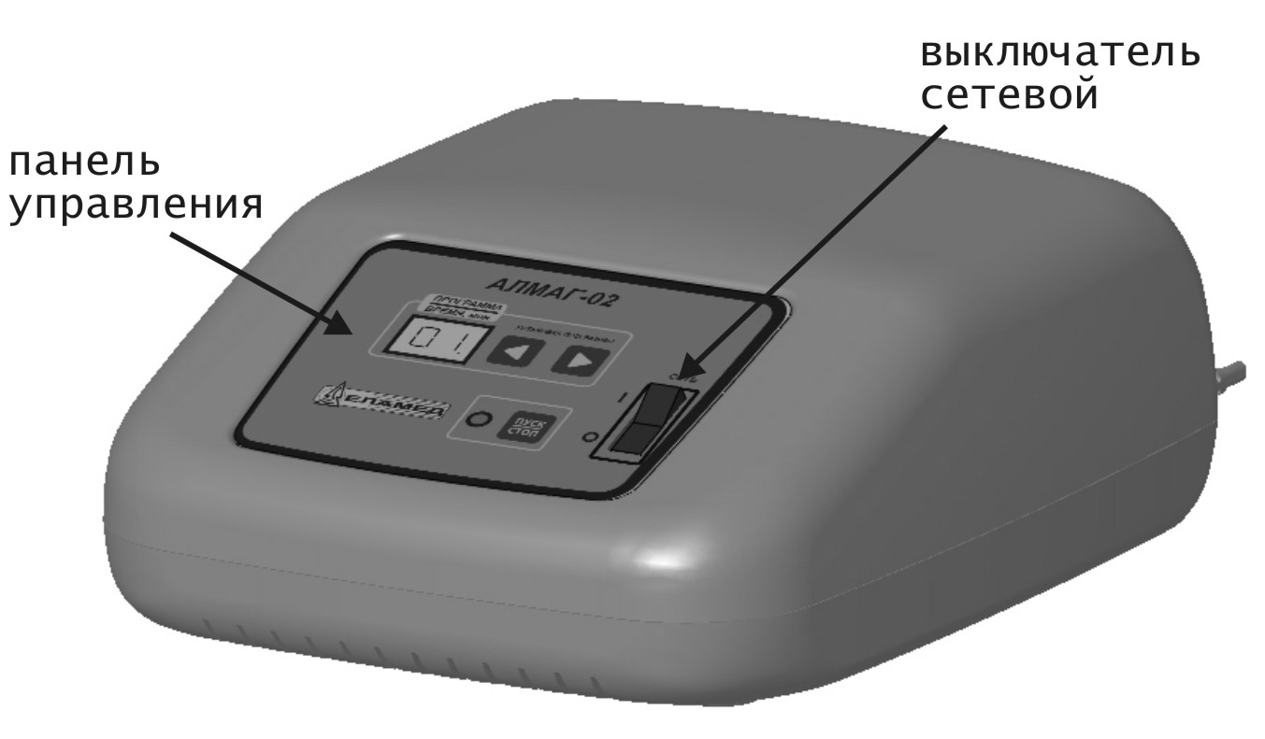
Fig. 1
Control panel

Power switch
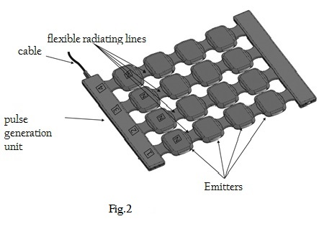
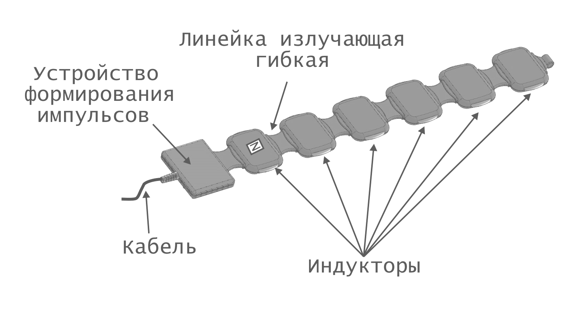
Flexible emitting lines
Cable
Emitters
Pulse generation unit (PGU)
Fig. 2

Pulse generation unit
(PGU)
Cable

Flexible emitting line
Emitters
Fig. 3

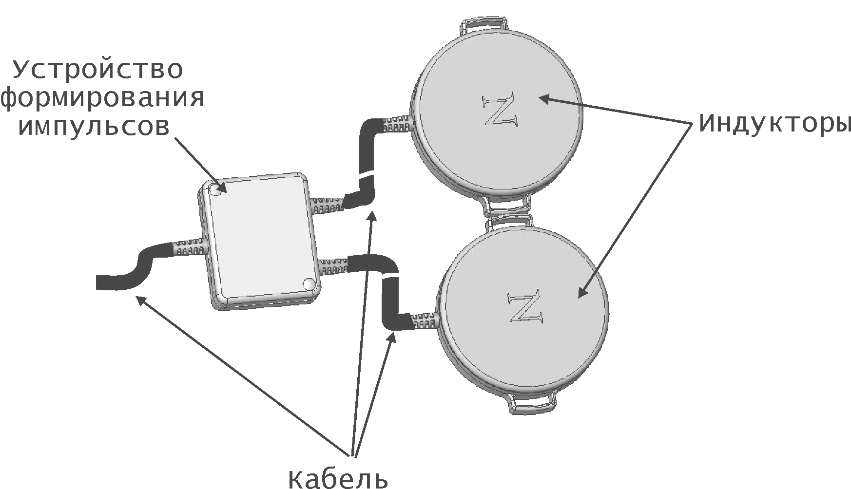
Fig. 4
cable
Pulse generation unit
Emitters

Functions of the control and display elements
Emitters
The front panel of the control unit has the following controls and displays (Fig. 5):
1 - Power switch;
2 - ‘’ ‘’ buttons: program number setup (number downwards / upwards);
3 - "ON/OFF" button: switching the PEMF action on/off;
4 - LED indicator displaying (depending on the operating mode) either the program number, or the exposure time under the selected program, or the error code;
5 - PEMF action indicator.
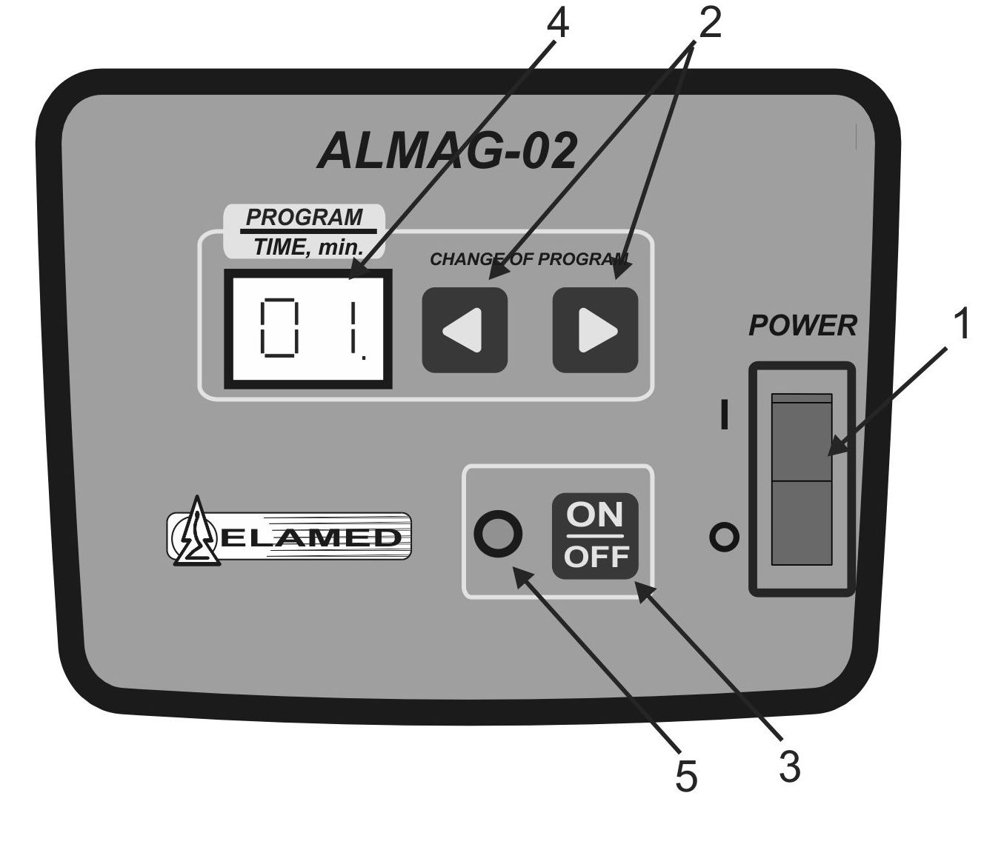
Fig. 5
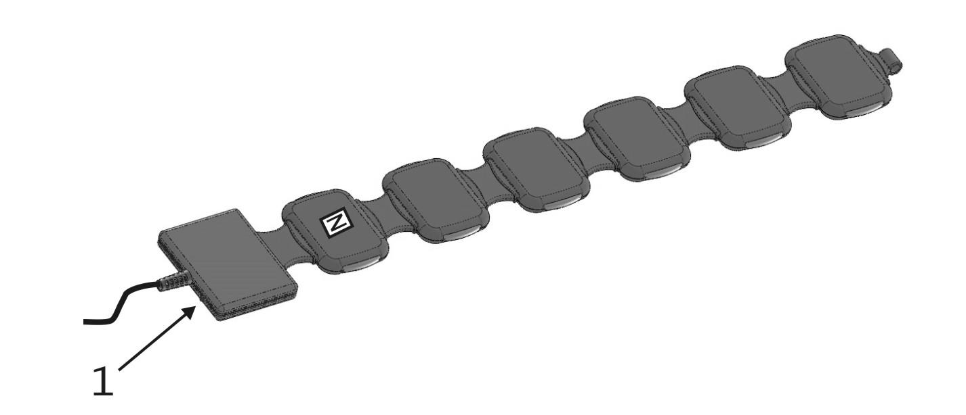
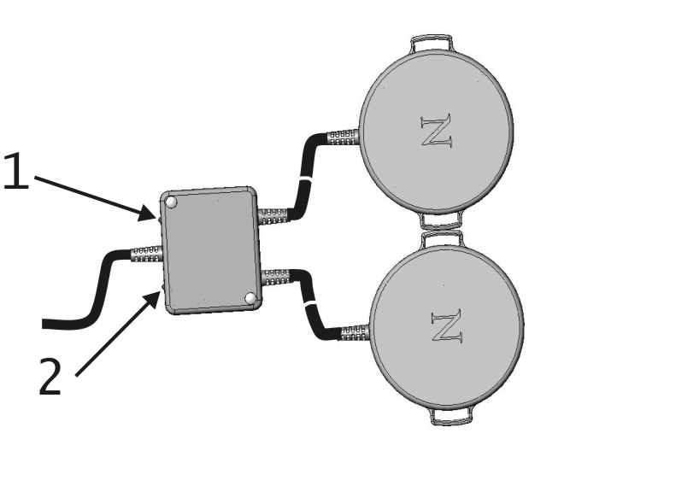
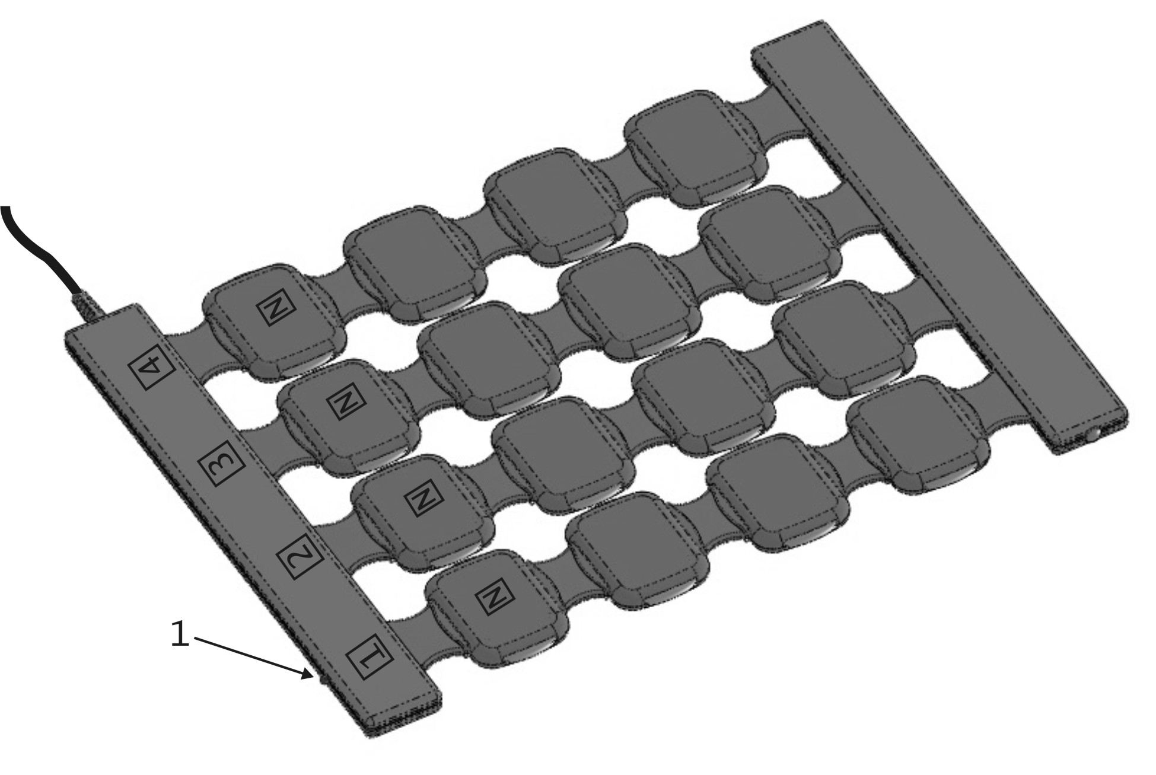
The pulse generation units (PGUs) of the emitters have indicators (Fig. 6, pos.1) signaling presence of the magnetic field;
Fig. 6

Indications for Use
Diseases of nervous system:
Migraine
Disorders of separate nerve roots and plexuses of upper and lower limbs
Diabetic polyneuropathy
Postherpetic neuropathy
Raynaud`s syndrome (“dead finger” syndrome)

Diseases of circulatory system:
After-effects of cerebrovascular diseases
Atherosclerotic vascular disease, endarteritis deformans or obliterating endarteritis
Atherosclerotic (discirculatory) encephalopathy
Varicose veins
Deep vein thrombophlebitis of the lower leg
Chronic thrombophlebitis accompanied by trophic disorders

Musculoskeletal system and the connecting tissue diseases:
Gout
Coxarthrosis (arthrosis of the hip joint)
Gonarthrosis (arthrosis of the knee)
Arthrosis of the first carpometacarpal joint
Internal and external humeral epicondylitis (tennis elbow and golf elbow)
Humeroscapular periarthrosis
Acute trophoneurotic bone atrophy (Sudeck`s atrophy)
Tenosynovitis crepitans of the forearm
Tietze’s syndrome (aseptic inflammation of coastal cartilages in the area of rib attachment to sternum, more often of ribs II-IV, with a painful thickening)
Osteochondropathy (Kohler disease, Kienbock’s disease, Perthes disease, Schlatter disease, Koenig’s disease)
Spondylitis deformans (Strumpell-Marie disease)
Osteoarthritis of the temporomandibular joint
Calcaneal periostosis (plantar fasciitis), heel spur
Joint contracture (Dupuytren`s contracture)
Rheumatoid arthritis
Osteoarthritis
Vertebral osteochondrosis (degenerative disk disorder)
Posterior cervical sympathetic syndrome
Vertebrobasilar syndrome
Vertebrogenic myelopathy syndrome
Osteoporosis with pathologic fracture
Osteoporosis without pathologic fracture

Traumas:
Wounds (after surgical debridement)
Posttraumatic hematoma (2-3 days after trauma)

Elbow and forearm traumas:
Dislocation, sprain or strain of the capsular ligamentous apparatus of the elbow joint
Dislocation of head of radial bone
Traumatic rupture of the radial collateral ligament

Nerve trauma at the forearm level:
Ulnar nerve trauma at the forearm level

Wrist and hand traumas:
Finger contusion without nail plate injury
Finger contusion with nail plate injury

Body traumas:
Superficial traumas of upper limbs
Superficial traumas of lower limbs

Coccygeal (tailbone), hip joint area and thigh traumas:
Hip joint contusion
Thigh contusion
Traumatic coccyalgia

Contusion of another clarified or non-clarified part of lower leg:
Multiple superficial traumas of the lower leg
Knee joint dislocation

Ankle joint and foot area traumas:
Ankle joint contusion
Toe contusion without nail plate injury
Toe contusion with nail plate injury
Multiple superficial traumas of ankle joint and foot
Ankle joint dislocation
Ligament rupture at the level of ankle joints and foot
Sprain and strain of ankle joint ligaments

Nerve trauma at the level of ankle joint and foot:
Lateral plantar nerve trauma
Medial plantar nerve trauma

Deep fibular nerve trauma at the level of ankle joint and foot:
Trauma of multiple nerves at the level of ankle joint and foot
Trauma of toe muscle long extensor and its tendon at the level of ankle joint and foot
Trauma of multiple muscles and tendons at the level of ankle joint and foot

  - Contraindications:
- hemorrhage and coagulopathy;
- systemic blood diseases;
- malignant neoplasms;
- severe cardiac rhythm disorders (atrial fibrillation, paroxysmal tachyarrhythmia);
- cardiac, aortic, and major vessels aneurism;
- myocardial infarction in the acute period;
- ischemic and hemorrhagic stroke in the acute period;
- purulent processes, acute tuberculous process, infectious diseases in the acute stage, febrile diseases;
- thyrotoxicosis;
- pregnancy;
- implanted pacemaker.

Attention!
  - Exposure to ALMAG-02’s pulsed electromagnetic field on the background of chemo- and radiotherapy courses is not contraindicated!
  - Presence of stents or condition after coronary artery bypass surgery is not a contraindication against device application.
  - Presence of titanium elements is not a contraindication!

- DIRECTIONS FOR USE
  - Preparation of the Device for Operation
After storage in cold premises, the device should be kept at room temperature for two hours before use.
Disinfection of the device’s outer surfaces (if required) is to be carried out by wiping them twice at a 10-15 minute interval with a heavy muslin or gauze cloth moistened with a disinfectant solution (for instance, 3% solution of hydrogen peroxide, or 1% solution of chloramine, or 70% solution of ethyl alcohol), making sure to squeeze the cloth out in order to avoid leakage of the solution inside the device.

  - Operating Procedure
Prior to actuating ALMAG-02, make sure the device is in operable condition: check the respective indication on the control unit and the emitters’ pulse generation unit for availability of program setting and magnetic induction generation.
Application of the device
Connect the emitters required for treatment procedure to the device (the best option is to connect all available emitters to the device, the ones not used will simply be deactivated). The main emitter is to be connected to connector “1”, and the flexible line and local emitter are to be connected to connectors “2” and “3” in random order (Fig. 7, 8).
!

ATTENTION!
To avoid improper connection of the emitters, pay attention to the markings “1”, “2” and “3” on the emitters` connectors. They should be turned upwards.
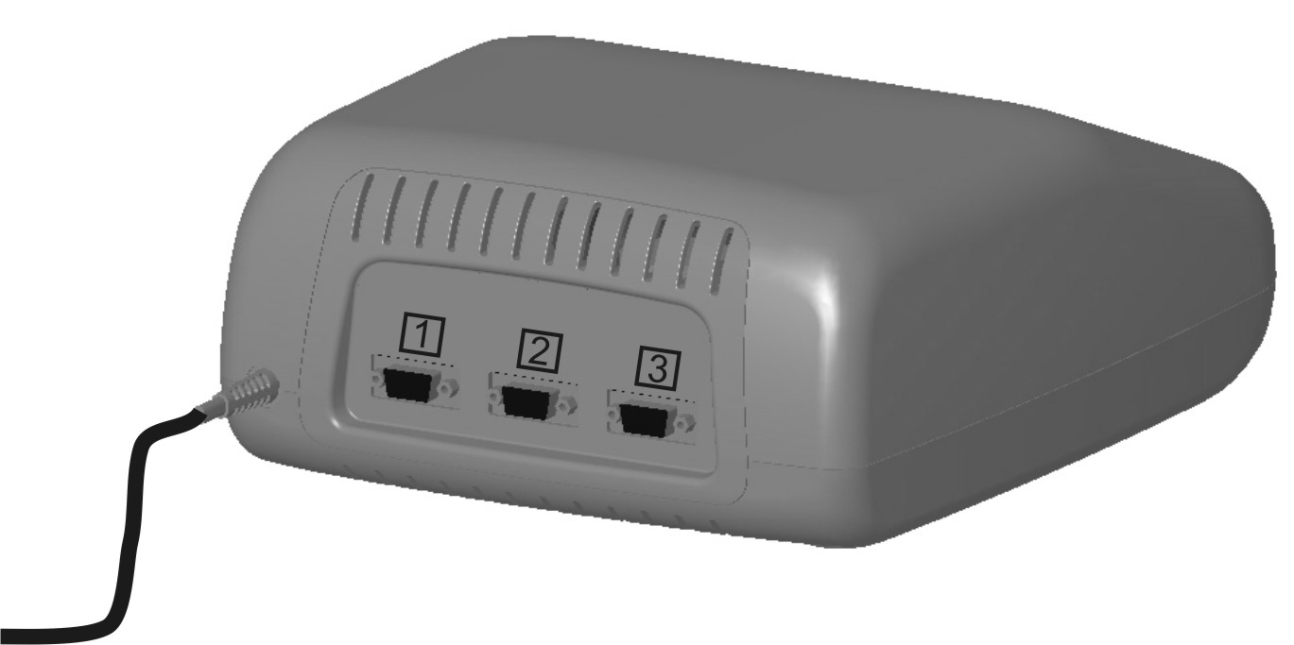

Fig. 7
Screw up
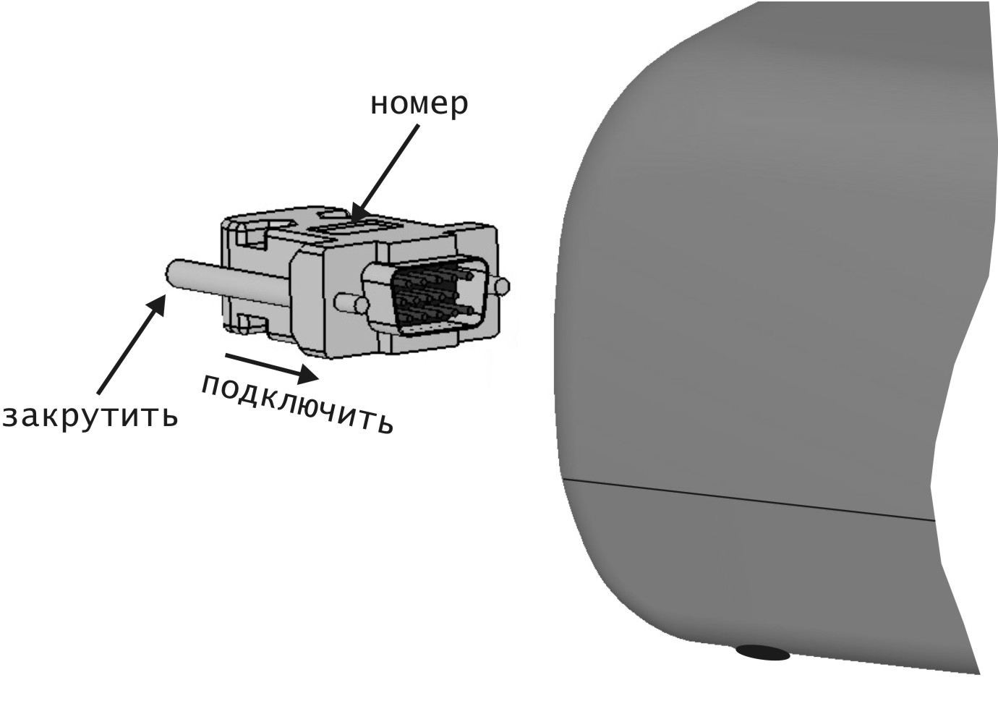
Fig. 8
Connect
Number mark

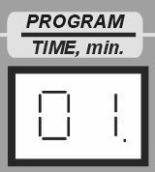
Press the “POWER” switch to activate ALMAG-02, while the active state indicators will light on the emitters’ pulse generation unit, and the control unit display box will be showing the number of the last program used. A dot will light in the right bottom corner of the display (Fig. 9).
Fig. 9
Dot

Set the number of the required program according to the present Manual’s instructions provided in the sections below using the “” and “” buttons.
Note: execution of programs beginning from 51 to 79 is only possible when the local emitter is used (delivery set option No.2).
Place the required emitters on the patient’s body subject to the right magnetic field polarity and direction in accordance with the selected procedure.
After pressing the “ON/OFF” button, the PEMF action indicator will light up, while the LED display will be showing the time remaining until the end of the procedure, and the dot in the lower right corner will disappear (Fig. 10). The specific emitters required for the selected procedure are thus activated, and the device starts generating the preset magneto-action.
The PEMF action indicators will light on the activated emitters.
Note:
- In case of malfunction of the emitter required for the procedure, or of the device itself, the device produces a sound indication, and an error code is displayed in the display box.
- Presence of magnetic field on the working surfaces of the emitting lines can be checked with the help of a magnetic field indicator. To do this, select an exposure program (as per the Operating Manual) with a field density of at least 25 mT. The LED on the indicator starts flashing when placed against the working surfaces of the emitting lines’ emitters (emitter clusters), confirming the magnetic field presence.
The magnetic field indicator has limited sensibility and does not indicate magnetic field of 10 mT and less. Absence of light indication is not a malfunction for such cases.

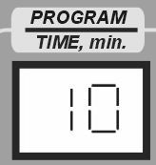
After the countdown of the pre-programmed exposure time is over, a sound indication of the procedure end will be generated, and both the PEMF action indicatoron the control panel and the magnetic field indicators on the emitters’ pulse generation unit will fade away, while the LED display will return to the last used program number (with the dot in the right bottom corner).
Fig. 10
No dot

After termination of the exposure procedure, take the emitter off the patient’s body.

If a next magneto-therapy session is not planned, switch the power and control unit off by pressing the "POWER" switch on the front panel.

For a convenient arrangement of the flexible lines of the main emitter and the individual flexible line to form a “solenoid”, use the emitters’ accessories set. The arrangement of these accessories is shown in Fig. 11, 12.

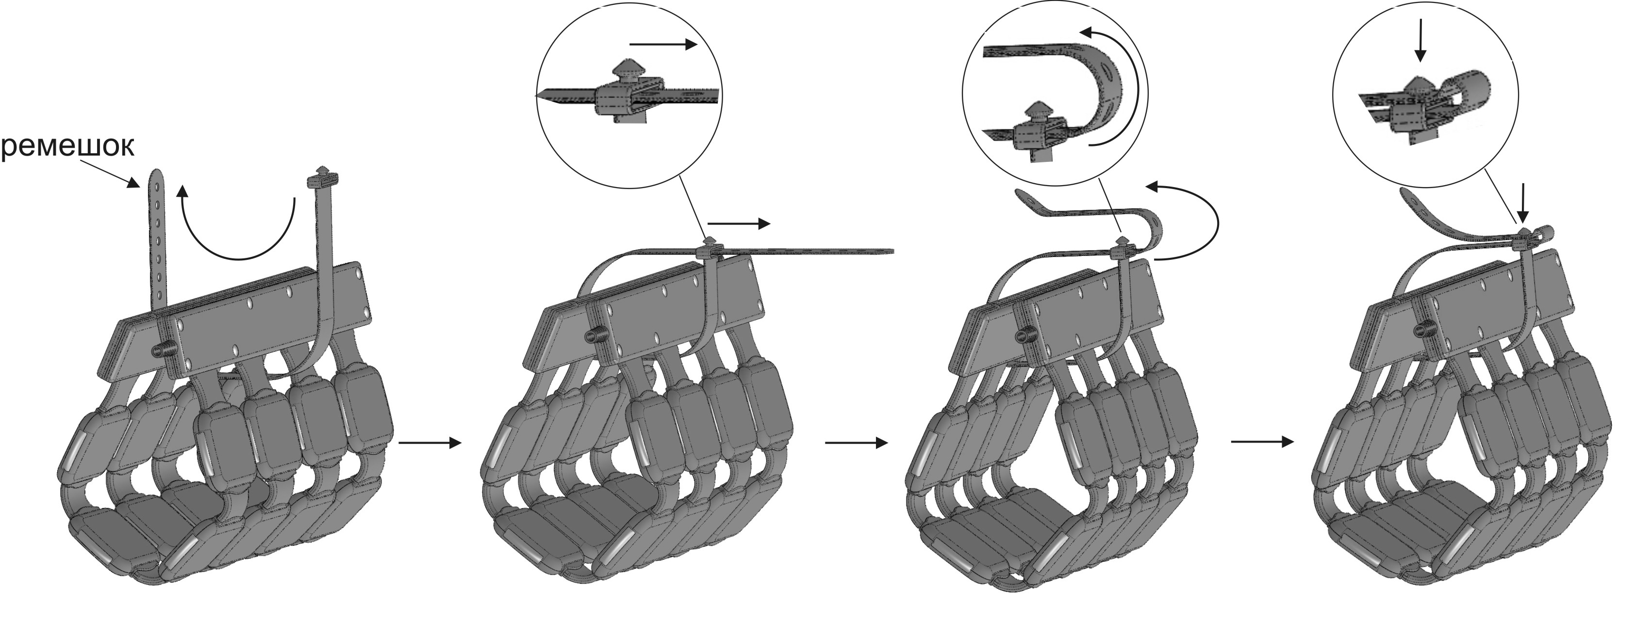
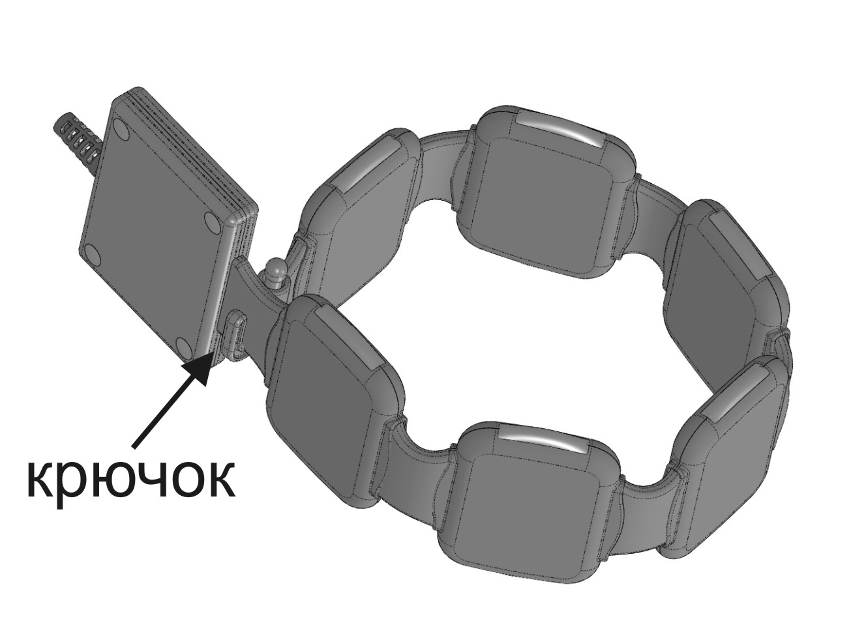
Fig. 11
Fig. 12

fixing belt
fixing hook

For a convenient fixing of the flexible emitting line on a limb, use the fixator provided on the line (as shown in Fig. 13).

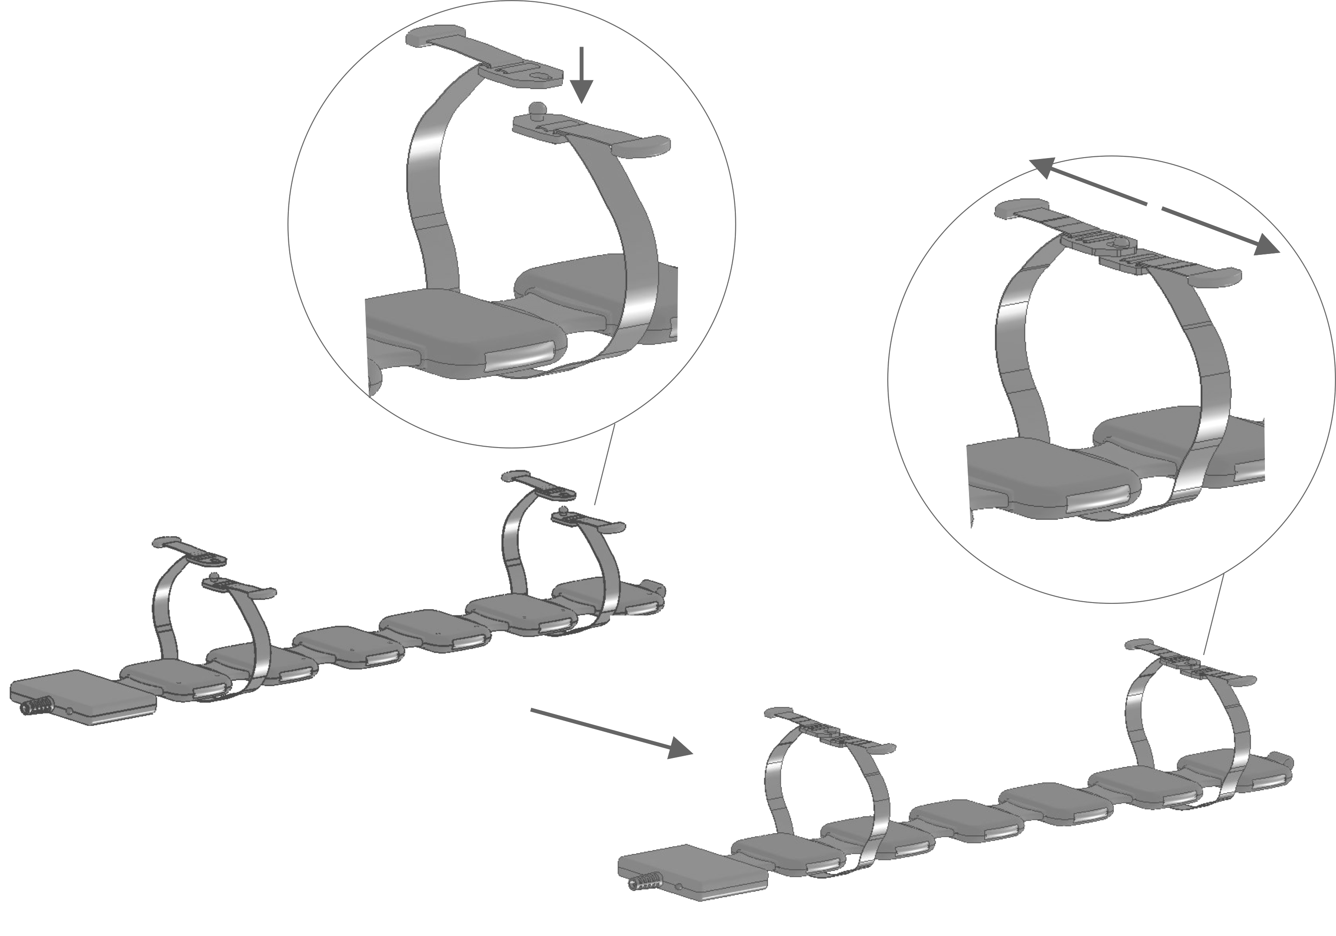
Fig. 13
Attention! To avoid injury, please use the emitters with CAUTION. Hold and carry the main emitter with both hands as shown in Fig. 14.

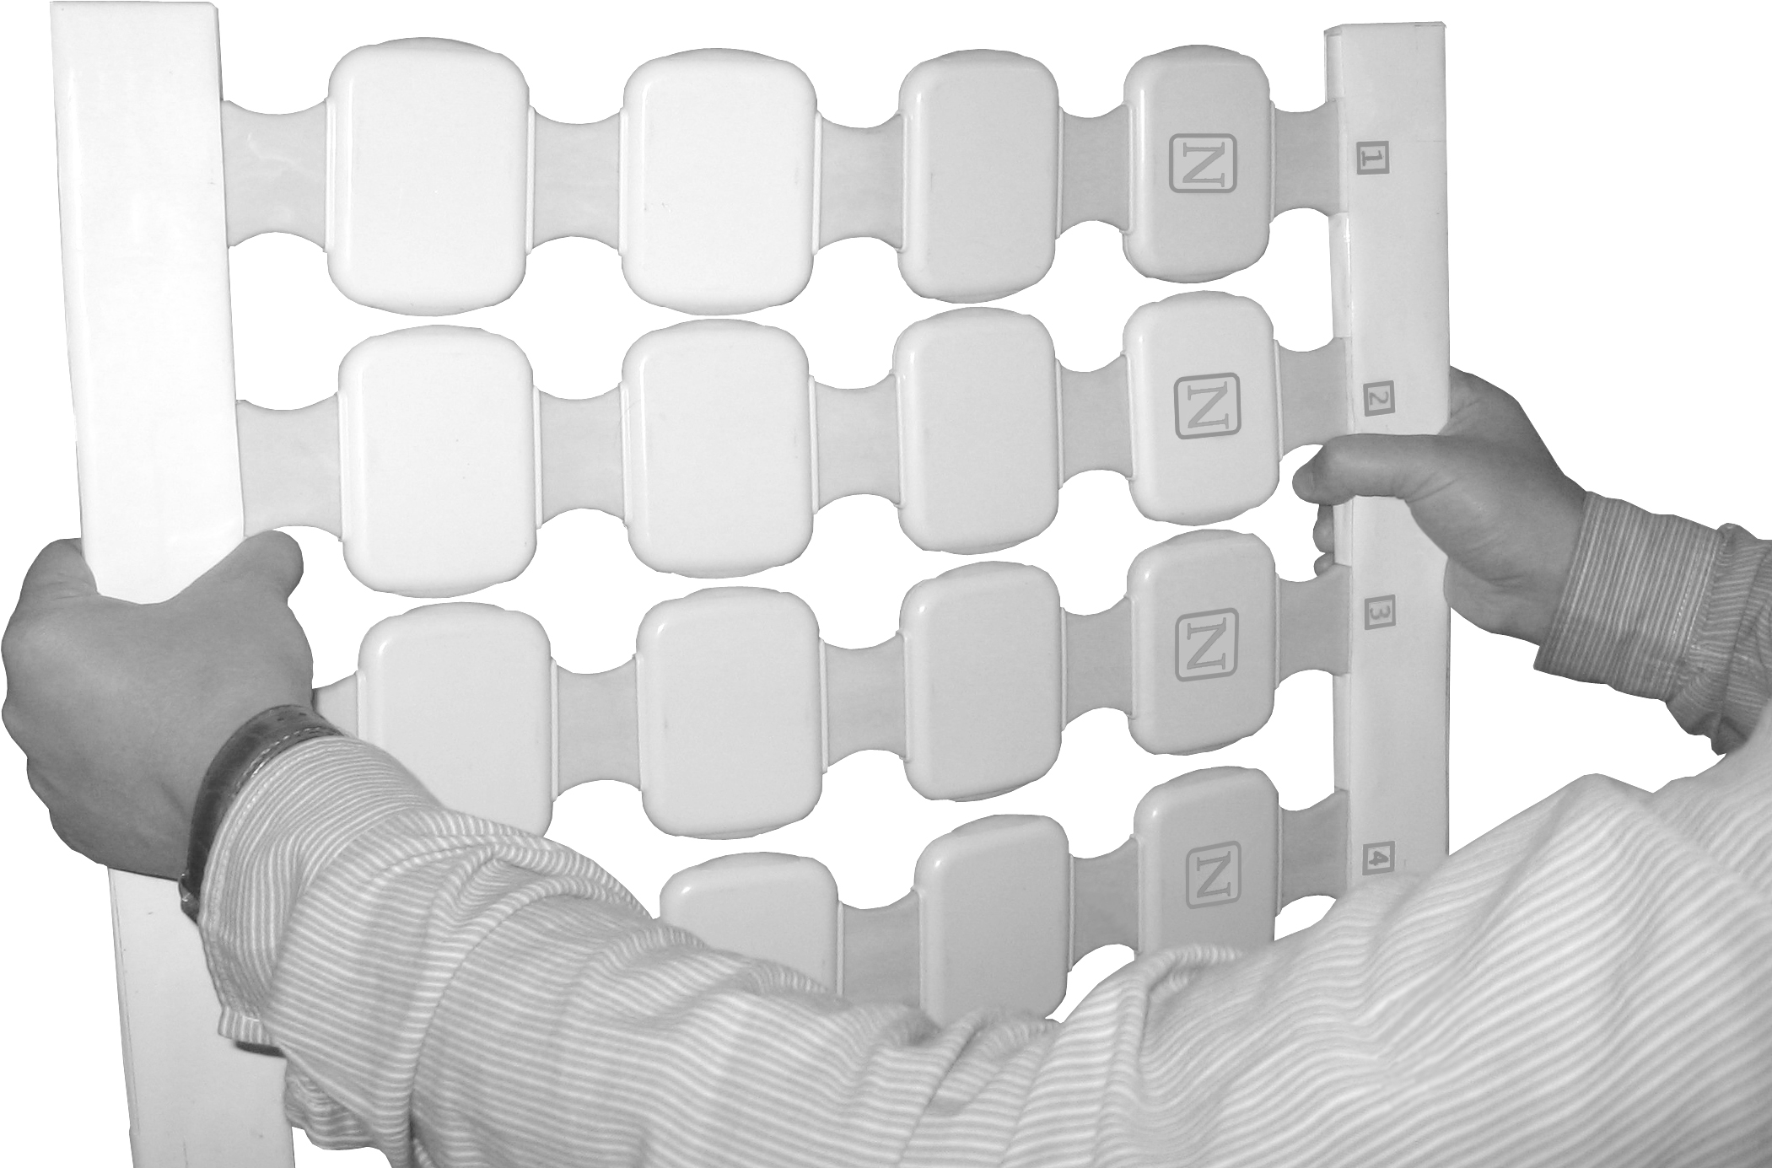
Fig. 14

For procedure convenience, the local emitters can be fixed onto a handle (Fig.15a) or on a support (Fig 15b). The support consists of a holder with a screw, stand and basis.
To fix the emitter on the support, use the holder thread segment (screw the emitter into the holder and place it on the support stand).The vertical position of the emitter on the support (the height) can be adjusted by means of the holder screw: to adjust the height, loosen the holder screw, position the emitter at the necessary height level, and fix the holder in that position with the screw.
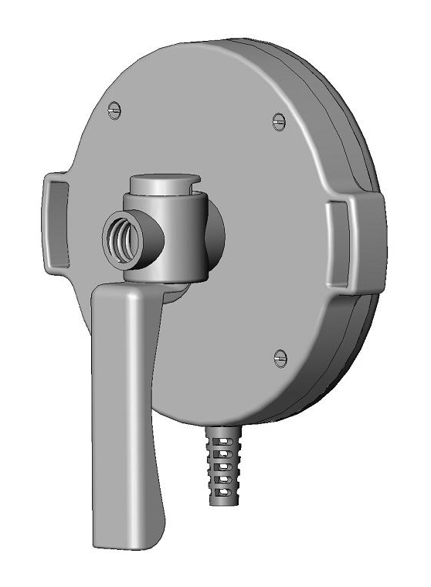
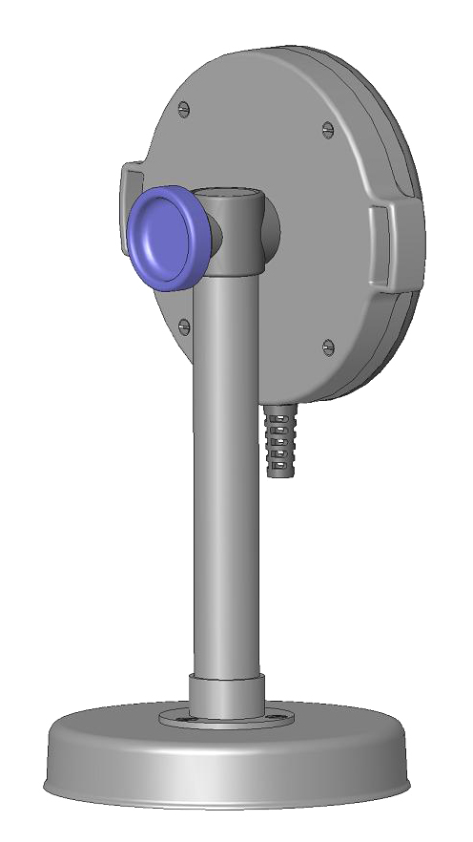
Holder
Basis
Stand
Local emitters
Fig. 15a
Screw
Handle
Fig. 15b

Fig. 7b

- SAFETY MEASURES
!

Please study this Operating Manual carefully prior to device application.

PLEASE DO NOT:
- twist the connecting cables of the emitters;
- switch the device on if the plug and socket do not match one another;
- unplug the device by pulling at the power cord;
- touch bare plug pins just after device disconnection;
- move the emitters while the magneto-therapy procedure is in progress.

Attention! In order to avoid device failure, DO NOT switch it on when the emitters’ cable connectors connected to the power and control unit are not fixed with screws.
Attention! Device operation at an ambient temperature above +35 °С is PROHIBITED.
Attention! During the time of magnetic exposure, the ACTIVATED EMITTERS should be placed at a distance of at least 0.9 m from the OPERATOR.
Attention! Use disinfected fabric to ensure a safe patient`s contact with the emitters’ accessible parts.

 Carry out the procedures in places suitable for plugging the device into the power supply socket without straining the mains cord. Use only properly functioning sockets with an operating voltage of ~220/230 V, frequency 50 Hz, or ~120 V (±10%), frequency 60 Hz.

It is PROHIBITED to lift or carry the device by the power cord.

 To avoid possible damage to the device, keep it away from unsupervised reach of children.
Make sure to examine the device for presence of mechanical damages of the cables, plug, mains cord, as well as the emitters’ and power and control unit’s housings. Using the device if any of these damages have been detected is PROHIBITED.

 Store and use the control unit and emitters only in dry places.

 Avoid penetration of moisture inside the power and control unit and the emitters while treating their surfaces with disinfectants. Protect the device from dampness, shock and impact, as well as from contact with open flame.

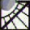 Keep the device away from direct sunlight and high temperatures.

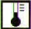 After storage or transportation of the device at low temperatures, keep it at room temperature for at least 4 hours prior to usage start.

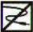 Do not twist or bend the cables; store the device in the consumer container after use.

 Do not place an operational device nearby (less than 0.5 m apart from) magnetic data carriers (floppy disks, credit cards, video records, mobile memory units).

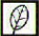 Instructions on environmental protection: Dispose of the device upon termination of its service life as electronic waste at specialized recycling points.
 Exclusion of liability: the Manufacturer shall not be held liable for damages resulting from non-observance of the above instructions.

- SPECIFICATIONS
4.1 The device is functional with power supply from alternating current mains of:
□~230V (-34,5V; +23V), frequency 50Hz
□~120V (-10V; +6V), frequency 60Hz
4.2 Device power consumption: 50 ± 7.5 VА.
4.3 The device generates pulsed electromagnetic fields of the following types and parameters.
The peak values of the magnetic field density on the emitters’ surface are:
а) for “traveling” field type:
- for the main emitter and flexible emitting line: from 2 to 25 mТ.
b) for “static” field type:
- for the main emitter and flexible emitting line: from 2 to 6 mТ.
- for the local emitter: from 2 to 45 mТ.
Absolute deviation of the field density peak value on the emitters’ surface for values from 2 up to 20 mТ for set one (А) is within ±[0.2А+0.6] mТ, for values from 25 up to 45 mТ it is within ± 6.3 mТ.
Magnetic pulses repetition frequency:
For the main emitter and flexible emitting line:
а) for “traveling” field type:
- from 1 pulse / sec to 75 pulses / sec with field density of 25 mТ;
- from 1 pulse / sec to 100 pulses / sec with field density of 2-20 mТ;
b) for “static” field type:
- from 1 pulse / sec to 16 pulses / sec with field density of 2-6 mТ;
For the local emitter:
- from 1 pulse / sec to 50 pulses / sec with field density of 35-45 mТ;
- from 1 pulse / sec to 100 pulses / sec with field density of 2-30 mТ.
Relative deviation of magnetic field pulses repetition frequency is within ±5%.
4.4 Total magnetic exposure time intervals range from 1 to 30 min. The relative deviation of the treatment course exposure time is within ±5%.
4.5 The device provides storage of 79 exposure programs in its non-volatile memory, including preset parameters and types of the magnetic field, as well as the total exposure time.
4.6 Temperature of the emitters’ surfaces, max: 41 ºС.
4.7 Device operating mode setting time, max: 30 s.
4.8 The surfaces of the device emitters contain markings of the magnetic field polarity: ‘N’ – north, ‘S’ – south.
4.9 In case of the device malfunction, generation of alarm signaling and automatic termination of the exposure mode is provided.
4.10 The device displays the following indications:
- program number;
- exposure time;
- malfunction code;
- presence of PEMF action;
- activation / deactivation of the emitters;
- magnetic field generation in the emitters.
4.11 Mean service life – 5 (five) years.
4.12 The exterior surfaces of the device components are resistant to disinfection with any chemical solution approved in medical practice for application on plastic and metal products.
4.13 The overall dimensions and weight of the device components are given in Table 2:
Table 2
Component name | Overall dimensions, mm, max. |  |  |  | Weight, kg,  max.
Component name | diameter | length | width | height | Weight, kg,  max.
Power and control unit  Main emitter  Flexible emitting line  Local emitter, including:  - coil (single emitter)  - pulse generation unit  - connective cables between the coils and pulse generation unit |  | 240±5  540±7  700±8  165±5  100±5  1100±100 | 299±5  400±7  100±5  140±5  90±5 | 114±5  18±2  18±2  28±2  50±2 | 3.0  3.0  1.0  1.8

- DELIVERY SET
Product complete set and its possible delivery options are given in the
table below.
Name | Delivery Set
Name | Delivery Option No.1 | Delivery Option No.2
Power and control unit | 1 | 1
Main emitter | 1 | 1
Flexible emitting line | 1 | 1
PEMF indicator | 1 | 1
Local emitter | - | 1
Fixing belt | 1 | 1
Handle | - | 2
Support | - | 2
Hook | 1 | 1
Fixator | 2 | 2
Operating manual | 1 | 1

Attention! Delivery option No.1 does not include local emitter, handle, support and medical elastic bandage.

- OPERATION AND TREATMENT PROCEDURES

  - Magnetic field’s effect on the human organism
Exposure of biological tissue to the "north pole" of a magnet and the "clockwise" rotation of magneto-action has demonstrated a proven and apparent positive effect as compared to the "south pole" of a magnet or "counterclockwise" rotation.
The mechanism of magnetic fields’ action on the human organism is quite complicated, but in brief it comes down to generation of electromotive forces (EMF) in tissues, which results in formation of induced ring currents affecting the para- and diamagnetic molecules. At the cellular level, the magnetic field action produces a rotary moment which initiates the molecules’ arrangement along the main axes of rotary symmetry. This, in its turn, results in:
- changes in cell membrane properties and cell structures (membrane permeability is restored; diffusive and osmotic processes in a cell are normalized, leading to normalization of its electrolytic structure);
- changes in the tissue’s electronic potential, enhancement of metabolism, oxidation-reduction processes and free radical oxidation;
- acceleration of enzymatic reactions and normalization of the transport properties of biological membranes;
- evident changes in the capillary bed condition (changes in permeability, endothelium condition and colloid osmotic pressure, leading to improved microcirculation caused by opening of previously non-functional capillaries).
All of the above stimulates acceleration of reparation processes, increase of immunologic responsiveness (cellular and humoral components of the immune system), and brings about a change in the activity of bradykinin system.
Magnetic field produces an apparent normalizing effect on the autonomic nervous system.
Most importantly, the effect of a pulsed electromagnetic field is far stronger than that of a static or alternating magnetic field.
In addition, the effect of a pulsed electromagnetic field is of a trace nature. After single exposure sessions, the response of the human organism is maintained for 1-6 days, while a full course of procedures is followed by a 30-45 days` response, hence the necessity for an interval before the repeated treatment course for this period.
Magnetic field passes freely through the body tissues, clothing, and plaster bandages, but fades down rather quickly depending on the distance from and shape of the emitter, which makes magnetic fields suitable for application in traumatology.
Magnetic field has no thermal effect; therefore, it causes less loads and is easier for patients to tolerate. Some patients do experience a ‘thermal’ effect in the magnetic exposure area, but it is explained by intensified blood circulation under magneto-action.
The responses of various human organs and systems to a magnetic field action are different. This selectivity of the body’s response depends on the electric and magnetic properties of tissues, their differences in micro-circulation, intensity of metabolism, and the state of neurohumoral circulation. Among the systems of the human organism, the nervous system is the most perceptive to magnetic field exposure, followed in descending order by the endocrine system, sensory organs, cardiovascular system, blood, muscular system, digestive organs, excretory, respiratory and skeletal systems.
The magnetic field’s effect on the nervous system involves positive changes in physiological and biological processes.
As a result of the PEMF stimulation of inhibition processes, a sedative effect, a favorable effect on sleep, and emotional stress relief is observed.
Under pulsed electromagnetic field action, the hypothalamus cells are stimulated to produce the substances (releasing factors) regulating the functions of the endocrine glands, which leads to normalized hormonal work of the endocrine glands (adrenal, thyroid glands, and pancreas), to improved metabolism and stimulation of other processes as well, thus favorably affecting the general condition of the body.
Pituitary-hypothalamic system stimulation provokes a chain reaction activating peripheral endocrine target glands under the influence of the releasing factors whose synthesis intensifies in the pituitary-hypothalamic system, which is followed by numerous other branched metabolic reactions. When the endocrine system is briefly (for up to 20 min.) exposed to a magnetic field of up to 30 mT density and up to 50Hz frequency, the training reaction develops and the activity of all branches of endocrine systems increases.
Stimulation of the thyroid gland function also occurs under exposure to magnetic field, as opposed to an inhibitory effect produced by many other stimuli, which makes magneto-therapy potentially suitable as part of a complex treatment of hypothyroidism. The sympathetic adrenal system demonstrates only a slight activation at the beginning of a magneto-therapy course, and starting from day 7-9 of treatment, inhibition of peripheral β-adrenoreceptors is developed, which is of great significance in producing an anti-stress effect, thus increasing the adaptive capabilities of the organism.
Therefore, the following positive effects are observed under the influence of a low-intensity magnetic field: reduction of the cerebral vessels tone, improvement of the cerebral blood supply, activation of nitrogen and carbohydrate-phosphorus metabolism, which enhances anoxia tolerance of the brain. Exposure to the magnetic field of the cervical ganglia and paretic limbs (in case of apoplectic patients) stimulates cerebral blood flow (based on rheoencephalography data) and normalizes increased blood pressure, which proves the reflex nature of the magnetic field action. When the suboccipital area is affected by magneto-action (in case of patients with posterior circulation system deficiency), an evident improvement of cerebral hemodynamics is noted.
Pulsed electromagnetic field action on the collar area also brings about an improvement of hemodynamics, and the systolic and diastolic pressures drop down to normal values. Thus, a possible correction of cerebral hemodynamics disorders associated with different pathological conditions may occur.
The peripheral nervous system responds to the magnetic field effect with a decreased sensitivity of peripheral receptors, which results in an analgesic effect and an improved conductive function, which promotes functional recovery of traumatized peripheral nerve endings due to accelerated axon growth, myelination, and inhibition of connective tissue growth.
Exposure of various areas (head, heart area, forearm) to pulsed electromagnetic field of a constant density and frequency causes a homogeneous response from the cardiovascular system, which allows to assume the reflex nature of the field’s action on it.
A pressure decrease in the deep and subcutaneous vein system, as well as in the arteries, is noted. This is accompanied by an increase in the vascular tone and changes in the viscoelastic properties and bioelectric resistance of vascular walls. Changes in hemodynamics, the hypotension effect in particular, occur due to the development of bradycardiac effect and reduction of myocardial contractile function. This property has found its application in hypertension therapy and is also used for releasing the heart burden.
Magnetic field action induces changes in the microcirculatory bed of various tissues. At the beginning of magneto-therapy exposure, a short-term (5-15 minutes) deceleration of capillary blood flow is experienced, which is then followed by intensification of microcirculation. Throughout and upon termination of the magneto-therapy course, the following effects are observed: acceleration of capillary blood flow, improved contractility and increased blood filling of the vascular walls. The lumen of the cappilary bed grows larger, and favourable conditions develop for the opening of preexisting capillaries, anastomoses and bypasses, which is extremely important in cases of atherosclerotic vessel changes.
The effect of magnetic fields especially on the large vessel areas causes a hypocoagulative action due to activation of the anticoagulative system, subsidence of intravascular parietal thrombogenesis (blood clotting), and reduction of blood viscosity through the effect produced by low-intensity magnetic fields on the fermentation processes, as well as on the electric and magnetic properties of the blood cells involved in hemocoagulation.
Under the effect of magnetic fields, the vascular and epithelial permeability increases, resulting in an accelerated resolution of edemas and dissolution of the injected medications. Owing to this action, magneto-therapy is widely used in treatment of traumas, injuries and their after-effects.
The traveling pulsed electromagnetic field stimulates an increase of metabolic processes in the bone regenerative tissue area (in case of bone fractures): at earlier stages, fibro- and osteoblasts develop in the regeneration area, while the process of bone substance formation generally intensifies and accelerates.
When large areas of the human body are exposed to pulsed electromagnetic fields (through the main emitter), this produces a considerable effect on the overall metabolism. Exposure of specific systems of the organism increases the whole protein and globulin content in the blood serum, as well as their concentration in tissues owing to α- and γ-globulin fractions. This is accompanied by protein structure change. Short-term daily overall exposures of the organism to a magnetic field reduce the content of pyruvic and lactic acids not only in the blood, but also in the liver and muscles, with a simultaneous rise of glycogen content in the liver.
The magnetic field action also reduces the number of Nа (sodium) ions in tissues and boosts the concentration of К (potassium) ions, which indicates a change in the cellular membrane permeability. A reduction of Fe (iron) content in the brain, heart, blood, liver, muscles, and spleen is noted, with its simultaneous increase in the bone tissue. Such redistribution of Fe is associated with changes in the blood forming organs’ state. This is accompanied by increased Cu (copper) concentration in the cardiac muscle, spleen and testes, resulting in the activation of the body’s adaptive and compensatory processes. The content of Cо (cobalt) is reduced in all organs, and its redistribution occurs amongst the blood, individual organs and tissues. The biological activity of Mg (magnesium) intensifies, leading to suppression of pathologic processes in the liver, heart and muscles.
Magnetic fields of low density are known to stimulate tissue respiration processes by changing the ratio of free and phosphorylation oxidation in the respiratory chain. Nucleic acid metabolism and protein synthesis are intensified, thus affecting the plastic processes. Effects on proliferation and regeneration are determined by activation of lipid peroxidation.
Activation of carbohydrate and lipid metabolism is considered to be another characteristic feature of the magnetic field’s effect on the human body. This is proved by increased concentration of nonesterified fatty acids and phospholipids in the blood and internal organs, as well as by lowering of the blood cholesterol level.
All of the above demonstrates the multifold action of a short-term exposure of the human organism to magnetic fields, resulting in the development of individual favourable effects. The most evident and clinically significant among them are the sedative, hypotensive, anti-inflammatory, anti-edematous, analgesic and trophico-regenerative effects. Under certain conditions, e.g. when large vessels are exposed, magneto-therapy promotes disaggregation and hypocoagulation, enhances micro- and regional circulation, and benefits the immunoresponsive and neurovegetative processes. Exposure to a magnetic field does not generally produce endogenic heat, nor does it cause temperature rise or skin irritation.
It is well tolerated by fragile and elderly patients suffering from cardiovascular and the concomitant diseases, which makes magneto-therapy devices applicable in cases when other therapeutic methods are contraindicated.

  - Types of magnetic fields generated by ALMAG-02
ALMAG-02 generates two types of pulsed electromagnetic fields: “travelling" and "static".
The main emitter generates “traveling” magnetic field of three kinds:
- “traveling horizontal” (Fig. 16): simultaneous excitation of all emitters in one line, followed by one-way excitation of all emitters of the neighboring line according to the cyclic law; the cycle comprises four ‘step-by-step’ excitations of the emitting lines (according to the number of the lines in the whole emitter);

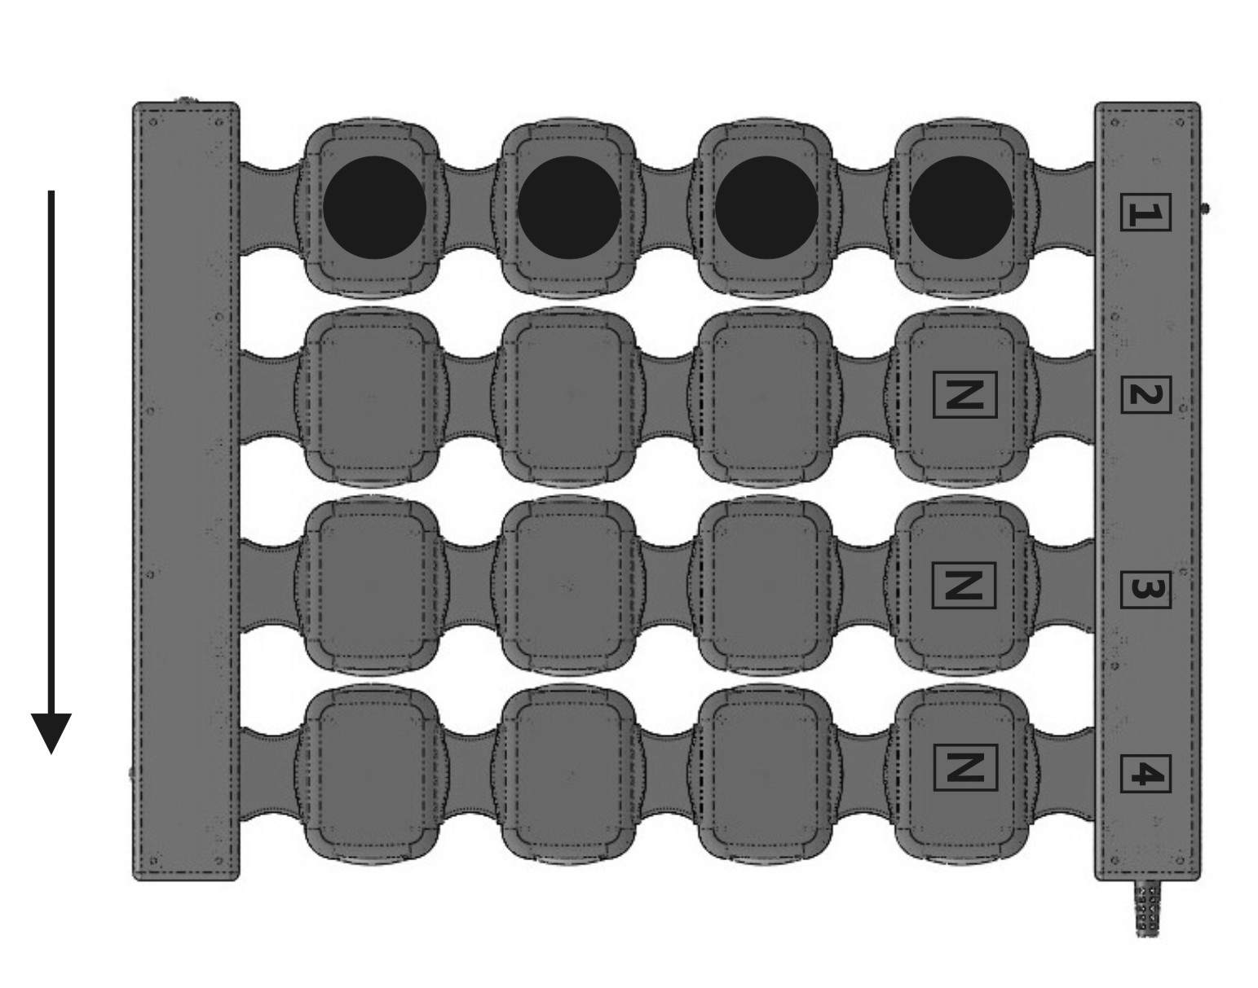
North pole mark

Fig. 16

- “traveling vertical” (Fig. 17): simultaneous excitation of the emitters of the same position in all four lines (exposure cluster), followed by one-way excitation of the same neighboring emitters according to the cyclic law; the cycle comprises four ‘step-by-step’ excitations of the neighboring emitters (according to the number of single emitters in one line);
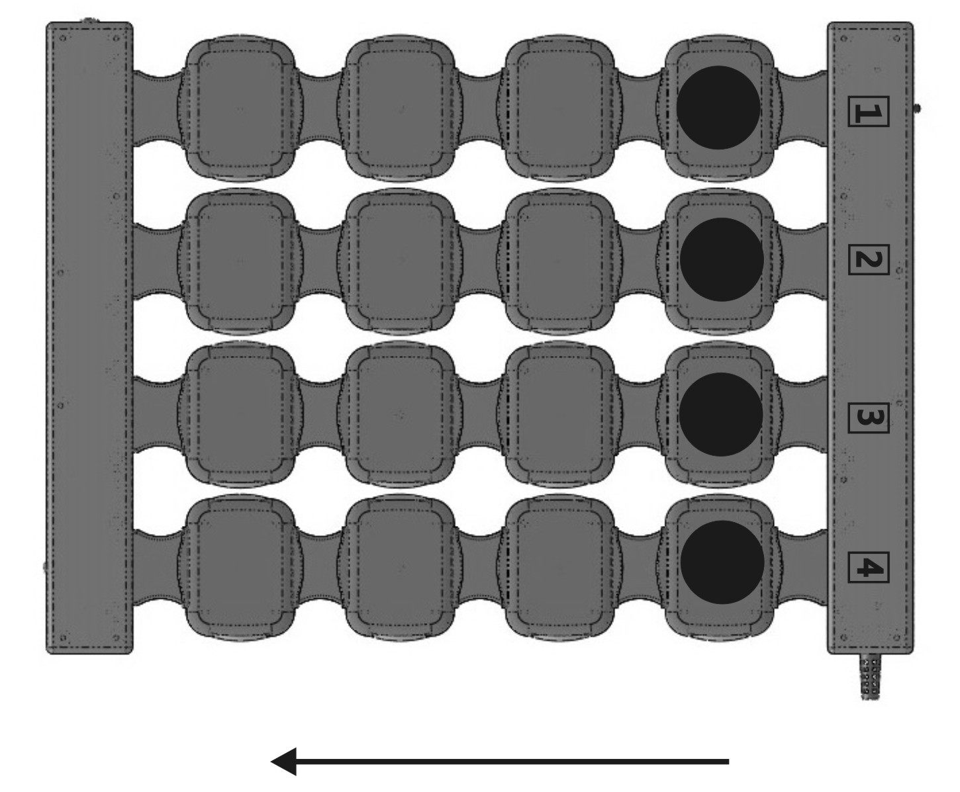

Fig. 17

- “traveling diagonal” (Fig. 18): sequential excitation of individual emitters located diagonally against one another, followed by one-way excitation of the neighboring emitters according to the cyclic law; the cycle comprises a seven-‘step’ excitation of the emitters (according to the number of possible combinations of the emitters’ excitation: 1-2-3-4-3-2-1).

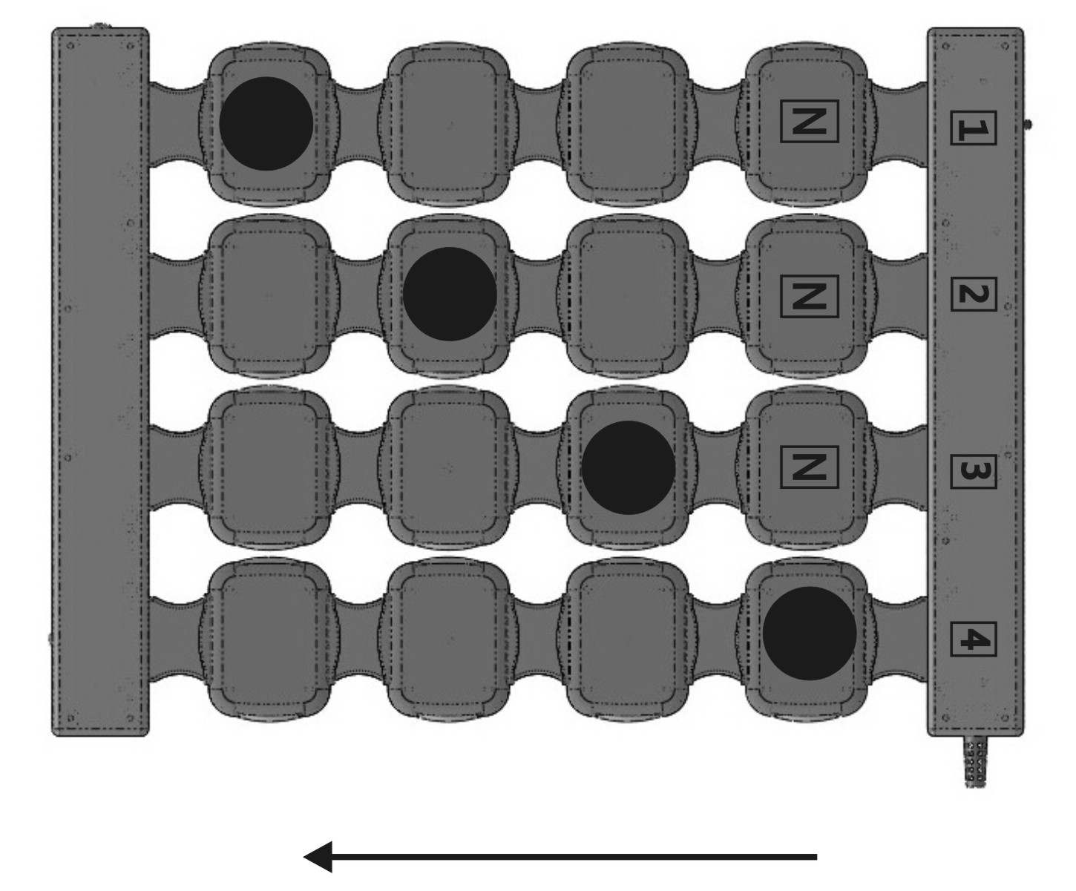

Fig. 18

In case of the separate flexible emitting line, the emitters’ excitation under the influence of the “traveling” field type occurs cyclically in one direction (Fig. 19); the cycle for the single line comprises a six-‘step’ excitation of the adjacent emitters (according to the number of individual emitters in the flexible line).
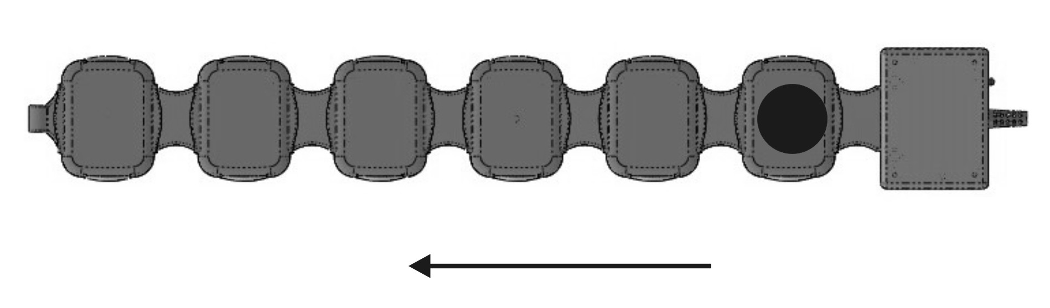

Fig. 19

Note: the pulsed electromagnetic field in ALMAG-02’s emitting lines travels only in one direction. Changing of the direction of the field area requires changing the emitters’ arrangement, e.g. as shown in Fig. 20. Pay attention to the “north” and “south” markings and numbering of the flexible lines in order to place the emitters in accordance with the Operating Manual.
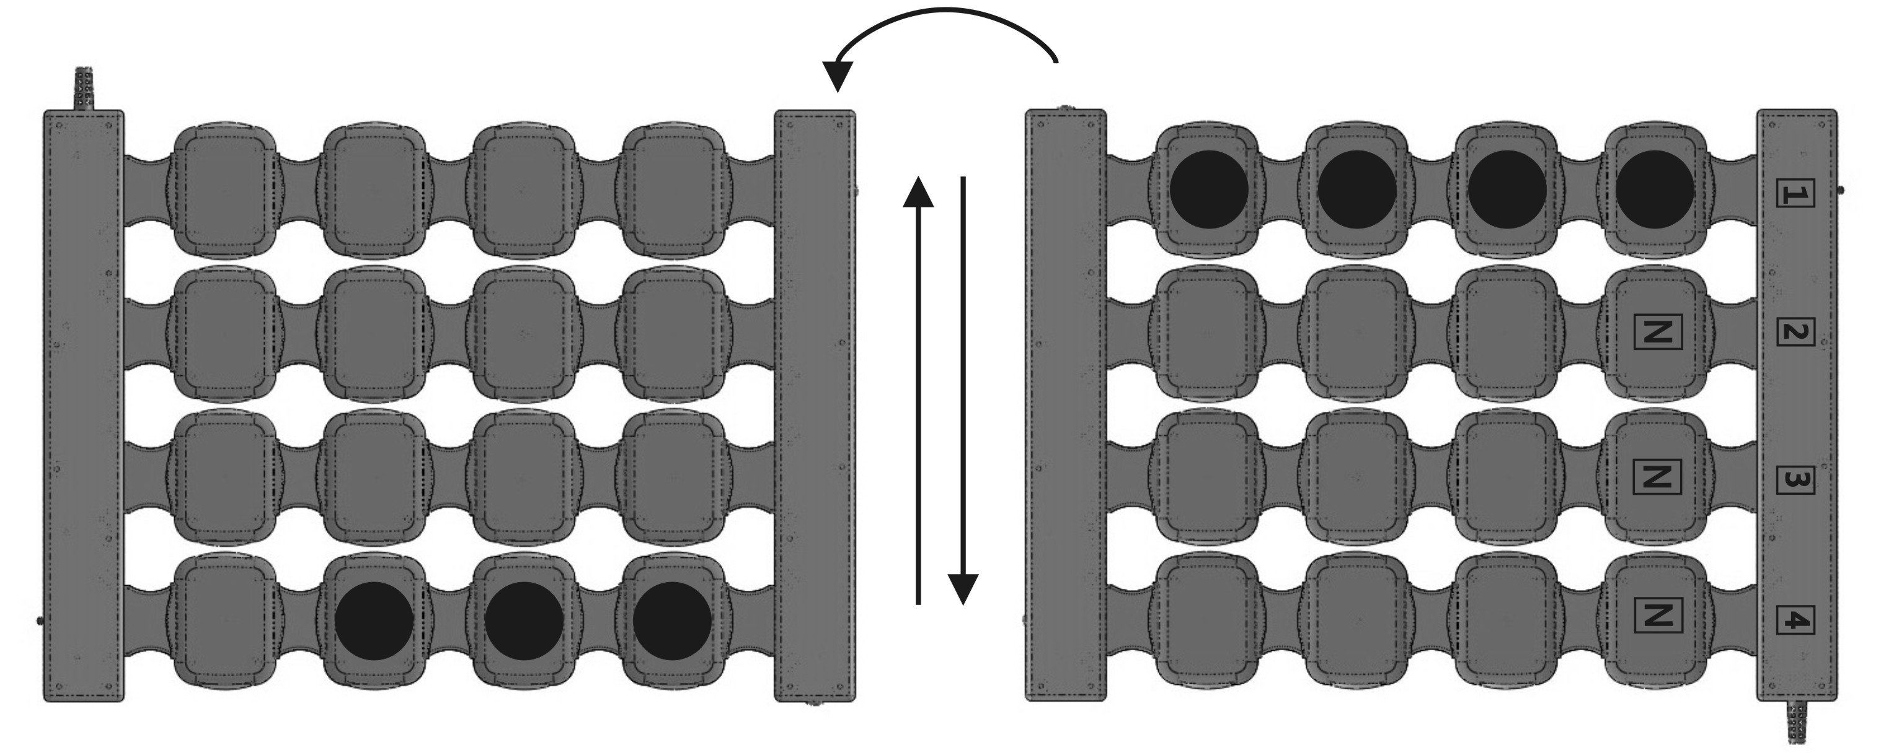

Fig 20

Рисунок 19

“Static” field type (Fig. 21): simultaneous excitation of all the emitters in the whole cluster or line.

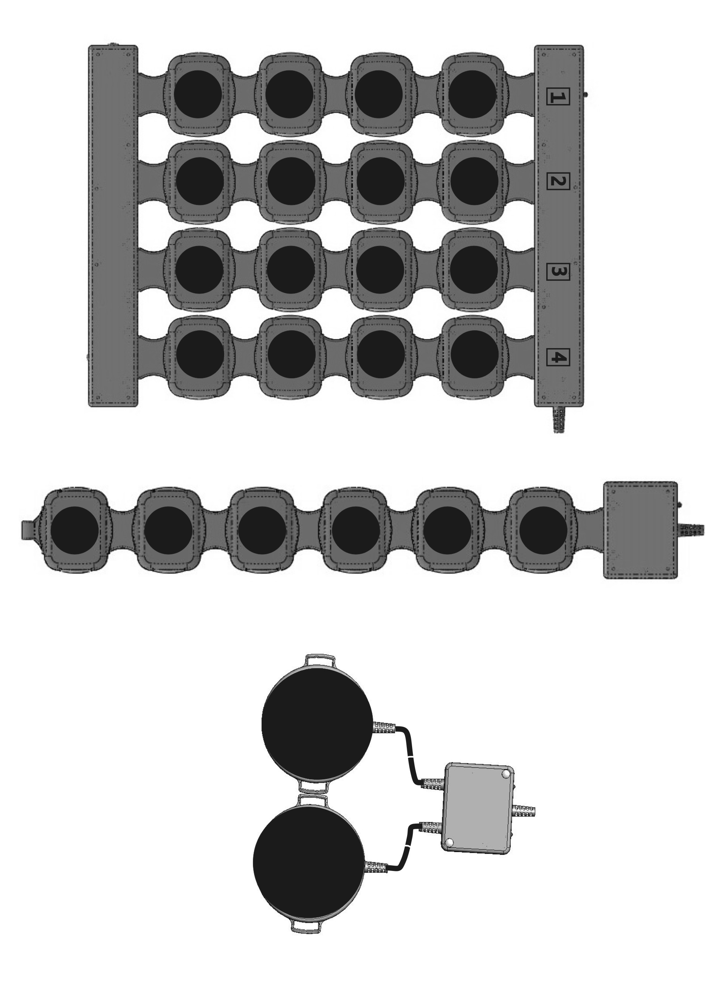

Fig. 21

  - General principles of treatment with ALMAG-02

Depending on the area exposed to magnetic field (limb segments, body trunk, head, local areas), usage of either the main emitter, the flexible emitting line, or the local (target) emitter is recommended. The emitters are placed directly over the exposed area through linen, a towel or a napkin, a bandage, including plaster one, or a light sports suit. The emitters are either spread out flat on the body (arrangement for the trunk, stomach, projection of the spinal column, local areas) or wrapped around a body part (ring-shaped arrangement, when the main emitter and/or flexible emitting line are wrapped around the head or limbs). This is essential while applying the traveling horizontal magnetic field running to the right, since the clockwise rotation effect is thus amplified. In order to amplify the opposite, ‘inhibitory’, effect of the exposure, the counterclockwise field direction can be used: in this case, the "S"-marked side of the emitters has to be the one in contact with the skin.

The exposure areas are selected depending on the disease:
- direct skin exposure (erysipelas, fistula, trophic ulcer);
- internals or joints projection;
- backbone regions (cervical, thoracic (chest), lumbosacral, coccygeal (tailbone);
- endocrine glands projection;
- central exposure (head).
2-5-8-10 Hz frequency is used for treatment of the diseases of internals, endocrine and urogenital systems, for stimulation of the smooth muscles of internal organs and vascular walls, as well as for wounds, skin trophic ulcers and mucosa healing processes stimulation.
The peristalsis frequency approximately coincides with the frequencies of the magnetic field generated by the device.
The frequency of about 50 Hz is used for exposure of the biologically active spots’ projections, skeletal muscles, and for an overall stimulating effect on the organism.
The 100 Hz frequency is used for an anti-inflammatory, anesthetic, and trophic (microcirculatory) effect.
The exposure intensity (magnetic field capacity) is determined by the disease stage. At the acute stage of a disease and in case of an evident pain syndrome, low intensity (2-4 mT) is preferable. During a course treatment, a subsiding period, or the pain syndrome reduction period, the exposure intensity is to be increased every 1-2 procedures (as recommended in the methodology). In case of chronic processes or musculoskeletal system traumas, for purposes of hematoma resolution or stimulation of skin reparation processes, the exposure intensity can be 15-20 mT and higher starting from the first procedure.
For stimulation of the immune system, exposure intensity shall not exceed 2 mT.
For the “static” pulsed electromagnetic field, the maximal density is only 6 mT, but its total capacity will exceed that of the traveling magnetic field with the same density value, as all the emitters in this case generate the magnetic field simultaneously throughout the whole exposure process.
The choice of the exposure procedure duration is based on the same principles as in the previous case: for stages of acute inflammation and severe pain syndrome, the procedure time is 10-15 minutes, for those of acute process subsiding – 20-30 minutes.
Thus, the medical "doze" of magneto-therapy comprises magnetic field density, exposure duration, magnetic field frequency and type. Generally, the minimal (sparing) "doze" is 2-5 mТ intensity for 10-15 minutes. Such doze is preferable during an acute disease period, for weakened, elderly patients, children, and patients with serious cardiovascular diseases. Doze reduction may be necessary (in very rare cases) for patients with high magneto-sensitivity, which is manifested in a drop or rise of arterial blood pressure by 20 mmHg or more after 1-3 procedures, resulting in headache, dizziness, deterioration of the general health condition. In these cases treatment is to be stopped, and a consultation of the attending physician on further treatment adjustment is required.
All patients are recommended to measure their blood pressure and pulse rate before the first procedure and one hour later. Changes in these measurements can serve as an indirect indicator of the patient’s sensitivity to magnetic field action.
The optimal magneto-therapy "doze" is 10-20 mТ for 20-30 minutes. The intensive magneto-therapy exposure "doze" is 21-35 mТ for 30 minutes and up to two 20-minute procedures a day (for instance, in cases of chronic osteomyelitis on the background of antibiotic therapy). Generally, the procedures are to be carried out daily; one treatment course consists of 12-15 daily procedures.
Attention! For some diseases, for example, diabetic polyneuropathy etc., the treatment procedures involve exposure of several body areas (parts).
Speeding up the recovery process by using maximal "dosage" of magnetic exposure is NOT advised due to possible overtreatment.

  - Device operation order
- Choose the required treatment procedure.
- Study the recommendations for the treatment procedure.
- Connect the emitters to the power and control unit, then switch the device on and check its operability.
- Set the program number on the control panel of the power and control unit.
- Arrange the emitter(s) in accordance with the procedure technique.
- Press the “ON/OFF” button on the power and control unit.

  - Specific techniques of pulsed electromagnetic field therapy with ALMAG-02
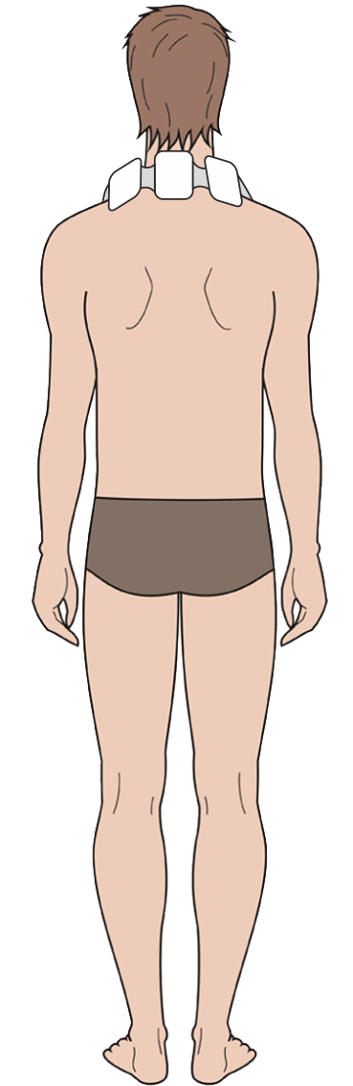
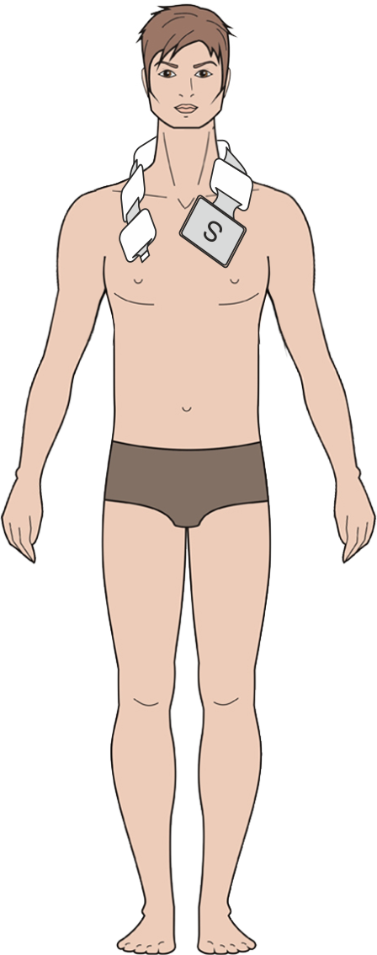
Fig. 22
Nervous system diseases
Migraine
Treatment course length – 10-12 procedures. One procedure per day.
Program No. 3 is set.
The emitters used: flexible emitting line.
Emitters’ arrangement: the flexible emitting line is placed on collar zone with the “N” surface facing the patient’s body (the PGU is on the left). See Fig. 22.

- The magnetic field direction – travelling from left to right;
- Density - 10 mT;
- Frequency: 12 Hz;
- Procedure duration: 10 min.

Disorders of separate nerve roots and plexuses of upper and lower limbs
Radial, median and ulnar nerve diseases
Treatment course length – 10-15 procedures, one procedure per day.
The emitters used: main emitter and flexible emitting line.
Emitters’ arrangement: the main emitter is placed over the cervicothoracic area of the vertebral column, the flexible emitting line – along the arm, on the affected nerve projection. Both emitters are placed with the “N” surface facing the patient’s body. See Fig. 23a.
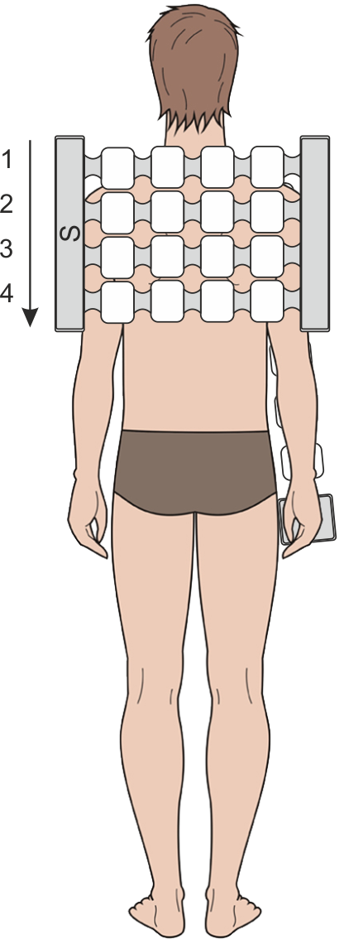
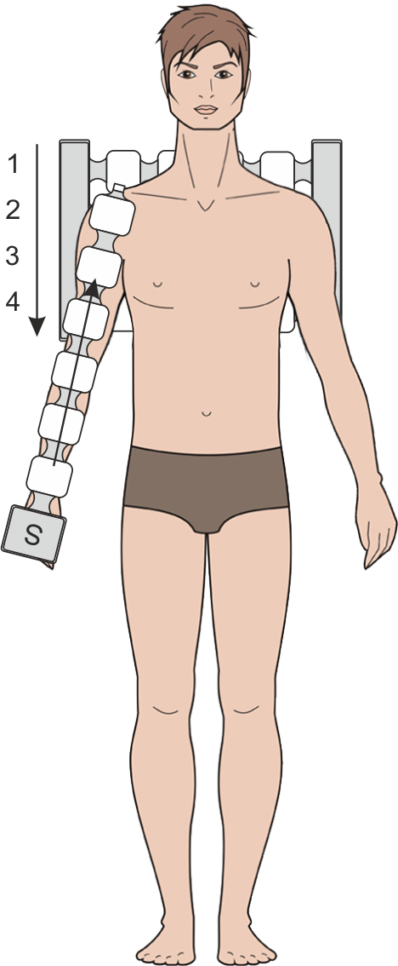
Fig. 23a
For the first 5 procedures, Program No.5 is set:
- The magnetic field direction in the main emitter: traveling top - down, in the flexible emitting line: traveling bottom - up;
- Density: main emitter – 1 mT, flexible emitting line – 2 mТ;
- Frequency: 100 Hz;
- Procedure duration: 10 min.

For the following 5-10 procedures, Program No.6 is set:
- The magnetic field direction is the same as that for the first 5 days of treatment;
- Density: main emitter – 10 mT, flexible emitting line – 25 mТ;
- Frequency: 12 Hz;
- Procedure duration: 10 min.

In case of developing paresis of the corresponding nerve
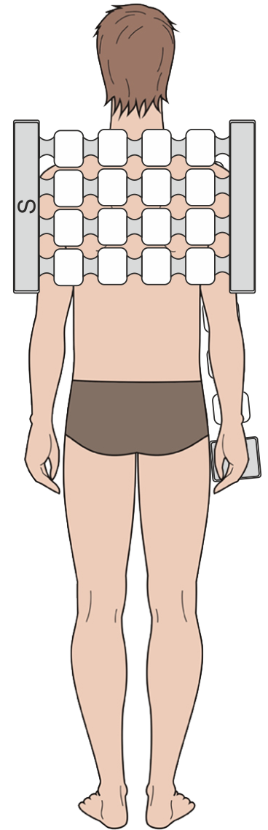
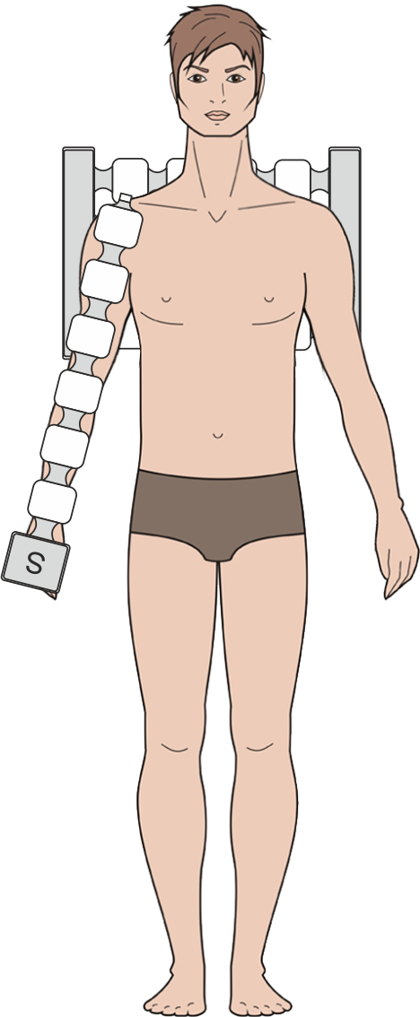
Treatment course – 15 procedures, one procedure per day.
Fig.23b
The emitters used: main emitter and flexible emitting line.
Emitters’ arrangement: the main emitter is placed over the cervicothoracic area of the vertebral column, the flexible emitting line – on the affected nerve projection, with the emitters’ “N” polarity surface facing the body. See Fig. 23b.

Setting of Program No.7:
- The magnetic field direction in the main emitter: static, in the flexible emitting line: static;
- Density: main emitter – 6 mT, flexible emitting line – 6 mТ;
- Frequency: 10 Hz;
- Procedure duration: 20 min.

Femoral, sciatic, tibial and fibular nerve diseases
Treatment course length – 10-15 procedures, one procedure per day.
The emitters used: main emitter and flexible emitting line.
Emitter’s arrangement: the main emitter is placed over of the lumbosacral area of the vertebral column, the flexible emitting line – on the affected nerve projection. Both emitters are placed with their “N” polarity surface facing the body. See Fig. 24.

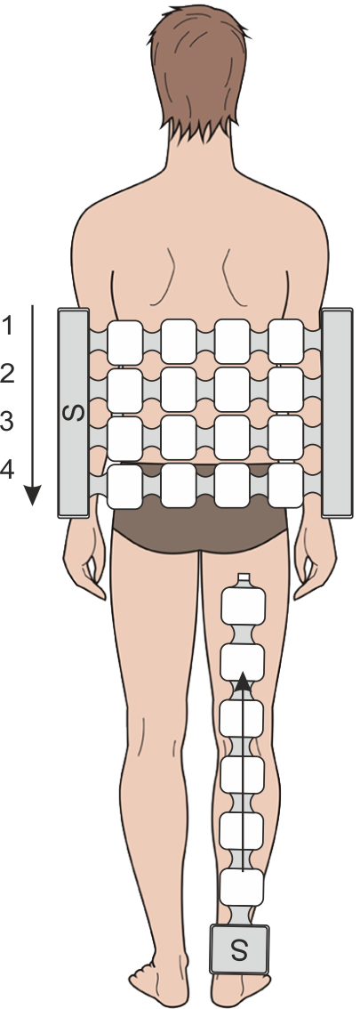
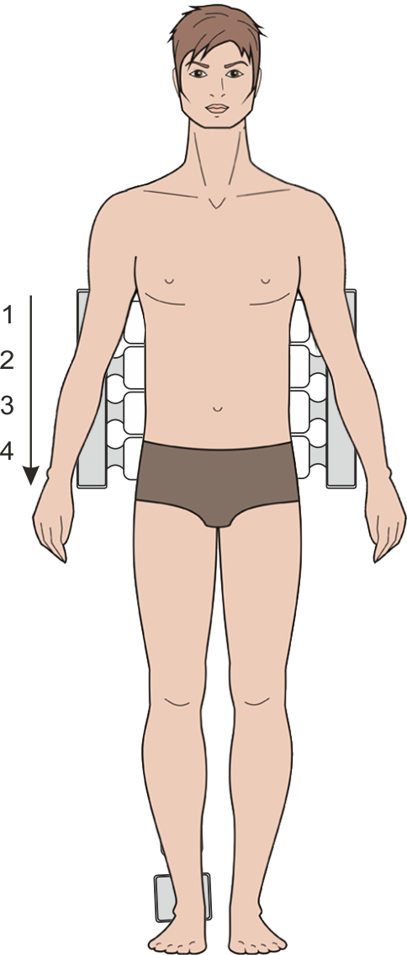
For the first five procedures, Program No.5 is set:
Fig. 24
- The magnetic field direction in the main emitter: traveling top - down, in the flexible emitting line: traveling bottom - up;
- Density: main emitter – 10 mT, flexible emitting line – 20 mТ;
- Frequency: 100 Hz;
- Procedure duration: 10 min.

For the following 5-10 procedures, Program No.6 is set:
- The magnetic field direction is the same as that for the first 5 days of treatment;
- Density: main emitter – 10mT, flexible emitting line – 25 mТ;
- Frequency: 12 Hz;
- Procedure duration: 10 min.
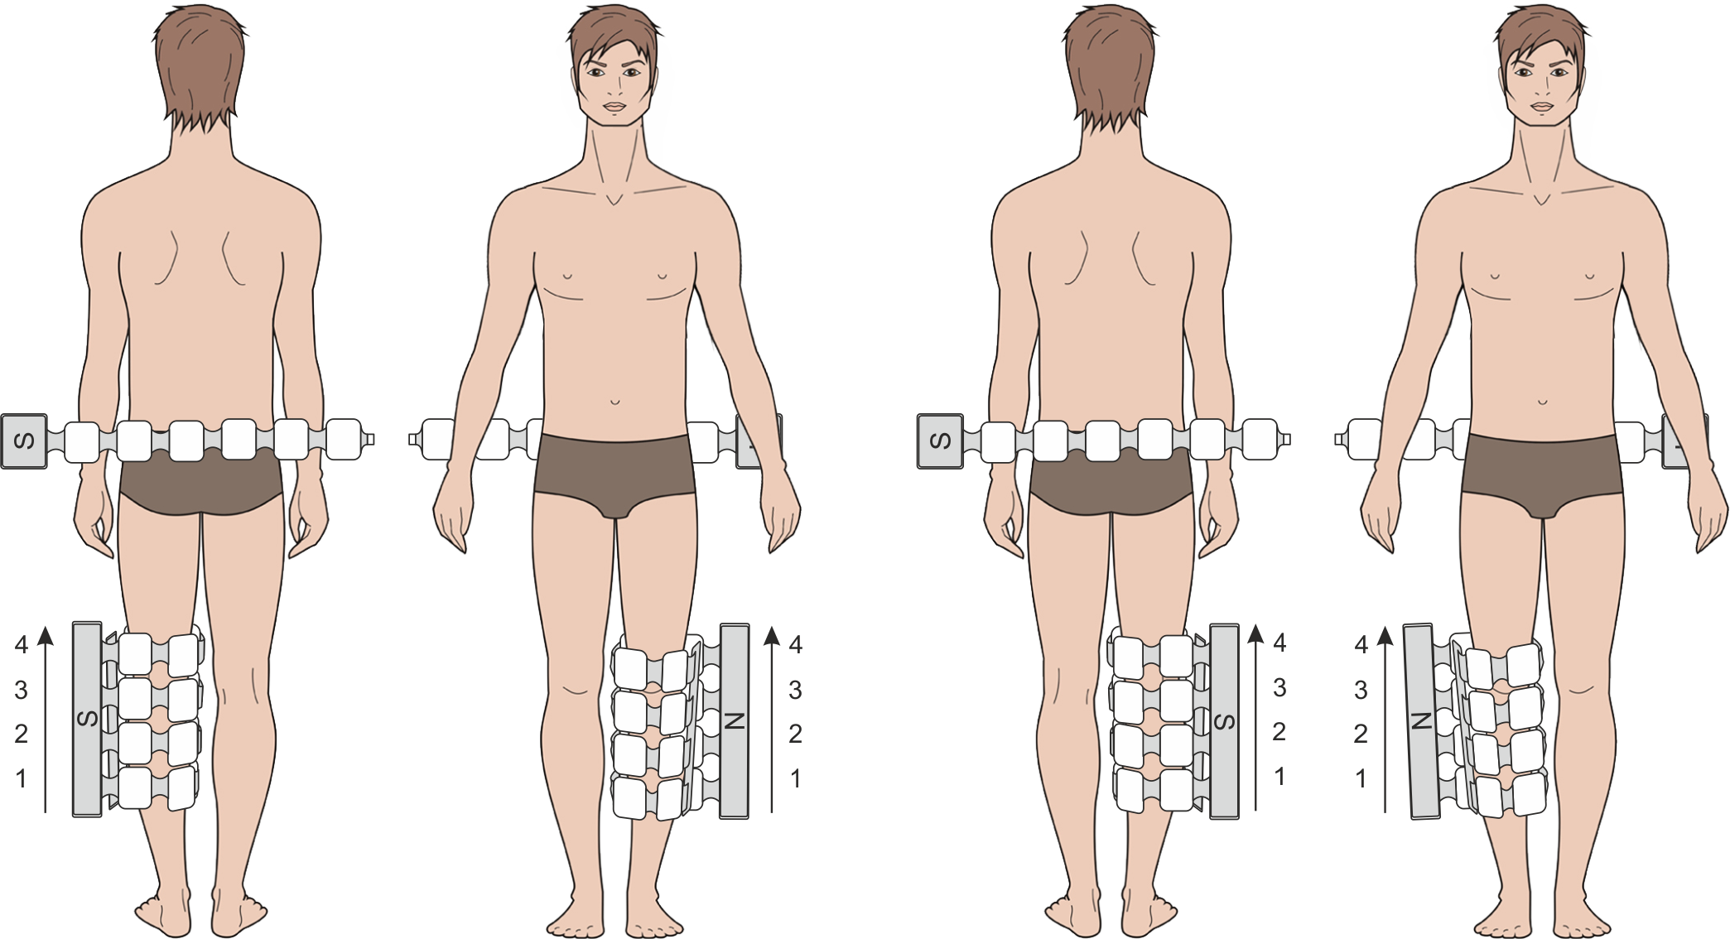
Fig. 25a
Diabetic polyneuropathy
Treatment course length – 15-20 procedures, one procedure per day.
Repeated treatment courses can be carried out in 3 months’ time, three courses per year.
The emitters used: main emitter and flexible emitting line.
At first, the flexible emitting line is placed over and across the lumbosacral area, and the lower leg including the adjacent knee joint of the affected limb are wrapped with the main emitter, the emitters’ “N” polarity surface facing the body. See Fig. 25a.

Setting of Program No.8:
- The magnetic field direction in the main emitter: traveling bottom-up, in the flexible emitting line – static;
- Density: main emitter – 20 mT, flexible emitting line – 6 mТ;
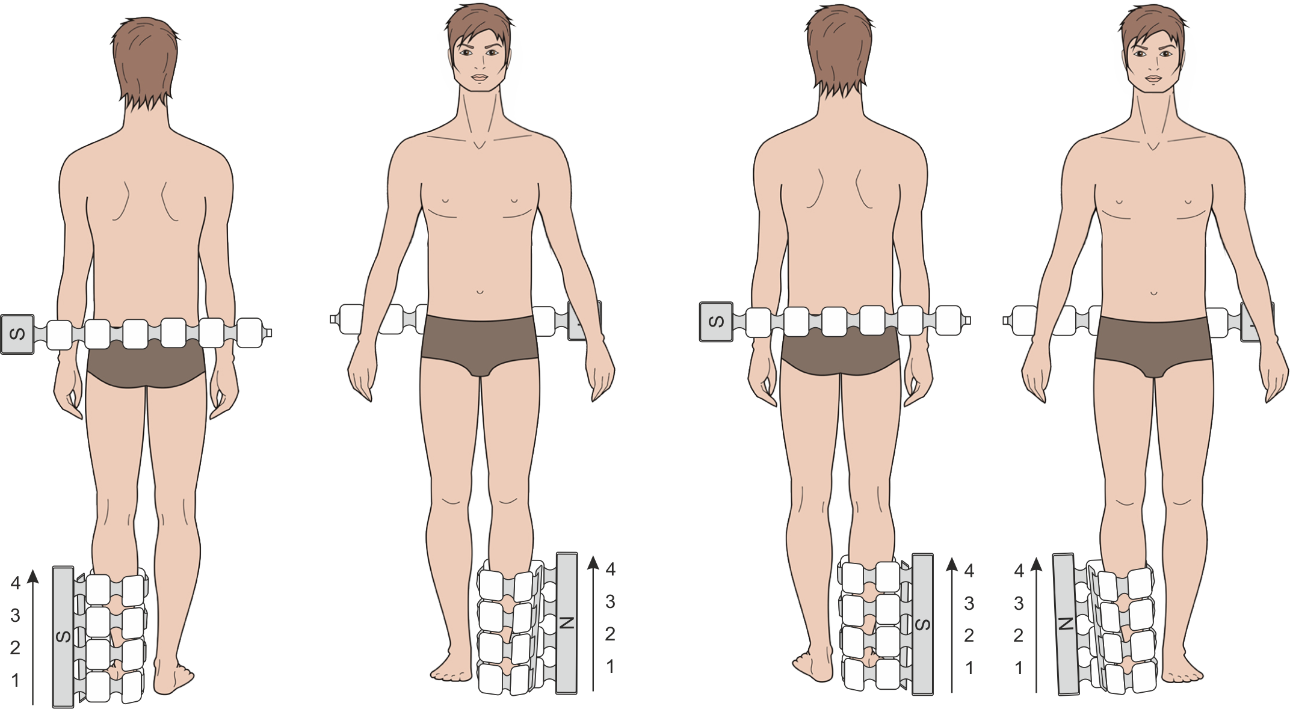
- Frequency: 10 Hz;
Fig. 25b
- Procedure duration: 10 min.

After the exposure time expires, the device remains plugged in, the flexible emitting line is left across the lumbosacral area, and the main emitter is moved down to wrap the foot of the affected leg or placed over the affected foot, with the emitters’ “N” polarity side turned towards the body. See Fig. 25b.

Then Program No.8 is to be set again:
- The magnetic field direction in the main emitter: traveling bottom-up, in the flexible emitting line – static;
- Density: main emitter – 20mT, flexible emitting line – 6 mТ;
- Frequency: 10 Hz;
- Procedure time: 10 min.
Attention! Treatment with blood sugar lowering medications and diets MUST BE CONTINUED on the background of magneto-therapy!
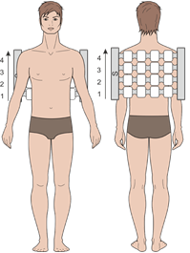
Fig. 26
Postherpetic neuropathy
Treatment course length – 15-20 procedures. One procedure per day. A repeated treatment course is to be carried out in a month.
The emitter used: main emitter.
Emitter’s arrangement: the main emitter is in contact with the affected backbone area, with the “N” polarity surface facing the body.
The main emitter is placed on a treatment couch with the “N” side up. The patient lies with his/her back onto the emitter, making sure to cover the affected backbone area (for the arms – the cervical and thoracic parts, for the body trunk – the thoracic part, for the pelvis and legs – the lumbar part). See Fig. 26.

At first, Program No.9 is set:
- The magnetic field direction in the main emitter: traveling bottom - up;
- Density: 20 mT;
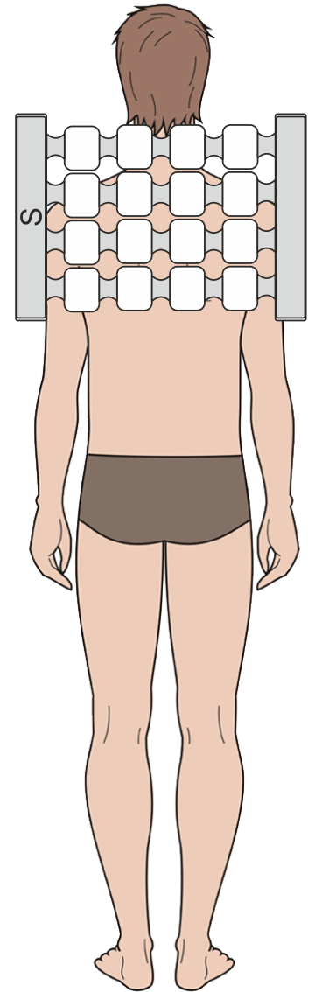
- Frequency: 100 Hz;
Fig. 27
- Procedure time: 15 min.
After exposure termination, the device remains plugged in, and the main emitter is moved onto the affected intercostal nerves area. See Fig. 27.
Setting of Program No.10:
- The magnetic field direction in the main emitter: static;
- Density: 6 mT;
- Frequency: 16 Hz;
- Procedure time: 15 min.

Raynaud`s syndrome (“dead finger” syndrome)
Treatment course – 15 procedures. One procedure per day. A repeated treatment course is to be carried out in two months.
The emitter used: main emitter.
Emitters’ arrangement: the main emitter is placed on the cervical collar area with its “N” polarity surface facing the body. See Fig. 27.

At first, Program No.11 is set:
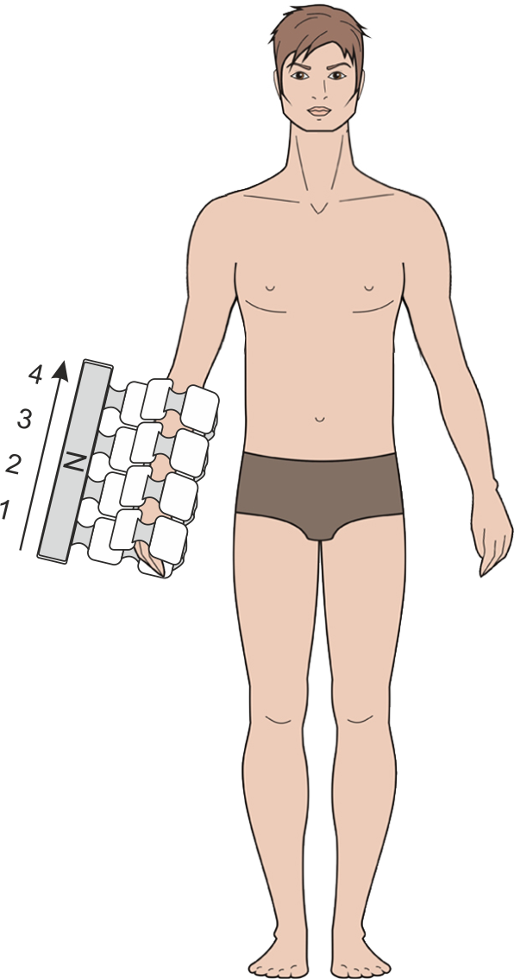
- The magnetic field direction in the main emitter: fixed;
Fig. 28
- Density: 6 mТ;
- Frequency: 16 Hz;
- Procedure duration: 10 min.

After the procedure termination, the device remains plugged in, and the main emitter is removed and wrapped around the affected limb covering the upper part of the hand, the “N” polarity surface facing the body. See Fig. 28.

Setting of Program No.12:
- The magnetic field direction in the main emitter: traveling bottom -up;
- Density: 25 mТ;
- Frequency: 75 Hz;
- Procedure duration: 10 min.

Diseases of circulatory system

After-effects of cerebrovascular diseases
The treatment course: 10-12 procedures.
One procedure per day.
The emitters used: main emitter, flexible emitting line.
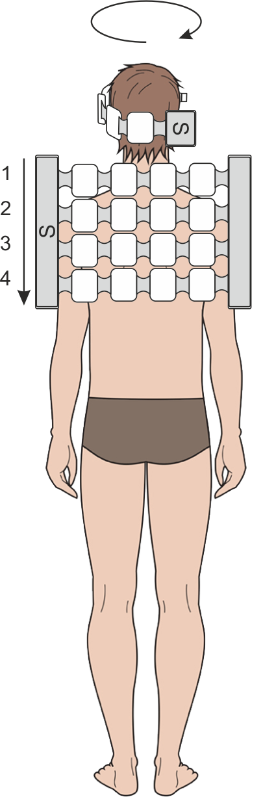
Emitters’ arrangement: the main emitter is placed over the cervicothoracic area of the spinal column, the head is wrapped with the flexible emitting line, with the emitters’ “N” polarity surface facing the body. See Fig. 29.
Fig. 29
Setting of Program No.16:
- The magnetic field direction in the main emitter: traveling top -down, in the flexible emitting line: traveling clockwise with the emitters’ “N” polarity surface facing the body.
- Density: 10 mT;
- Frequency: main emitter – 100 Hz, flexible emitting line – 10 Hz;
- Procedure time: 20 min.

Atherosclerotic vascular disease, endarteritis deformans or obliterating endarteritis
The treatment course: 15 procedures. One procedure per day. A repeated course is carried out in 2-3 months.
The emitters used: main emitter, flexible emitting line.
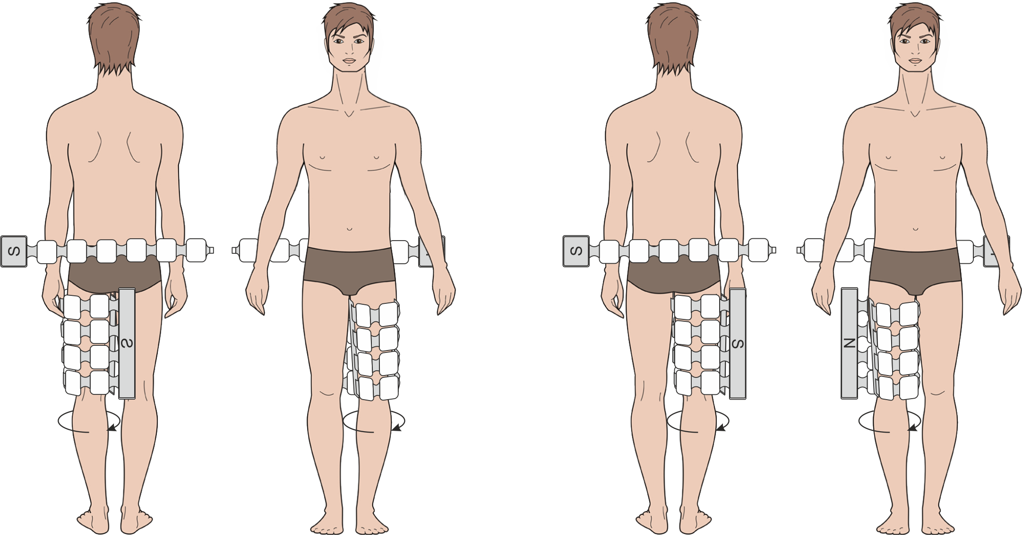
Emitters’ arrangement: the thigh bone is wrapped with the main emitter, the flexible emitting line is placed over the waist sympathetic ganglions projection area, with the emitters’ “N” polarity surface facing the body. See Fig. 30a.
Fig. 30a
Setting of Program No.17:
- The magnetic field direction in the main emitter: traveling from right to left, in the flexible emitting line: static;
- Density: main emitter – 20 mT, flexible emitting line – 6 mT;
- Frequency: main emitter – 10 Hz, flexible emitting line – 16 Hz;
- Procedure duration: 10 min.
After the procedure time expiration, the device remains plugged in, and the main emitter is moved as follows: the lower leg is wrapped with the main emitter, while the flexible emitting line stays on the waist sympathetic ganglions projection area, with the emitters’ “N” polarity surface facing the body. See Fig. 30b.
Setting of Program No.17:
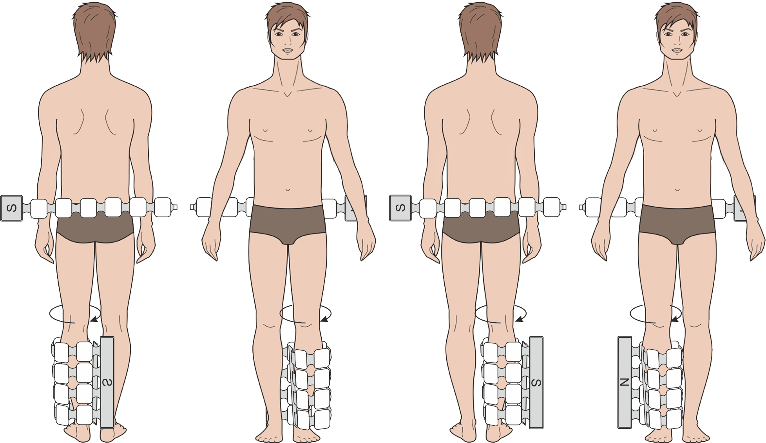
- The magnetic field direction in the main emitter: traveling from right to left, in the flexible emitting line: static;
Fig. 30b
- Density: main emitter – 20 mT, flexible emitting line – 6 mT;
- Frequency: main emitter – 10 Hz, flexible emitting line – 16 Hz;
- Procedure time: 10 min.

Atherosclerotic (discirculatory) encephalopathy
Treatment course length: 10-12 procedures. One procedure per day.
The procedures can be carried out every other day.
The emitters used: main emitter, flexible emitting line.
Emitters’ arrangement: the main emitter is placed over the cervicothoracic area of the spinal column, the head is wrapped with the flexible emitting line, with the emitters’ “N” polarity surface facing the body. See Fig. 31.
Fig. 31

Setting of Program No.16:
- The magnetic field direction in the main emitter: traveling top - down, in the flexible emitting line: traveling clockwise;
- Density: 10 mT;
- Frequency: main emitter –100 Hz, flexible emitting line – 10 Hz;
- Procedure time: 20 min.

Varicose veins
The treatment course: 15 procedures. One procedure per day.
A repeated course can be carried out in 2-3 months.
The emitters used: main emitter.
Emitters’ arrangement: at first, the main emitter is wrapped around the lower leg of the affected limb, with the emitters’ “N” polarity surface facing the body. See Fig. 32a.

Setting of Program No.18:
- The magnetic field direction in the main emitter: traveling bottom - up;
- Density: 20 mT;
- Frequency: 100 Hz;
- Procedure time: 10 min.
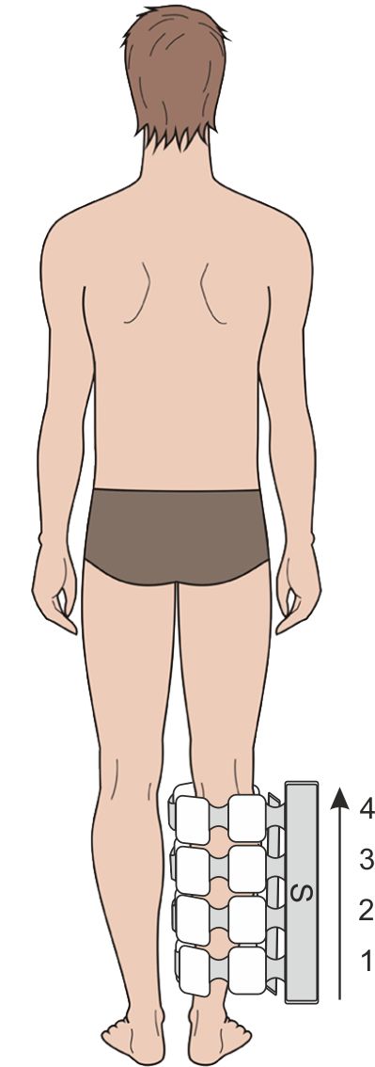
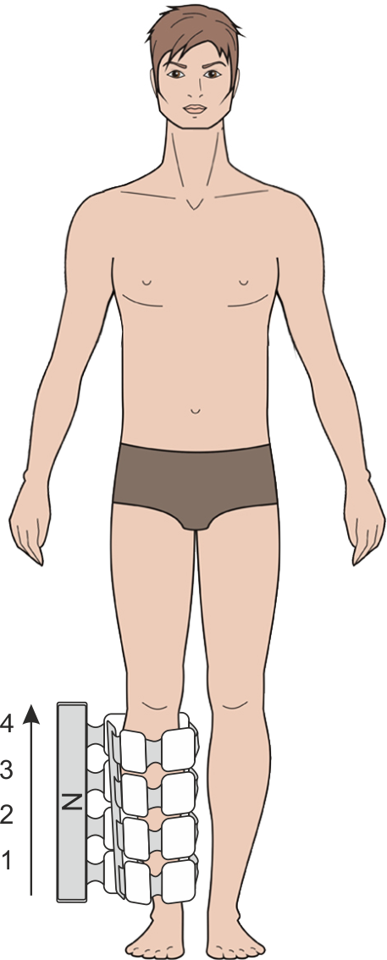
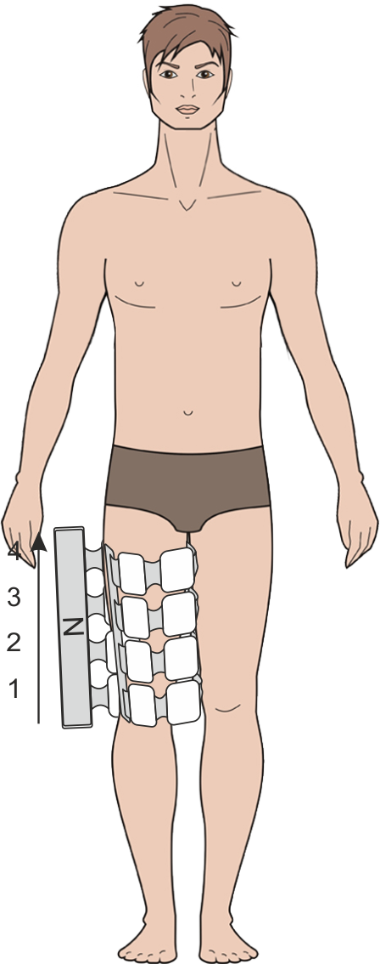
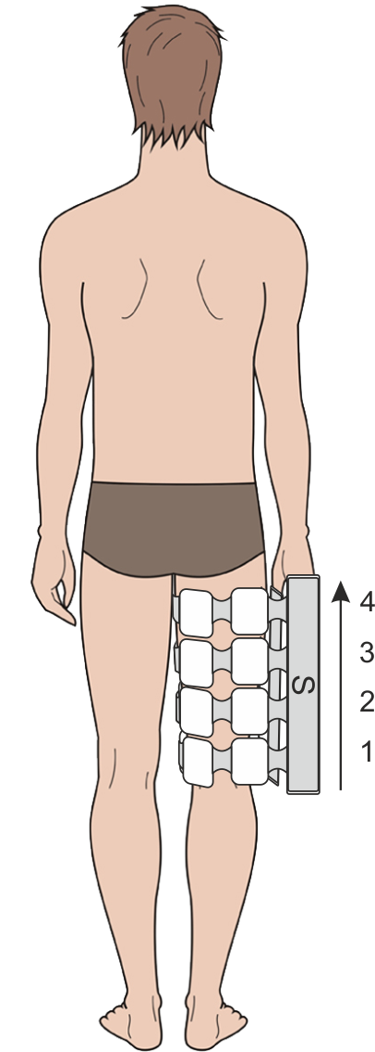
After the procedure time expiration, the device remains plugged in, and the main emitter is moved to wrap the thigh of the affected limb, with the emitters’ “N” polarity surface facing the body. See Fig. 32b.
Fig. 32a
Fig. 32b

Setting of Program No.18:
- The magnetic field direction in the main emitter: traveling bottom - up;
- Density: 20 mT;
- Frequency: 100 Hz;
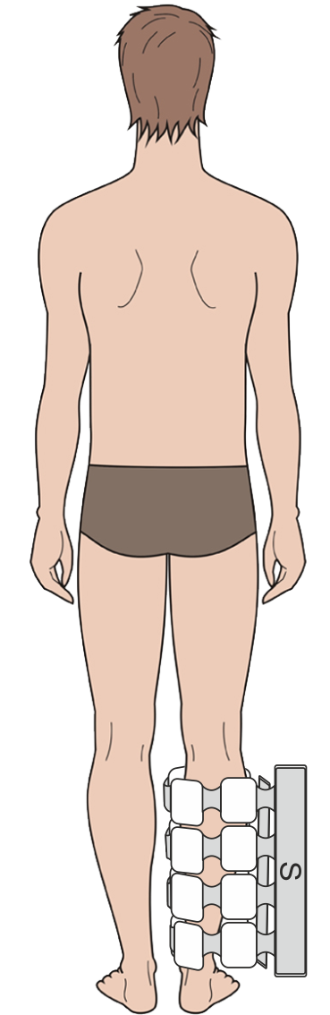
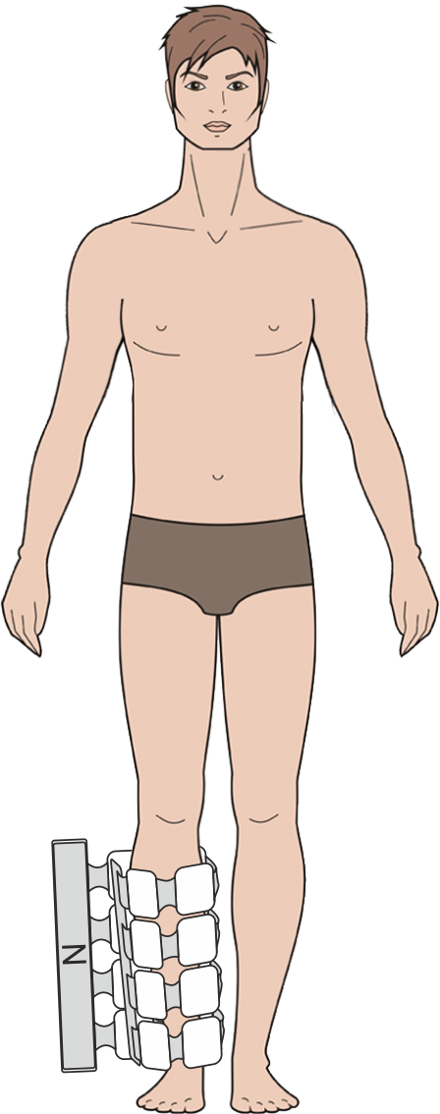
- Procedure time: 10 min.
Fig. 33

Deep vein thrombophlebitis of the lower leg
The treatment can be intensified with heparin-based ointments applied before the treatment procedure.
The treatment course: 15 procedures. One procedure per day. A repeated course can be carried out in 2-3 months.
The emitters used: main emitter.
Emitters’ arrangement: the main emitter is wrapped around the lower leg of the affected limb, with the emitters’ “N” polarity surface facing the body.
See Fig. 33.
Setting of Program No.35:
- The magnetic field direction in the main emitter: static;
- Density: 6 mT;
- Frequency: 16 Hz;
- Procedure duration: 20 min.
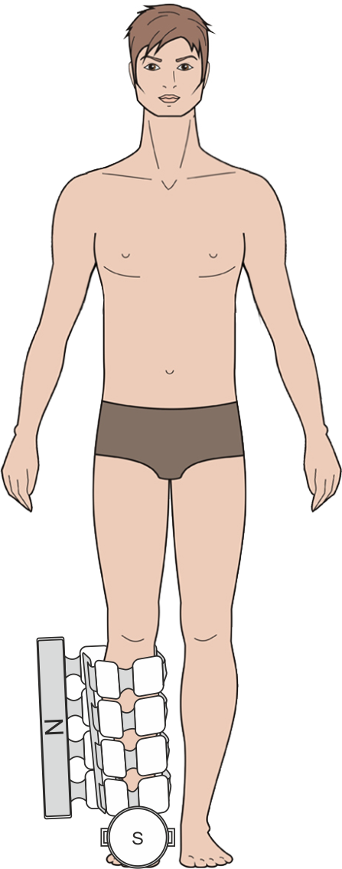
Chronic thrombophlebitis accompanied by trophic disorders
Fig. 34a
During the exposure procedure, the ulcerous defect is to be covered with a sterile bandage or a bandage to which a healing acceleration medication is applied.
The treatment course contains 10 procedures. One procedure per day.
A repeated course is carried out after a 30-day period. The following routine treatment courses can be carried out after 2-3 months.
The emitters used: main emitter, local emitter.
Emitters’ arrangement: the main emitter is placed on a couch or bed, and the patient lies down so as to put the lower leg of his/her diseased limb over the emitter, while the local emitter is placed on the bandaged ulcerous area, with the emitters’ “N” polarity surfaces facing the body. See Fig. 34a.

Setting of Program No.55:
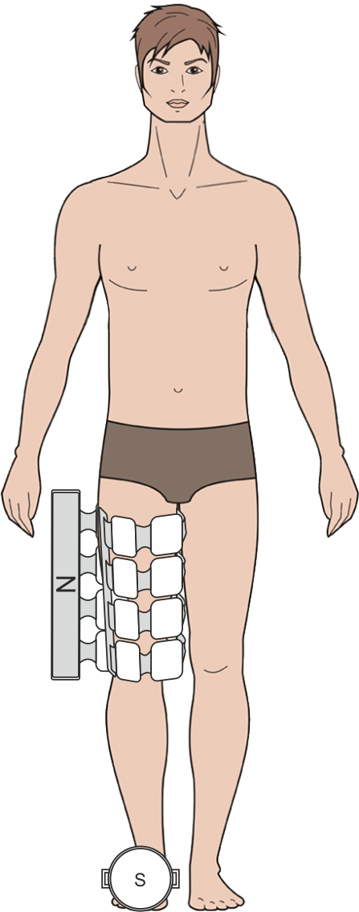
- The magnetic field direction in the main and local emitter: static;
Fig.34b
- Density: 6 mT;
- Frequency: 16Hz;
- Procedure time: 10 min.

After the procedure time expiration, the device remains plugged in, the main emitter remains on the couch or bed, and the patient lies on it with the thigh of his/her diseased limb over the emitter, while the local emitter is placed on the ulcerous area, with the emitters’ “N” surfaces facing the body. See Fig. 34b.

Setting of Program No.55:
- The magnetic field direction in the main and local emitter: static;
- Density: 6 mT;
- Frequency: 16 Hz;
- Procedure time: 10 min.

Chronic lymphedema (lymphatic edema)
The treatment course: 15 procedures. One procedure per day.
A repeated course is carried out after a 30-day period. The following routine treatment courses can be carried out after 2-3 months.
Fig. 35a
Fig. 35b
The emitter used: main emitter.
The lower leg of the diseased limb is wrapped with the main emitter, its “N” polarity side turned towards the body. See Fig. 35a.

Setting of Program No.19:
- The magnetic field direction in the main emitter: traveling bottom - up;
- Density: 20 mT;
- Frequency: 50Hz;
- Procedure time: 15 min.
After the procedure time expiration, the device remains plugged in, and the thigh of the diseased limb is wrapped with the main emitter. See Fig. 35b.

Setting of Program No.19:
- The magnetic field direction in the main emitter: traveling bottom - up;
- Density: 20 mT;
- Frequency: 50Hz;
- Procedure time: 15 min.

Musculoskeletal system and the connecting tissue diseases

Gouty arthritis
The treatment course length is 15 procedures. One procedure per day.
Due to the chronic disease nature, preventive routine courses of pulsed magnetic therapy are recommended to be taken 2-3 times a year.
The emitter used: local emitter.

The first 3 procedures:
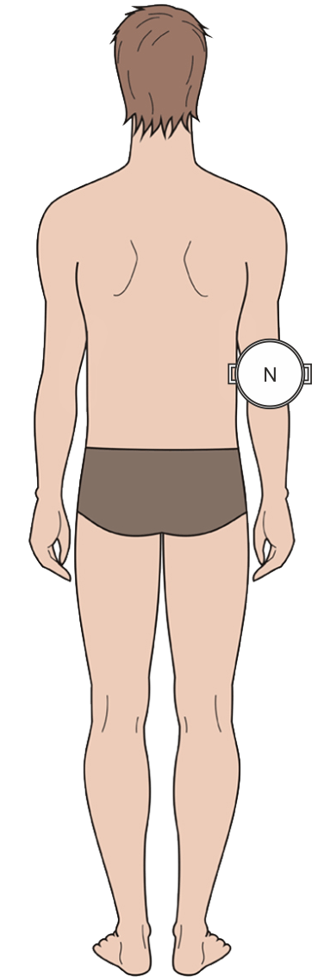
The local emitter is placed over the affected joint, with its “N” polarity side turned towards the body. See Fig. 36.
Fig. 36

Setting of Program No.69:
- The magnetic field direction in the local emitter: static;
- Density: 10mT;
- Frequency: 100 Hz;
- Procedure duration: 10 min.

Procedure 4 and up to the treatment course end:
The local emitter is placed over the affected joint, with its “N” polarity side turned towards the body.

Setting of Program No.70:
- The magnetic field direction in local emitter: static;
- Density: 15mT.
- Frequency: 10 Hz;
- Procedure duration: 20 min.

Coxarthrosis
The treatment course: 15 procedures. One procedure per day.
Due to the chronic disease nature, preventive routine courses of pulsed magnetic therapy are recommended to be taken 2-3 times a year.
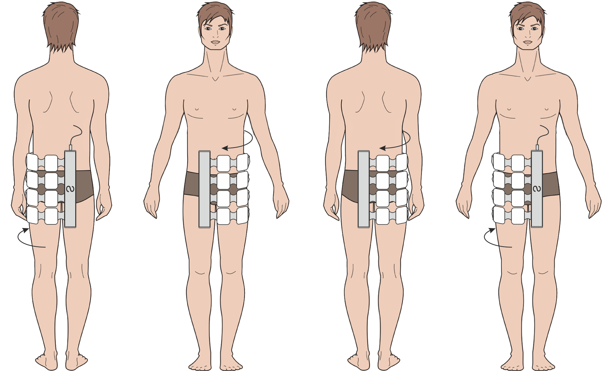
The emitter used: main emitter.
Fig. 37

The first 5 procedures:
The main emitter is wrapped around the affected joint, with its “N” polarity surface facing the body. See Fig. 37

Setting of Program No.27:
- The magnetic field direction in the main emitter: traveling from left to right;
- Density: 15 mT;
- Frequency: 100 Hz;
- Procedure duration: 15 min.

Procedure 6 and up to the treatment course end:
The main emitter is wrapped around the affected joint, with its “N” polarity surface facing the body.

Setting of Program No.28:
- The magnetic field direction in the main emitter: traveling from left to right;
- Density: 10 mT;
- Frequency: 25 Hz;
- Procedure duration: 20 min.

Gonarthrosis
The treatment course: 15 procedures. One procedure per day.
Due to the chronic disease nature, preventive routine courses of pulsed magnetic therapy are recommended to be taken 2-3 times a year.
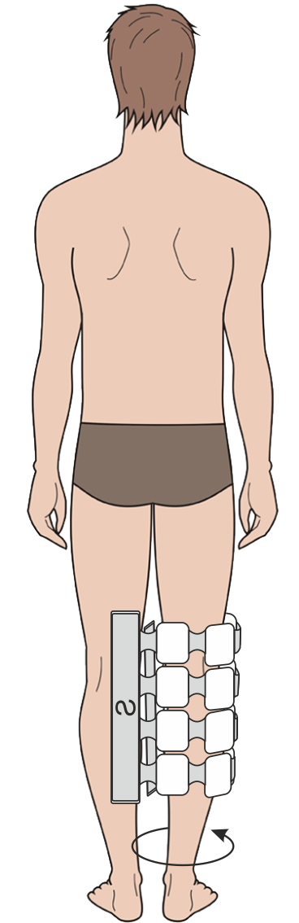
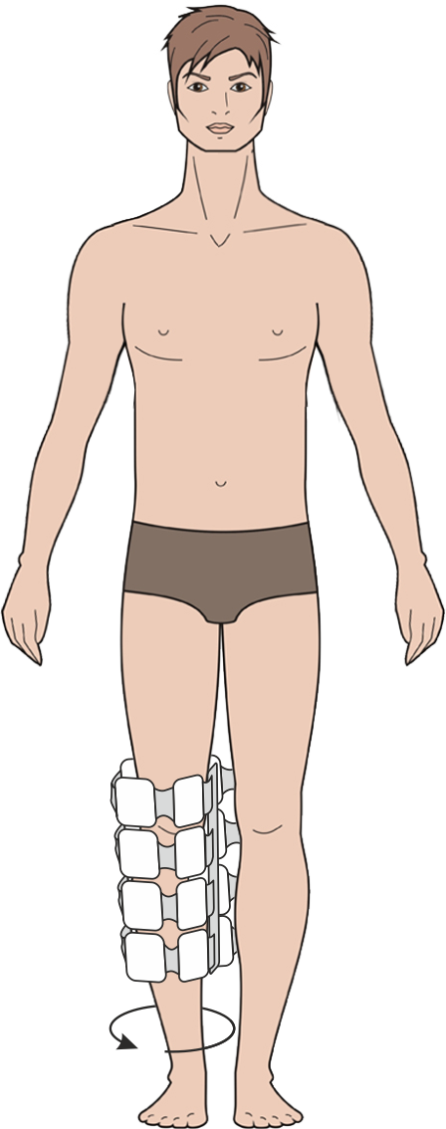
The emitter used: main emitter.
Fig. 38

The first 5 procedures:
The main emitter is wrapped around the affected joint, with its “N” polarity surface facing the body. See Fig. 38.

Setting of Program No.29:
- The magnetic field direction in the main emitter: traveling from left to right;
- Density: 10 mT;
- Frequency: 100 Hz;
- Procedure duration: 15 min.

Procedure 6 and up to the treatment course end:
The main emitter is wrapped around the affected joint, with its “N” polarity surface facing the body.

Setting of Program No.30:
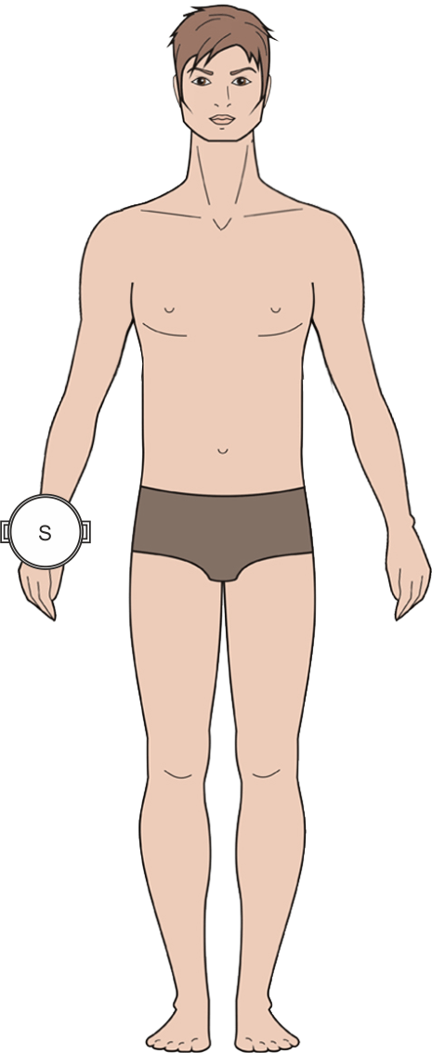
- The magnetic field direction in the main emitter: traveling from left to right;
Fig. 39
- Density: 20 mT;
- Frequency: 10 Hz;
- Procedure duration: 20 min.

Arthrosis of the first carpometacarpal joint
The treatment course: 15 procedures. One procedure per day.
Due to the chronic disease nature, preventive routine courses of pulsed magnetic therapy are recommended to be taken 2-3 times a year.
The emitter used: local emitter.

The first 3 procedures:
The local emitter is placed against the affected joint, with its “N” polarity surface facing the body. See Fig. 39.

Setting of Program No.71:
- The magnetic field direction in the local emitter: static;
- Density: 8 mT;
- Frequency: 100 Hz;
- Procedure time: 15 min.

Procedure 4 and up to the treatment course end:
The local emitter is placed against the affected joint, with its “N” polarity surface facing the body.

Setting of Program No.72:
- The magnetic field direction in the local emitter: static;
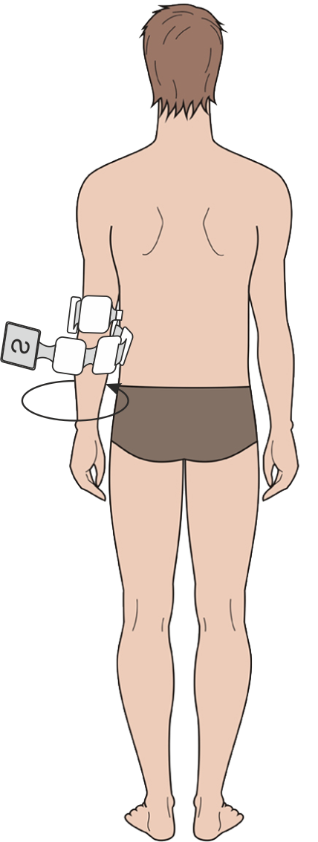
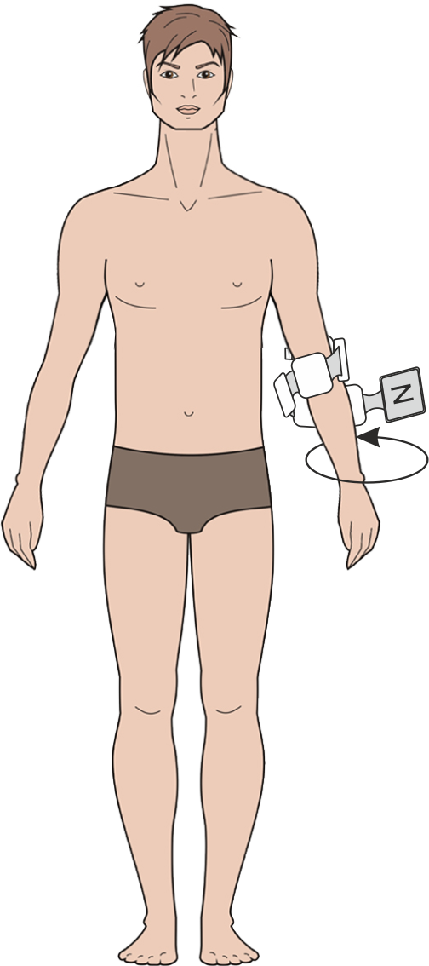
- Density: 15 mT;
Fig. 40
- Frequency: 10 Hz;
- Procedure time: 20 min.

Internal and external humeral epicondylitis (tennis elbow and golf elbow)
The treatment course length – 15 -20 procedures. One procedure per day.
The emitter used: flexible emitting line.
Emitter’s arrangement: the flexible emitting line is wrapped around the affected elbow, with its “N” polarity surface facing the body. See Fig. 40.

Setting of Program No.31:
- The magnetic field direction in the flexible emitting line: traveling clockwise:
- Density: 20 mT;
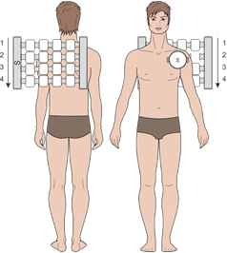
- Frequency: 100 Hz;
Fig. 41
- Procedure time: 15 min.

Humeroscapular periarthrosis
The treatment course: 10 procedures. One procedure per day.
The emitters used: main emitter, local emitter.
Emitters’ arrangement: the main emitter is placed over the cervicothoracic area of the spinal column with a shift towards the affected joint, while the local emitter is placed against the affected joint, with the emitters’ “N” polarity surfaces facing the body. surface facing the body. See Fig. 41.

Setting of Program No.73:
- The magnetic field direction in the main emitter: traveling top - down, in the local emitter: static;
- Density: main emitter – 20 mT, local emitter – 30 mT;
- Frequency: main emitter – 100 Hz, local emitter – 10 Hz;
- Procedure time: 15 min.

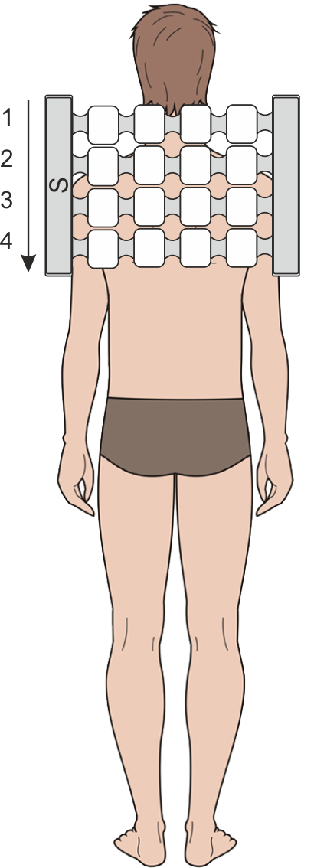
Acute trophoneurotic bone atrophy (Sudeck`s atrophy)
Fig. 42a
The treatment course: 10 procedures. One procedure per day.
The emitters used: main emitter.
During the procedure, the main emitter is placed on 2 areas in turn.
At first, the main emitter is placed on the couch or bed, while the patient lies down over it so that his/her cervicothoracic part of the spinal column is against the emitter. The emitter’s “N” polarity surface is turned towards the patient`s body. See Fig. 42a.

Setting of Program No.32:
- The magnetic field direction: traveling top - down;
- Density: 20 mT;
- Frequency: 100 Hz;
- Procedure time: 7 min.
After that, while the device remains plugged in, the main emitter is wrapped around the forearm and arm, with the “N” polarity surface facing the body. See Fig. 42b.
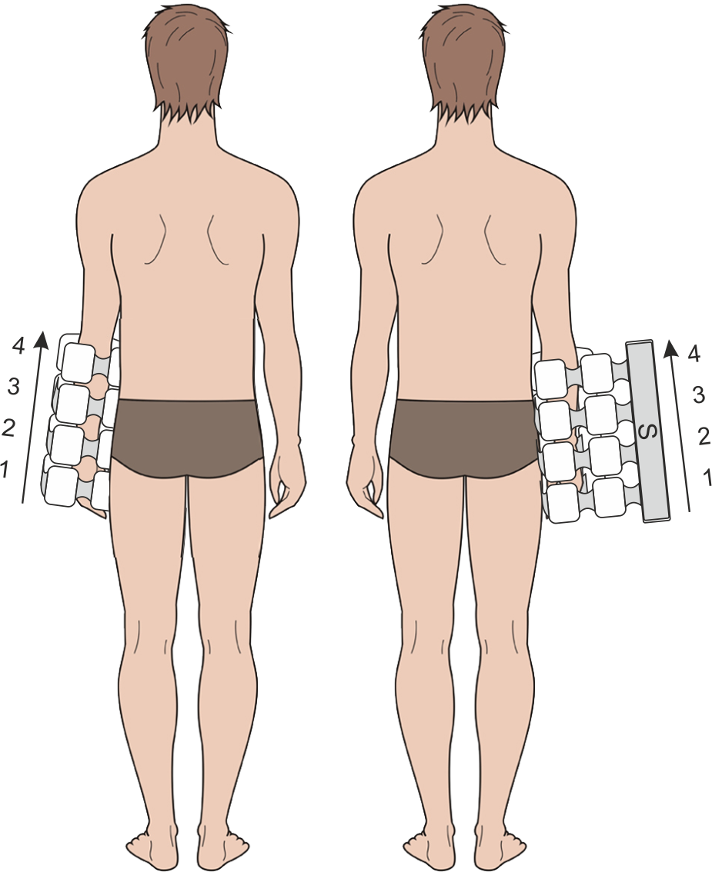
Fig. 42b

Setting of Program No.32:
- The magnetic field direction: the main emitter traveling bottom - up;
- Density: 20 mT;
- Frequency: 100 Hz;
- Procedure time: 7 min.

Note: This is a severe complication of radial bone fracture in a typical spot (lower third of the forearm). Even when timely and properly immobilized, the patient’s arm continues to ache for a long period after cast removal, which is accompanied by a non-resolving swelling of the fingers, wrist and lower forearm; there is a "glass"-like sensation to the fingers, they are cold to touch, and a contracture develops in the wrist, fetlock and interphalangeal joints, manifested on X-ray images as patchy osteoporosis of hand bones. The underlying medical condition, which will most likely lead to the patient’s disablement in case of lack of treatment, is a severe microcirculatory dysfunction in the affected arm, with complete cessation of blood flow in some of the capillaries with their subsequent passive dilatation, as well as with an acid-base imbalance shifting towards acidosis, which results in an active proliferation of fibroblasts and synthesis of tropocollagen. This process ends up in a rapid replacement of highly differentiated tissue of the hand’s gliding mechanism with scar tissue and the subsequent hand immobility. A contraindication specific for this disease is absolute exclusion of any kind of thermal exposure (the well-known advice of “heating the hand with steam” is totally prohibited in such cases). Even moving the affected fingers forcedly with the good hand is not allowed. The therapeutic action of PEMF in these cases affects the blood rheological properties, produces an analgesic, anti-inflammatory, tropho-stimulating and anti-edematous effect, and normalizes microcirculation and the venous blood flow. It is the absence of any thermal effect that makes magneto-therapy essential for application in such cases. Moreover, exposure can be started as early in the treatment process as immediately after plaster fixation. If this was done, such patients experienced edema resolution and restoration of the hand’s functions 2-3 weeks earlier than the patients who did not go through a magneto-therapy course.
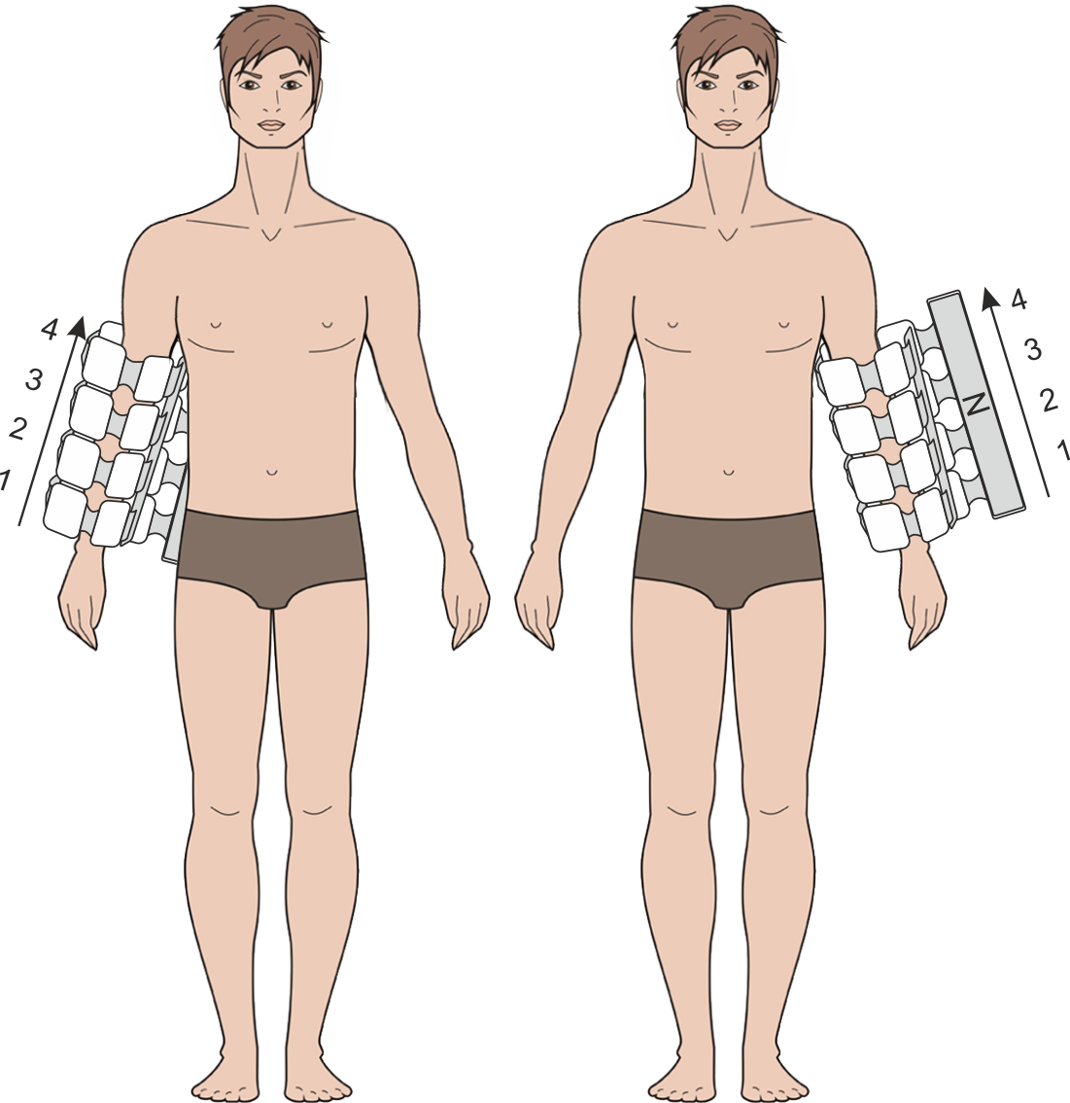
Fig. 43
Tenosynovitis crepitans of the forearm
The treatment course: 15 procedures. One procedure per day.
The emitter used: main emitter.
The affected limb is wrapped with the emitter, with its “N” polarity surface facing the body. See Fig. 43.
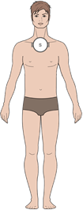
Fig. 44
Setting of Program No.33:
- The magnetic field direction: the main emitter traveling bottom - up;
- Density: 25 mT;
- Frequency: 75 Hz;
- Procedure time: 20 min.

Tietze’s syndrome (aseptic inflammation of coastal cartilages in the area of rib attachment to sternum, more often of ribs II-IV, with a painful thickening)
The treatment course: 15 procedures. One procedure per day.
The emitter used: local emitter.
The local emitter is placed against the affected area with its “N” polarity surface facing the body. See Fig. 44.

Setting of Program No.74:
- The magnetic field direction: static;
- Density: 35 mT;
- Frequency: 50 Hz;
- Procedure time: 15 min.

Osteochondropathy (Kohler disease, Kienbock’s disease, Perthes disease, Schlatter disease, Koenig’s disease)
The treatment course: 10 procedures. One procedure per day.
The emitter used: main emitter.
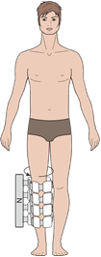
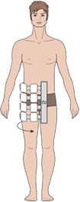
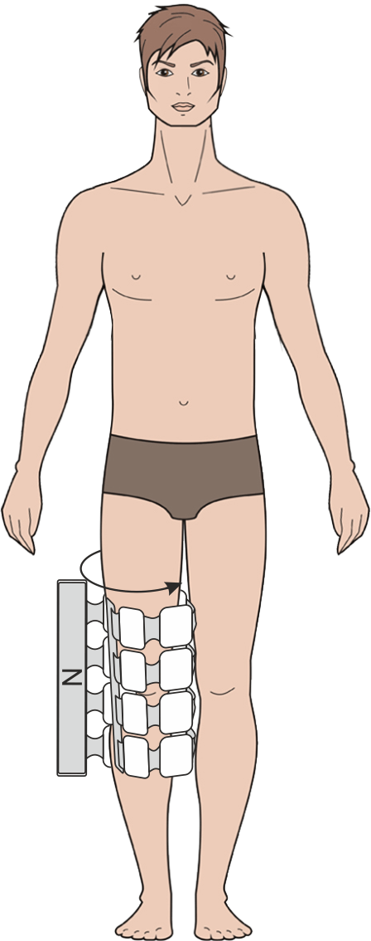
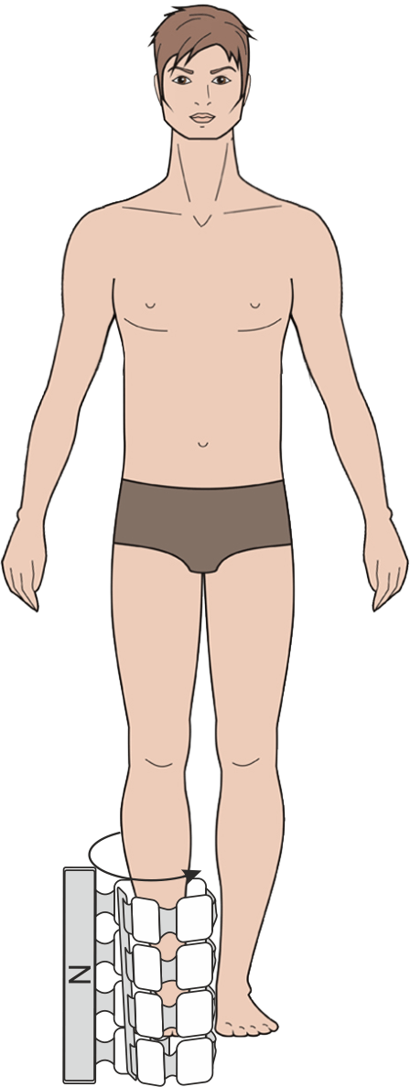
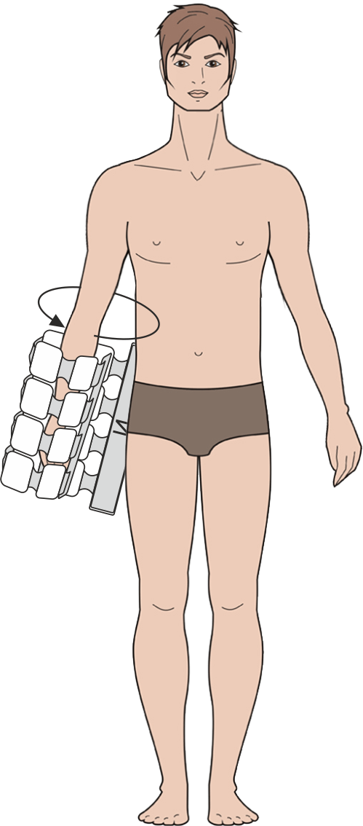
The main emitter is placed over the affected area (which is either covered by or wrapped with it, depending on its location), with the “N” polarity surface facing the body. See Fig. 45.
Koenig’s disease | Schlatter disease | Kohler disease  Fig. 45 | Perthes disease | Kienbock’s disease

Setting of Program No.34:
- The magnetic field direction: the main emitter traveling from left to right;
- Density: 15 mT;
- Frequency: 100 Hz;
- Procedure time: 15 min.

Spondylitis deformans (Strumpell-Marie disease)
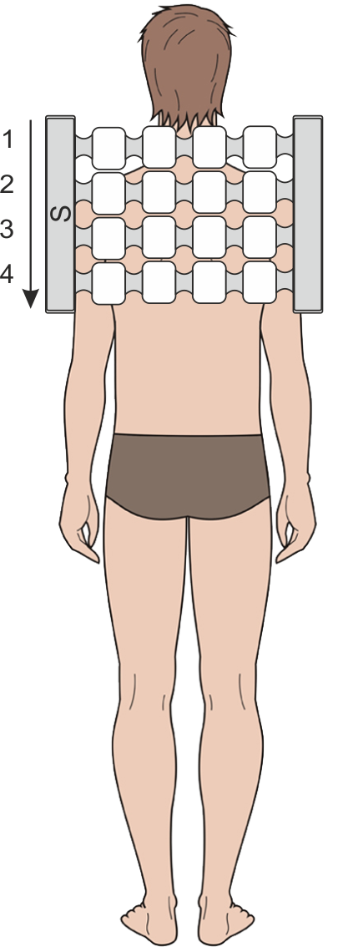
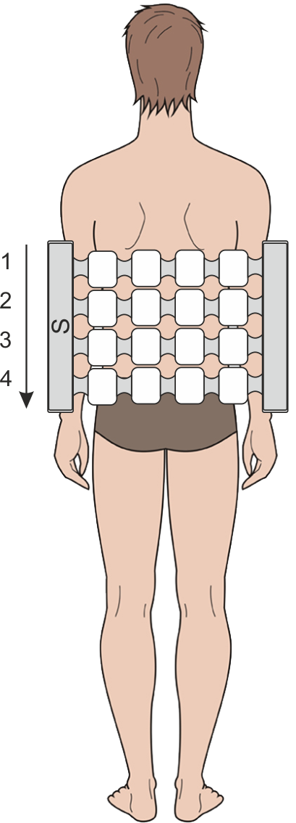
In this case, magneto-therapy is effective at early (I-II) stages of the disease. Magneto-therapy is not carried out in cases of a high process activity (blood sedimentation test, acute phase reactants).
Fig. 46a
Fig. 46b
The treatment course: 20 procedures. One procedure per day.
The emitter used: main emitter.
The main emitter is placed on a couch or bed with its “N” polarity surface upward, and the patient lies down on it so that his/her cervicothoracic area of the spinal column is above the emitter. See Fig. 46a.

Setting of Program No.11:
- The magnetic field direction in the main emitter: static;
- Density: 6 mT;
- Frequency: 16 Hz;
- Procedure time: 10 min.

After the exposure time expiration, the device is left plugged in, and the main emitter is moved down along the couch or bed to the level of the patient’s lumbosacral area of the spinal column. See Fig. 46b.

Program No.11 is set again.

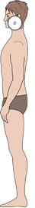
Osteoarthritis of the temporomandibular joint
Fig. 47
The treatment course: 15-20 procedures. One procedure per day.
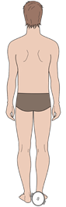
The emitter used: local emitter.
Fig. 48
The emitter is placed against the affected area with its “N” polarity surface to the body. See Fig. 47.

Setting of Program No.75:
- The magnetic field direction of the local emitter: fixed;
- Density: 20 mT;
- Frequency: 50 Hz;
- Procedure time: 15 min.

Calcaneal periostosis (plantar fasciitis), heel spur
The treatment course: 15-20 procedures. One procedure per day.
The emitter used: one or two local emitters.
The emitters’ arrangement: put the heel on one local emitter or place the two local emitters around the affected heel bone with the emitters’ “N” polarity side towards the body. See Fig. 48.

Setting of Program No.76:
- The magnetic field direction: static;
- Density: 30 mT;
- Frequency: 10 Hz;
- Procedure time: 20 min.

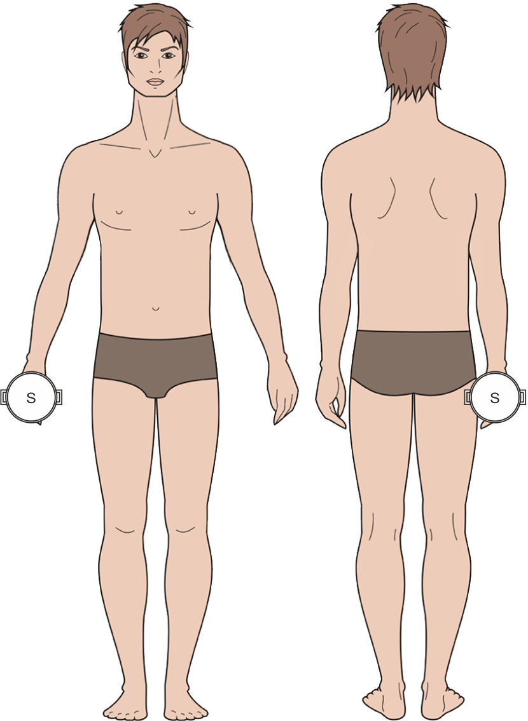
Joint contracture (Dupuytren`s contracture)
Fig. 49
The treatment course: 15-20 procedures. One procedure per day.
The emitter used: local emitter.
The emitters are placed against both sides of the affected hand bone with their “N” polarity surfaces to the body. See Fig. 49.
Setting of Program No.65:
- Magnetic field direction: static;
- Density: 35 mT;
- Frequency: 50 Hz;
- Procedure time: 20 min.

Rheumatoid arthritis (exudative stage)
The treatment course: 15-20 procedures.
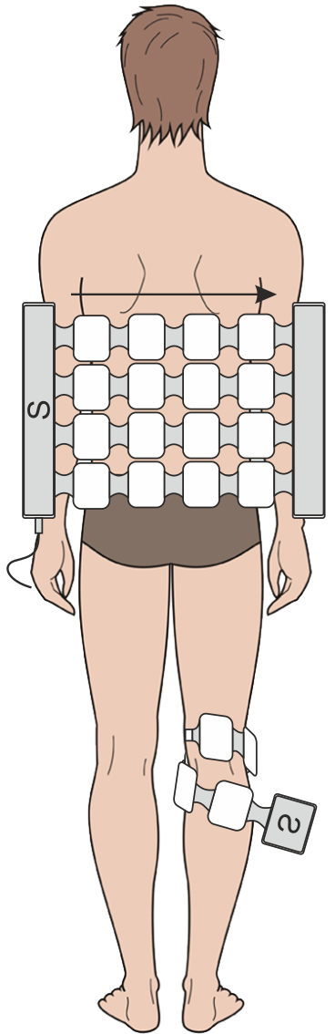
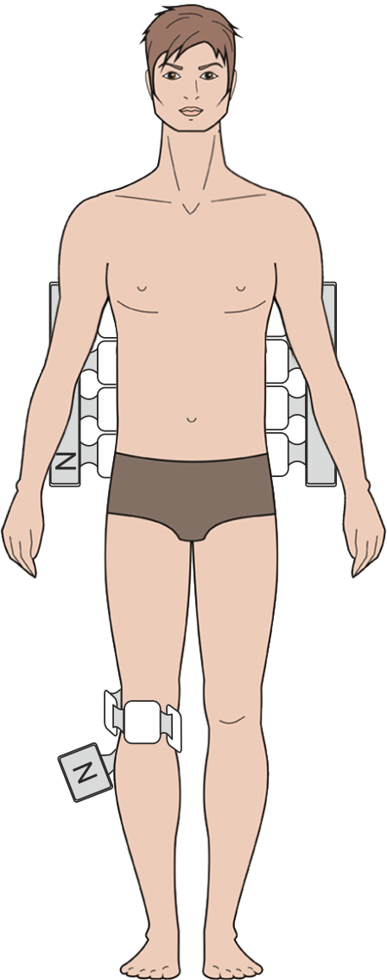
During the procedure, one or two joints at a time can be exposed (e.g. both knee joints).
Fig.50
The emitters used: main emitter and flexible emitting line.
Emitters’ arrangement: the main emitter is placed over the adrenal glands projection area, and the affected joint is wrapped with the flexible emitting line, with the emitters’ “N” polarity surfaces turned towards the bod. See Fig. 50.

Setting of Program No.36:
- The magnetic field direction in the main emitter: traveling clockwise, in the flexible emitting line: fixed;
- Density:
main emitter – 10 mT, flexible emitting line –
6 mT;
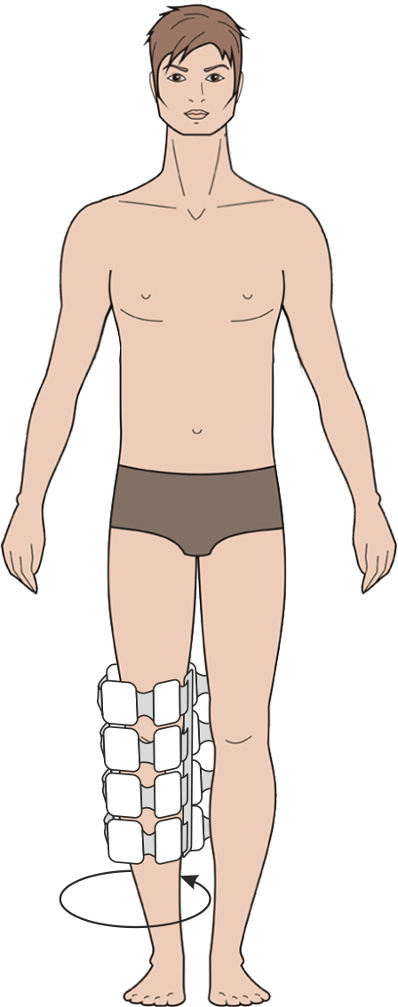
- Frequency:
main emitter – 100 Hz, flexible emitting line – 16 Hz;
Fig. 51
- Procedure time: 10min.

In case if there are more than 2 affected joints, the main emitter stays on the adrenal glands projection area, and the other affected joint is wrapped with flexible emitting line, with the emitters’ “N” polarity surface facing the body.

Setting of Program No.36:
- The magnetic field direction in the main emitter: traveling clockwise, in the flexible emitting line: fixed;
- Density: main emitter – 10 mT; flexible emitting line – 6 mT;
- Frequency: main emitter – 100 Hz, flexible emitting line – 16 Hz;
- Procedure time: 10 min.

Osteoarthritis
The treatment course length – 15 procedures.
The emitter used: main emitter.
For severe cases and synovitis
The affected joint is wrapped with the main emitter, with its “N” polarity surface facing the body. See Fig. 51.

Setting of Program No.37:
- The magnetic field direction in the main emitter: traveling clockwise;
- Density: 10 mT;
- Frequency: 100 Hz;
- Procedure time: 10 min.

Without synovitis
The treatment course length – 15 procedures.
The emitter used: main emitter.
The affected joint is wrapped with the main emitter, with its “N” polarity surface facing the body. See Fig. 51.

Setting of Program No.38:
- The magnetic field direction in the main emitter: traveling clockwise;
- Density: 25 mT;
- Frequency: 10 Hz;
- Procedure time: 15 min.

Vertebral osteochondrosis (degenerative disk disorder)
The treatment course: 12-15 procedures.
The emitter used: main emitter.
The main emitter is placed over the affected vertebral area, with its “N” polarity surface facing the body. See Fig. 52.

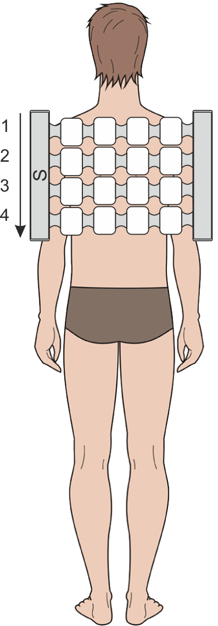
The first 3 procedures:
Fig. 52
Setting of Program No.39:
- The magnetic field direction in the main emitter: traveling top - down;
- Density: 10 mT;
- Frequency: 3 Hz;
- Procedure time: 20 min.

Procedure 4 up to the treatment course end:
Setting of Program No.40:
- The magnetic field direction in the main emitter: traveling top - down;
- Density: 15 mT;
- Frequency: 10 Hz;
- Procedure time: 20 min.

Posterior cervical sympathetic syndrome
Clinical symptoms of the disease: a burning, constrictive pain in the back of the head, neck, front chest wall, shoulder, or interscapular area. The syndrome is likely to develop on the background of cervical osteochondrosis.
The treatment course: 15 procedures. One procedure per day.
The emitter used: main emitter.
The main emitter is placed over the cervicothoracic area of the spinal column, with its “N” polarity surface facing the body. See Fig. 53a.

Setting of Program No.41:
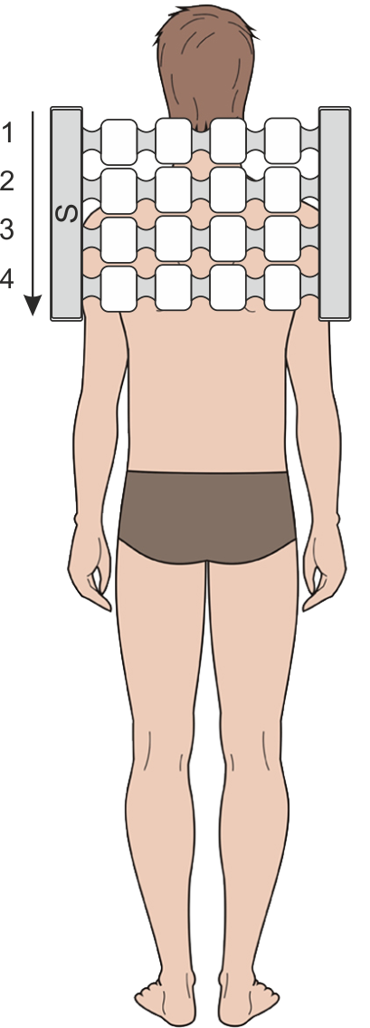
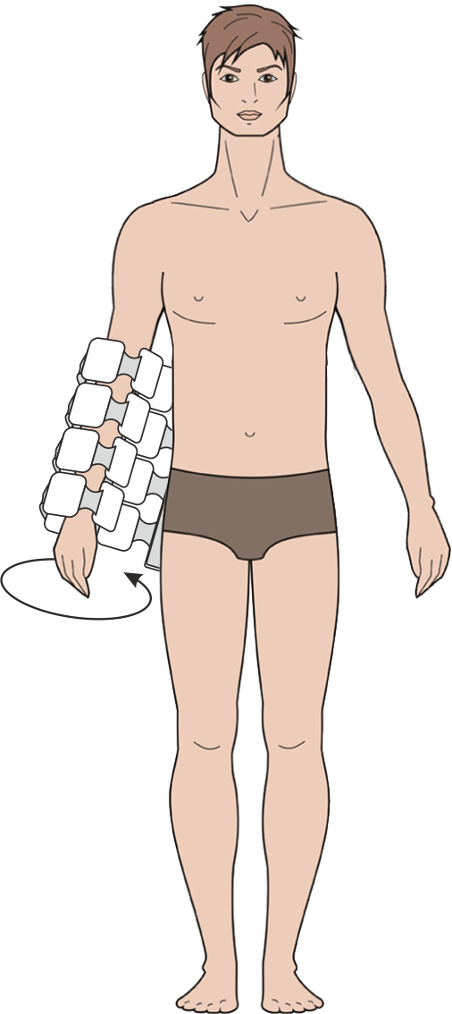
- The magnetic field direction in the main emitter: traveling top - down;
Fig. 53a
Fig. 53b
- Density: 2 mT;
- Frequency: 100 Hz;
- Procedure time: 10 min.

After the procedure end (without unplugging the device), the main emitter is wrapped around the diseased limb, with its 'N” polarity surface facing the body. See Fig. 53b.

Setting of Program No.42:
- The magnetic field direction in the main emitter: traveling clockwise;
- Density: 20 mT;
- Frequency: 100 Hz;
- Procedure time: 10 min.

Vertebrobasilar syndrome (reflex compressive syndrome of the vertebral artery)
It is a widespread combination of cerebral and autonomic irritable symptoms occurring during stimulation of the sympathetic plexus of the vertebral artery, deformation of its wall or change in its lumen (herniated disc, spondylitis deformans, tension of neck muscles during muscular tonic syndromes, etc.). Typically manifested by stabbing, shooting, throbbing, burning pains in the cervico-occipital area spreading to the parietal (top of the head), postaural (behind the ears), temporal and fronto-occipital regions, often occurring when turning the head or as a result of its uncomfortable position during sleep. The following symptoms may also be present: ear buzzing, ringing, stuffiness, or a combination of pain with the signs of vertebrobasilar insufficiency (dizziness, staggering while walking, a sudden sensation of motion sickness while in transport).
The treatment course: 15 procedures. One procedure per day. A repeated course to be taken in 1.5 - 2 months.
The emitters used: main emitter, flexible emitting line.

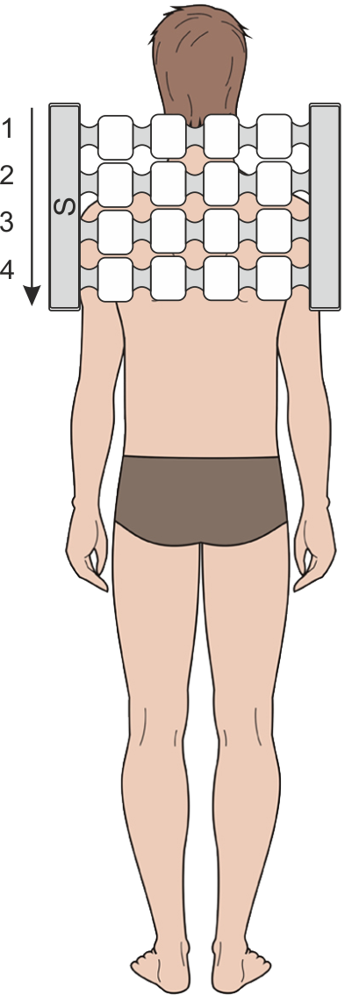
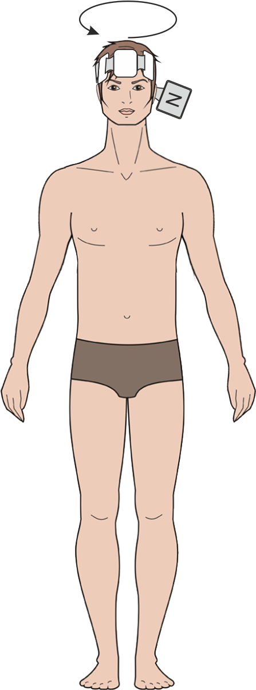
The first 5 procedures:
Fig. 54a
Fig. 54b
At first, the main emitter is placed over the cervicothoracic area of the spinal column, with its “N” polarity surface facing the body. See Fig. 54a.
Setting of Program No.43:
- The magnetic field direction in the main emitter: traveling top - down;
- Density: 10 mT;
- Frequency: 100 Hz;
- Procedure time: 20 min.
After the procedure is over (without unplugging the device), the head is wrapped with the flexible emitting line, with its “N” polarity surface turned to the body. See Fig. 54b.

Setting of Program No.44:
- The magnetic field direction in the flexible emitting line: traveling clockwise;
- Density: 10 mT;
- Frequency: 12 Hz;
- Procedure time: 10 min.

Procedure 6 up to the treatment course end:
At first, the main emitter is placed over the cervicothoracic region of the spinal column, with its “N” polarity side turned towards the body. See Fig. 54a.

Setting of Program No.45:
- The magnetic field direction in the main emitter: traveling top - down;
- Density: 25 mT;
- Frequency: 10 Hz;
- Procedure time: 20 min.

After the procedure end (without unplugging the device), the head is wrapped with the flexible emitting line, with its “N” polarity surface facing the body. See Fig. 54b.

Setting of Program No.46:
- The magnetic field direction in the flexible emitting line: traveling clockwise;
- Density: 15 mT;
- Frequency: 12 Hz;
- Procedure time: 10 min.

Vertebrogenic myelopathy syndrome
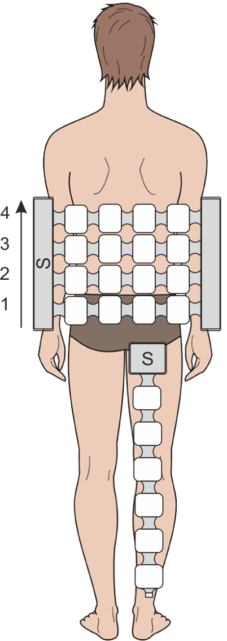
The syndrome implies weakness and numbness in the lower limb(s) on the background of lumbar degenerative disc disease, atrophy (usually unilateral) of lower leg muscles, prancing gait ("foot dropping"), trophic disorders, active incontinence of urine, occasional intermittent claudication (jitter legs).
Fig. 55

The treatment course: 15 procedures. One procedure per day. A repeated course is taken in 1.5 - 2 months’ period.
The emitters used: main emitter, flexible emitting line.
Emitters’ arrangement: the main emitter is placed over the lumbosacral area of the spinal column, and the flexible emitting line is spread along the thigh bone and lower leg, with the emitters’ “N” polarity surfaces facing the body. See Fig. 55.

Setting of Program No.47:
- The magnetic field direction in the main emitter: traveling bottom - up, in the flexible emitting line – traveling;
- Density: 20 mT;
- Frequency: 100 Hz;
- Procedure time: 15 min.

In case of paresis:
The course length – 15 procedures. One procedure per day. A repeated course is taken in 1.5 - 2 months.
The emitters used: main emitter.
At first, the emitter is placed on a couch or bed with its “N” polarity surface upward, and the patient lies down with the lumbosacral area of his/her spinal column over the emitter (the pulse generation unit can be placed at any side of the body). See Fig. 56a.

Setting of Program No.10:
- The magnetic field direction in the main emitter: static;
- Density: 6 mT;
- Frequency: 16 Hz;
- Procedure time: 15 min.

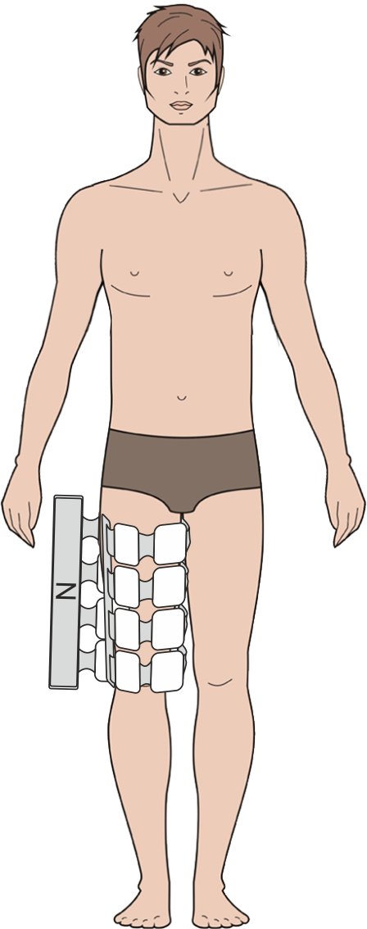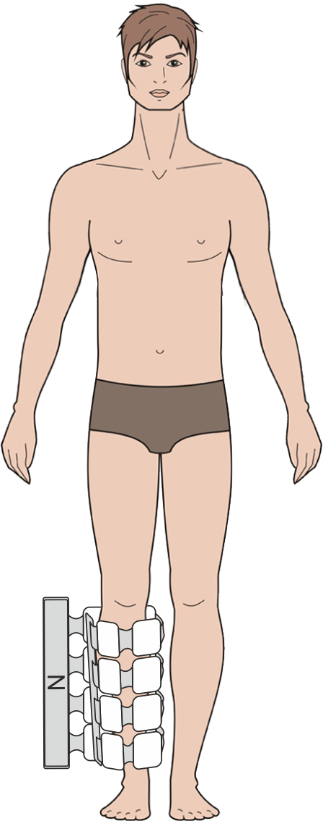
Fig.56a
Fig. 56b
Fig. 56c

After the procedure is over (without unplugging the device), the main emitter is wrapped around the thigh bone of the affected limb, with its “N” polarity surface facing the body. See Fig. 56b.

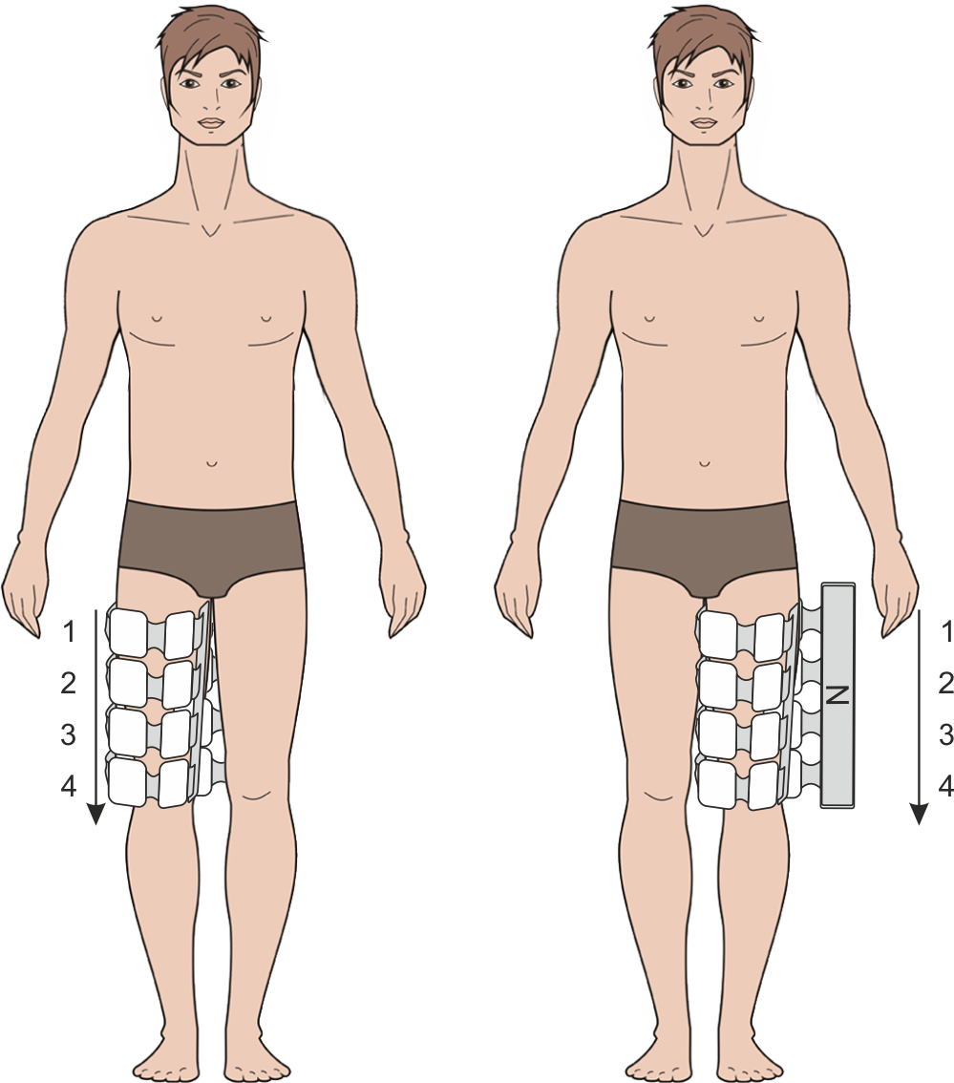
Setting of Program No.10:
Fig. 57
- The magnetic field direction in the main emitter: static;
- Density: 6 mT;
- Frequency: 16 Hz;
- Procedure time: 15 min.

After the exposure termination (without unplugging the device), the main emitter is wrapped around the lower leg part of the affected limb, with its “N” polarity surface facing the body. See Fig. 56c.

Setting of Program No.10:
- The magnetic field direction in the main emitter: static;
- Density: 6 mT;
- Frequency: 16 Hz;
- Procedure time: 15 min.

Osteoporosis with and without pathologic fracture
The treatment course: 15 procedures. One procedure per day. A repeated course is taken in 1.5 - 2 months’ period.
The emitter used: main emitter.
The main emitter is wrapped around the affected limb with the “N” polarity side turned towards the body. See Fig. 57.

Setting of Program No.48:
- The magnetic field direction in the main emitter: traveling top - down;
- Density: 10 mT;
- Frequency: 8 Hz;
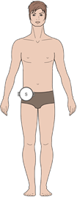
- Procedure time: 20 min.
Fig. 58

Traumas

Wounds (after surgical debridement)
The treatment course: 15 - 20 procedures. One procedure per day.
The emitter used: local emitter.
The emitter is placed onto the wound (over the bandage) with its “N” polarity surface facing the body. See Fig. 58.

Setting of Program No.68:
- The magnetic field direction: static;
- Density: 20 mT;
- Frequency: 50 Hz;
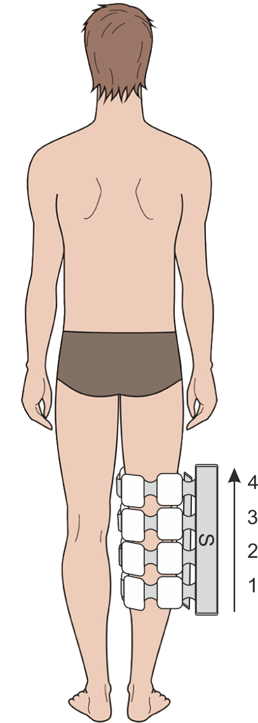
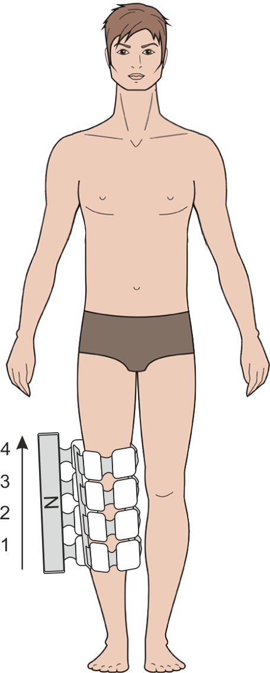
- Procedure time: 20 min.
Fig. 59

Bursitis (including the post-operative condition, starting from the third day after surgery)
The treatment course: 10 - 15 procedures. One procedure per day.
The emitter used: main emitter.
An injured joint is wrapped with the main emitter, with its “N” polarity surface turned towards the body. Fig. 59.

Setting of Program No.18:
- The magnetic field direction in the main emitter: traveling bottom - up;
- Density: 20 mT;
- Frequency: 100 Hz;
- Procedure duration: 10 min.

General treatment procedure for traumas (contusion, joint dislocation)
The treatment course: 10 procedures. One procedure per day.
The emitter used: main emitter.
Fig. 60
An injured joint is wrapped with the main emitter, with its “N” polarity surface turned towards the body. See Fig. 60.

Setting of Program No.50:
- The magnetic field direction in main emitter: traveling bottom - up;
- Density: 20 mT;
- Frequency: 100 Hz;
- Procedure time: 20 min.

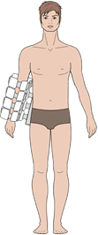
Elbow and forearm traumas:
Fig. 61
Dislocation, sprain or strain of the capsular ligamentous apparatus of the elbow joint
Dislocation of head of radius
Traumatic rupture of the radial collateral ligament

Magneto-therapy is to be started on the 3rd-5th day after trauma occurrence.
Treatment course length – 10 procedures. One procedure per day.
The emitter used: main emitter.
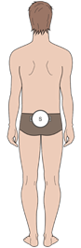
The injured joint is wrapped with main emitter, with its “N” polarity surface facing the body. See Fig. 61.
Fig. 62

Setting of Program No.23:
- The magnetic field direction in the main emitter: static;
- Density: 6 mT;
- Frequency: 16 Hz.
- Exposure time: 30 min.

Coccygeal (tailbone), hip joint area and thigh traumas:
Traumatic coccyalgia
The treatment course: 10 - 15 procedures. One procedure per day.
The emitter used: local emitter.
The emitter is placed over the pelvic area with the “N” polarity towards the body. See Fig. 62.

Setting of Program No.65:
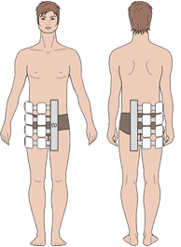
- The magnetic field direction: static;
Fig. 63
- Density: 35 mТ;
- Frequency: 50 Hz;
- Procedure time: 20 min.

Hip joint contusion
Treatment course length – 10 - 15 procedures. One procedure per day.
The emitter used: main emitter.
The main emitter is placed over the affected hip joint, with the “N” polarity surface towards the body. See Fig. 63.

Setting of Program No.23:
- The magnetic field direction: fixed;
- Density: 6 mТ;
- Frequency: 16 Hz;
- Procedure time: 30 min.
Fig. 64
Thigh contusion
The treatment course: 10 - 15 procedures. One procedure per day.
The emitter used: main emitter.
The injured thigh is wrapped with the main emitter, with its “N” polarity surface facing the body. See Fig. 64.

Setting of Program No.23:
- The magnetic field direction in the main emitter: fixed;
- Density: 6 mТ;
Fig. 65
- Frequency: 16 Hz;
- Procedure time: 30 min.

Knee and lower leg traumas
Contusion of another clarified or non-clarified part of lower leg
Multiple superficial traumas of the lower leg

The treatment course: 10 - 15 procedures. One procedure per day.
The emitter used: main emitter.
The injured lower leg is wrapped with the main emitter, with its “N” polarity surface towards the body. See Fig. 65.

Setting of Program No.23:
- The magnetic field direction in the main emitter: static;
- Density: 6 mТ;
- Frequency: 16 Hz;
- Procedure time: 30 min.
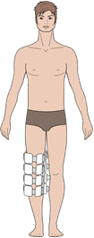
Fig.66
Dislocation of knee
The magneto-therapy can be started on the 3rd-5th day after trauma.
The treatment course: 10 - 15 procedures. One procedure per day.
The emitter used: main emitter.
The Injured knee is wrapped with the main emitter, with its “N’ polarity surface towards the body. See Fig. 66.

Setting of Program No.23:
- The magnetic field direction: static;
- Density: 6 mТ;
- Frequency: 16 Hz;
- Procedure time: 30 min.
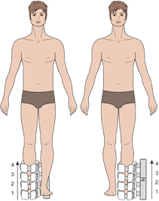
Fig. 67
Ankle joint and foot area traumas
Sprain and strain of ankle joint ligaments (72 hours after trauma)
The treatment course: 10 procedures. One procedure per day.
The emitter used: main emitter.
The injured joint is wrapped with the main emitter, with its “N” polarity side towards the body. The pulse generation unit is placed on the right from the limb. See Fig. 67.

Setting of Program No.50:
- The magnetic field direction in the main emitter: traveling bottom -up;
- Density: 20 mТ;
- Frequency: 100 Hz;
- Procedure time: 20 min.

Ankle joint contusion
Treatment course length – 10 - 15 procedures.
The emitter used: main emitter.
The injured ankle joint is wrapped with the main emitter, with its “N” polarity surface facing the body. See Fig. 68.

Setting of Program No.23:
- The magnetic field direction: static;
- Density: 6 mТ;
- Frequency: 16 Hz;
- Procedure time: 30 min.

Toe contusion without nail bed injury
Toe contusion with nail bed injury
The treatment course: 10 - 15 procedures. One procedure per day.
The emitter used: main emitter.
The injured foot is wrapped with the main emitter, with its “N” polarity surface facing the body. See Fig. 68.

Setting of Program No.23:
- The magnetic field direction in main emitter: static;
- Density: 6 mТ;
- Frequency: 16 Hz;
- Procedure time: 30 min.

Multiple superficial traumas of ankle joint and foot
Ankle joint dislocation
The treatment course: 10 - 15 procedures. One procedure per day.
The emitter used: main emitter.
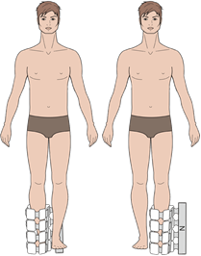
The injured ankle and foot joints are wrapped with the main emitter, with its “N” polarity surface facing the body. See Fig. 68.
Fig. 68

Setting of Program No.23:
- The magnetic field direction in the main emitter: static;
- Density: 6 mТ;
- Frequency: 16 Hz;
- Procedure time: 30 min.

Ligament rupture at the level of ankle joints and foot
Magneto-therapy is to be started after immobilization by means of a plaster bandage.
Treatment course length – 10 - 15 procedures. One procedure per day.
The emitter used: main emitter.
The injured lower leg, ankle joint and foot are wrapped with the main emitter, with its “N” polarity surface facing the body. See Fig. 68.

Setting of Program No.23:
- The magnetic field direction: static;
- Density: 6 mТ;
- Frequency: 16 Hz;
- Procedure time: 30 min.

Sprain and strain of ankle joint ligaments
The treatment course: 10 - 15 procedures. One procedure per day.
The emitter used: main emitter.
The Injured foot is wrapped with the main emitter, with its “N” polarity surface facing the body. See Fig. 68.

Setting of Program No.23:
- The magnetic field direction in the main emitter: static;
- Density: 6 mТ;
- Frequency: 16 Hz;
- Procedure time: 30 min.

Nerve traumas at the level of ankle joint and foot
External lateral plantar nerve trauma
Internal medial plantar nerve trauma
Treatment course length – 10 - 15 procedures. One procedure per day.
The emitter used: main emitter.
The injured ankle joint and foot are wrapped with the main emitter, its “N” polarity surface facing the body. See Fig. 68.

Setting of Program No.23:
- The magnetic field direction: static;
- Density: 6 mТ;
- Frequency: 16 Hz;
- Procedure time: 30 min.

Deep fibular nerve trauma at the level of ankle joint and foot
Trauma of multiple nerves at the level of ankle joint and foot
Trauma of toe muscle long extensor and its tendon at the level of ankle joint and foot
Treatment course length – 10 - 15 procedures. One procedure per day.
The emitter used: main emitter.
The injured lower leg, ankle joint and foot are wrapped with the main emitter, its “N” polarity surface facing the body. See Fig. 68.

Setting of Program No.23:
- The magnetic field direction: static;
- Density: 6 mТ;
- Frequency: 16 Hz;
- Procedure time: 30 min.

Trauma of multiple muscles and tendons at the level of ankle joint and foot
Other muscles and tendons’ trauma at the level of ankle joint and foot
The treatment course: 10 - 15 procedures. One procedure per day.
The emitter used: main emitter.
The injured lower leg, ankle joint and foot are wrapped with the main emitter, with its “N” polarity side turned towards the body. See Fig. 68.
Fig. 69
Setting of Program No.23:
- The magnetic field direction in the main emitter: static;
- Density: 6 mТ;
- Frequency: 16 Hz;
- Procedure time: 30 min.

Nerve traumas at the level of forearm
Ulnar nerve trauma at the level of forearm
Magneto-therapy is to be started from the 2nd-3rd day after trauma.
The treatment course: 10 - 15 procedures. One procedure per day.
The emitter used: main emitter.
The injured elbow joint and forearm are wrapped with the main emitter, its “N” polarity surface facing the body. See Fig. 69.

Setting of Program No.23:
- The magnetic field direction in the main emitter: static;
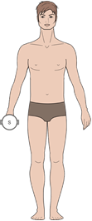
- Density: 6 mТ;
Fig. 70
- Frequency: 16 Hz;
- Procedure time: 30 min.

Wrist and hand traumas
Finger contusion without nail bed injury
Finger contusion with nail bed injury
The treatment course: 10 - 15 procedures.
The emitter used: local emitter.
Fig. 71
The emitter is placed directly over the trauma area or over the edematous area of the injured limb (the injured hand is placed between the two local emitters), with the “N” polarity surfaces turned towards the body. See Fig. 70.

Setting of Program No.79:
- The magnetic field direction in the local emitters: static;
- Density: 6 mТ;
- Frequency: 16 Hz;
- Procedure time: 30 min.

Traumas involving several body regions
Multiple surface traumas of upper limbs
Multiple surface traumas of lower limbs
Treatment course length – 10 - 15 procedures. One procedure per day.
The emitter used: main emitter.
The injured limb is wrapped with the main emitter, its “N” polarity surface facing the body. See Fig. 71.
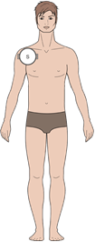
Fig. 72
Setting of Program No.23:
- The magnetic field direction: static;
- Density: 6 mТ;
- Frequency: 16 Hz;
- Procedure time: 30 min.

Posttraumatic hematoma (2-3 days after trauma)
The treatment course: 10 - 15 procedures. One procedure per day.
The emitter used: local emitter.
The local emitter is placed over the hematoma area with its “N” polarity surface turned to the body. See Fig. 72.

Setting of Program No.79:
- The magnetic field direction in the local emitter: static;
- Density: 6 mТ;
- Frequency: 16 Hz;
- Procedure time: 30 min.

- MAINTENANCE SERVICE
Maintenance of the ALMAG-02 device includes repairs, routine inspection, cleaning from dust and dirt, disinfection, and periodic control of its operability.
The periodic control of the device operability is to be carried out at least once a year. For this purpose, do the following:
- connect the emitters to the device and arrange them in a way to provide easy access to all the individual emitters;
- plug the device into the mains and press the “POWER” switch to activate it;
- select an exposure program which involves action of the main emitter and the flexible emitting line (preference is to be given to a program with the maximal parameters of field density and pulse repetition frequency, e.g. Program No 47);
- activate the magneto-action;
- check the presence of magnetic field in each of the activated emitters with the help of the magnetic field indicator;
- stop the action;
- select an exposure program which involves action of the local emitter (with the maximal parameters of field density and pulse repetition frequency);
- activate the magneto-action;
- check the presence of magnetic field in each of the activated emitters with the help of the magnetic field indicator;
- stop the action;
- press the “POWER” switch to deactivate the device and unplug it from the mains.
Routine inspection is to be performed at least once every three months. During the inspection, it is necessary to check the integrity of the cables, plug, mains cord, the emitters, and the control unit housing.
Disinfection is to be carried out as may be necessary.

The device is provided with the function of self-diagnostics: in case of a malfunction, the exposure stops, and an error code is indicated on the display, accompanied by a sound signal. The list of malfunctions and troubleshooting methods are given in Table 1.
Table 1
Visual and audible indication of a malfunction | Possible cause | Troubleshooting method
1. An alarm sound signal is generated and an "E1" code is displayed | - There is a bad contact in the main emitter’s connector.  - Beak in the connecting cable. | - Switch the device off. Check the connector fixation.  Switch the device on.  - Contact the service office.
2. An alarm sound signal is generated and an "E2" code is displayed | - There is a bad contact in the connectors of the flexible emitting line or local emitter.  - Beak in the connecting cable. | - Switch the device off. Check the connector fixation.  Switch the device on.  - Contact the service office.
3. An alarm sound signal is generated and an "E3" code is displayed | - Malfunction of the main emitter. | - Contact the service office.
4. An alarm sound signal is generated and an "E4" code is displayed | - Malfunction of the flexible emitting line or local emitter. | - Contact the service office.
5. An alarm sound signal is generated and an "E5" code is displayed | - The emitter required for the preset procedure is missing. | - Switch the device off. Correct the connection of the required emitter. Switch the device on.

- STORAGE AND TRANSPORTATION
The device endures storage in a non-heated storage room with air temperature from -50 °С to +40 °С with relative air humidity of up to 98%.
The device can be transported by all covered vehicles according to the rules of carriage at an ambient temperature from -50 °С to +50 °С and relative air humidity of up to 98%.

- GUIDANCE and manufacturer’s declaration –

electromagnetic emissions and immunity
Medical electrical equipment needs special precautions regarding EMC and needs to be installed and put into service according to EMC information provided in this document.

Guidance and manufacturer’s declaration — electromagnetic emissions
These devices are intended for use in the electromagnetic environment specified below. The customer or the user of the device should assure that the device is used in such an environment.
Emissions test | Compliance | Electromagnetic environment—guidance
RF emissions CISPR 11 | Group 1 | The device uses RF energy only for its internal function. Therefore, its RF emissions are very low and are not likely to cause any interference in nearby electronic equipment.
RF emissions CISPR 11 | Class B | The device is suitable for use in all establishments, including domestic establishments and those directly connected to the public low-voltage network that supplies buildings used for domestic purposes.
Harmonic  Emissions  IEC 61000-3-2 | Class A
Voltage Fluctuations/Flicker Emissions  IEC 61000-3-3 | Complies

WARNING
• The device should not be used adjacent to or stacked with other equipment. If adjacent or stacked use is necessary, the device should be observed to verify normal operation in the configuration in which it will be used.
• The use of accessories other than those specified for the device is not recommended. They may result in increased emissions or decreased immunity of the device.

Guidance and manufacturer’s declaration – electromagnetic immunity
These devices are intended for use in the electromagnetic environment specified below. The customer or the user of the device should assure that the device is used in such an n environment.
Immunity test |  | IEC60601-1-2 test level |  | Compliance level | Electromagnetic environment –guidance
Electrostatic discharge (ESD) IEC 61000-4-2 |  | ±6 kV contact  ±8 kV air |  | ±6 kV contact  ±8 kV air | Floors should be wood, concrete or ceramic tile. If floors are covered with synthetic material, the relative humidity should be at least 30%.
Electrical fast  transient/burst  IEC 61000-4-4 |  | ±2 kV for power supply lines  ±1 kV for input/output lines |  | Complies | Mains power quality should be that of a typical commercial or hospital environment.
Surge  IEC 61000-4- |  | ±1 kV differential mode  ±2 kV common mode |  | Complies | Mains power quality should be that of a typical commercial or hospital environment.
Voltage dips,  Short interruptions and voltage  variations on power supply input lines  IEC 61000-4-11 |  | <5% Ut (>95% dip in Ut) for 0.5 cycle  40% Ut (60% dip in Ut) for 5 cycles  70% Ut (30% dip in Ut) for 25 cycles  <5% Ut (>95% dip in Ut) for 5 sec |  | Complies | Mains power quality should be that of a typical commercial or hospital environment.  If the user of the device requires continued operation during power mains interruptions, it is recommended that the device be powered from an uninterruptible power source.
Power frequency  (50/60 Hz)  magnetic field  IEC  61000-4-8 |  | 3 А/м |  | Complies | Power frequency magnetic fields should be at levels characteristic of a typical location in a typical commercial or hospital environment.
Conducted RF  IEC 61000-4-6 |  | 3 Vrms  150 kHz to 80 MHz |  | Complies | Portable and mobile RF communications equipment should be used no closer to any part of the device, including cables, than the recommended  separation distance calculated from the equation applicable to the frequency of the transmitter.  Recommended separation distance:  d = 1.17 √P  d = 1.17 √P 80 MHz to 800 MHz  d = 2.33 √P 800 MHz to 2.5 GHz  where P is the maximum output power rating of the transmitter in watts (W) according to the transmitter manufacturer and d is the recommended separation distance in metres (m).  Field strengths from fixed RF transmitters, as determined by an electromagnetic site survey,  a should be less than the compliance level in each frequency range.  b Interference may occur in the vicinity of equipment marked with the following symbol  
Radiated RF  IEC 61000-4-3 |  | 3 V/m  80 MHz to 2.5 GHz |  | Complies
Note:
Ut is the AC mains voltage prior to application of the test level.
At 80 MHz and 800 MHz, the higher frequency range applies.
These guidelines may not apply in all situations. Electromagnetic propagation is affected by absorption and reflection from structures, objects and people.
a Field strengths from fixed transmitters, such as base stations for radio (cellular/cordless) telephones and land mobile radios, amateur radio, AM and FM radio broadcast and TV broadcast cannot be predicted theoretically with accuracy. To assess the electromagnetic environment due to fixed RF transmitters, an electromagnetic site survey should be considered. If the measured field strength in the location in which the device is used exceeds the applicable RF compliance level above, the device should be observed to verify normal operation. If abnormal performance is observed, additional measures may be necessary, such as reorienting or relocating the device.
b Over the frequency range 150 kHz to 80 MHz, field strengths should be less than 3 V/m.
Recommended separation distances between portable and mobile RF communications equipment and the device
The device is intended for use in an environment in which radiated RF disturbances are controlled. The customer or the user of the device can help prevent electromagnetic interference by maintaining a minimum distance between portable and mobile RF
communications equipment (transmitters) and the device as recommended below, according to the maximum output power of the communications equipment.
Rated maximum output power of transmitter (W) | Separation distance according to frequency  of transmitter (m)
 | 150 kHz to 80 MHz  d = 1.17 √P |  | 80 MHz to 800 MHz  d = 1.17 √P |  |  | 800 MHz to 2.5 GHz  d = 2.33 √P
0,01 | 0,12 |  | 0,12 |  |  | 0,23
0,1 | 0,38 |  | 0,38 |  |  | 0,73
1 | 1,2 |  | 1,2 |  |  | 2,3
10 | 3,8 |  | 3,8 |  |  | 7,3
100 | 12 |  | 12 |  |  | 23
For transmitters rated at a maximum output power not listed above, the recommended separation distance d in metres (m) can be determined using the equation applicable to the frequency of the transmitter, where P is the maximum output power rating of the transmitter in watts (W) according to the transmitter manufacturer.
Note:
• At 80 MHz and 800 MHz, the separation distance for the higher frequency range applies.
• These guidelines may not apply in all situations. Electromagnetic propagation is affected by absorption and reflection from structures, objects and people.

- ACCEPTANCE CERTIFICATE
ALMAG-02 magneto-therapy device, factory serial number _________ is manufactured and accepted in compliance with the technical specification GIKS.941519.104 TU and is hereby validated as ready-for-service.

Delivery option No. 1

Delivery option No. 2

Date of production ______________________
Seal
__________________________________
(signature of a person responsible for acceptance)

ALMAG-02 magneto-therapy device is packed in accordance with the requirements specified in the design documentation.

Date of packing ___________________
Seal
Packed by _______________

- MANUFACTURER'S WARRANTY
The Manufacturer hereby guarantees that the quality of the device conforms to the requirements of the Operating Manual (“Specifications” section), provided that the conditions of proper storage, transportation, and usage are met by the Customer.
Warranty period is 24 months from the date of sale.
Within the warranty period, the Manufacturer shall repair or replace the defective device or its parts at their own expense upon presentation of the warranty service coupon.
Warranty terms
The warranty is only valid if the Customer has a correctly filled-in warranty coupon, with the factory serial number, date of sale, and a vivid stamp of the seller.
The warranty does not cover the following cases:
- if the device bears traces of outside interference or repair attempts by non-authorized servicing companies;
- if unauthorized changes into the design or construction of the device have been detected;
- if the device has any mechanical damages;
- if the device has been damaged as a result of penetration of foreign objects, substances or liquids;
- if the device has been damaged as a result of connecting it to a power line that does not comply with the national standards.
The Manufacturer shall forward the electric circuit diagram, description, and other technical files upon request of the authorized servicing centers.
Please send a faulty device for repairs, together with the Operating Manual and an enclosed explanatory note, to the following address:

Yelatma Instrument Making Enterprise, JSC
25 Yanina St., Yelatma, Kasimov District, Ryazan Region
391351 Russia
Call us for any additional information on the device maintenance at:
+7 (495) 669-1044; +7 (49131) 2-09-60
E-mail: ved@elamed.com
Web: www.elamed.com

ENVIRONMENTAL RESPONSIBILITY
The external covers of ALMAG-02 are made of high-quality plastics and can be recycled and re-used as building materials. The electric and electronic components are to be disposed of separately in special facilities used for this purpose under the local law. Disposal of these components together with household waste is prohibited.
Proper disposal of a worked-out product helps prevent potential negative consequences for the environment and human health.
Exhibit А

Parameters and Features of the Preset Exposure Programs
Program No. | Emitters used |  |  | Type of field and scan | Field density amplitude,  mT | Pulse repetition frequency, pulses / sec | Total exposure time,  min
Program No. | Main | Flexible emitting line | Target (local)
1 | 2 | 3 | 4 | 5 | 6 | 7 | 8
1 | + | + |  | travelling horizontal  travelling | 8  8 | 3  3 | 10
2 | + | + |  | travelling horizontal  travelling | 10  10 | 10  10 | 20
3 |  | + |  | travelling | 10 | 12 | 10
4 | + | + |  | travelling horizontal  travelling | 20  10 | 100  100 | 20
5 | + | + |  | travelling horizontal  travelling | 10  20 | 100  100 | 10
6 | + | + |  | travelling horizontal  travelling | 10  25 | 12  12 | 10
7 | + | + |  | static | 6 | 10 | 20
8 | + | + |  | travelling horizontal  static | 20  6 | 10  10 | 10
9 | + |  |  | travelling horizontal | 20 | 100 | 15
10 | + |  |  | static | 6 | 16 | 15
11 | + |  |  | static | 6 | 16 | 10
12 | + |  |  | travelling horizontal | 25 | 75 | 10
13 | + | + |  | travelling horizontal  travelling | 20  10 | 100  100 | 10
14 | + |  |  | travelling horizontal | 20 | 100 | 10
15 | + |  |  | static | 6 | 16 | 15
16 | + | + |  | travelling horizontal  travelling | 10  10 | 100  10 | 20
17 | + | + |  | travelling vertical  static | 20  6 | 10  16 | 10
18 | + |  |  | travelling horizontal | 20 | 100 | 10
19 | + |  |  | travelling horizontal | 20 | 50 | 15
20 | + |  |  | travelling vertical | 20 | 100 | 20
21 | + | + |  | travelling vertical  static | 20  6 | 100  16 | 30
1 | 2 | 3 | 4 | 5 | 6 | 7 | 8
22 | + |  |  | static | 6 | 3 | 30
23 | + |  |  | static | 6 | 16 | 30
24 | + |  |  | static | 6 | 16 | 20
25 | + |  |  | travelling horizontal | 25 | 75 | 15
26 | + | + |  | travelling vertical  travelling | 2  2 | 5  5 | 8
27 | + |  |  | travelling vertical | 15 | 100 | 15
28 | + |  |  | travelling vertical | 10 | 25 | 20
29 | + |  |  | travelling vertical | 10 | 100 | 15
30 | + |  |  | travelling vertical | 20 | 10 | 20
31 |  | + |  | travelling | 20 | 100 | 15
32 | + |  |  | travelling horizontal | 20 | 100 | 7
33 | + |  |  | travelling horizontal | 25 | 75 | 20
34 | + |  |  | travelling vertical | 15 | 100 | 15
35 | + |  |  | static | 6 | 16 | 20
36 | + | + |  | travelling vertical  static | 10  6 | 100  16 | 10
37 | + |  |  | travelling vertical | 10 | 100 | 10
38 | + |  |  | travelling vertical | 25 | 10 | 15
39 | + |  |  | travelling horizontal | 10 | 3 | 20
40 | + |  |  | travelling horizontal | 15 | 10 | 20
41 | + |  |  | travelling horizontal | 2 | 100 | 10
42 | + |  |  | travelling diagonal | 20 | 100 | 10
43 | + |  |  | travelling horizontal | 10 | 100 | 20
44 |  | + |  | travelling | 10 | 12 | 10
45 | + |  |  | travelling horizontal | 25 | 10 | 20
46 |  | + |  | travelling | 15 | 12 | 10
47 | + | + |  | travelling horizontal  travelling | 20  20 | 100  100 | 15
48 | + |  |  | travelling horizontal | 10 | 8 | 20
49 | + |  |  | travelling horizontal | 25 | 75 | 15
50 | + |  |  | travelling horizontal | 20 | 100 | 20
51 |  |  | + | static | 20 | 50 | 7
52 |  |  | + | static | 20 | 50 | 10
53 |  |  | + | static | 20 | 10 | 10
54 |  |  | + | static | 20 | 5 | 10
55 | + |  | + | static  static | 6  6 | 16  16 | 10
56 |  |  | + | static | 30 | 50 | 15
57 | + |  | + | travelling horizontal  static | 20  30 | 10  12 | 10
1 | 2 | 3 | 4 | 5 | 6 | 7 | 8
58 | + |  | + | travelling horizontal  static | 20  30 | 100  16 | 15
59 | + |  | + | travelling vertical  static | 20  35 | 100  50 | 15
60 | + |  | + | travelling vertical  static | 10  10 | 100  100 | 15
61 | + |  | + | travelling vertical  static | 10  10 | 10  10 | 15
62 |  |  | + | static | 10 | 45 | 15
63 |  |  | + | static | 30 | 100 | 15
64 |  |  | + | static | 35 | 50 | 12
65 |  |  | + | static | 35 | 50 | 20
66 | + |  | + | travelling horizontal  static | 10  20 | 100  50 | 10
67 | + |  | + | travelling horizontal  static | 20  20 | 100  50 | 10
68 |  |  | + | static | 20 | 50 | 20
69 |  |  | + | static | 10 | 100 | 10
70 |  |  | + | static | 15 | 10 | 20
71 |  |  | + | static | 8 | 100 | 15
72 |  |  | + | static | 15 | 10 | 20
73 | + |  | + | travelling horizontal  static | 20  30 | 100  10 | 15
74 |  |  | + | static | 35 | 50 | 15
75 |  |  | + | static | 20 | 50 | 15
76 |  |  | + | static | 30 | 10 | 20
77 | + |  | + | travelling horizontal  static | 15  25 | 100  50 | 20
78 | + |  | + | travelling horizontal  static | 25  20 | 100  50 | 20
79 |  |  | + | static | 6 | 16 | 30
Note: A continuous (uninterrupted) exposure mode is used for all programs.

Manufacturer’s Address: Yelatma Instrument Making Enterprise, JSC

25 Yaninа St., Yelatma, Kasimov District,

Ryazan Region, Russia 391351
Tel./fax: +7 (49131) 2-04-57

WARRANTY SERVICE COUPON
for repairs (replacement) within the warranty period
АLMAG-02 magneto-therapy device is manufactured and accepted in compliance with the technical specification GIKS.941519.104 TU

Delivery Option No.1 Delivery Option No.2

Date of production ________________ No._______________

Purchased by_______________________________________
(to be filled in by the trading company)

_____________________________________________

Put into operation _________________________________
(date, signature)
Accepted for after-sales servicing by repair provider _____________________________ Date _____________

City ___________________________________________

Released after repair ______________________________
(date, signature)

SEAL Signature of the repair provider manager
_______________________

Signature of the owner institution manager

________________________________________________

The warranty service coupon is to be sent to the Manufacturer’s address and serves as the billing basis for the repairs done within the warranty period.

Manufacturer’s Address: Yelatma Instrument Making Enterprise, JSC

25 Yaninа St., Yelatma, Kasimov District,

Ryazan Region, Russia 391351
Tel./fax: +7 (49131) 2-04-57

WARRANTY SERVICE COUPON
for repairs (replacement) within the warranty period
АLMAG-02 magneto-therapy device is manufactured and accepted in compliance with the technical specification GIKS.941519.104 TU

Delivery Option No.1 Delivery Option No.2

Date of production ________________ No._______________

Purchased by_______________________________________
(to be filled in by the trading company)

_____________________________________________

Put into operation _________________________________
(date, signature)
Accepted for after-sales servicing by repair provider _____________________________ Date _____________

City ___________________________________________

Released after repair ______________________________
(date, signature)

SEAL Signature of the repair provider manager
_______________________

Signature of the owner institution manager

________________________________________________

The warranty service coupon is to be sent to the Manufacturer’s address and serves as the billing basis for the repairs done within the warranty period.

