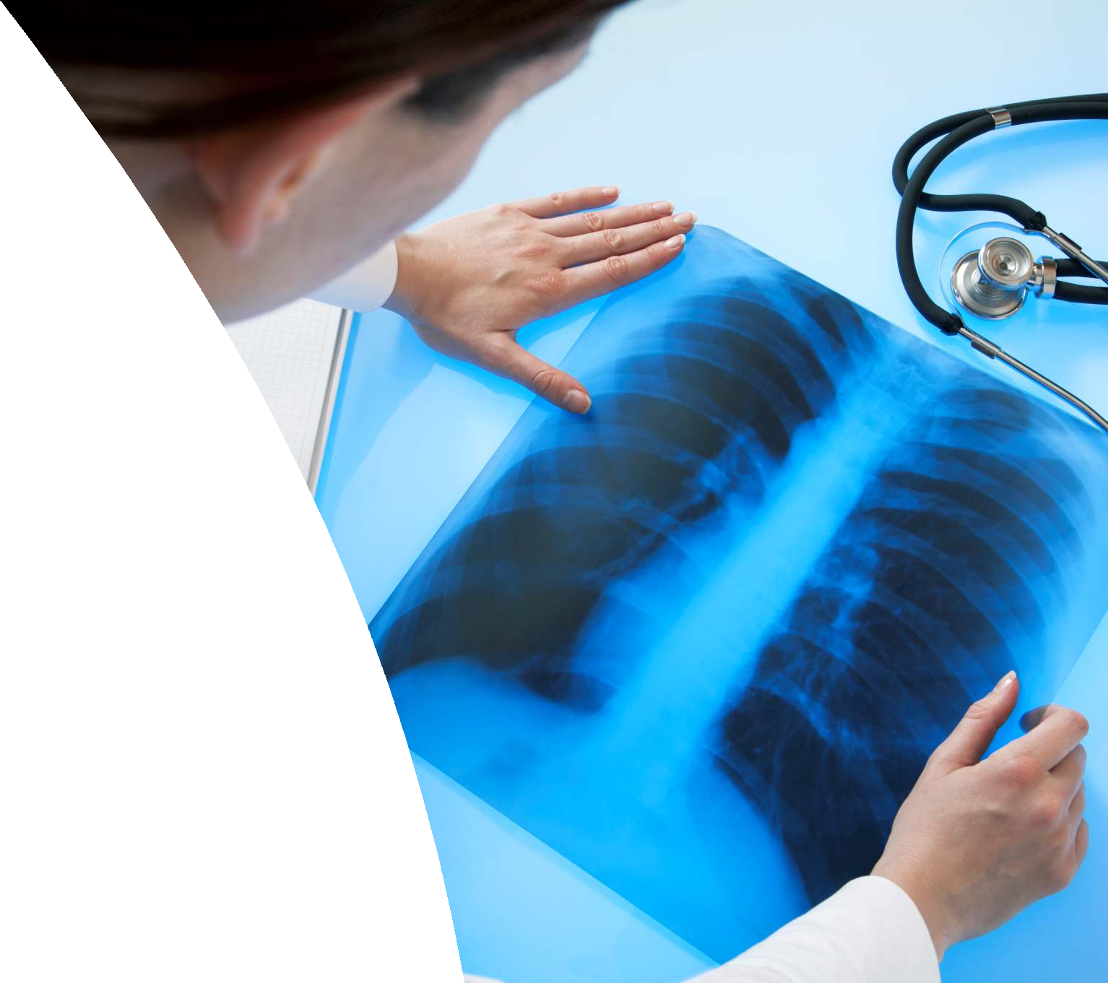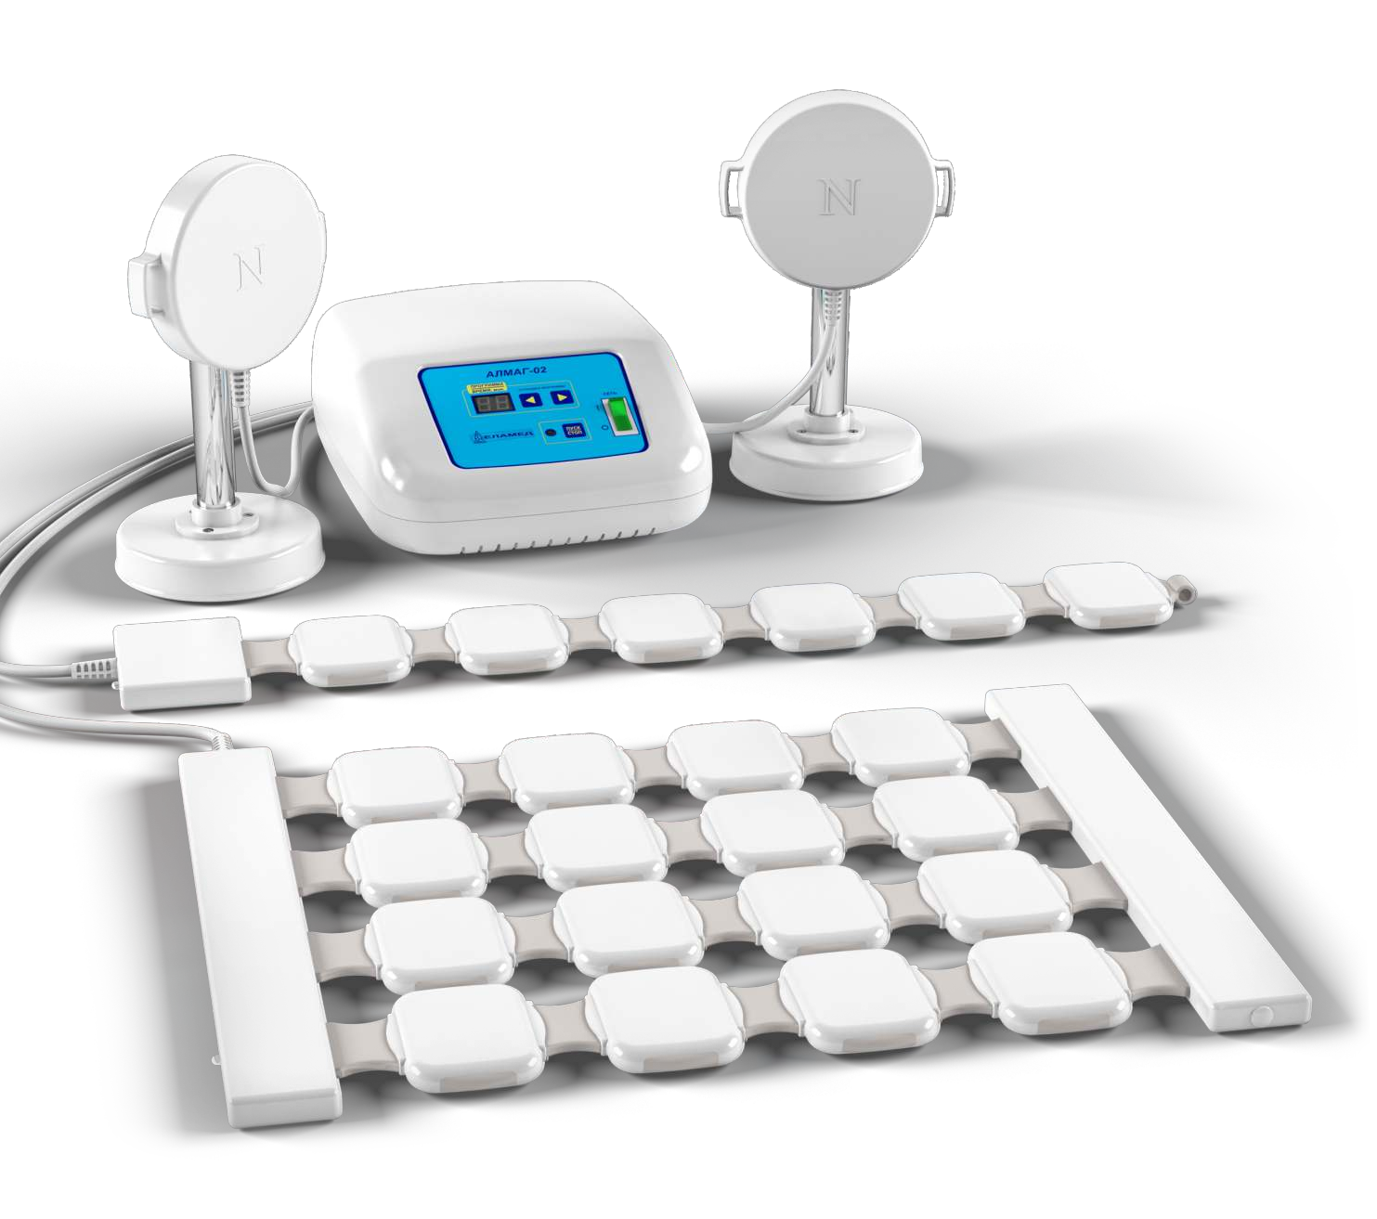

APPLICATION OF ALMAG-02 DEVICE
IN THE COMBINATION THERAPY OF THE DISEASES OF BRONCHOPULMONARY SYSTEM

Yelatma Instrument Making Enterprise, JSC TM ELAMED 2020

DEAR COLLEAGUES,
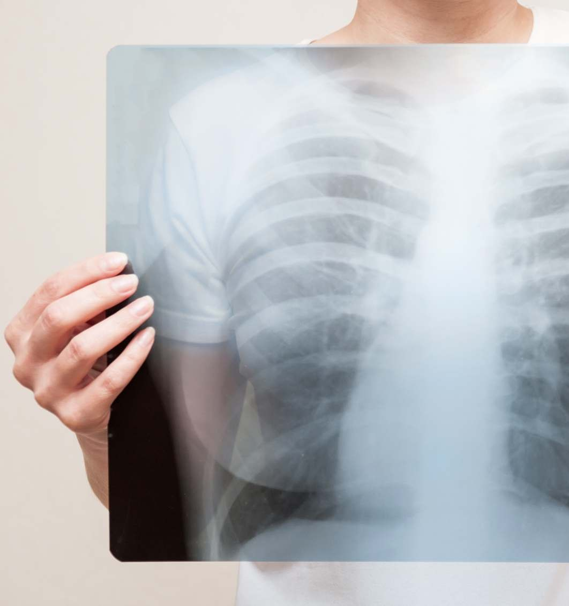
Diseases of the bronchopulmonary system occupy one of the leading places in the structure of disease incidence and annually affect up to 30 % of Russia’s population, increasing the level of disease incidence and mortality in the population.
Frequency of these diseases occurrence is growing, and it has multiple medical and social character adverse effects.
Medical institutions have a difficult task: under difficult conditions to render people timely and high-quality medical aid that is associated with the demand for human, financial, pharmaceutical, and technical resources.
It must be noted that all this proceeds in an unrealistically difficult situation of overloaded hospitals and lack of staff!

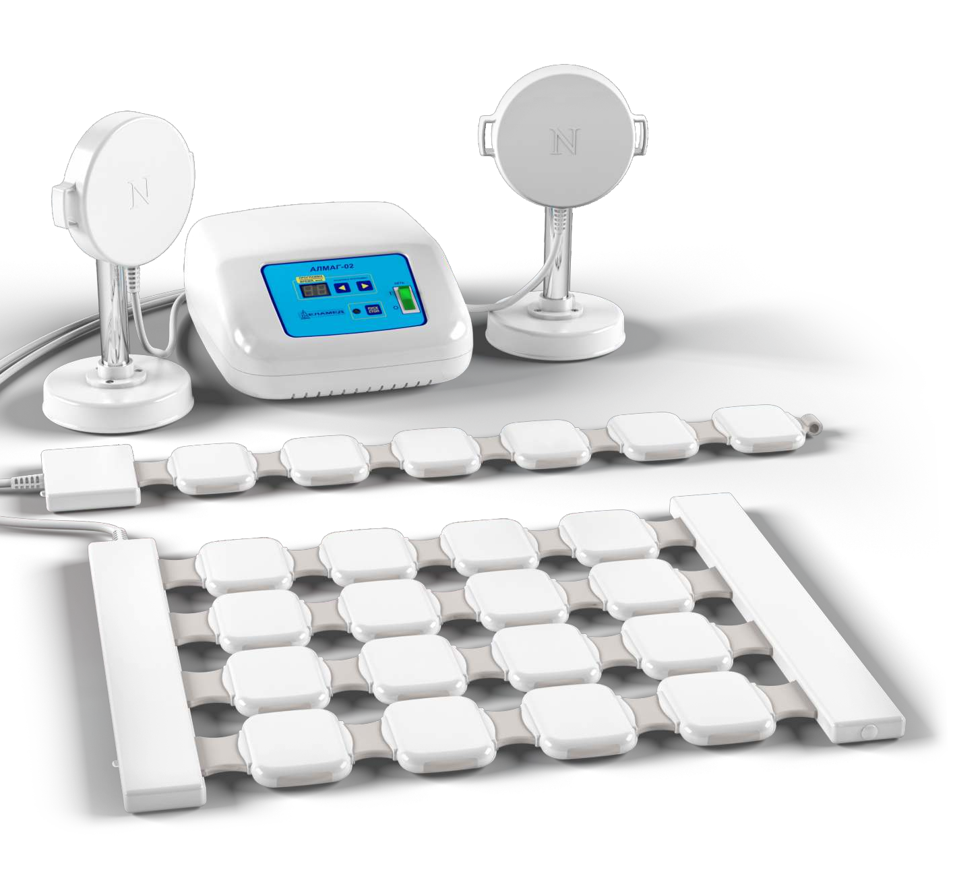In order to reduce the inpatient treatment period for patients with bronchopulmonary diseases and to facilitate the work of health professionals, we suggest you to include ALMAG-02 device, an affordable medical equipment with proven effectiveness, in therapeutic complex.

ALMAG-02 device was originally developed to organize physiotherapeutic treatment at medical and preventive treatment facilities that were not staffed with physiotherapists, as well as to avoid the heavy utilization of POLIMAG devices at multidisciplinary medical and preventive treatment facilities.
It is an economical and simplified version of POLIMAG. It is smaller in size, but its capabilities and proven efficiency are similar to the capabilities and efficiency of stationary equipment.
Owing to the possibility to carry out procedures directly in hospital wards, the treatment process becomes convenient and more efficient.

The device is intended for the therapy of acute and chronic diseases of various body systems, including the bronchopulmonary system, with the use of low frequency and low intensity magnetic field.

The mandatory participation of a specialist to operate ALMAG-02 is not required, so a medical professional may perform other activities during the treatment procedure.

The device is distinguished by its mobility, compactness, low weight and easy transportation to hospital wards and physicians’ offices.
ALMAG-02 is a linchpin between the simplicity of portable equipment and the efficiency of such medical equipment of stationary type as POLIMAG-02M!

Diseases of the respiratory system are a serious public health problem.

DISEASES OF THE RESPIRATORY SYSTEM ARE ONE OF CAREFULLY DEVELOPED AND WELL STUDIED SPECIALTIES OF THE DEVICE.

Indications for the use of ALMAG-02 device in diseases of the bronchopulmonary system:

џ Viral pneumonia
џ Bacterial pneumonia
џ Chronic bronchitis in non exacerbation state
џ Asthma and chronic obstructive pulmonary disease
џ Exudative pleurisy (three days after thoracocentesis, the removal of fluid from the pleural space)

Combination therapy, including means that activate the immune system, for example, magnetotherapy, is mandatory in severe pulmonary diseases.
The operation of the ALMAG-02 device is based on the therapeutic effect of a traveling pulsed magnetic field with anti-inflammatory, decongestant, and analgesic effects.

Adults and children shall be provided with service A17.30.019 (exposure to an alternating magnetic field) for the purpose of prevention, treatment and medical rehabilitation in accordance with Orders of the Ministry of Health of the Russian Federation No. 1213n and No. 1658n on the approval of the standard of specialized and primary health care for pneumonia.

Magnetotherapy increases the efficiency of drug delivery, and also has its own therapeutic effect in pulmonary diseases.

YELATMA INSTRUMENT MAKING ENTERPRISE, JSC

USEFUL CHARACTERISTICS OF ALMAG-02 DEVICE

In case of pneumonia ALMAG-02 device contributes to:
- improving blood circulation and gas exchange in the lungs;
- slowing down the reproduction of pathogenic microorganisms;
- enhancing the detoxification of the nidus of infection;
- activating immunity;
- relieving bronchospasm, reducing cough and improving expectoration;
- reducing the viscosity of secretions and removing them from the lungs;
- eliminating pulmonary spasm and inflamed tissues irritation;
- reducing medicamental load on the organism;
- reducing treatment time, accelerating patient’s rehabilitation;
- improving the patient’s general condition;
- accelerating recovery after inflammation;
- the final suppression of the inflammatory process;
- avoiding chronic lung problems, complications, disability.

Method has a proven high effect of application and is absolutely safe in case of observing the regulations concerning treatment and contraindications.
The device generates two types of pulsed magnetic fields that are the most effective for therapeutic purposes. They are traveling pulsed magnetic fields and steady pulsed magnetic fields.

79 treatment programs developed by the specialists of the Burdenko Main Military Clinical Hospital (Moscow) are stored in the internal storage of the device. It allows to employ an individual approach to the treatment of various diseases, disease stages and patient’s states.

An individual program is activated by pressing a single button, following which the device starts to work according to the program provided specifically for a given disease or its stage ensuring the maximum possible effect.

The light weight and increased wear resistance of the emitters allow the device to be operated as intensively as required under the conditions of increased disease incidence.

Small overall dimensions provide the possibility of treating bed patients directly in hospital wards, as well as introducing hospital-replacing technologies.

PRIMARY EMITTERS
stationary field

traveling horizontal
traveling vertical
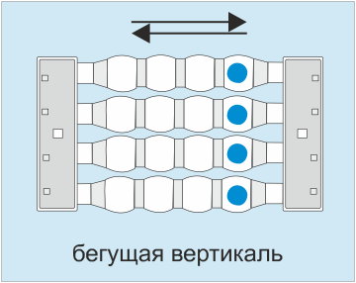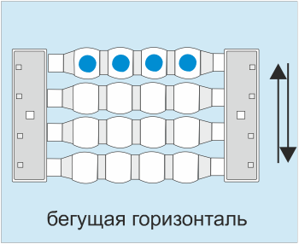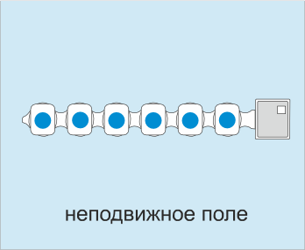traveling diagonal

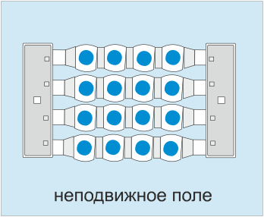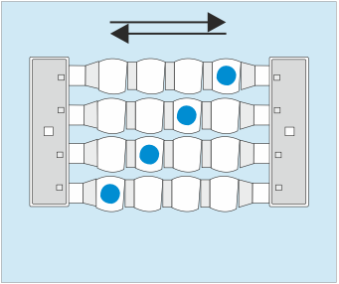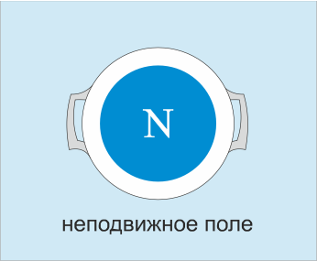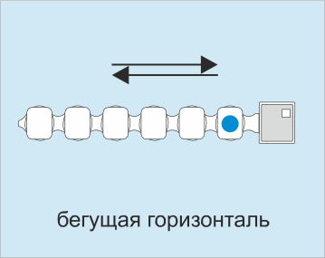LOCAL EMITTER Flexible emitting strip
Flexible emitting strip
stationary field
traveling horizontal
stationary field

ALMAG-02 has proven itself as a reliable and efficient medical device.

Advantages of ALMAG-02 Device

safety and ease of operation does not require special training of medical personnel

reliability in a wide range of external conditions

high penetration in depth by the magnetic field, allowing to conduct manipulation of internal organs

positive response in patients of any age

acceleration of the treatment and rehabilitation of bronchopulmonary patients
the absence of the effects of addiction and overdose

a significant reduction in the aggregate expenses for treatment due to the reduction of the length of patients’ stay in hospital and a decrease in the number of medications

possibility of application in hospital wards for severe bed patients

contributes to free up time, saves energy, rationalizes and facilitates the work of medical personnel, as it does not require continuous stay with a patient during magnetotherapy sessions

checked high quality

ALMAG-02 may significantly accelerate the treatment and rehabilitation of pulmonary patients and reduce the length of patients’ stay in hospital.

ELAMED Company offers optimal conditions for the purchase, delivery and installation of medical equipment and is ready to take on all related cares. Thank you for your invaluable contribution to people's health!

