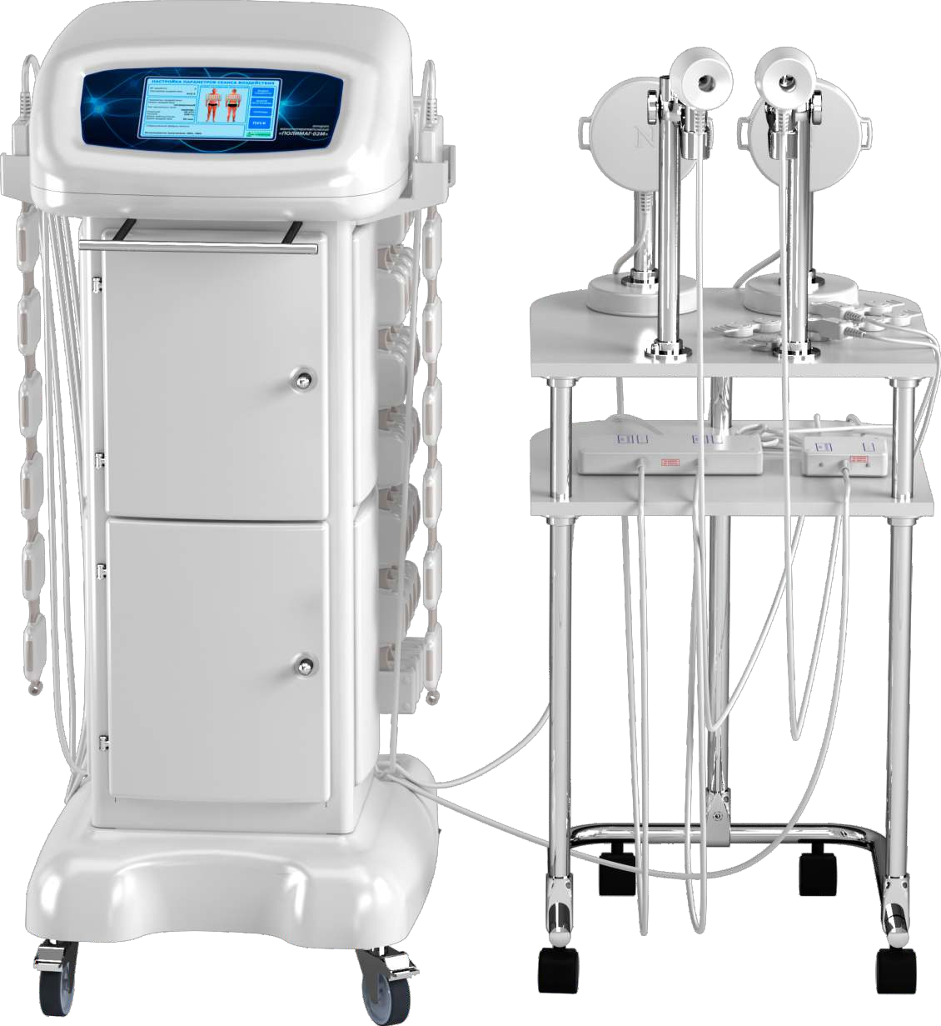

APPLICATION OF POLYMAG-02M DEVICE
IN THE COMBINATION THERAPY OF THE DISEASES OF BRONCHOPULMONARY SYSTEM

Yelatma Instrument Making Enterprise, JSC TM ELAMED 2020

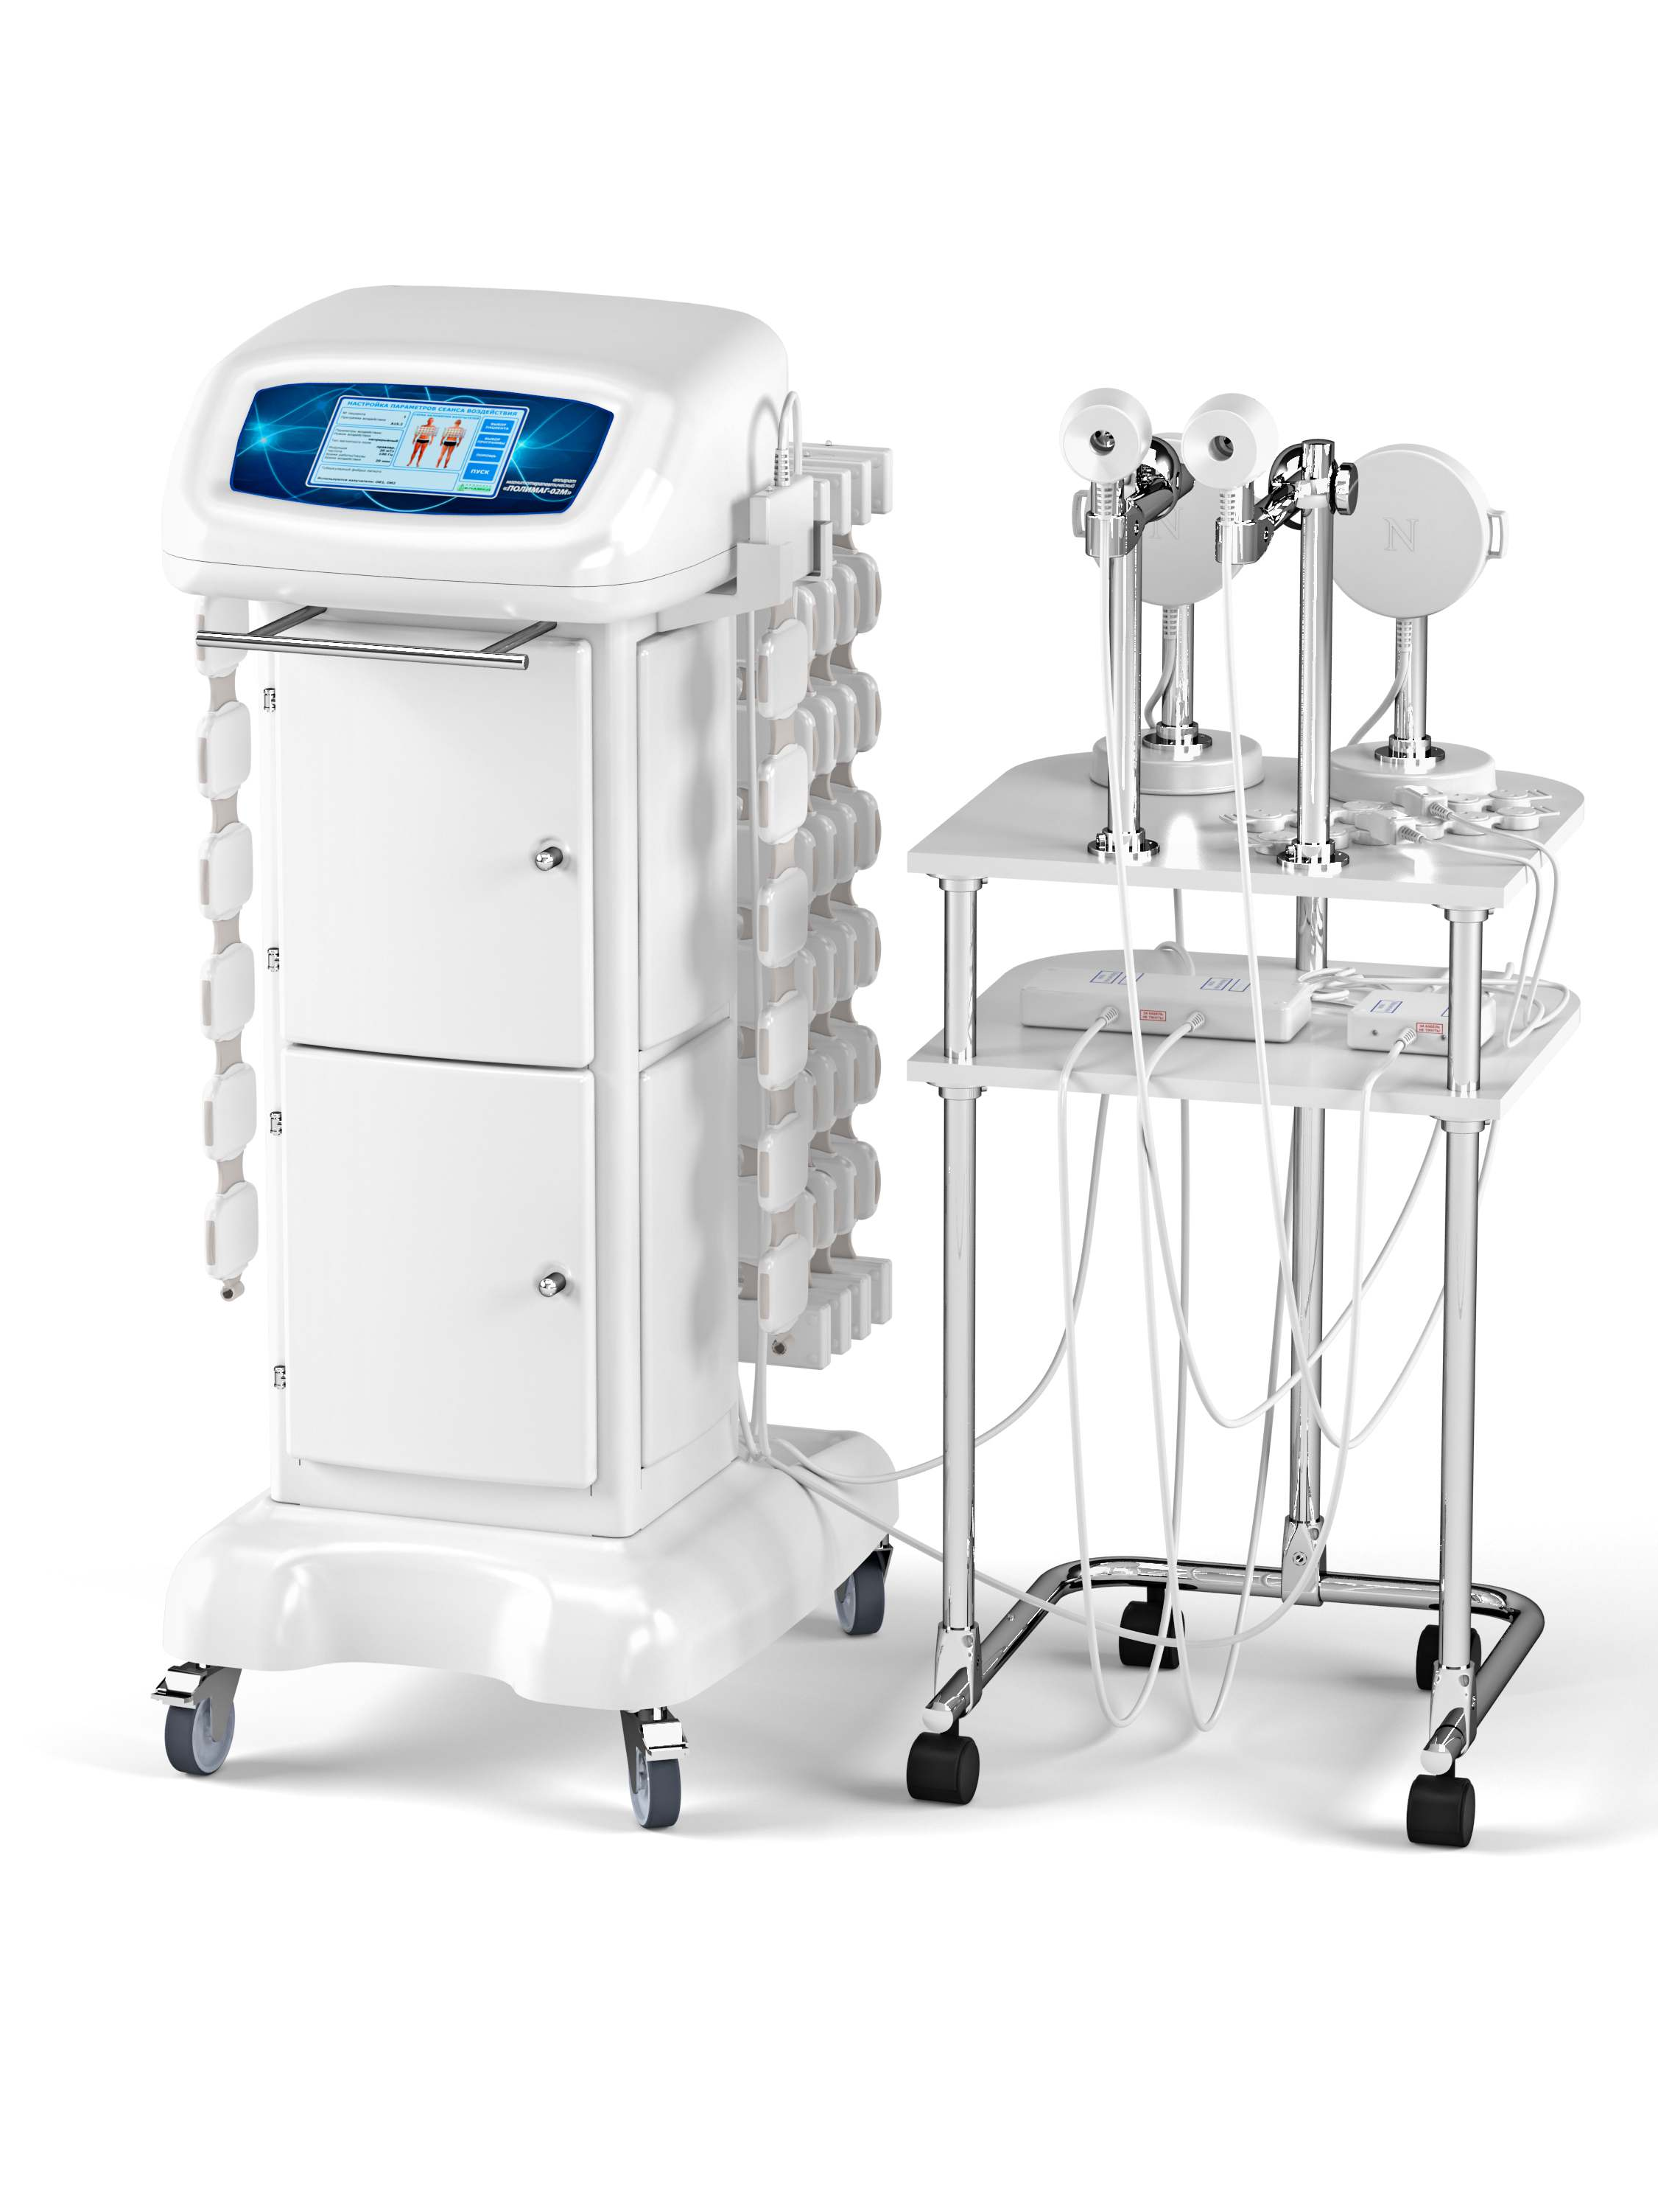

POLYMAG-02M
magnetotherapy device

Yelatma Instrument Making Enterprise, JSC

DEAR COLLEAGUES,

Diseases of the bronchopulmonary system are an actual medical and social problem. They constitute one of the most severe threats to human health worldwide, as they lead to disability and even premature death. At the same time, treatment and rehabilitation of patients are very labor-intensive and time taking, and involve substantial expenses for first aid, hospitalization and medicines.

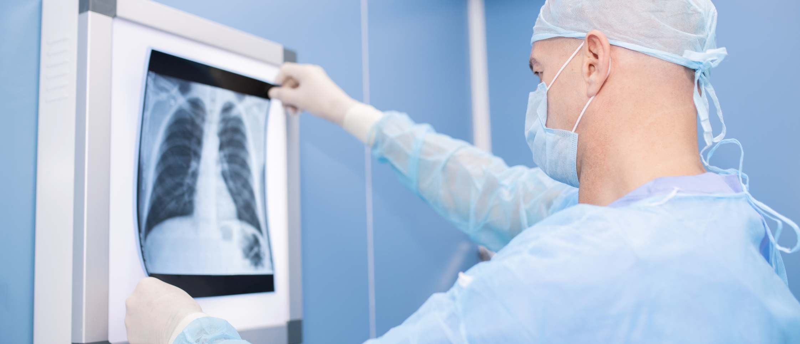

According to the WHO, every sixth death in the world is due to lung diseases.

The task of modern medicine is to ensure a favorable outcome in the fight against diseases of bronchopulmonary system in a short time with a view to a more effective use of hospital bed fund.

Tо achieve this, modern medicine shall be equipped with effective, ergonomic, and safe means comfortable in use, including non-pharmaceutical means.

So, physiotherapy is able to significantly enhance treatment outcomes safely and comfortably for the patient and the physician.
There is a wide range of problems that hamper the favorable result of treatment:

- a large and ever-growing number of the patients that need timely and high-quality medical care;
- the growth of complicated cases requiring an enhanced complex approach to treatment;
- the lack of affordable, effective and efficient treatment, lack of medical personnel, work under the pressure of time;
- poor efficacy of antibiotic therapy and inhalation therapy in the treatment of pneumonia.

! IT IS IMPORTANT: Combined therapy that includes means activating the immune system is mandatory in severe pulmonary diseases.

We suggest to expand the range of medical remedial measures by the integration of POLIMAG-02M magnetotherapy device in the treatment of pulmonary diseases.

POLIMAG-02M – is a new-generation professional medical device with a high therapeutic effect. In terms of design, it is very convenient for use under the conditions of Russian health care centers.

ALL POSSIBLE MAGNETOTHERAPY METHODS IN ONE COMPLEX!

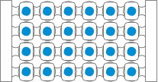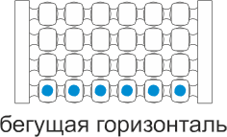Magnetotherapy is a promising direction in the rehabilitation of pulmonary patients.
MAIN EMITTERS

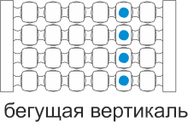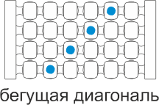POLIMAG-02M generates continuous and intermittent pulsed magnetic fields (traveling, rotating, pulsed) that differ in configuration, intensity, and direction and speed of traveling in space.
traveling horizontal
stationary field

Indications for the use of POLIMAG-02M device in the diseases of the respiratory system:

- J00-J06. Acute respiratory infections of upper respiratory tract.
- J10-J18. Pneumonias.

- J20-J22. Other acute respiratory infections of lower respiratory tract.

- J30-J39. Other diseases of upper respiratory tract.

- J40-J47. Chronic diseases of lower respiratory tract.

- J60-J70. Lung Diseases caused by external agents.

traveling diagonal
traveling vertical

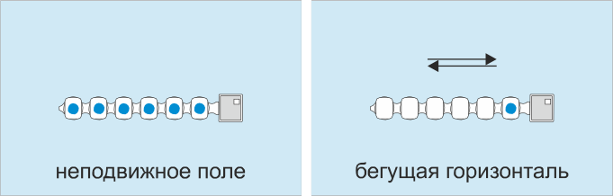Flexible emitting strip
OphtalmologicaL emitter
rotating field
stationary field
Local emitter
traveling horizontal
stationary field
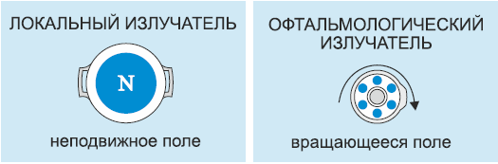
Headband Emitter

Indications for the use of POLIMAG-02M device in the diseases of the respiratory system:

- J12. Viral pneumonia, not elsewhere classified.

- J13. Pneumonia due to Streptococcus pneumoniae.

- J15. Bacterial pneumonia, not elsewhere classified.

- J16. Pneumonia due to other infectious organisms, not elsewhere classified

- J17*. Pneumonia in diseases classified elsewhere.
- J18. Pneumonia, unspecified organism
- J18.1. Lobar pneumonia, unspecified organism.
- J18.2. Hypostatic pneumonia, unspecified organism

- J18.8. Other pneumonia, unspecified organism

traveling field

Magnetotherapy increases the efficiency of drug delivery, and also has its own therapeutic effect in pulmonary diseases.
Adults and children shall be provided with service A17.30.019 (exposure to an alternating magnetic field) for the purpose of prevention, treatment and medical rehabilitation in accordance with Orders of the Ministry of Health of the Russian Federation No. 1213n and No. 1658n on the approval of the standard of specialized and primary health care for pneumonia.

Method has a proven high effect of application and is absolutely safe in case of observing the regulations concerning treatment and contraindications.

POLYMAG-02M – LOTS OF THERAPEUTIC OPPORTUNITIES!

In pneumonias POLYMAG-02M device
contributes to:
- improving blood circulation and gas exchange in the lungs;
- slowing down the reproduction of pathogenic microorganisms;
- enhancing the detoxification of the nidus of infection;
- activating immunity;
- relieving bronchospasm, reducing cough and improving expectoration;
- reducing the viscosity of secretions and removing them from the lungs;
- eliminating pulmonary spasm and inflamed tissues irritation;
- reducing medicamental load on the organism;
- reducing treatment time, accelerating patient’s rehabilitation;
- improving the patient’s general condition;
- accelerating recovery after inflammation;
- the final suppression of the inflammatory process, avoiding chronic lung problems, complications, disability.

VALUABLE FEATURES OF THE DEVICE

    - It forms the most required low-frequency magnetic field parameters with a magnetic induction range of 2 to 45 mT and a frequency range of 1 to 100 Hz.

    - The non-volatile memory of the device stores 622 treatment protocols of 1,355 nosological forms, classified according to ICD 10.

    - It is activated by entering the disease code in accordance with the classification according to ICD 10, while the device displays the location of the emitters on the touch screen, and automatically sets the necessary therapy parameters.

The use in pediatrics is permitted and regulated in detail in a special section of medical instruction

- The turning on and off (automatic) of the device is accompanied by a sound signal, which allows the medical professional not to stay near the patient during the procedure;
- Allows to carry out general magnetotherapy with the simultaneous use of all the main emitters, extensively affecting the microvasculature of organism and increasing the effectiveness of treatment.
- Zonal or local influence is also possible - with one, two main or additional emitters (based on disease and selected methodology).
- Emitters may be used by means of planar pack to create a solenoid.

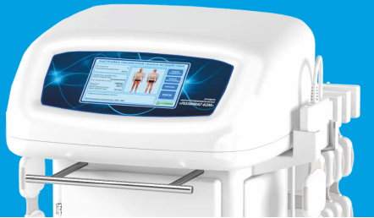
POLIMAG-02M is a stationary magnetotherapeutic complex, a complete computer with powerful therapeutic potential in practical terms.

Device has no analogues in view of the design and functional capacities that implement all the known methods of magnetotherapy.

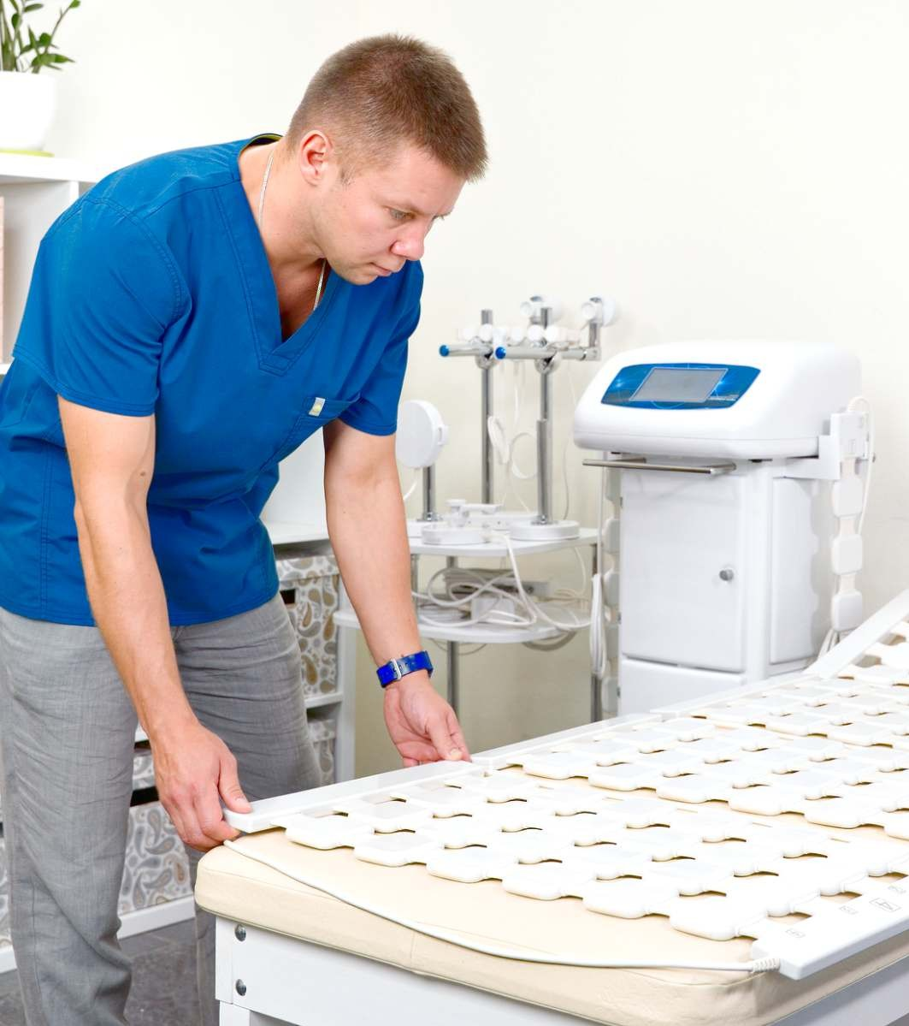ADVANTAGES OF POLYMAG-02M DEVICE

Owing to its functional capacities POLIMAG-02M has all the advantages of modern large-sized units in the treatment process. At the same time, it has a whole list of indisputable advantages over the analogues:

  - it gives an occasion to simultaneous treatment of 2 patients with various diseases that ensures high patient capacity in hospitals;

  - it may be operated continuously at least 8 hours (in a cyclic mode: 30 minute magnetic effect followed by 10 minute break);

  - it may be moved effortlessly from one room to another owing to the presence of wheels that simplifies disinfection measures in the medical office;
  - The kit includes:

    - a specialized mobile rack for the control unit, the main emitters and flexible emitting strips;
    - a convenient trolley table for emitters: ophthalmic, local and headband emitters;

- it takes little space, does not require grounding;
- it has affordable price.

POLYMAG-02M HAS BEEN CLINICALLY TESTED AND HAS PROVEN EFFICACY

POLYMAG-02M has been applied at Physiotherapy Department of the N. N. Burdenko Clinical Hospital since 2005.
According to the decision of the Scientific Council of the Main Military Clinical Hospital, the developed unique methods of treatment of common nosologies with the device use were published as “Use of POLIMAG device in physiotherapy practice” illustrated methodological manual for medical doctors.
Ushakov A.A., Honored Doctor of the Russian Federation, obtained an invaluable experience in the treatment of focal pneumonia with the help of low-frequency magnetotherapy using POLYMAG-02M device.
According to x-ray control, there was a complete resorption of the inflammatory infiltrate

Note: Magnetotherapy is prescribed in the resolution period of the acute inflammatory process. Treatment is carried out in hospitals. Treatment course: 10 to 12 procedures. Exposure time: 10-20 min. The emitters are placed over the area of inflammation or used to wrap the chest.

after a course of magnetotherapy in all patients with focal pneumonia.
According to laboratory studies and auscultation, the patients had fully recovered, 3—4 days earlier than the patients who had received only medical treatment.

We have reviews of the high efficiency of using the device not only in the treatment process of city hospitals, but also in sanatorium-resort and restorative medicine.
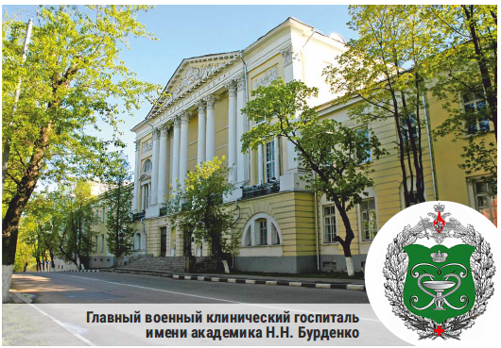

The N. N. Burdenko Main Military Clinical Hospital

POLYMAG-02M – FLAGSHIP OF ELAMED PHYSIOTHERAPY DEVICES

Why is it worth including POLIMAG-02M in a medical complex?

Proven clinical efficacy of pulsed low-frequency magnetotherapy.

Predicted clinical outcome of therapy.

Increased number of predefined treatment protocols (622) and number of nosologies (1355).

Wide selection of emitters for therapy.
Lack of age restrictions.

Ability to provide services to two patients with different diseases at once.

Increased patient capacity, possibility to free up bed capacity.

Ease of mastering the device by personnel of any level.

The medical instruction is arranged in accordance with ICD-10 and registered by the Russian Federal Health Service.

Under modern conditions, POLIMAG-02M may become a reliable tool in the treatment of patients with pulmonary diseases and reduce the time spent by patients in hospital.

ELAMED Company offers optimal conditions for the purchase, delivery and installation of medical equipment and is ready to take on all related cares. Thank you for your invaluable contribution to people's health!

