Table of contents

Introduction…………………………………………………………………………...2
The types of magnetic field generated by the device……………………………2
Magnetic field effect on human organism …..…………………………………….5
Indication for application …………………………………………………………….6
Contraindications ………………….……………………………………………......9
ALMAG -02 treatment general principles …………………………………………9
The order of operation ………………………………………………………………10
ALMAG-02 magneto-therapy particular techniques …………….……………….11

Introduction
Medical possibilities of modern medicine are great and especially it concerns medicinal preparations. But you should not forget, that the medical preparations have not only positive effect but can do harm to an organism in the form of side-effects. So there is the urgency of development and application of non medicamentous methods in treatment which in a combination with the existing schemes of medicinal treatment, allow to reduce a dose of medical prepations or to refuse them completely , without spoiling results of treatment.. One of perspective non medicamentous methods of treatment is the magnetotherapy in general and a pulse magnetotherapy, in particular. It is proved, that the pulsed magnetic field possesses the greatest medical efficiency for the considerable number of diseases. ALMAG - 02 is the magneto-thrapeutic device (hereinafer - the device) with the help of low-frequency, low intensity pulses magnetic field.
The device is intended to treat patients with acute and chronic internal bodies diseases , diseases of central and peripheral nervous system, loco-motor system traumas and postoperative complications with pulsed traveling, low intensity magnetic field. The concept "traveling " means, that the magnetic field moves in space, being consistently formed in a separate inductors line (one after another) or in several lines of fixed inductors, but always in strict sequence, that conventionally called as "traveling" field.

Types of magnetic field generated by the device
The device generates pulsed magnetic field of two types - «traveling» and «fixed».

Traveling magnetic field
Basic emitter
“Traveling” magnetic field has three scanning types in the basis emitter.
- «traveling horizontal» - simultaneous excitation of all coil-inductors in one stripe-line with the following unidirectional excitation of all coil-inductors the neighbour stripe-line under the cyclic law; the cycle for the scanning of this type makes four "step" excitation of coil-inductor lines (according to the numbers of stripe-lines in the emitter);
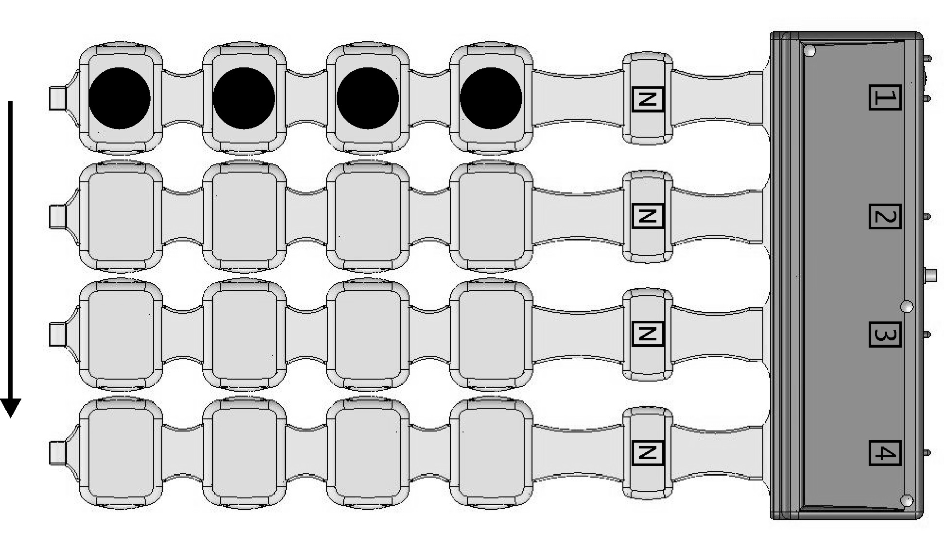
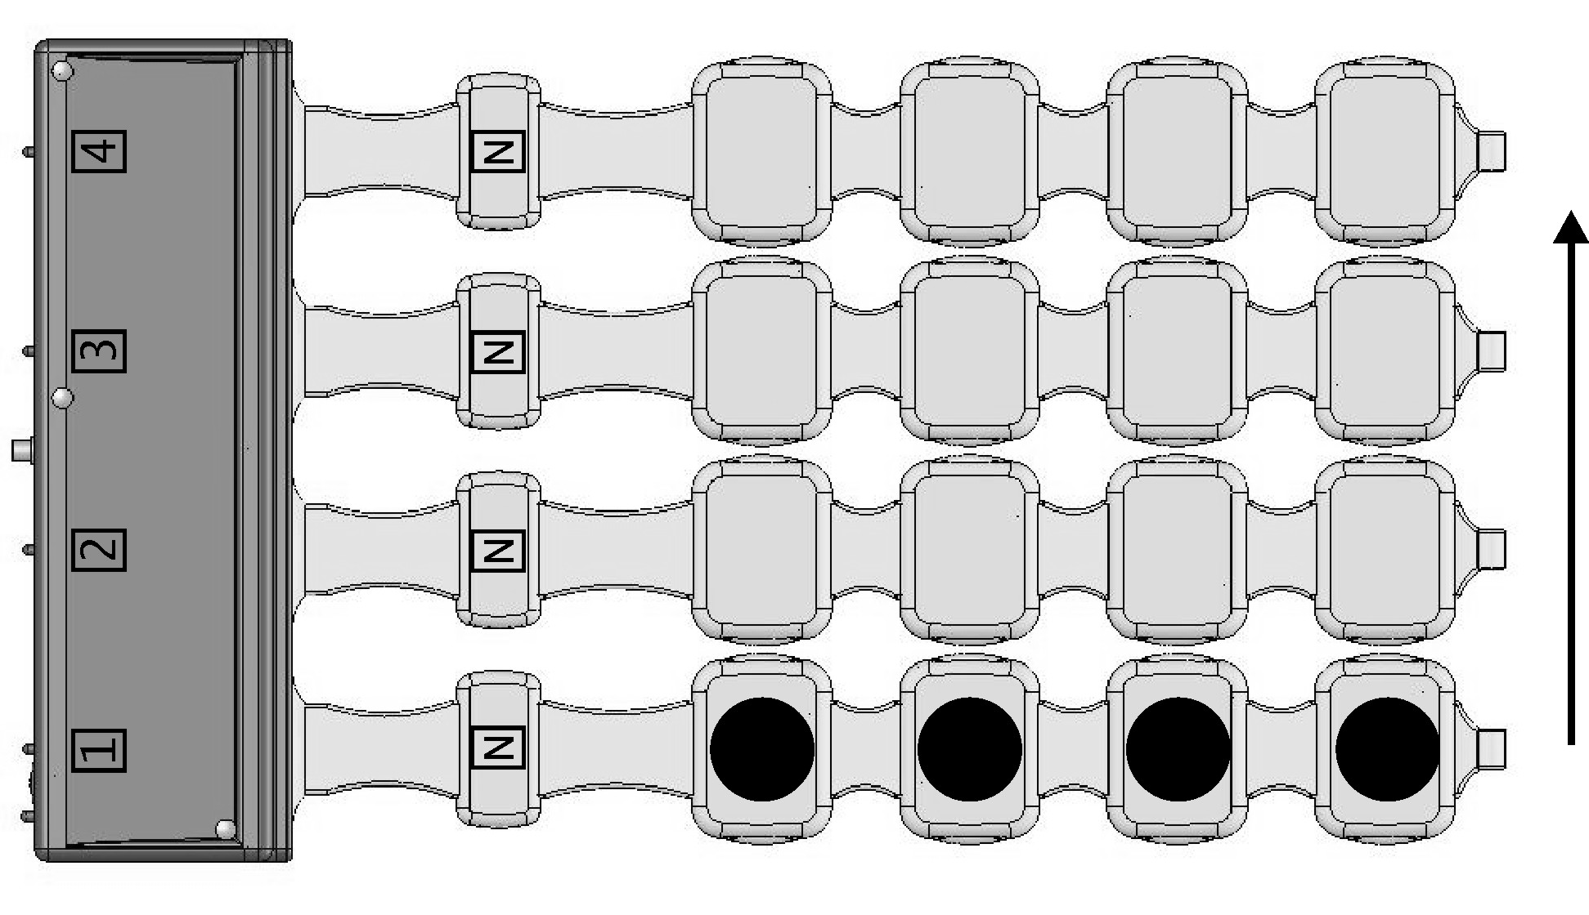
Marking of magnetic field polarity

Marking of emitters` lines numeration
Working surface
«Traveling horizontal», magnetic field polarity from the side directed to you is “N” north one:
а) magnetic field direction – up-down
b) magnetic field direction – down-up

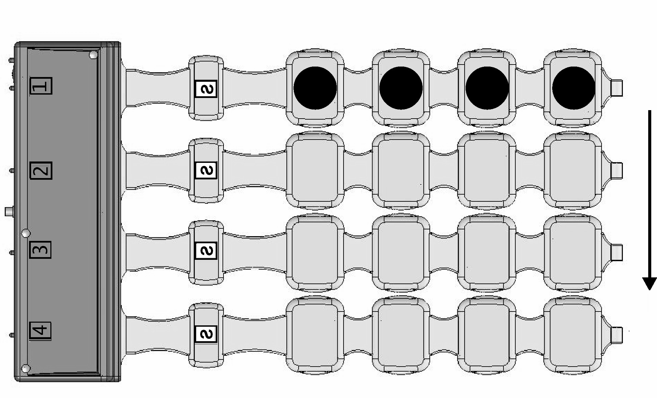
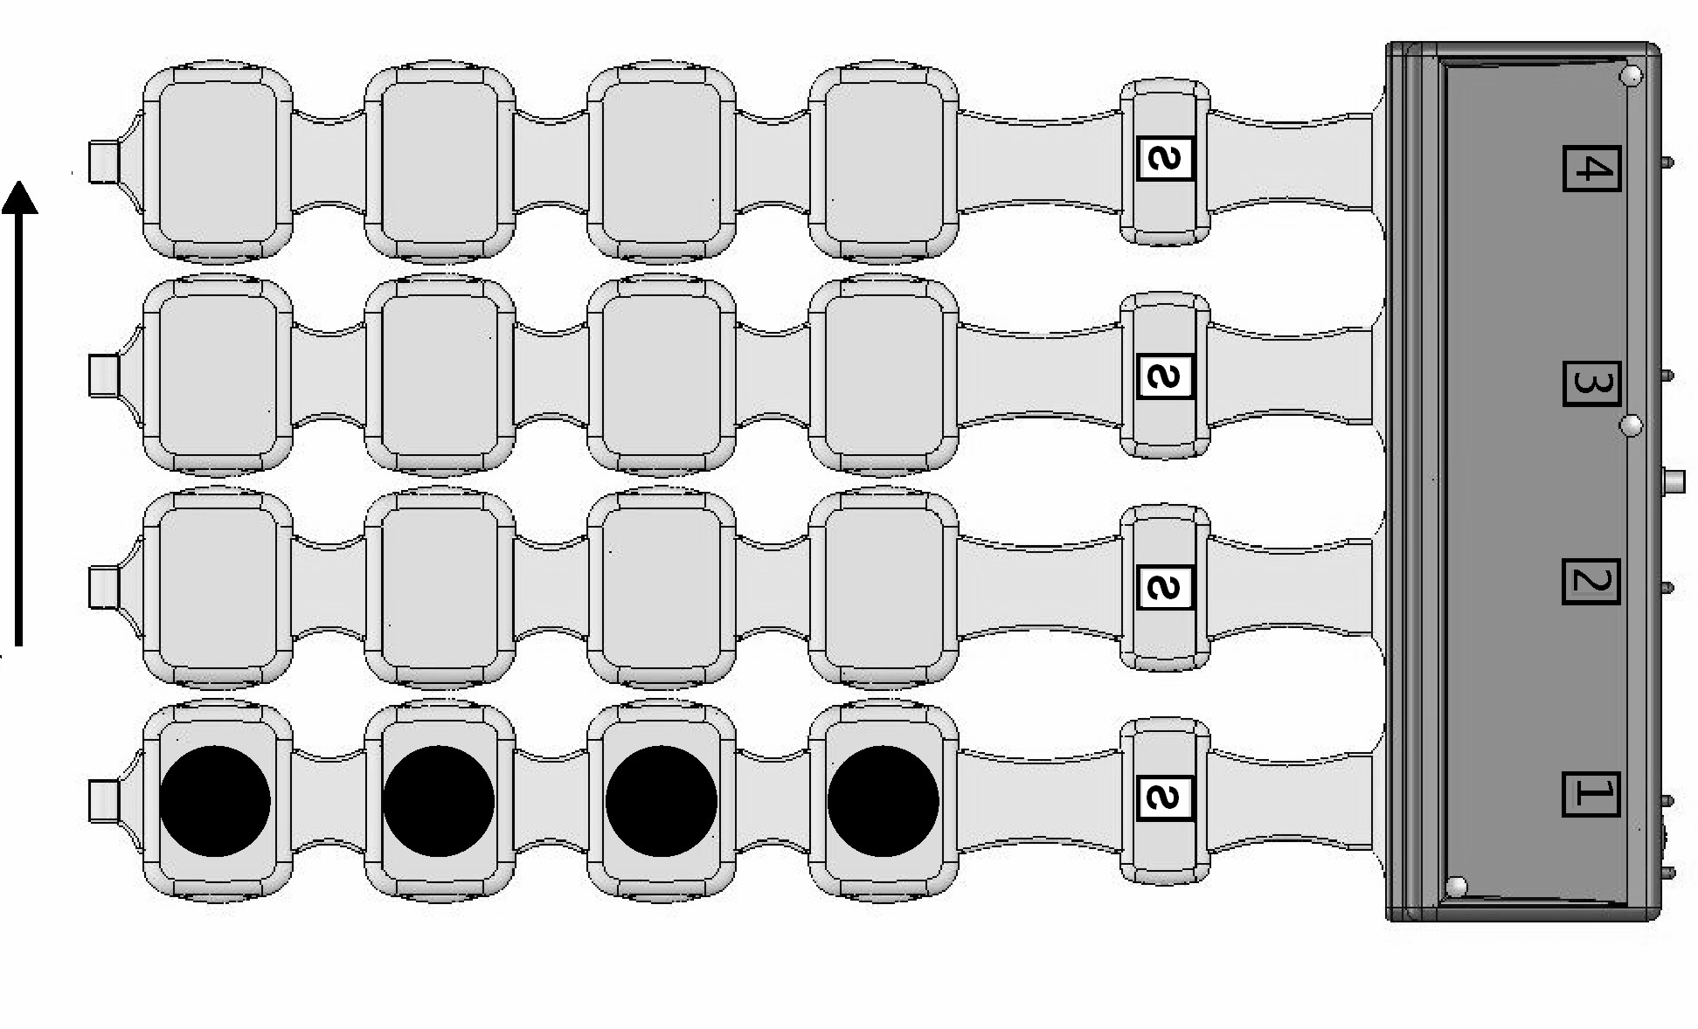

а) b)
Traveling horizontal, magnetic field polarity from the side directed to you – the south one (polarity marking - S).
- magnetic field direction – up-down
- magnetic field direction – down-up

«Traveling vertical» -simultaneous excitation of the same name coil-inductors in all stripe-lines with the following unidirectional excitation of the neighbour coil-inductors under the cyclic law, a cycle for the scanning of this type makes four "step" excitation of the neighbour coil-inductors (according to the number of coil-inductors in a stripe-line);
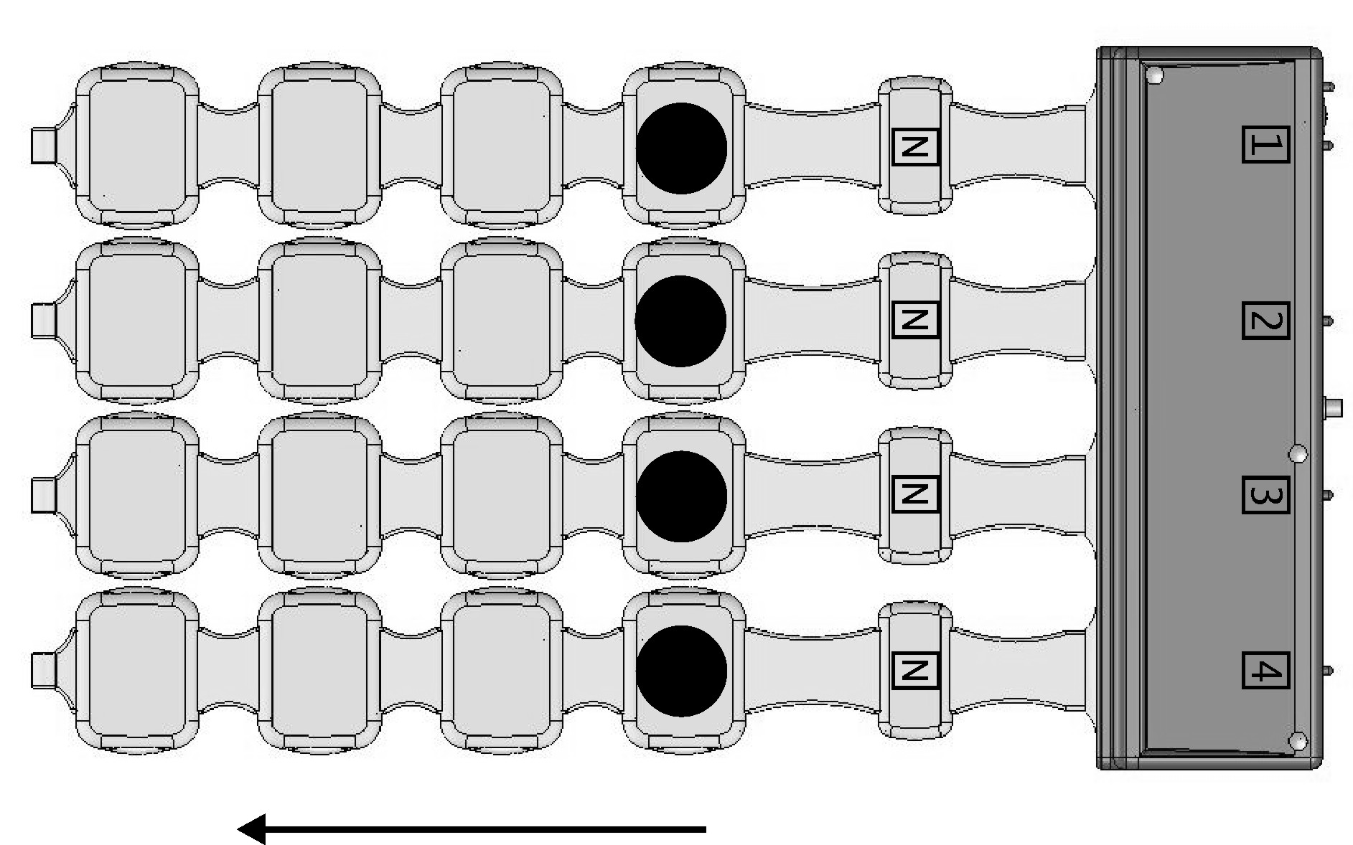
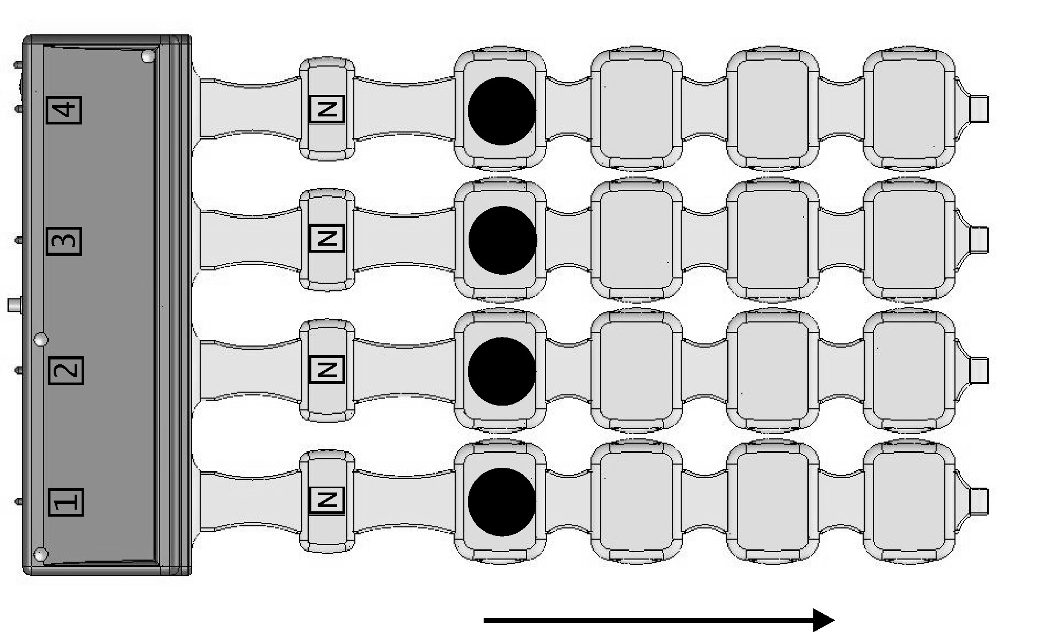

а) b)
Traveling vertical, magnetic field polarity from the side directed to you - north (the marking of polarity on the emitter`s stripe-lines – “N”)
- magnetic field direction – from right to lift
b)magnetic field direction – from lift to right

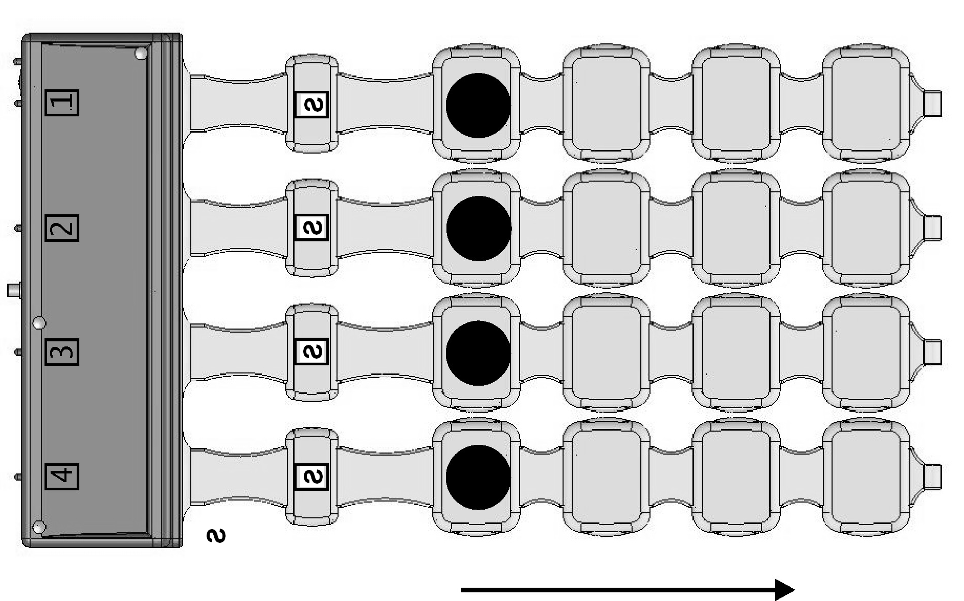
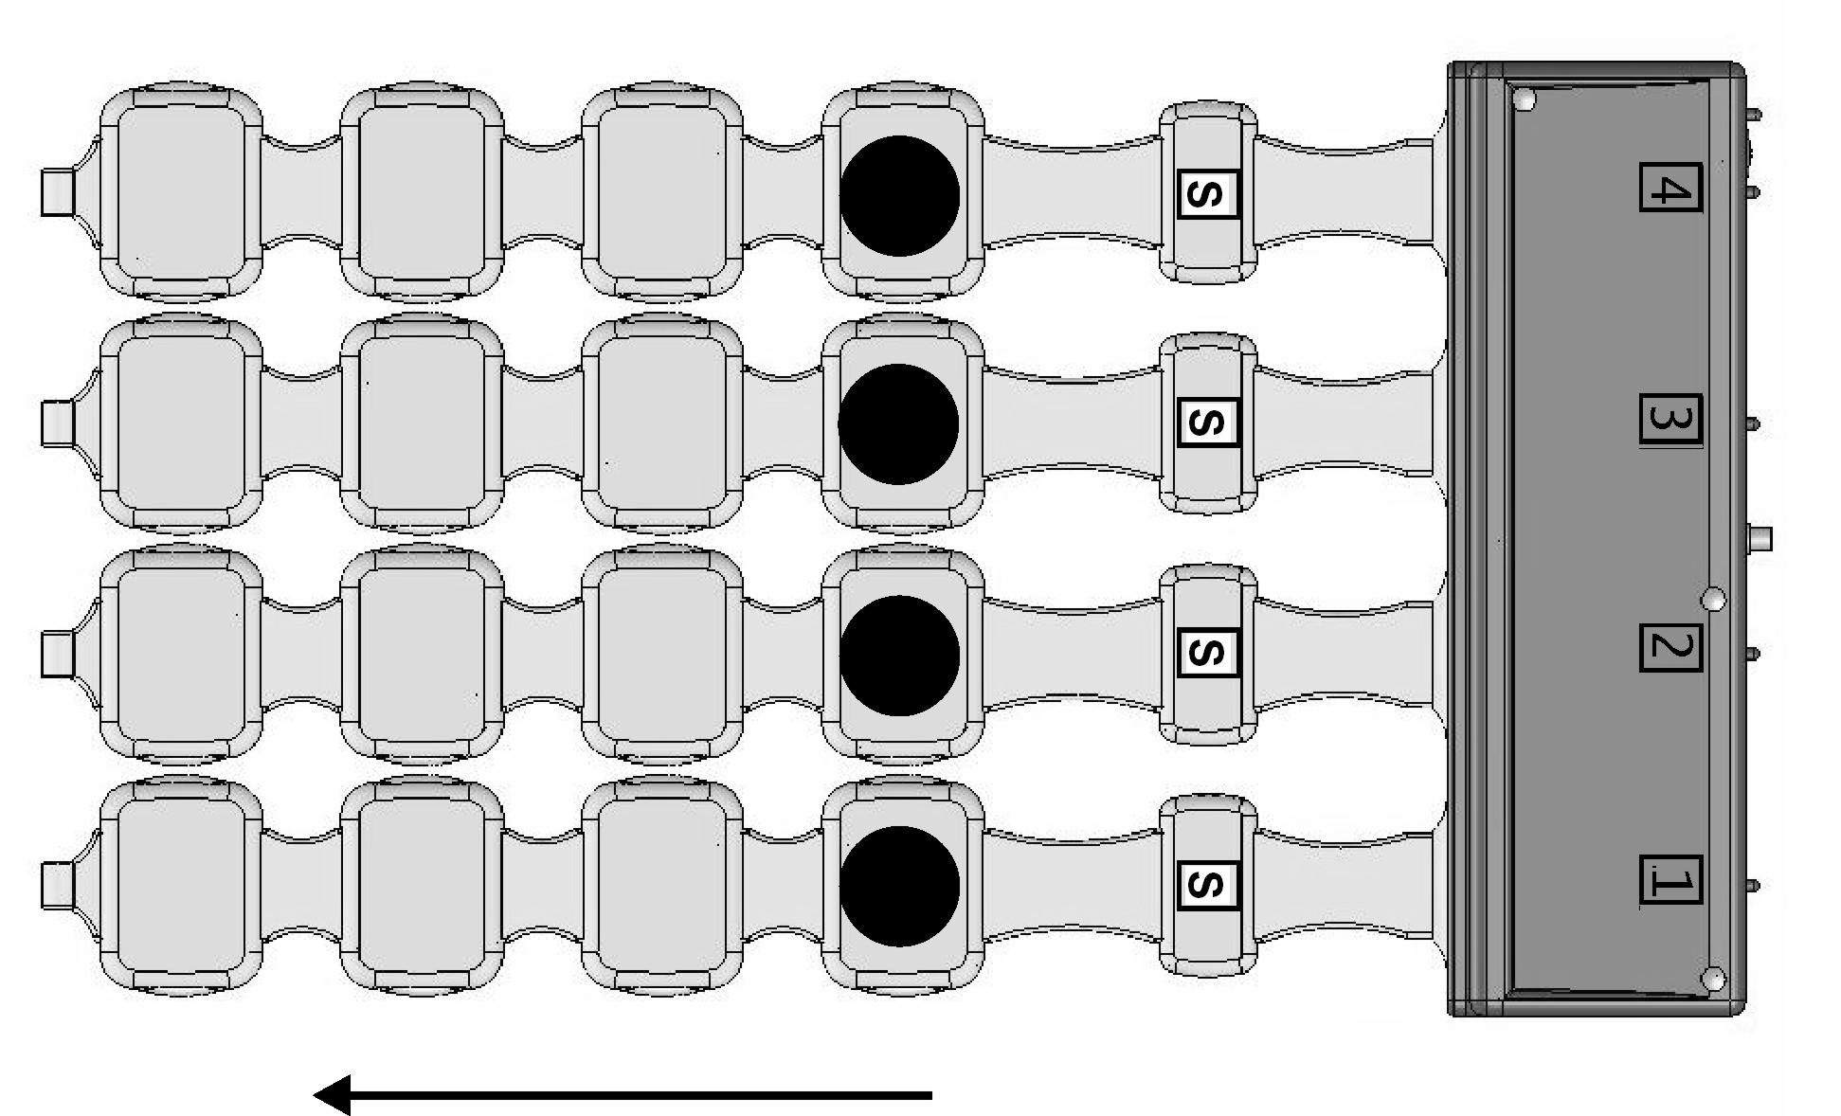

а) b)
Traveling vertical, magnetic field polarity from the side directed to you – south (polarity marking –“S”)
a)magnetic field direction – from right to lift
b) magnetic field direction – from lift to right

Traveling diagonal” - sequential excitation of the coil-inductors, located diagonally with the subsequent unidirectional excitation of neighbour coil-inductors under the cyclic law; the cycle for the this type scanning makes induction seven "step" excitation (according to the number of coil-inductors excitation possible combinations.
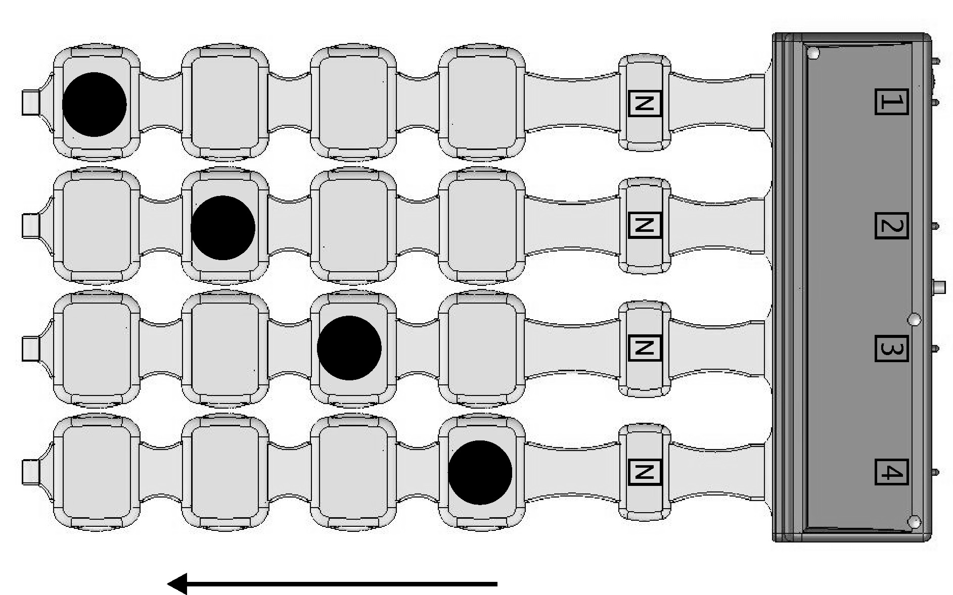
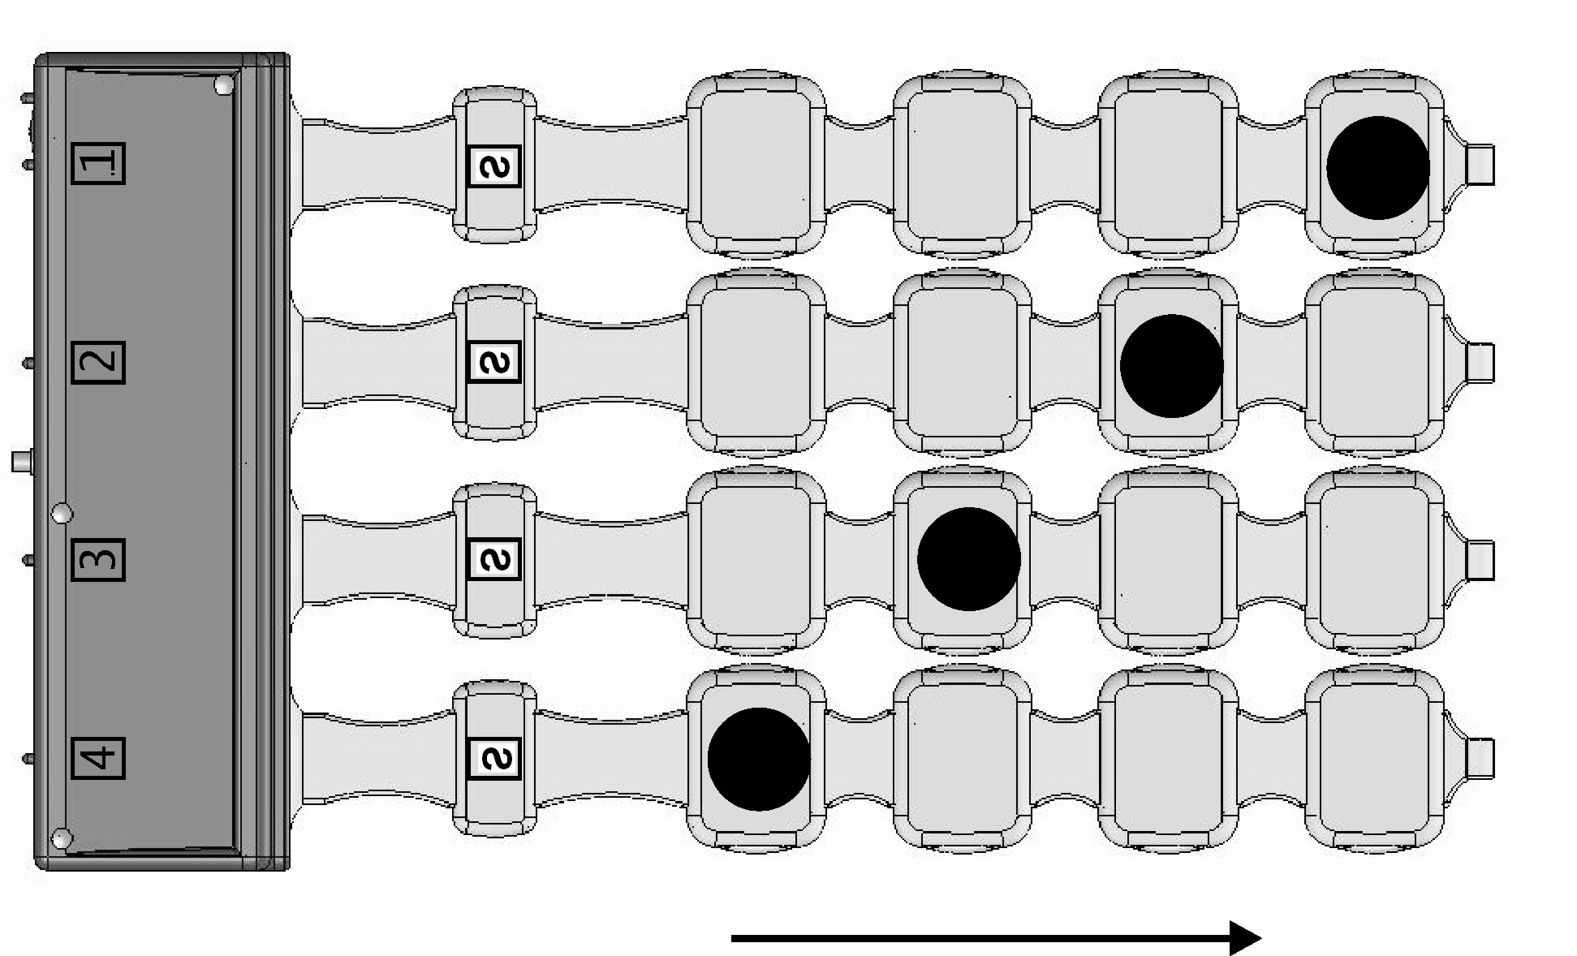

а) b)
Traveling diagonal, magnetic field polarity from the side directed to you
- – north (polarity marking –“N”)
- – south (polarity marking – “S”)

Flexible emitting stripe-line
In flexible emitting stripe-line “ traveling“ field – coil-inductors excitation under the cyclic law in one direction; stripe-line cycle makes six “step” excitation of the beighbour coil-inductors (according to number of coil);

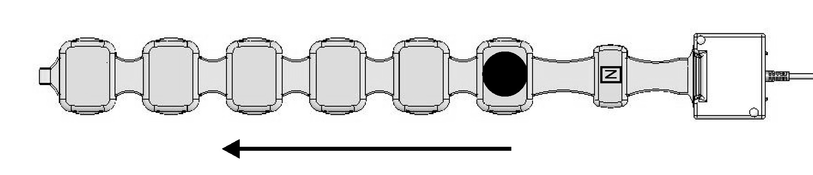
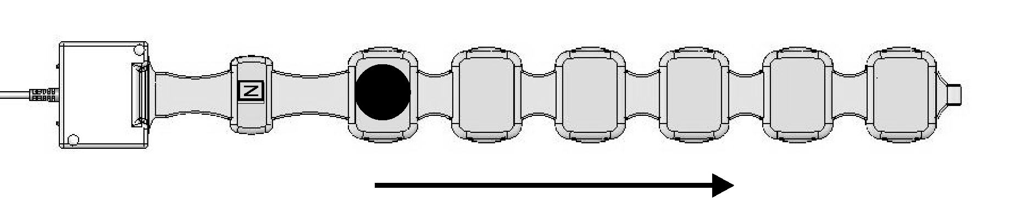

Working surface Magnetic field polarity marking
а) b)

Flexible emitting stripe-line. Magnetic field polarity from the side directed to you – north (polarity marking –“N”)
- magnetic field direction from the right to the left;
- magnetic field direction from the left to the right.
Note: In the device emitters pulsed magnetic field travels only in one direction and in order to change the direction of field traveling in area, it is necessary to change emitter arrangement, for example, as it is shown in fig. 4-7.

Fixed magnetic field
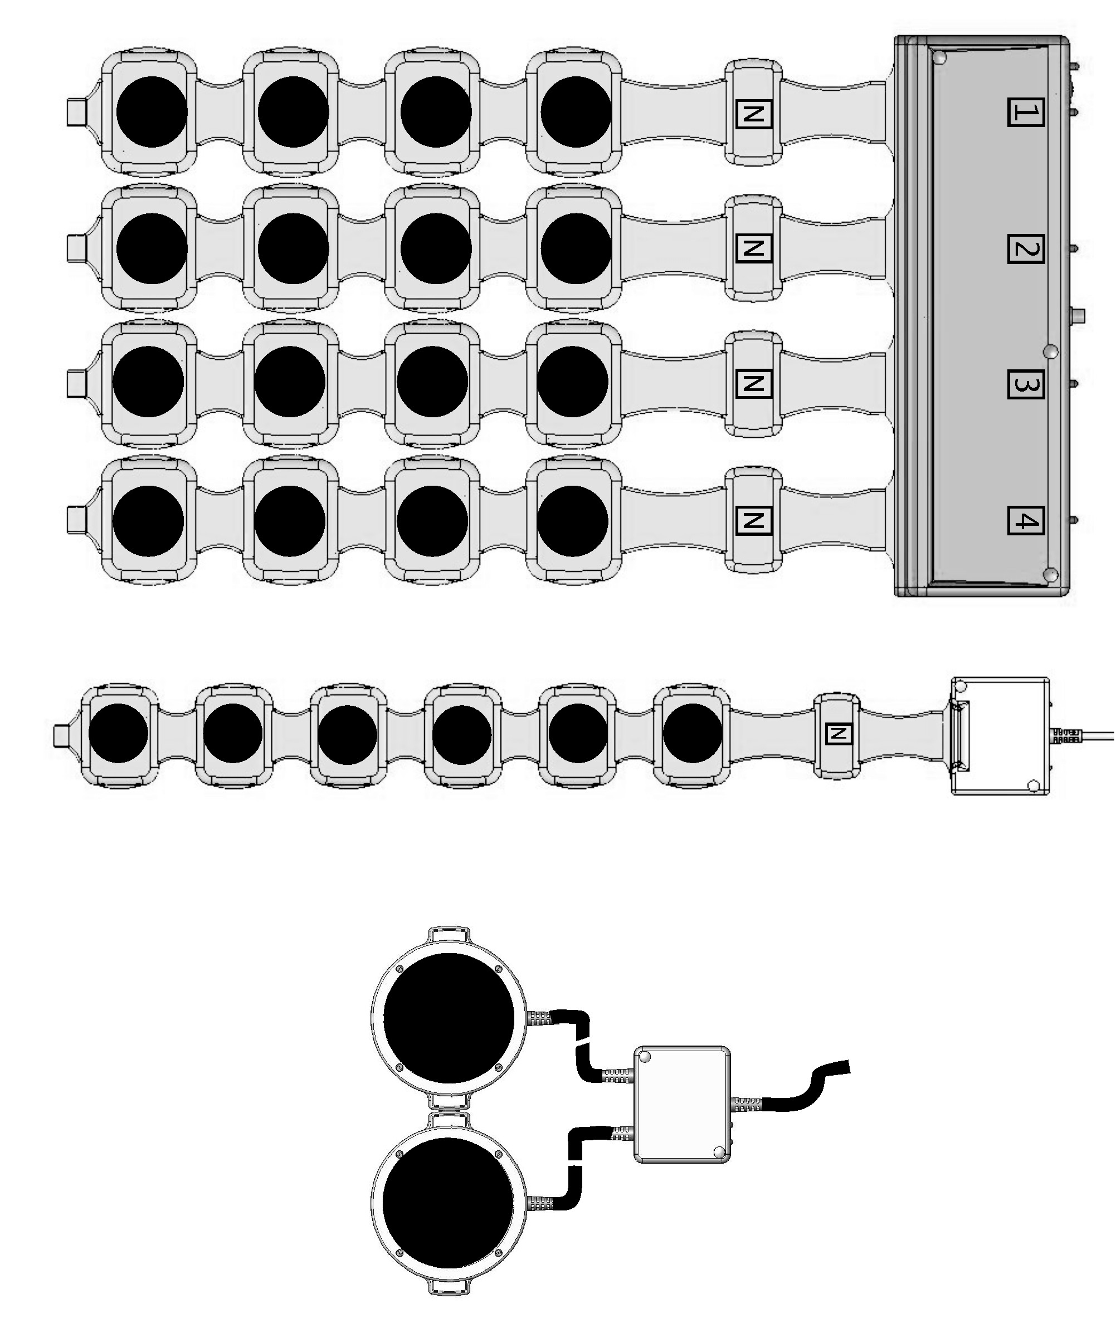
For each emitters type “Fixed field” presents itself
simultaneous excitation of emitters` all coil-inductors

Device pulsed magnetic field parameters and characteristics
Induction amplitude value on the emitters coil-inductors surface:
- for “ traveling” field type:
- for basic emitter and flexible emitting stripe-line: from 2 to 25mTl.
- for “fixed” field type:
- for basic emitter and flexible emitting stripe-line: from 2 to 6 mTl.
- for local emitter from 2 to 45 mTl.
Magnetic field pulses frequency rate:
For basic emitter and flexible emitting stripe-line:
- for “ traveling” field type:
- from 1 pul/s to 75pul./s with induction 25mTl.;
- from 1 pul/s to 100pul./s with induction 2-20mTl.;
b) for “fixed” field type:
- from 1 pul/s to 16pul./s with induction 2-6mTl

For local emitter:
-from 1 pul/s to 50pul./s with induction 35-45mTl
- from1 pul/s to 100pul./s with induction 2-30mTl

Magnetic exposure time intervals range: from 1 to 30 min.
Exposure programs (program), where magnetic field parametres and characteristics as well as exposure time are set for definite emitters , are stored with identification numbers in memory of the device. Number of the corresponding program is specified in a treatment procedure.
Device provides indication of the parameters and modes as follows:
- program number;
- exposure time;
- malfunction code;
- availability of the magneto-therapeutic exposure;
- emitters activation/ de-activation;
- magnetic field generation in the emitters.

Magnetic field effect on human organism

It is determined, that magnet "clockwise" rotation and its "north" part action on biological fabric have an expressed positive effect in comparison with "south" or "counterclockwise" one.
The mechanism of magnetic fields effect on an organism is complicated enough, but in brief it can be presented as the promption of electromotive forces in fabrics, and as a result - to formation of the induced ring currents making effect on pair - and- diamagnetic molecules. At a cellular level under action of magnetic field there is a rotary moment under the influence of which a molecules arranged along the basic axes of rotary symmetry. As a result we have:
the change both of cell membranes and cell`s structures (permeability restoration, normalization of diffusive and osmotic processes in a cell and, accordingly, its electrolyte structure);
- the change of tissue electronic potential, increase of both metabolism level, oxidation-restorative processes and free radical oxidations.;
- acceleration of enzymatic reactions process and normalization of biological membranes transport properties.
- marked change in a capillary race (change of permeability, a condition of endothelium, colloid-osmotic pressure, improvement of microcirculation (nonfunctioning capillaries open).
As a result there are acceleration of reparation processes, increase of immunological reactivity (immunity cellular and humoral level),the change of changes of bradykinin systems activity.
Magnetic field makes marked normalizing effect on vegetative nervous system.
It is very important that pulsed magnetic field has considerably more expressed effect, than constant or variable ones.
Pulsed magnetic field has trace character effect. After magnetic field single exposure, human organism response lasts for 1-6 days, while the procedure courses is followed by 30-45 days` response, so there is necessity to take interval between repeated treatment procedure courses for this period.
The magnetic field freely goes through an organism tissues, clothes, plaster bandages, but rather quickly fades depending on distance and the form of inductor, that property allows to apply magnetic fields in traumatology.
The magnetic field has no thermal effect, so it is less loading, is more easy withstood by patients. Some of the patients mark "thermal" effect in a place of magnetic field exposure which is connected to an intensification of blood circulation under action of a magnetic field.
The response of various human organs and systems to a magnetic field effect is not similar. Selectivity of body response reaction depends on electric and magnetic properties of tissues, their difference in micro-circulation, intensity of metabolism and the state of neurohumoral circulation. Among organism different systems, sensitivity of nervous system to the magnetic field exposure takes the first place, then goes endocrine system, cardiovascular system, blood, muscular, digestic apparatus, excretory, respiratory and bone systems.
Magnetic field effect on nervous system is characterized by physiologic and biologic processes positive changes.
Stimulation of inhibition processes takes place resulting in the emergency of sedative effect, favorable action on sleep and emotional state.
In the hypothalamus cells there is stimulation of substance produce (releasing factors) which regulate the functions of endocrine glands resulting in restoration both of endocrine gland hormones normal work - adrenal, thyroid and pancreas gland and metabolism that favourably effects the organism general condition, the other process are stimulated as well.
Stimulation of hypothalamo-hypophysial system provokes chain reaction activating peripheral endocrine glands-targets under the influence of releasing factors , the synthesis of which is stimulated in hypothalamo- hypophysial system followed by numerous ramified metabolic reactions. When endocrine system is effected by an alternating magnetic field with the induction up to 30mTl and frequency of 50Hz, the the exposition time max.20 minutes there is the development of training reaction and inncreased activity of all branches of endocrine systems.
Stimulation of thyroid gland function is noted being exposed by a magnetic field in contrast to a inhibitory effect of many other stimuli, this considered as a precondition for magnetic complex therapy in case of its hypofunction. Showing only a slight activation at the beginning of a magnetotherapy course sympatheticoadrenal systen begins to form inhibition of peripheral -adrenoreceptors by the 7th-9th day of treatment which is of great significance in producing antistress effect.
So under the influence of magnetic field with low intensity we have evident positive effect: reduction of cerebral vessels tone, improvement of brain blood supply, activation of nitrogen and carbohydrate - phosphoric metabolism increasing brain stability to hypoxia. Under the influence of low frequency magnetic field on cervical sympathetic nodes and paretic extremities (patient sustained cerebral stroke) there is improvement of a cerebral blood flow (the data of rheovasography) and normalization of increased arterial pressure proving the magnetic field reflex action. Under the influence on suboccipital area (patients with a circulatory insufficiency invertebrobasilar system) there is evident improvement of a cerebral hemodynamics.
Pulsed magnetic field action on a collar zone results in improvement of hemodynamics and both systolic and diastolic pressure decrease up to normal state. Here we can say about possibility of cerebral hemodynamics disorder correction with different pathology conditions.
Peripheral nervous system responds to the magnetic field effect by decreased sensitivity of peripheral receptors which results in analgesic effect and improvement of conductivity function which produces a favorable effect on functional recovery of traumatized peripheral nerve ending due to accelerated axon growth, myelination and inhibition of connective tissue growth.
Under influence of a pulsed magnetic field of the same induction and frequency with its various localizations (the head, area of heart, a forearm) there is emergence of the same type reaction from the part of cardiovascular system that gives the basis to assume the reflex nature of the field action on it.
Pressure decrease in the system of deep and subcutaneous veins as well as in arteries is noted. Simultaneously, vascular tension increases, elastic properties and bioelectric resistance of vascular walls change. Hemodynamics changes, hypotensive effect in particular, is due to the development of bradycaria effect and thanks to the of contractile myocardial function. This property found its application in hypertension therapy and is applied as well for heart loading reduction.
Magnetic field produces changes in microcirculatory race of numerous tissues. At the beginning of a magnetotherapy course there is a short-term (5-15 minutes) retardation of capillary blood flow which followed by micro-circulation intensification. During and on termination a magnetotherapy course there are: acceleration of capillary blood flow,

Pressure decrease in the system of deep and subcutaneous veins as well as in arteries is noted. Simultaneously, vascular tension increases, elastic properties and bioelectric resistance of vascular walls change. Hemodynamics changes, hypotensive effect in particular, is due to the development of bradycaria effect and thanks to the of contractile myocardial function. This property found its application in hypertension therapy and is applied as well for heart loading reduction.
Magnetic field produces changes in microcirculatory race of numerous tissues. At the beginning of a magnetotherapy course there is a short-term (5-15 minutes) retardation of capillary blood flow which followed by micro-circulation intensification. During and on magnetotherapy course termination there are: acceleration of capillary blood flow, improvement of contractile behavior of vascular walls and increase of vascular blood filling. The lumen of functioning components in the microcirculatory bed becomes larger, the conditions promoting the opening of preexisting capillaries, anastomoses and bypasses develop.
Under the effect of magnetic fields especially in the area of large vessels there is the emergence of hypocoagulation effect due to the activation of anticoagulative system, reduction of intravascular parietal thrombogenesis and decrease of blood viscosity through the effect produced by magnetic field of low intensity on enzymatic processes, electric and magnetic properties of blood corpuscles participating in hemocoagulation.
Under the effect of magmetic fields and injected medicinal preparations there is increase of vascular and epithelial permeability resulting in edamas accelerated resolution. Thanks to this effect magnetotherapy began to be widely used in cases of traumas, injuries and their aftereffects.
Traveling pulsed magnetic field stimulates the increase of metabolic process in the area of bone regenerative tissue (in case of bone fractures)and the esarlier development of fibro-and- osteoblasts in the regeneration zone, the process of bone substance formation is more intense even at the earlier stages.

Pulsed magnetic fields action on human organism big areas (basic emitter) produces a considerable effect on body metabolism. When exposed to a particular system it increases the protein and globulin content in blood serum, their concentration in tissue is increased due to α- and γ- globulin fraction. This is accompanied by protein structure change. Short-term daily general effects of magnetic field decrease the content of pyruvic and lactic acids not only in the blood but also in liver and muscles. This is accompanied by the increase of glycogen content in liver.
Magnetic field effect reduces the number of Nа –ions with simultaneous increase of К-ion concentration which indicates the change of cellular membrane permeability. Fe concentration reduction in brain, heart, blood, liver, muscles, spleen is noted with its increase in bone tissue. Such Fe redistribution is associated with the change of hemopoietic organs state. This is accompanied by Cu concentration increase in cardiac muscle, spleen and testes resulting in the activation of adaptation-compensatory processes in body. Cо- concentration decreases in all organs and its redistribution occurs between blood, individual organs and tissues. Biological activity of Mg becomes higher. This results in reduction of pathological processes in the liver, heart and muscles.
It has been noted that magnetic fields of low induction stimulate the processes of tissue respiration, changing the ratio of free and phosphorylation oxidation in the respiratory chain. Nuclein acid metabolism and protein synthesis are intensified producing the effect on plastic processes. Proliferation and regeneration effects are determined by activation of lipid peroxidation.
Metabolism activation of carbohydrates and lipids is considered to be a characteristic feature of magnetic field effect on human body. This is proved by increased concentration of nonesterificated fatty acids and phospholipids in the blood and inner organs as well as by blood cholesterol reduction.
Thus, a short-term effect of magnetic fields is characterized by multifold action on human organism resulting in the development of individual reversible favorable effects. The most evident and clinically significant are sedative, hypotensive, anti-inflammatory, antiedematic,analgesic and trophicoregenerative effects. Under certain conditions, e.g. when exposing to large vessels, magnetotherapy produces deaggregation and hypocoagulation effects, improves micro-and-regional circulation, makes favorable effects on immunoreactive and neurovegetative processes. Magnetic field effect does not generally generate endogenic heat, nor it causes temperature rise or skin irritation.
It is well tolerated by weak and elderly patients suffering from concomitant cardiovascular diseases which allows the magnetotherapy devices to be used when other physical procedures are contraindicated.

Indications for application
Illnesses of nervous system:
Neurocirculatory dystonia on hypertonic type
Migraine.
Transient transitional cerebral ischemic attacks and congenerous symptoms.
Affection of separate nervous roots and plexuses of upper and lower extremities.
Alcoholic polyneuropathy
Diabetic polyneuropathy
Postherpetic neuropathy
Raynaud`s syndrome (syndrome of hand “dead finger)

Ear, throat and nose illnesses:
Chronic maxillary sinusitis (antritis), chronic frontal sinusitis (frontitis)
Acute and chronic eustachitis (salpingootitis)
Acute laryngitis
Chronic laryngitis
Sensorineural deafness

Illnesses of circulatory system:
Hypertensive disease
Stable angina of I-II stress functional class
Insult
Aftereffects of cerebrovascular illnesses
Vessels atherosclerotic illness, deforming or an obliterating endarteritis
Aterosclerotic encephalopathy
Varicose disease
Lower leg deep vein thrombophlebitis
Chronic thrombophlebitis accompanied with trophic disorders
Chronic lymphedema (lymphatic edema)

Illnesses of respiratory organs:
Virus pneumonia
Bacterial pneumonia
Chronic bronchitis non-acute condition
Bronchial asthma and chronic obstructive pulmonary illness
Exudative pleurisy (after liquid extraction from pleural cavity, three days later after theracocentesis)

Illnesses of digestive apparatus:
Reflux-esophagitis
Stomach and duodenum ulcer.
Gastritis and duodenitis
Chronic hepatitis
Toxic kidney affection
Syndrome of irritant large intestine without diarrhea
Liver alcoholic illness
Cholecystitis
Biliary dyskinesia
Gallbladder hypomotor dyskinesia (cholecystopathy without gall-stones)
Chronic pancreatitis
Syndrom of operated stomach
Postcholecystectomy syndrom

Illnesses of the skin and subcutaneous fat:
Keloid cicatrix
Lichen ruber planus
Limited neurodermatitis, skin itch, nettle-rash, eczema, neurodermatitis, prurigo,
atopic dermatitis
Psoriasis
Hydradenitis

Osteomuscular system and the connecting tissue diseases:
Podagra
Polyarthrosis
Coxarthrosic
Gonarthrosis
Arthrosis of the first carpometacarpal joint
Internal and external (tennis elbow) (golf elbow в гольф») humeral epicondylitis
Scapulohumeral periarthrosis
Acute trophoneurotic bone atrophy (Sudeck`s atrophy)
Paratenonitis (crepitant forearm tendovaginitis)
Tietze`s syndrom (aseptic coatal cartilage inflammation in the area of rib joining to sternum, more often II-IV ribs with the painful thickening)
Osteochondropathy (Celer disease,Kienböck`s disease,Perthes`disease, Schlatter disease, Cenig disease)
Ankylosing spondylitis (Bechterew`s disease)
Temporomandibulat joint osteoarthrosis
Calcaneal periosteosis , heel spur
Joint contracture (Dupuytren`s conracture)
Rheumatic ioint inflammation
Spinal column osteochondrosis
Cervical migraine
Vertebro- Вертебро-basilar syndrom
Vertebrogen myelopathy syndrom
Osteoporosis with pathologic fracture
Osteoporosis without pathologic fracture

Urogenital system diseases :
Chronic tubulointerstitial nephritis (tubulointerstitial and tubular injuries caused by medicinal agents and heavy metals)
Renal and ureteral caluluses
Cystitis
Salpingits and oophoritis

Traumas:
Wounds (after surgical treatment of wound)
Post-traumatic hematoma (2-3 days after trauma)

Elbow and forearm traumas:
Elbow joint capsular -ligamentous apparatus dislocation, sprain, defatigation.
Transradial styloid dislocation
Radial collateral ligaments traumatic rupture
Nerves trauma on the level of forearm:
Elbow nerve trauma on the level of forearm
Wrist and hand trauma:
Hand`s fingers hurt without nail plate injury
Hand`s fingers hurt with nail plate injury

Body traumas:
Upper extremities surface traumas
Lower extremities surface traumas

Pelvic, thigh, hip joint area traumas:
Hip joint hurt
Thigh bone hurt
Traumatic coccygodynia
Clarified and non-clarified part of lower leg hurt
Lower leg multiply surface traumas
Knee-joint dislocation

Ankle joint and foot area traumas:
Ankle joint hurt
Foot fingers hurt without nail plate injury
Foot fingers hurt with nail plate injury
Ankle joint and foot multiply surface traumas
Ankle joint dislocation
Joints rupture on the level of ankle joints and foot
Ankle joint strain and overstrain

Nerves trauma on the level of ankle joint and foot :
Lateral plantar nerve trauma
Medial plantar nerve trauma
Deep fibular nerve trauma on the level of ankle joints and foot
Several nerves traumas on the level of ankle joints and food
Big toe musculus extensor and its tendon trauma on the level of ankle joint and foot
Several muscles and tendons trauma on the level of ankle joint and foot

Contraindications:
- hemorrhage and coagulopathy;
- blood systemic diseases;
- malignant new formations;
-cardiac rate severe disorders (fibrillation, paroxysmal tachyarrythmia);
- cardiac aneurism, aorta and big vessels aneurism;
- myocardial infarction acute period;
- ischemic and hemorrhagic stroke acute period;
- purulent processes, acute tuberculous process, infection diseases acute stages, febrile diseases;
- thyrotoxicosis;
- pregnancy;
- implanted cardiostimulator.

Attention !
The application of «ALMAG-02” device pulsed magnetic field is not contraindicated on the back ground of both the chemotherapy and ray therapeutics course!
The presence of stents or the condition of post coronary artery grafting is not considered as contraindication to device application.
The general principles of treatment by ALMAG-02device

Depending on magnetic field influenced area: extremities segments, body, head, local area it is possible to use the basic emitter , flexible emitting stripe-line or local emitter; The emitters are imposed directly on the influenced area through linen, a towel or a napkin, a bandage, plaster bandage, thin sports suit. The emitters flat (plane) arrangement for body, a stomach, a projection of a spine column, local zones and ring shaped (when by basic emitter and-or flexible emitting stripe-line are wrapped over the head or extremities) is applied . It is especially important for the application of magnetic field right traveling horizontal (an amplification of clockwise effect). With the purpose to amplify exposure brake effect it is possible to use counterclockwise direction, and emitters with "S"marking are to be placed on the skin

Influenced (exposed) zones are chosen depending on disease:
- skin direct exposure (erysipelas, fistula, trophic ulcer);
- Internals or joints projection;
- backbone segmentary zones (cervical, chest, lumbosacral, tailbone);
- endocrine gland projection;
- central exposure (head).
2-5-8-10 Hz frequency is used for internals illnesses, endocrine and urinogenital systems treatment, internals and vascular wall smooth muscles, wounds, skin trophic ulcers and mucous tunic healing processes stimulation.
Peristalsis frequency coincides approximately with frequencies of magnetic field generated by the device.
Frequency about 50 Hz is used for biological - active points projection, skeletal muscles or with the purpose to effect functional condition of an organism as a whole.
100 Hz frequency is used to make anti-inflammatory, anesthetizing, trophic effect.
Magnetic field exposure intensity is defined by disease stage. At the disease acute stage and with evident painful syndrome low exposure intensity (2-4 m Tl.) is more preferable. At course treatment, with illness subside and painful syndrome abatement treatment exposure intensity are to be increased in every 1-2 procedures. (it is marked in the techniques). With chronic processes, loco-motor system traumas, with the purpose of hematoma resorption, for skin reparation processes stimulation the exposure intensity can be 15-20 mTl and more beginning with the first procedure.
For immunity stimulation exposure intensity does not exceed 2 mTl.
With fixed pulsating magnetic field induction maximal power is only 6 mTl, but its total power will exceed traveling magnetic field with the same induction value as all coil-inductors in this case simultaneously generate magnetic field during all process of exposure.
The choice of exposure procedure duration is based on the same principles, as a choice of other parameters: with acute inflammation and evident painful syndrome the procedure time is 10-15 minutes, with acute process attenuation (subside) - 20-30 minutes.
Thus, medical "doze" of a magnetotherapy is made up of magnetic field induction), exposure duration, magnetic field frequency and type. It is possible to tell conventionally, that minimal (sparing) "doze" is 2-5 mТl intensity for 10-15 minutes. Such doze is more preferable for disease acute period, the weakened patients, elderly patients, children and patients with heavy cardiovascular diseases. Necessity of doze reduction (extremely seldom) can arise with patient high sensitivity to the magnetic field which is found out in 20 and more mm Hg. decrease or increase of arterial pressure after one - three magnetotherapy procedures resulting in headache, dizziness, deterioration of the state of health. In these cases treatment is necessary to be stopped and address for consultation to the attending physician
All patients are recommended to take blood arterial pressure and count pulse before the first procedure and one hour later. Change of these indexes will be as indirect indicator of patient sensitivity to the magnetic field action.
Optimum magnetotherapy "doze" - 10-20 mТl for 20-30 minutes. Magnetotherapy intensive "doze" - 21-35 mТl during 30 mines, it is possible twice day for 20 minutes each (an example: a chronic osteomyelitis on a background of antibiotic therapy). Procedures are carried out daily, for course of treatment includes 12-15 daily procedures.
Attention! The treatment procedures for some diseases, for example, diabetic polyneuropathy , etc. are carried out exposing several body areas
It is not necessary to speed up process of recovery by use of maximal "dozes" of a magnetic field.

The device operation order
1.To choose necessary treatment procedure.
2. To study treatment procedure.
3.To connect emitters to power supply and control block-unit, to switch the device on to be sure in its state of operability.
4. Set the number of program on power supply and control block-unit control board .
5.To arrange emitter in accordance with procedure technique.
6.Press bottom «ON/OFF» on power supply and control block-unit control board

Examples of the basic emitter and flexible emitting stripe-line arrangement on the person body to form variants of magnetic field traveling direction taking into consideration flexible emitting stripe-line surface polarity direction to a patient body and pulse formation block-unit position.

Polarity marking

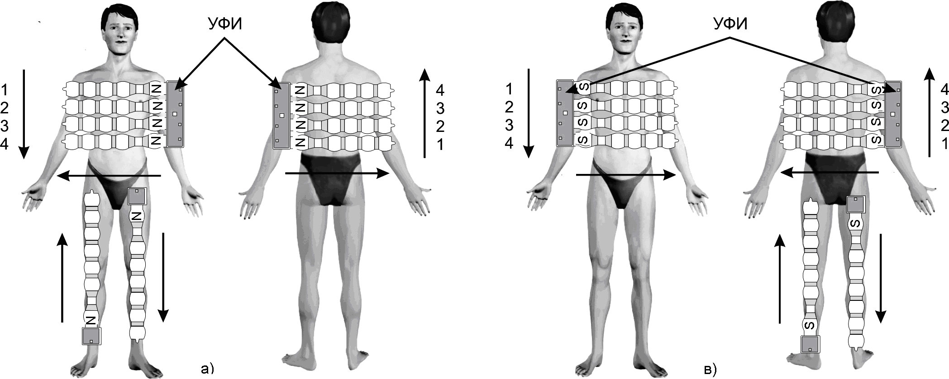
emitter
emitter

Direction of magnetic field traveling

The numbering of lines

Arrangement of unfolded basic emitter and flexible emitting stripe-line of different polarity to the patient body with magnetic field traveling different directions in space:

а) S polarity surface to the body , b) N polarity surface to body

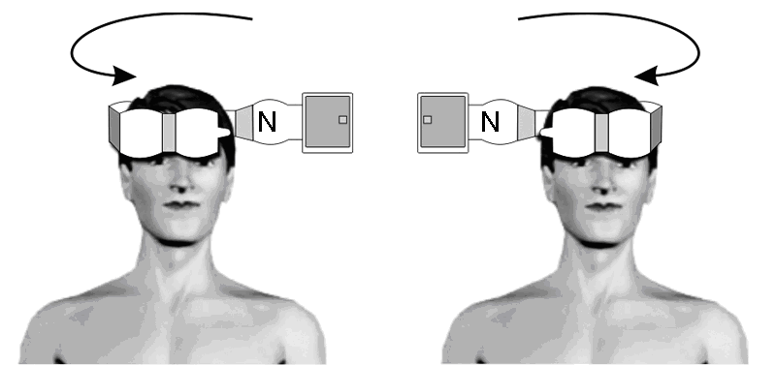
а) b)
The arrangement of flexible emitting stripe-line on a head with magnetic field various traveling directions in space: а) with conuterclockwise direction
в) with clockwise direction.
Direction of emitter magnetic field traveling does not depend on surface polarity directed to the head .

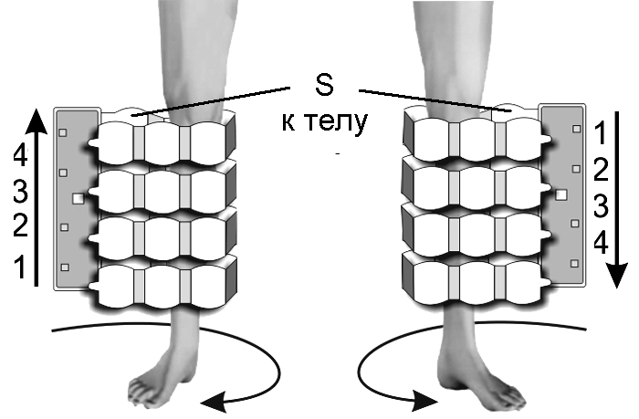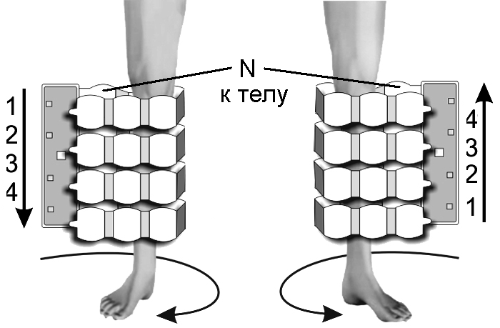
To body
To body
а) b) с) d)

The arrangement of basic emitter to on extremities with different polarity surface to the body at magnetic field various traveling directions in space:
а) S polarity surface to the body , directions : clockwise or bottom - up;
b) S polarity surface to the body , directions : counterclockwise or up –bottom;
с) N polarity surface to the body , directions : clockwise or up-bottom;
d) N polarity surface to the body , directions : counterclockwise or bottom -up .

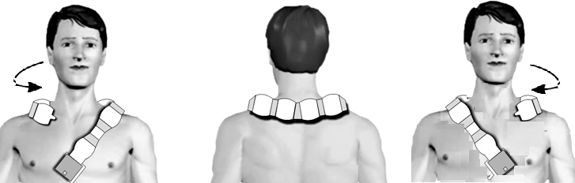
а) b)
The arrangement of flexible emitting stripe-line on collar zone with different directions of magnetic field in space:
а) with counterclockwise ,
b) with clockwise
Direction of emitter magnetic field traveling does not depend on polarity of the surface being directed to the body.

ALMAG-02 magneto-therapy particular techniques

Nervous system diseases

Neurocirculatory dystonia on hypertonic type
The used emitters: basic emitter, flexible emitting stripe-line.
Emitters arrangement : basic emitter is placed on lumbar area with kidneys and adrenal glands coverage, flexible emitting stripe-line - on «collar » area. Both emitters are placed with their “N” polarity surface to the body .
The course of treatment includes 10-12 procedures. One procedure a day .
For first three procedures Program No.1 is set.
- Magnetic field direction in basic emitter: traveling up-bottom, in flexible emitting stripe-line – traveling from left to right (the pulse generation block-unit is placed on the left);
- Induction - 8 mTl;
- Frequency - 3 Hz.
- Procedure time - 10 min.
For the following 7-9 procedures Program No.2 is set.
- Magnetic field direction in basic emitter: traveling up-bottom, in flexible emitting stripe-line – traveling from left to right;
- Induction - 10 mТl;
- Frequency: 10 Hz;
- Procedure time - 20 min.
Migraine.
The course of treatment - 10-12 procedures. One procedure a day
Setting Program No.3.
The used emitter: flexible emitting stripe-line
Emitter (flexible emitting stripe-line) is placed on the collar» zone with its “N” polarity surface to the body (the pulse generation block-unit is on the left)).
- Magnetic field direction in flexible emitting stripe-line - traveling from left to right :
- Induction - 10 mТl;;
- Frequency: 12 Hz;
- Procedure time - 10 min.

Transient transitional cerebral ischemic attacks and congenerous symptoms.
The treatment procedures are possible only in 3-6 weeks after transitory ischemic attack and in more late rehabilitation and residual period.
The course of treatment — not less then 15 procedures. One procedure a day
The used emitters: basic emitter and flexible emitting stripe-line.
Emitters arrangement : basic emitter is placed on lumber area , flexible emitting stripe-line is used to wrap the head. Both emitters are placed with their “N” polarity surface to the patient body.
Setting Program No.4.
- The direction of magnetic field in basic emitter - traveling up-bottom , in flexible emitting stripe-line – clock wise ;
- Induction: basic emitter- 20mTl, flexible emitting stripe-line - 10 mТl;
- Frequency: 100 Hz;
- Procedure time - 20 min.

Affection of separate nervous roots and plexuses of upper and lower extremities.
Attention !
Techniques of the clause are used to treat similar diseases in the case of alcoholic neuropathy

Radial, median and ulnar nerves
The course of treatment - 10-15 procedures. One procedure a day
The used emitters: basic emitter and flexible emitting stripe-line.
Emitters arrangement: basic emitter is placed on vertebral column cervicothoracic part , flexible emitting stripe-line – on the arm , on the affected nerve projection. Both emitters are placed with “N” surface to the patient body.
For the first 5 procedures Program No.5 is set:
- The direction of magnetic field in basic emitter - traveling up-bottom , in flexible emitting stripe-line – traveling bottom-up.
- Induction: basic emitter- 20mTl, flexible emitting stripe-line - 10 mТl;
- Frequency: 100 Hz;
- Procedure time: 10 min.
For the following 5-10 procedures Program No.6 is set.
- Magnetic field direction is the same as that for the first 5 day treatment.
- Induction: basic emitter- 10mTl, flexible emitting stripe-line - 25 mТl;
- Frequency: 12 Hz;
- Procedure time - 10 min.

The development of corresponding nerve paresis.
The course of treatment - 15 procedures. One procedure a day
The used emitters: basic emitter and flexible emitting stripe-line.
Emitters arrangement : basic emitter is placed on vertebral column cervicothoracic part , flexible emitting stripe-line – on the affected nerve projection with emitters “N” polarity surface to the body
Setting Program No.7.
- Magnetic field direction in basic emitter - fixed, in flexible emitting stripe-line– fixed.
- Induction: basic emitter- 6mTl, flexible emitting stripe-line - 6 mТl;
- Frequency: 10 Hz;
- Procedure time - 20 min.

Femoral, sciatic, tibial-and- fibular nerves illnesses
The course of treatment - 10-15 procedures. One procedure a day
The used emitters: basic emitter and flexible emitting stripe-line.
Emitters arrangement: basic emitter is placed on vertebral column lumbosacral projection , flexible emitting stripe-line is placed on the affected nerve projection. Both emitters are placed with their “N” polarity surface to the body.
For the first five procedures Program No.5 is set.
- The direction of magnetic field in basic emitter - traveling up-bottom , in flexible emitting stripe-line –
traveling bottom-up.
- Induction: basic emitter- 10mTl, flexible emitting stripe-line - 20 mТl;
- Frequency: 100 Hz;
- Procedure time: 10 min.
The following 5-10 procedures Program No.6 is set.
- Magnetic field direction is the same as that for the first 5 day treatment.
- Induction: basic emitter- 10mTl, flexible emitting stripe-line - 25 mТl;
- Frequency: 12 Hz;
- Procedure time - 10 min.

Diabetic polyneuropathy
The course of treatment - 15-20 procedures. One procedure a day
The repeated treatment courses are to be carried out after 3month expiration, three courses a year.
The used emitters: basic emitter and flexible emitting stripe-line.
First flexible emitting stripe-line is placed across lumbosacral part; lower leg and adjacent part of affected extremity knee joint are wrapped by the basic emitter with emitters “N” polarity surface to the body.
Setting Program No.8.
The direction of magnetic field in basic emitter - traveling bottom-up , in flexible emitting stripe-line – fixed
- Induction: basic emitter- 20mTl, flexible emitting stripe-line - 6 mТl;
- Frequency: 10 Hz;
- Procedure time: 10 min.
After the procedure time termination, the device is not plugged, flexible emitting stripe-line is left across lumbosacral part, the foot of affected extremity is wrapped by basic emitter or it is placed over the foot with emitters “N” polarity surface to the body. Then Program No.8 is to be set again.
- The direction of magnetic field in basic emitter — traveling bottom-up, in flexible emitting stripe-line – fixed;
- Induction: basic emitter- 20mTl, flexible emitting stripe-line - 6 mТl;
- Frequency: 10 Hz;
- Procedure time - 10 min.
You should not refuse to take sugar-reducing preparations and diets on the background of treatment by a magnetic field!

Postherpetic neuropathy.
The course of treatment - 15-20 procedures. One procedure a day . The repeated treatment course is to be carried out in a month.
The used emitter: basic emitter.
Emitters arrangement: basic emitter is placed on the backbone with its «N» polarity surface to the body.
First Program No.9 is set .
- Magnetic field direction in basic emitter- traveling botton-up;
- Induction : 20 mТl;
- Frequency: 100 Hz;
- Procedure time - 15 min.
After the procedure termination, the device is not plugged, basic emitter is replaced on the area of affected intercostal nerves.
Setting Program No.10
- Magnetic field direction in basic emitter – fixed;
- Induction : 6 mТl;
- Frequency: 16 Hz;
- Procedure time - 15 min.

Raynaud`s syndrome (syndrome of hand “dead finger)
The course of treatment — 15 procedures. One procedure a day. The repeated treatment course is to be carried out in two months.
The used emitter: basic emitter.
Emitters arrangement : to place basic emitter on cervicothoracic-collar zone with its «N» polarity surface to the body.
First,setting Program No.11.
- Magnetic field direction in basic emitter - fixed;
- Induction : 6 mТl;
- Frequency: 16 Hz;
- Procedure time: 10 min.
After the procedure termination, the device is not plugged, the affected extremity involving a part of hand is wrapped with basic emitter with its «N» polarity surface to the body.
Setting Program No.12.
- Magnetic field direction in basic emitter: traveling bottom -up;
- Induction : 25 mТl;
- Frequency: 75 Hz;
- Procedure time - 10 min.

Ear, throat and nose illnesses:
Attention!
Purulent processes or inflammation with a sinuses secretion outflow disorder are contra-indication for physiotherapy!

Chronic maxillary sinusitis (antritis), chronic frontal sinusitis (frontitis) in the non-exacerbation stage.
Antritis
The course of treatment — 10 procedures. One procedure a day.
The used emitter: flexible emitting stripe-line.
Emitters arrangement: flexible emitting stripe-line is placed on the nose involving the adjacent area of maxillary sinus projection with emitter «N» polarity surface to the body .
The setting Program No.51.
- Magnetic field direction: fixed;
- Induction 20 mTl.;
- Frequency: 50 Hz;
- Procedure time: 7 min.

Frontitis
The course of treatment — 10 procedures. One procedure a day.
The used emitter: flexible emitting stripe-line.
Emitters are placed on the area of frontal sinus projection with emitter «N» polarity surface to the body .
The setting Program No.52
- Magnetic field direction: fixed;
- Induction 20 mTl.;
- Frequency: 50 Hz;
- Procedure time: 10 min.

Acute and chronic eustachitis (salpingootitis) in the period of disease acute stage attenuation or the phase of remission.
The course of treatment — 10 procedures. One procedure a day. With chronic eustachitis the treatment courses can be repeated after the expiration of 30 days.
The used emitter: flexible emitting stripe-line.
Emitters arrangement: flexible emitting stripe-line is placed on the diseased ear involving the area of mastoid bone with the emitter «N» polarity surface to the body.
The setting Program No.53.
- Magnetic field direction: fixed;
- Induction 20 mTl.;
- Frequency: 10 Hz;
- Procedure time: 10 min.

Chronic laryngitis
The course of treatment — 8-10 procedures. One procedure a day.
The used emitter: flexible emitting stripe-line.
Emitter is placed on the larynx area with its «N» polarity surface to the body.
The setting Program No.54
- Magnetic field direction: fixed;
- Induction 20 mTl.;
- Frequency: 5 Hz;
- Procedure time: 10 min.

Neorosensorineural deafness
The course of treatment — 8-10 procedures daily or in a day.
The used emitter: flexible emitting stripe-line.
Emitter is placed on the ear area with its «N» polarity surface to the body.
The setting Program No.52
- Magnetic field direction: fixed;
- Induction 20 mTl.;
- Frequency: 50 Hz;
- Procedure time: 10 min.

Illnesses of circulatory system:

Hypertensive disease
The course of treatment — 15 procedures. One procedure a day. The repeated treatment course after 2-3 months expiration.
The used emitters: basic emitter, flexible emitting stripe-line.
Emitters arrangement: basic emitter is placed on spinal column cervicothoracic part, the head is wrapped by flexible emitting stripe-line with the emitters «N» polarity surfaces to the body.
The setting Program No.13
- Magnetic field direction in basic emitter: traveling up-bottom, in flexible emitting stripe-line: traveling clockwise;
- Induction 20 mTl.;
- Frequency: 100 Hz;
- Procedure time: 10 min.

With heart ischemic disease treatment procedure purpose: sympathoadrenal systems activity reduction and strengthening of CNS inhibitory processes with the subsequent reduction both of sympathetic actions on heart and a spasm of coronary vessels or resistive vessels dilation in shin muscles (heart muscle loading reduces)
The course of treatment — 15 procedures. One procedure a day. The repeated treatment course after 2-3 months expiration.
The used emitter: basic emitter.
First, the treatment procedure starts with basic emitter exposure on spinal column cervicothoracic part with the emitter «N» polarity surface to the body.
The setting Program No.14.
- Magnetic field direction in basic emitter: traveling up-bottom ;
- Induction: 20 mTl;
- Частота: 100 Гц;
- Procedure time: 10 min.
After the procedure time termination the device is not unplugged, the lower leg is covered with the basic emitter “N” polarity surface to the body
The setting Program No.15
Magnetic field direction in basic emitter: fixed;
- Induction: 6 mTl;
- Frequency: 16 Hz;
- Procedure time: 15 min.

Insult
The treatment starts not early than in 6 weeks after ischemic attack and later in the rehabilitation and residual period.
Treatment course includes 15 procedures. One procedure a day.
The used emitters: basic emitter, flexible emitting stripe-line.
Emitters arrangements: basic emitter is placed on spinal column cervicothoracic part, the head is wrapped by flexible emitting stripe-line with the emitters «N» polarity surface to the body..
The setting Program No.4
- Magnetic field direction in basic emitter: traveling up-bottom, in flexible emitting stripe-line : traveling clockwise ;
- Induction: basic emitter -20 mTl; flexible emitting stripe-line – 10 mTL;
- Frequency: 100 Hz;
- Procedure time: 20 min.

Aftereffects of cerebrovascular illnesses
Treatment course includes 10-12 procedures. One procedure a day.
The used emitters: basic emitter, flexible emitting stripe-line.
Emitters arrangements: basic emitter is placed on spinal column cervicothoracic part, the head is wrapped by flexible emitting stripe-line with the emitters «N» polarity surface to the body.
The setting Program No.16
- Magnetic field direction in basic emitter: traveling up-bottom, in flexible emitting stripe-line: traveling clockwise with emitters N» polarity surface to the body.
- Induction: 10 mTl;
- Frequency: basic emitter-100 Hz, flexible emitting stripe-line – 10 Hz;
- Procedure time: 20 min.

Vessels atherosclerotic illness, deforming or an obliterating endarteritis
Treatment course includes 15 procedures. One procedure a day. The repeated course are carried out after the expiration of 2-3 months.
The used emitters: basic emitter, flexible emitting stripe-line.
Emitters arrangement: thigh bone is wrapped by the basic emitter, flexible emitting stripe-line is placed on the area of waist sympathetic ganglions projection with emitters N» polarity surface to the body.
The setting Program No.17
- Magnetic field direction in basic emitter: traveling from right to left , in flexible emitting stripe-line : fixed;
- Induction: basic emitter -20 mTl; flexible emitting stripe-line – 6 mTL;
- Frequency: basic emitter-10 Hz, flexible emitting stripe-line – 16 Hz;
- Procedure time: 10 min.
After the procedure time termination the device is not unplugged, the emitters are replaced: the lower leg is covered with the basic emitter, flexible emitting stripe-line is placed on the area of waist sympathetic ganglions projection with emitters N» polarity surface to the body.
The setting Program No.17
- Magnetic field direction in basic emitter: traveling from right to left in flexible emitting stripe-line: fixed;
- Induction: basic emitter -20 mTl; flexible emitting stripe-line – 6 mTL;
- Frequency: basic emitter-10 Hz, flexible emitting stripe-line – 16 Hz;
- Procedure time: 10 min.

Aterosclerotic encephalopathy
Treatment course includes 10-12 procedures. One procedure a day.
Procedures are carried out in a day.
The used emitters: basic emitter, flexible emitting stripe-line.
Emitters arrangement: basic emitter is placed on spinal column cervicothoracic part, the head is wrapped by flexible emitting stripe-line with the emitters «N» polarity surface to the body.
The setting Program No.16
- Magnetic field direction in basic emitter: traveling up-bottom, in flexible emitting stripe-line: traveling clockwise;
- Induction: 10 mTl;
- Frequency: basic emitter-100 Hz, flexible emitting stripe-line – 10 Hz;
- Procedure time: 20 min.

Varicose disease
Treatment course includes 15 procedures. One procedure a day.
The repeated course are carried out after the expiration of 2-3 months.
The used emitters: basic emitter.
Emitters arrangement: first, affected extremity lower leg is wrapped by the basic emitter with emitter “N» polarity surface to the body.
The setting Program No.18
- Magnetic field direction in basic emitter: traveling bottom-up;
- Induction: 20 mTl;
- Frequency: 100 Hz;
- Procedure time: 10 min.
After the procedure time termination the device is not unplugged: affected extremity thigh is wrapped by basic emitter with emitter N» polarity surface to the body.“N”
The setting Program No.18
- Magnetic field direction in basic emitter: traveling bottom-up;
- Induction: 20 mTl;
- Frequency: 100 Hz;
- Procedure time: 10 min.

Low legs deep veins thrombophlebitis
Before the procedure you can apply “ Lioton”, “ Gepalpan”, “ Doloben” gel on the skin in the area of exposure this manipulation promotes increase of the treatment procedure quality.
Treatment course includes 15 procedures. One procedure a day.
The treatment course is repeated after the expiration of 2-3 months.
The used emitter: basic emitter.
Affected extremity lower leg is wrapped by basic emitter with emitter “N» polarity surface to the body.
The setting Program No.35.
- Magnetic field direction in basic emitter: fixed ;
- Induction: 6 mTl;
- Frequency: 16 Hz;
- Procedure time : 20 min.

Chronic thrombophlebitis accompanied with trophic disorders
At carrying exposure procedure out the ulcer defect is to be covered with a sterile bandage or a bandage with a medical preperation to accelerate healing of ulcer defect.
Treatment course includes 10 procedures. One procedure a day.
The repeated course is carried out after 30 days expiration. Then, with the prophylactic purpose, the treatment courses are carried out after the expiration of 2-3 months
The used emitters: basic emitter, flexible emitting stripe-line.
Basic emitter is placed on the couch or bed, the patient lies on it so that his/her diseased extremities are to be on emitter, flexible emitting stripe-line is placed on the area of ulcer defect with emitters “N» polarity surfaces to the body.
The setting Program No.55.
- Magnetic field direction in basic emitter: fixed, in flexible emitting stripe-line:fixed
- Induction: 6 mTl;
- Frequency: 16Hz;
- Procedure time : 10 min.
After the procedure time termination the device is not unplugged, basic emitter is placed on the couch or bed, the patient lies on it so that his/her diseased extremity`s thin` should be on emitter, flexible emitting stripe-line is placed on the area of ulcer defect with emitters “N» surfaces to the body.
The setting Program No.55.
- Magnetic field direction in basic emitter: fixed, in flexible emitting stripe-line:fixed
- Induction: 6 mTl;
- Frequency: 16 Hz;
- Procedure time : 10 min.

Chronic lymphedema (lymphatic edema)
Treatment course includes 15 procedures. One procedure a day.
The repeated course is carried out after 30 days expiration. Then, with the prophylactic purpose, the treatment courses are carried out after the expiration of 2-3 months
The used emitter: basic emitter.
Diseased extremity thin is wrapped by basic emitter with emitter “N» polarity surface to the body.
The setting Program No.19.
- Magnetic field direction in basic emitter: traveling bottom-up;
- Induction: 20 mTl;
- Frequency: 50Hz;
- Procedure time : 15 min.
After the procedure time termination the device is not unplugged, diseased extremity lower leg is wrapped by basic emitter
The setting Program No.19.
- Magnetic field direction in basic emitter: traveling bottom-up;
- Induction: 20 mTl; ;
- Frequency: 50Hz;
- Procedure time : 15 min.

Illnesses of respiratory organs:

Virus pneumonia
Bacterial pneumonia
Chronic bronchitis non-acute stage
Treatment course includes 15 procedures. One procedure a day.
The used emitter: basic emitter.
Basic emitter is placed on the couch, the patient is the lying position on his/her back, the patient`s interscapular part is to be on the emitter`s middle part with its “N” polarity surface to the body
The setting Program No.20.
- Magnetic field direction in basic emitter: traveling from right to left;
- Induction: 20 mTl;
- Frequency: 100 Hz;
- Procedure time : 20 min.

Bronchial asthma and chronic obstructive pulmonary illness
Treatment course includes 15 procedures. One procedure a day.
Repeated course - after the expiration of 2- 3 months
The used emitters: basic emitter and flexible emitting stripe-line.
Emitters arrangement: basic emitter is placed on lung`s root projection, flexible emitting stripe-line – on the adrenal projection with the emitters “N” polarity surfaces to the body
The setting Program No.21.
- Magnetic field direction in basic emitter: traveling from right to left , in flexible emitting stripe-line:fixed;
- Induction: basic emitter-20 mTl,flexible emitting stripe-line– 6 mTl;
- Frequency: basic emitter- 100 Hz, flexible emitting stripe-line -16Hz;
- Procedure time: 30 min.

Exudative pleurisy (after liquid extraction from pleural cavity, three days later after theracocentesis)
Treatment course includes 15 procedures. One procedure a day.
The used emitter: basic emitter.
Treatment procedure: during the first tree procedures the patient lies on his/her healthy side, basic emitter is placed on the chest along the diseased part from the back with emitter “N” polarity surface to the body.
The setting Program No.22..
- Magnetic field direction in basic emitter: fixed;
- Induction:6 mTl;
- Frequency: 3 Hz;
- Procedure time: 30 min.
Beginning with the fourth procedure and up to the course termination the emitter has the same arrangement on the diseased part.
The setting Program No.23.
- Magnetic field direction in basic emitter: fixed ;
- Induction: 6 mTl;
- Frequency: 16 Hz;
- Procedure time : 30 min.

Diseases of digestive apparatus:
Reflux-esophagitis
Treatment course includes 15 procedures . One procedure a day.
Repeated treatment course in 2- 3 months.
The used emitter: flexible emitting stripe-line.
The emitters are placed on epigastrium area (the bottom part of costal arch, right and left front side) with emitters «N» polarity surfaces to the body.
The setting Program No.56..
- Magnetic field direction in flexible emitting stripe-line: fixed ;
- Induction:30 mTl;
- Frequency: 50 Hz;
- Procedure time: 15 min.

Stomach and duodenum ulcer.
Treatment course includes 10-12 procedures . One procedure a day.
Repeated treatment course in 2- 3 months.
The used emitters: basic emitter,flexible emitting stripe-line.
Emitters arrangement: basic emitter is placed on the spinal column chest and waist parts, flexible emitting stripe-line – on the epigastrium area with emitters «N» polarity surfaces to the body.
The setting Program No.57.
- Magnetic field direction in basic emitter: traveling up-bottom, in flexible emitting stripe-line: fixed ;
- Induction: basic emitter-20 mTl, flexible emitting stripe-line–30 mTl;
- Frequency: basic emitter-10 Hz, flexible emitting stripe-line – 12 Hz;
- Procedure time: 10 min.

Gastritis and duodenitis
Treatment course includes 15-20 procedures . One procedure a day.
Repeated treatment course in 2- 3 months.
The used emitters: basic emitter, flexible emitting stripe-line.
Emitters arrangement: basic emitter is placed on the spinal column chest and waist parts, flexible emitting stripe-line – on the epigastrium area with emitters «N» surface to the body.
The setting Program No.58.
- Magnetic field direction in basic emitter: traveling up-bottom, in flexible emitting stripe-line: fixed ;
- Induction: basic emitter-20 mTl, flexible emitting stripe-line– 30 mTl;
- Frequency: basic emitter-100 Hz, flexible emitting stripe-line – 16 Hz;
- Procedure time: 15 min.

Syndrom of irritant large intestine without diarrhea
Treatment course includes 10 procedures . One procedure a day.
The used emitter: basic emitter.
Basic emitter is placed on the abdomen with its «N» polarity surface to the body.
The setting Program No.24.
- Magnetic field direction in basic emitter: fixed;
- Induction: 6 mTl;
- Frequency: 16 Hz;
- Procedure time: 20 min.

Liver alcoholic illness
Alcohol is contra-indicated on a background of ongoing treatment!
Treatment course includes 10 procedures. One procedure a day.
The used emitter: basic emitter.
Emitters arrangement: basic emitter is placed on the area of liver projection from the back with its «N» polarity surface to the body.
The setting Program No.25.
- Magnetic field direction in basic emitter: traveling bottom-up;
- Induction: 25 mTl;
- Frequency: 75 Hz;
- Procedure time: 15 min.

Chronic hepatitis.
Not specified liver toxic affection
Treatment course includes 10 procedures . One procedure a day.
The used emitters: basic emitter,flexible emitting stripe-line.
Emitters arrangement: basic emitter is placed on the back(emitter working area is on the area of liver projection), flexible emitting stripe-line - on the area of gall-bladder, with emitters N» polarity surfaces to the body.
The setting Program No.59.
- Magnetic field direction in basic emitter: traveling from left to right, in flexible emitting stripe-line: fixed ;
- Induction: basic emitter-20 mTl,flexible emitting stripe-line– 35 mTl;
- Frequency: basic emitter-100 Hz, flexible emitting stripe-line – 50 Hz;
- Procedure time: 15 min.

Cholecystitis
The treatment procedures are being started in sub-acute period or in the period of disease subside with prophylaxis purpose.
Treatment course includes 10-12 procedures .
The used emitters: basic emitter,flexible emitting stripe-line.
Emitters arrangement: basic emitter is placed on the spinal column chest and waist parts, flexible emitting stripe-line – on the area of gall-bladder, with emitters N» polarity surfaces to the body.
For the first 3 procedures Program No.60 is set.
- Magnetic field direction in basic emitter: traveling from left to right, in flexible emitting stripe-line: fixed;
- Induction: 10 mTl;
- Frequency: 100 Hz;
- Procedure time: 15 min.
Beginning with the 4th procedure up to the treatment course termination Program No.61 is set
- Magnetic field direction in basic emitter: traveling from left to right, in flexible emitting stripe-line: fixed ;
- Induction: 10 mTl;
- Frequency: 10 Hz;
- Procedure time: 15 min.

Biliary dyskinesia
The treatment procedures are being started in sub-acute period or in the period of disease subside with prophylaxis purpose.
Treatment course includes 10-12 procedures . One procedure a day.
The used emitter: basic emitter, flexible emitting stripe-line;
Emitters arrangement: basic emitter is placed on spinal column chest and waist parts, flexible emitting stripe-line - on gall-bladder projection with emitters «N» polarity surfaces to the body.
The setting Program No.61.
- Magnetic field direction in basic emitter: traveling from left to right, in flexible emitting stripe-line: fixed ;
- Induction: 10 mTl;
- Frequency: 10 Hz;
- Procedure time: 15 min.

Gallbladder hypomotor dyskinesia (cholecystopathy without gall-stones)
Treatment course includes 10 procedures . One procedure a day.
The used emitter:flexible emitting stripe-line
The emitter is placed on area of gall-bladder projection with its «N» polarity surface to the body.
The setting Program No.62.
- Magnetic field direction: fixed;
- Induction: 10 mTl;
- Frequency: 45 Hz;
- Procedure time: 15 min.

Chronic pancreatitis
Treatment course includes 10 procedures. One procedure a day.
The used emitters: basic emitter, flexible emitting stripe-line.
Basic emitter is placed on spinal column chest and waist parts , flexible emitting stripe-line – on the area of pancreas projection, on the abdominal wall with emitters «N» polarity surfaces to the body.
The setting Program No.26.
- Magnetic field direction in basic emitter: traveling from left to right, in flexible emitting stripe-line: traveling from left to right.
- Induction: 2 mTl;
- Frequency: 5 Hz;
- Procedure time: 8 min.

Syndrom of operated stomach
Treatment course includes 10-12 procedures. One procedure a day.
The used emitter: flexible emitting stripe-line.
The emitter is placed on the area of epigastrium projection and postoperative scar with its “N” polarity surface to the body
The setting Program No.63.
- Magnetic field direction in flexible emitting stripe-line: fixed ;
- Induction: 30 mTl;
- Frequency: 100 Hz;
- Procedure time: 15 min.

Postcholecystectomy syndrom
Treatment course includes 10-12 procedures .
Emitters: 2 flexible emitting stripe-lines.
Emitters are placed on liver projection in back direction segmentally with emitters “N” polarity surfaces to the body.
The setting Program No.64.
- Magnetic field direction in flexible emitting stripe-line: fixed ;
- Induction: 35 mTl;
- Frequency: 50 Hz;
- Procedure time: 12 min.

Illnesses of the skin and subcutaneous fat:

In case of using ointments and creams before procedure, procedures are carried out through the underwear or napkins not to dirty emitters.

Keloid cicatrix
Attention! With the purpose of keloid cicatix formation prophylaxis the same technique is applied for postoperative and posttraumatic wounds treatment
Treatment course includes 10 -12 procedures. One procedure a day.
The used emitters: flexible emitting stripe-line
Emitters arrangement: flexible emitting stripe-line is placed on the area of cicatrix with emitter «N» polarity surface to the body.
The setting Program No.65.
- Magnetic field direction in flexible emitting stripe-line – fixed;
- Induction: 35 mTl;
- Frequency: 50 Hz;
- Procedure time: 20 min.

Lichen ruber planus
Treatment course includes 10 -12 procedures. One procedure a day.
The used emitters: basic emitter, flexible emitting stripe-line.
Emitters arrangement: basic emitter is placed on the spinal column part corresponding to the area of appearance of skin rash, flexible emitting stripe-line – on the area of appearance of skin rash with emitters «N» polarity surfaces to the body.
The setting Program No.66.
- Magnetic field direction:in basic emitter – traveling up-down, in flexible emitting stripe-line – fixed;
- Induction: basic emitter - 10 mTl, flexible emitting stripe-line- 20 mTl;
- Frequency:-100 Hz, flexible emitting stripe-line – 50 Hz;
- Procedure time: 10 min.

Limited neurodermatitis, skin itch, nettle-rash, eczema, neurodermatitis, prurigo, atopic dermatitis
Treatment course includes 10 -12 procedures. One procedure a day.
The used emitters: basic emitter, flexible emitting stripe-line.
Emitters arrangement : basic emitter is placed on the spinal column part corresponding to the area of appearance of skin rash, flexible emitting stripe-line – on the area of appearance of skin rash with emitters «N» side to the body.
The setting Program No.67.
- Magnetic field direction: in basic emitter – traveling up-bottom, in flexible emitting stripe-line – fixed;
- Induction: 20 mTl;
- Frequency: basic emitter-100 Hz, flexible emitting stripe-line – 50 Hz;
- Procedure time: 10 min.

Psoriasis
Treatment course includes 15 procedures. One procedure a day.
The used emitters: basic emitter, flexible emitting stripe-line.
Emitters arrangement : basic emitter is placed on the spinal column part corresponding to the area of focal lesion , flexible emitting stripe-line – on the area of focal lesion with emitters «N» polarity surface to the body.
The setting Program No.66.
- Magnetic field direction:in basic emitter – traveling bottom-up, in flexible emitting stripe-line – fixed;
- Induction: basic emitter- 10 mTl, flexible emitting stripe-line - 20 mTl;
- Frequency: basic emitter-100 Hz, flexible emitting stripe-line – 50 Hz;
- Procedure time: 10 min.

Psoriatic arthropathy case
Treatment course includes 15 procedures. One procedure a day.
The used emitters: flexible emitting stripe-line.
Emitters arrangement: the affected joint is placed between 2 flexible emitting stripe-lines with emitters «N» polarity surface to the body.
The setting Program No.52.
- Magnetic field direction: flexible emitting stripe-line – fixed;
- Induction: flexible emitting stripe-line - 20 mTl;
- Frequency: flexible emitting stripe-line 50 Hz;
- Procedure time: 10 min.

Hydradenitis
Treatment course includes 15 -20 procedures. One procedure a day.
The used emitters: flexible emitting stripe-line.
The first three procedures:
Flexible emitting stripe-line is placed on the cutting area with emitter «N» polarity surface to the body.
The setting Program No.68.
- Magnetic field direction: flexible emitting stripe-line – fixed;
- Induction: flexible emitting stripe-line - 20 mTl;
- Frequency:flexible emitting stripe-line -50 Hz;
- Procedure time: 20 min.
Beginning with the 4th procedure up to the procedure termination .
Flexible emitting stripe-line is placed on the cutting area with emitter «N» polarity surface to the body.
The setting Program No.68.
- Magnetic field direction: flexible emitting stripe-line – fixed;
- Induction: flexible emitting stripe-line - 20 mTl;
- Frequency: flexible emitting stripe-line -50 Hz;
- Procedure time: 20 min.

Osteomuscular system and the connecting tissue diseases:

Gouty arthritis.
Procedure course includes 15 procedures. One procedure a day.
In connection with the fact that disease have chronic character, with the purpose of relapses prophylaxis it is necessary to carry out repeated courses of pulsed magnetic therapy 2-3 times a year.
The used emitter:flexible emitting stripe-line
The first 3 procedures:
flexible emitting stripe-line is placed on affected joint with its «S» polarity surface to the body
The setting Program No.69.
- Magnetic field direction in flexible emitting stripe-line – fixed;
- Induction: flexible emitting stripe-line 10mTl.
- Frequency: flexible emitting stripe-line 100 Hz;
- Procedure time: 10min.
Beginning with the 4th procedure up to the treatment course termination :
flexible emitting stripe-line is placed on affected joint with its «N» polarity surface to the body.
The setting Program No.70.
- Magnetic field direction in flexible emitting stripe-line – fixed;
- Induction: flexible emitting stripe-line 15mTl.
- Frequency: flexible emitting stripe-line 10 Hz;
- Procedure time: 20min.

Coxarthrosic
Procedure course includes 15 procedures. One procedure a day.
As the disease have chronic character, with the purpose of relapses prophylaxis it is necessary to carry out repeated courses of pulsed magnetic therapy 2-3 times a year.
The used emitter: basic emitter.
The first 5 procedures.
Emitters arrangement: affected joint is wrapped with basic emitter with its “N” polarity surface to the body.
The setting Program No.27.
- Magnetic field direction in basic emitter – traveling from left to right ;
- Induction: 15 mTl;
- Frequency: 100 Hz;
- Procedure time: 15min.
Beginning with the 6th procedure up to the treatment course termination :
Emitters arrangement: affected joint is wrapped with basic emitter with “N” polarity surface to the body.
The setting Program No.28.
- Magnetic field direction in : basic emitter – traveling from lift to right;
- Induction: 10 mTl;
- Frequency: 25 Hz;
- Procedure time: 20min.

Gonarthrosis
Procedure course includes 15 procedures. One procedure a day.
As the disease have chronic character, with the purpose of relapses prophylaxis it is necessary to carry out repeated courses of pulsed magnetic therapy 2-3 times a year.
The used emitter: basic emitter.
The first 5 procedures
Emitters arrangement: affected joint is wrapped with basic emitter with its “N” polarity surface to the body.
The setting Program No.29.
- Magnetic field direction in : basic emitter – traveling from lift to right;
- Induction: 10 mTl;
- Frequency: 100 Hz;
- Procedure time: 15min.

Beginning with the 6th procedure up to the treatment course termination :
Emitters arrangement: affected joint is wrapped with basic emitter with its “N” polarity surface to the body.
The setting Program No.30.
- Magnetic field direction in : basic emitter – traveling from lift to right;
- Induction: 20 mTl;
- Frequency: 10 Hz;
- Procedure time: 20min.

Arthrosis of the first carpometacarpal joint
Procedure course includes 15 procedures. One procedure a day.
As the disease have chronic character, with the purpose of relapses prophylaxis it is necessary to carry out repeated courses of pulsed magnetic therapy 2-3 times a year.
The used emitter: flexible emitting stripe-line.
The first 3 procedures:
Emitters arrangement: flexible emitting stripe-line is placed on the affected joint with “N” polarity surface to the body.
The setting Program No.71.
- Magnetic field direction in flexible emitting stripe-line – fixed;
- Induction: flexible emitting stripe-line -8 mTl;
- Frequency: flexible emitting stripe-line 100 Hz;
- Procedure time: 15min.

Beginning with the 4th procedure up to the treatment course termination :
Emitters arrangement: flexible emitting stripe-line is placed on the affected joint with its “N” polarity surface to the body.
The setting Program No.72.
- Magnetic field direction in flexible emitting stripe-line – fixed;
- Induction: flexible emitting stripe-line 15 mTl;
- Frequency: flexible emitting stripe-line 10 Hz;
- Procedure time: 20min.

Internal and external (tennis elbow) (golf elbow) humeral epicondylitis
Procedure course includes 15 -20 procedures. One procedure a day.
The used emitter: flexible emitting stripe-line.
Emitters arrangement: affected elbow is wrapped with flexible emitting stripe-line with its “N” polarity surface to the body.
The setting Program No.31.
- Magnetic field direction in flexible emitting stripe-line – traveling clockwise.
- Induction: 20 mTl;
- Frequency: 100 Hz;
- Procedure time: 15min.

Scapulohumeral periarthrosis
Procedure course includes 10 procedures. One procedure a day.
The used emitters: basic emitter, flexible emitting stripe-line.
Emitters arrangement: basic emitter is placed on spinal column thoracocervical with shift to affected joint, flexible emitting stripe-line - on the affected joint with emitters «N» polarity surfaces to the body .
The setting Program No.73.
- Magnetic field direction in basic emitter — traveling up-bottom, in flexible emitting stripe-line – fixed;
- Induction: basic emitter 20 mTl; flexible emitting stripe-line 30mTl.
- Frequency: basic emitter 100 Hz, flexible emitting stripe-line 10 Hz;
- Procedure time: 15min.

Acute trophoneurotic bone atrophy (Sudeck`s atrophy)
Procedure course includes 10 procedures. One procedure a day.
The used emitters: basic emitter.
During the procedure basic emitter is being replaced in turn on 3 areas.
First, basic emitter is placed on the couch or bed, the patient is in lying position with spinal column cervicothoaracic part on it. The emitter with “N” polarity surface is turned to the patient` body
The setting Program No.32.
- Magnetic field direction -traveling up-bottom;
- Induction: 20 mTl;
- Frequency: 100 Hz;
- Procedure time:7 min.
After the exposure time termination, no need to unplug device, wrap the shoulder by basic emitter with «N» polarity surface to the body
The setting Program No.32.
- Magnetic field direction: basic emitter -traveling bottom-up;
- Induction: 20 mTl;
- Frequency: 100 Hz;
- Procedure time: 7 min.
Then, not unplugging the device, wrap the forearm and arm by the basic emitter with «N» polarity surface to the body .
The setting Program No.32.
- Magnetic field direction: basic emitter traveling bottom-up;
- Induction: 20 mTl;
- Frequency: 100 Hz;
- Procedure time: 7min.

Paratenonitis (crepitant forearm tendovaginitis)
Procedure course includes 15 procedures. One procedure a day.
The used emitter: basic emitter.
The affected extremity is wrapped by the emitter with its «N» polarity surface to the body .
The setting Program No.33.
- Magnetic field direction: basic emitter -traveling bottom-up;
- Induction: 25mTl;
- Frequency: 75Hz;
- Procedure time: 20min.

Tietze`s syndrom (aseptic coatal cartilage inflammation in the area of rib joining to sternum, more often II-IV ribs with the painful thickening)
Procedure course includes 15 procedures. One procedure a day.
The used emitter: flexible emitting stripe-line
Flexible emitting stripe-line is placed on the affected area with its «N» polarity surface to the body .
The setting Program No.74.
- Magnetic field direction: fixed;
- Induction: 35 mTl;
- Frequency: 50 Hz;
- Procedure time: 15min.

Osteochondropathy (Celer disease,Kienböck`s disease,Perthes`disease, Schlatter disease, Cenig disease)
Procedure course includes 10 procedures. One procedure a day.
Emitters arrangement: basic emitter is placed on the affected area (which is covered or wrapped depending on affected area) with its “N” polarity surface to the body.
The setting Program No.34.
- Magnetic field direction: basic emitter -traveling from left to right;
- Induction: 15 mTl;
- Frequency: 100 Hz;
- Procedure time: 15min.

Ankylosing spondylitis (Bechterew`s disease)
In this case magnetotherapy is effective at the disease early (I-II) stages. Magneto-therapy is not carried out under the diseased high activity process (acute stage) .
Procedure course includes 20 procedures. One procedure a day.
The used emitter: basic emitter.
Basic emitter is placed on the couch or bed with its “N” polarity surface upward, the patient is in lying position with his/her spinal column cervicothoracic part on it .
The setting Program No.11.
- Magnetic field direction: basic emitter -fixed;
- Induction: 6 mTl;
- Frequency: 16 Hz;
- Procedure time: 10min.

After the exposure time termination (with the device serviceable state) basic emitter is moved down along the couch or bed so that spinal column lumbosacral part to be on it.
Program No.11 is set again.

Temporomandibulat joint osteoarthrosis
Procedure course includes 15-20 procedures. One procedure a day.
The used emitter: flexible emitting stripe-line.
Emitters arrangement: emitter is placed on the affected area with its“N” polarity surface to the body.
The setting Program No.75.
- Magnetic field direction: flexible emitting stripe-line - fixed;
- Induction: 20 mTl;
- Frequency: 50 Hz;
- Procedure time: 15min.

Calcaneal periosteosis , heel spur
Procedure course includes 15-20 procedures. One procedure a day.
The used emitter: flexible emitting stripe-line.
Emitter arrangement: flexible emitting stripe-line is placed on the heel or 2 flexible emitting stripe-lines are arranged along the both sides of affected heel bone with emitters 'N” polarity surface to the body .
The setting Program No.76.
- Magnetic field direction: flexible emitting stripe-line- fixed;
- Induction: 30 mTl;
- Frequency: 10 Hz;
- Procedure time: 20min.

Joint contracture (Dupuytren`s conracture)
Procedure course includes 15-20 procedures. One procedure a day.
The used emitter: flexible emitting stripe-line.
Emitters are arranged along the both sides of affected heel bone with 'N” polarity surfaces to the body.
The setting Program No.65.
- Magnetic field direction: flexible emitting stripe-line- fixed;
- Induction: 35 mTl;
- Frequency: 50 Hz;
- Procedure time: 20min.

Rheumatic arthritis (exudative stage)
Procedure course includes 15-20 procedures.
During the procedure it is possible to carry out the treatment of 2 joints simultaneously .
The used emitters: basic emitter and flexible emitting stripe-line.
Emitters arrangement: basic emitter is placed on the area of adrenal gland projection, the affected joint is wrapped by flexible emitting stripe-line with emitters 'N” polarity surfaces to the body.
The setting Program No.36.
- Magnetic field direction in basic emitter – traveling clockwise, flexible emitting stripe-line- fixed;
- Induction: basic emitter 10 mTl; flexible emitting stripe-line 6mTl.
- Frequency: basic emitter 100 Hz, flexible emitting stripe-line 16 Hz;
- Procedure time: 10min.
In case the number of affected joints is more than one: basic emitter is left on the on the area of adrenal gland projection , and the other affected joint is wrapped by flexible emitting stripe-line with emitters “N” polarity surface to the body.
The setting Program No.36.
- Magnetic field direction in basic emitter – traveling clockwise, flexible emitting stripe-line- fixed;
- Induction: basic emitter 10 mTl; flexible emitting stripe-line 6mTl.
- Frequency: basic emitter 100 Hz, flexible emitting stripe-line 16 Hz;
- Procedure time: 10min.

Osteoarthrosis
Procedure course includes 15 procedures.
The used emitter: basic emitter.
With evident syndrome and synovitis
The affected joint is wrapped by basic emitter with its “N” polarity surface to the body.
The setting Program No.37.
- Magnetic field direction in basic emitter – traveling clockwise;
- Induction: 10 mTl;
- Frequency: 100 Hz;
- Procedure time: 10min.

Without synovitis
Procedure course includes 15 procedures.
The used emitter: basic emitter.
The affected joint is wrapped by basic emitter with its “N” polarity surface to the body
The setting Program No.38.
- Magnetic field direction in basic emitter – traveling clockwise;
- Induction: 25 mTl;
- Frequency: 10 Hz;
- Procedure time: 15min.

Spinal column osteochondrosis
Procedure course includes 12-15 procedures.
The used emitter: basic emitter
Emitters arrangement: basic emitter is placed on the affected spinal column part with its “N” polarity surface to the body.
The first 3 procedures:
The setting Program No.39.
- Magnetic field direction in basic emitter – traveling up-bottom;
- Induction: 10 mTl;
- Frequency: 3 Hz;
- Procedure time: 20min.

Beginning with the 4th procedure up to the treatment course termination:
The setting Program No.40.
- Magnetic field direction in basic emitter – traveling up-bottom;
- Induction: 15 mTl;
- Frequency: 10 Hz;
- Procedure time: 20min.

Back cervical sympathetic syndrome
Disease clinical symptoms: burning, constrictive pain in back of the head, neck, chest front wall, shoulder or interscapular region. More frequently syndrome is developed on the background of cervical osteochondrosis .
Procedure course includes 15 procedures. One procedure a day.
The used emitter: basic emitter
Emitters arrangement: basic emitter is placed on the spinal column cervicothoracic part with its «N» polarity surface to the body. .
The setting Program No.41.
- Magnetic field direction in basic emitter – traveling up-bottom;
- Induction: 2 mTl;
- Frequency: 100 Hz;
- Procedure time: 10min.
After procedure termination (not unplugging the device), the diseased extremity is wrapped by the basic emitter with its 'N” polarity surface to the body.
The setting Program No.42.
- Magnetic field direction in basic emitter – traveling clockwise;
- Induction: 20 mTl;
- Frequency: 100 Hz;
- Procedure time: 10min.

Vertebro- -basilar syndrom (vertebral artery reflex- compressive syndrome)
Procedure course includes 15 procedures. One procedure a day. Repeated course in 1,5 – 2 a months.
The used emitters: basic emitter, flexible emitting stripe-line.
The first 5 procedures:
First, basic emitter is placed on spinal column cervicothoracic part with its “N” polarity surface to the body.
The setting Program No.43.
- Magnetic field direction in basic emitter – traveling up-bottom;
- Induction: 10 mTl;
- Frequency: 100 Hz;
- Procedure time: 20min.
After procedure termination (not unplugging the device), the head is wrapped with flexible emitting stripe-line with its «N» polarity surface to the body.
The setting Program No.44.
- Magnetic field direction in flexible emitting stripe-line– traveling clockwise;
- Induction: 10 mTl;
- Frequency: 12 Hz;
- Procedure time: 10min.

Beginning with the 6th procedure up to the treatment course termination:
First, spinal column cervicothoracic part is wrapped by the basic emitter with its «N» к телу.
The setting Program No.45.
- Magnetic field direction in basic emitter – traveling up-bottom;
- Induction: 25 mTl;
- Frequency: 10 Hz;
- Procedure time: 20min.

After procedure termination (not unplugging the device), the head is wrapped with flexible emitting stripe-line with its «N» polarity surface to the body.
The setting Program No.46.
- Magnetic field direction in flexible emitting stripe-line– traveling clockwise;
- Induction: 15 mTl;
- Frequency: 12 Hz;
- Procedure time: 10min.

Vertebrogen myelopathy syndrom.
The disease is developed on the background of lumbar osteochondrosis.
Procedure course includes 15 procedures. One procedure a day. Repeated course is taken after the expiration of 1,5 – 2 months.
The used emitters: basic emitter, flexible emitting stripe-line.
Emitters arrangement: basic emitter is placed on the spinal column lumbosacral part,flexible emitting stripe-line – on the thigh bone and lower leg with emitters “N” polarity surfaces to the body.
The setting Program No.47.
- Magnetic field direction in basic emitter – traveling bottom-up, imflexible emitting stripe-line– traveling;
- Induction: 20 mTl;
- Frequency: 100 Hz;
- Procedure time: 15min.

Porosis
Procedure course includes 15 procedures. One procedure a day. Repeated course is taken after the expiration of 1,5 – 2 months.
The used emitters: basic emitter.
First the emitter is placed on the couch or bed with its “N” polarity surface upward, the patient is in lying position with his/her spinal column lumbosacral part on it .
The setting Program No.10.
- Magnetic field direction in basic emitter- fixed;
- Induction: 6 mTl;
- Frequency: 16 Hz;
- Procedure time: 15min.

After procedure termination (not unplugging the device), the affected extremity thigh bone is wrapped with the basic emitter with its «N» polarity surface to the body.
The setting Program No.10.
- Magnetic field direction in basic emitter- fixed;
- Induction: 6 mTl;
- Frequency: 16 Hz;
- Procedure time: 15min.

After procedure termination (not unplugging the device), the affected extremity lower leg is wrapped with the basic emitter with its «N» polarity surface to the body.
The setting Program No.10.
- Magnetic field direction in basic emitter- fixed;
- Induction: 6 mTl;
- Frequency: 16Hz;
- Procedure time: 15min.

Osteoporosis with and without pathologic fracture
Procedure course includes 15 procedures. One procedure a day. Repeated course is taken after the expiration of 1,5 – 2 months.
The used emitter: basic emitter.
The affected extremity is wrapped with the basic emitter with its «N» polarity surface to the body.
The setting Program No.48.
- Magnetic field direction in basic emitter- traveling up-bottom;
- Induction: 10 mTl;
- Frequency: 8Hz;
- Procedure time:20min.

Urogenital system diseases :
Chronic tubulointerstitial nephritis (tubulointerstitial and tubular injuries caused by medicinal agents and heavy metals)
Procedure course includes 10-15 procedures.
The used emitter: basic emitter.
First the basic emitter is placed on the couch or bed with its “N” polarity surface upward, the patient is in lying position with his/her kidney area on it .
The setting Program No.49.
- Magnetic field direction in basic emitter- traveling up-bottom;
- Induction: 25 mTl;
- Frequency: 75 Hz;
- Procedure time: 15 min.
In the remission phase
Procedure course includes 10-15 procedures.
The used emitter: basic emitter.
The basic emitter is placed on the couch or bed with its “N” polarity surface upward, the patient is in lying position with his/her kidney area on it .
The setting Program No.15.
- Magnetic field direction in basic emitter- fixed;
- Induction: 6 mTl;
- Frequency: 16 Hz;
- Procedure time: 15 min.

Renal and ureteral caluluses
Procedure course includes 12 procedures.
The used emitter: basic emitter.
The basic emitter is placed on the couch or bed with its “N” polarity surface upward, the patient is in lying position with his/her lumbar region on it .
The setting Program No.49.
- Magnetic field direction in basic emitter- traveling up-bottom ;
- Induction: 25 mTl;
- Frequency: 75 Hz;
- Procedure time: 15 min.

Cystitis
Procedure course includes 12 procedures.
The used emitters: basic emitter, flexible emitting stripe-line.
The emitters arrangement: the basic emitter is placed on the couch or bed with its “N” polarity surface upward, the patient is in lying position with his/her kidney region on it , flexible emitting stripe-line is placed on the urinary bladder region projection. Both emitters are placed with their “N” polarity surface to the body.
The setting Program No.77.
- Magnetic field direction in basic emitter- traveling up-bottom, in flexible emitting stripe-line - fixed;
- Induction: basic emitter- 15 mTl, flexible emitting stripe-line – 25 mTl;
- Frequency: basic emitter- 100Hz, flexible emitting stripe-line – 50Hz;
- Procedure time: 15 min.

Salpingits and oophoritis.
Procedure course includes 10-12 procedures. One procedure a day.
The used emitters: basic emitter, flexible emitting stripe-line.
The emitters arrangement: the basic emitter is placed on the couch or bed , the patient is in lying position with his/her lumbosacral region on it , flexible emitting stripe-line is placed on small pelvis region projection. Both emitters are placed with their “N” polarity surface to the body.
The setting Program No.78.
- Magnetic field direction in basic emitter- traveling up-bottom, in flexible emitting stripe-line - fixed;
- Induction: basic emitter- 25 mTl, flexible emitting stripe-line – 20 mTl;
- Frequency: basic emitter- 100Hz, flexible emitting stripe-line – 50Hz;
- Procedure time: 15 min.

Traumas:
Wounds (after surgical treatment)
Treatment course comprises 15 - 20 procedures . One procedure a day.
The used emitter: emitting stripe-line
Emitter (emitting stripe-line) is placed on the wound (over the bandage) with its “N” polarity surface to the body .
The setting Program No.68;
- The direction of magnetic field in emitting stripe-line – fixed ;
- Induction : 20 mTl;
- Frequency: 50Hz;
- Exposure procedure time : 20 min.

Bursitis (encoding those after surgical treatment (the third day after operation)
Treatment course comprises 10 – 15 procedures. One procedure a day
The used emitter: basic emitter.
The emitters arrangement : The injured joint is wrapped by basic emitter with its “N” polarity surface to the body .
The setting Program No.18.
-The direction of magnetic field in basic emitter – traveling bottom-up ;
-Induction : 20 mTl;
-Frequency: 100 Hz;
- Exposure procedure time: 10 min..

Trauma treatment procedure (contuse, joint dislocation)
Treatment course comprises 10 procedures. One procedure a day
The used emitter: basic emitter.
The injured joint is wrapped by basic emitter with its “N” polarity surface to the body .
The setting Program No.50.
-The direction of magnetic field in basic emitter – traveling bottom-up ;
-Induction : 20 mTl;
-Frequency: 100 Hz;
-Exposure procedure time: 20 min.

Elbow and forearm traumas:
Elbow joint capsular -ligamentous apparatus dislocation, sprain, defatigation.
Transradial styloid dislocation
Radial collateral ligaments traumatic rupture
Pulsed magnetic therapy should be started on the 3 -5th day after getting trauma
Treatment course comprises 10 procedures. One procedure a day
The used emitter: basic emitter.
The injured joint is wrapped by basic emitter with its “N” polarity surface to the body
The setting Program No.23.
-The direction of magnetic field in basic emitter – fixed;
- Induction : 6 mTl;
-Frequency: 16Hz.;
-Exposure procedure time: 30 min..

Pelvic, thigh, hip joint area traumas:
Traumatic coccygodynia
Treatment course comprises 10 – 15 procedures. One procedure a day.
The used emitter: emitting stripe-line.
Emitter (emitting stripe-line) is placed on the pelvic area with “N” polarity to the body .
The setting Program No. 65.
-The direction of magnetic field in emitting stripe-line – fixed;
-Induction : 35 mТl;
-Frequency: 50 Hz;
-Exposure procedure time: 20 min.

Hip joint hurt
Treatment course comprises 10 - 15 procedures. One procedure a day
The used emitter: basic emitter.
Basic emitter is placed on the affected hip joint with emitter “ N” polarity surface to the body.
The setting program No. 23.
-The direction of magnetic field in basic emitter – fixed;
-Induction : 6 mТl;
-Frequency: 16 Hz;
-Exposure procedure time: 30 min.

Thigh bone hurt
Treatment course comprises 10 - 15 procedures. One procedure a day
The used emitter: basic emitter.
The injured thigh is wrapped by the basic emitter with its “N” polarity surface to the body .
The setting Program No. 23.
-The direction of magnetic field in basic emitter – fixed;
-Induction : 6 mТl;
-Frequency: 16 Hz;
-Exposure procedure time: 30 min.

Knee and lower leg dislocation
Clarified and non-clarified part of lower leg hurt
Lower leg multiply surface traumas

Treatment course comprises 10 - 15 procedures. One procedure a day
The used emitter: basic emitter.
The injured lower leg is wrapped by the basic emitter with its “N” polarity surface to the body.
The setting Program No. 23.
-The direction of magnetic field in basic emitter – fixed;
-Induction : 6 mТl;
-Frequency: 16 Hz;
-Exposure procedure time: 30 min.

Ankle joint dislocation
Pulsed magnetic therapy starts beginning with 3-5th day after trauma.
Treatment course comprises 10 - 15 procedures. One procedure a day
The used emitter: basic emitter.
Injured ankle joint is wrapped by the basic emitter with its “N’ polarity surface to the body..
The setting Program No. 23.
-The direction of magnetic field in basic emitter – fixed;
-Induction : 6 mТl;
-Frequency: 16 Hz;
-Exposure procedure time: 30 min.

Ankle joint and foot multiply surface traumas
Ligamentous laxity of ankle joint (72 hours after trauma)
Treatment course comprises 10 procedures. One procedure a day
The used emitter: basic emitter.
The injured joint is wrapped by basic emitter with its “N” polarity surface to the body .
The setting Program No. 50.
-The direction of magnetic field in basic emitter – traveling bottom-up;
-Induction : 20 mТl;
-Frequency: 100Hz;
-Exposure procedure time: 20 min.

Ankle joint hurt
Treatment course comprises 10 - 15 procedures.
The used emitter: basic emitter.
The injured ankle joint is wrapped by basic emitter with its “N» polarity surface to the body.
The setting Program No. 23.
-The direction of magnetic field in basic emitter – fixed;
-Induction : 6 mТl;
-Frequency: 16 Hz;
-Exposure procedure time: 30 min.

Foot toes hurt without nail plate injury
Foot toes hurt with nail plate injury
Treatment course comprises 10 - 15 procedures. One procedure a day
The used emitter: basic emitter.
The injured foot is wrapped by basic emitter with its «N» polarity surface to the body.
The setting Program No. 23.
-The direction of magnetic field in basic emitter – fixed;
-Induction : 6 mТl;
-Frequency: 16 Hz;
- Exposure procedure time: 30 min.

Ankle and foot joints multiply surface traumas
Ankle joint dislocation
Treatment course comprises 10 - 15 procedures. One procedure a day
The used emitter: basic emitter.
Injured ankle and foot joints are wrapped by basic emitter with its «N» polarity surface to the body.
The setting Program No. 23.
-The direction of magnetic field in basic emitter – fixed;
-Induction : 6 mТl;
-Frequency: 16 Hz;
-Exposure procedure time: 30 min.

Joints rupture on the level of ankle joints and foot
Magnito-therapy is to be carried out after immobilization through plaster bandage.
Treatment course comprises 10 - 15 procedures. One procedure a day
The used emitter: basic emitter.
Injured lower leg and ankle joint are wrapped by basic emitter with its «N» polarity surface to the body. are wrapped by basic emitter with its «N» polarity surface to the body.
The setting Program No. 23.
-The direction of magnetic field in basic emitter – fixed;
-Induction : 6 mТl;
-Frequency: 16 Hz;
-Exposure procedure time: 30 min.

Foot toe capsular-ligamentous apparatus joints strain and overstrain
Treatment course comprises 10 - 15 procedures. One procedure a day
The used emitter: basic emitter.
Injured foot is wrapped by basic emitter with its «N» polarity surface to the body.
The setting Program No. 23.
- The direction of magnetic field in basic emitter – fixed;
-Induction : 6 mТl;
-Frequency: 16 Hz;
-Procedure time: 30 min.

Nerves trauma on the level of ankle-joint and foot
Trauma of external lateral plantar nerve.
Trauma of internal medial plantar nerve.
Treatment course comprises 10 - 15 procedures. One procedure a day
The used emitter: basic emitter.
The ankle -joint, injured extremity foot are wrapped with its “N” polarity surface to the body.
The setting Program No.23;
- The direction of magnetic field in basic emitter – fixed;
-Induction : 6 mТl;
-Frequency: 16 Hz;
-Procedure time: 30 min.

Trauma of deep peroneal nerve on the level of ankle-joint and foot
Several nerves trauma on the level of ankle-joint and foot
Long extension toe and its tendon on the level of ankle-joint and foot
Treatment course comprises 10 - 15 procedures. One procedure a day
The used emitter: basic emitter.
The lower leg, ankle -joint, injured extremity foot are wrapped with its “N” polarity surface to the body.
The setting Program No.23;
- The direction of magnetic field in basic emitter – fixed;
-Induction : 6 mТl;
-Frequency: 16 Hz;
- procedure time: 30 min.

Several muscles and tendoms trauma on the level of ankle-joint and foot.
Other muscles and tendoms trauma on the level of ankle-joint and foot
Treatment course comprises 10 - 15 procedures. One procedure a day
The used emitter: basic emitter.
The lower leg, ankle -joint, injured extremity foot are wrapped with its “N” polarity surface to the body.
The setting Program No.23;
- The direction of magnetic field in basic emitter – fixed;
-Induction : 6 mТl;
-Frequency: 16 Hz;
- Procedure time: 30min.

Nerves trauma on the level of forearm
Anconal nerve trauma on the level of fore arm
Pulsed magnetic therapy is top be started beginning with 2-3 days after trauma.
Treatment course comprises 10 - 15 procedures. Treatment course comprises 10 - 15 procedures.. One procedure a day
The used emitter: basic emitter.
Emitters arrangement: injured extremity anconal joint and fore arm are wrapped by basic emitter with its «N» polarity surface to the body
The setting Program No. 23.
-The direction of magnetic field in basic emitter – fixed;
-Induction : 6 mТl;
-Frequency: 16 Hz;
-Exposure procedure time: 30 min.

Wrist and hand traumas
Hand fingers hurt without nail plate injury
Hand fingers hurt with nail plate injury
Treatment course comprises 10 - 15 procedures.
The used emitter: emitting stripe-line.
Emitter is placed over the area of injured extremity or its edema area (injured hand is placed between two flexible emitting stripe-lines) with their «N» polarity surfaces to the body.
The setting Program No. 79.
-The direction of magnetic field in emitting stripe-line – fixed;
-Induction : 6 mТl;
-Frequency: 16 Hz;
-Exposure procedure time: 30 min.

Traumas involving body several areas
Surface traumas of upper extremities several areas.
Surface traumas of lower extremities several areas.
Treatment course comprises 10 - 15 procedures. One procedure a day
The used emitter: basic emitter.
Injured extremity is wrapped by basic emitter with its «N» polarity surface to the body
The setting program No. 23.
-The direction of magnetic field in basic emitter – fixed;
-Induction : 6 mТl;
-Frequency: 16 Hz;
-Exposure procedure time: 30 min.

Post traumatic hematoma (2-3 days after trauma)
Treatment course comprises 10 - 15 procedures. Treatment course comprises 10 - 15 procedures.
One procedure a day
The used emitter: emitting stripe line.
The us4ed emitter: flexible emitting stripe-line.
Flexible emitting stripe-line is placed on the hematoma «N» polarity surface to the body .
The setting program No. 79.
-The direction of magnetic field in emitting stripe-line – fixed;
-Induction : 6 mТl;
-Frequency: 16 Hz;
- Exposure procedure time: 30 min.

